A comprehensive overview of various topics within bio-inspired computing. Here's how each section fits together to form a coherent whole, starting from the basic concepts and progressing through more advanced topics:

**1. Introduction and Overview (Section 1)**

This section introduces the module, defines bio-inspired computing, and outlines the section's structure. It covers preliminary concepts such as functions, iterated functions, and fixed points, which are foundational for understanding the more complex topics discussed later.

**2. Fractal Geometry and L-Systems (Section 2)**

This section delves into fractals' mathematical and visual aspects, explaining how simple rules can generate complex patterns. It introduces L-systems, which are used to model the growth processes of plants and other organisms through recursive rules.

**3. Iterated Function Systems (Section 3)**

Building on fractals, this section focuses on the Chaos Game and Iterated Function Systems (IFS), demonstrating how repeated application of simple transformations can create intricate patterns like the Sierpinski Triangle and Barnsley's Fern. The Collage Theorem is introduced, explaining its applications in fractal image compression and pattern generation.

**4. Cellular Automata (Section 4)**

Cellular Automata (CAs) are presented as discrete models where grid cells evolve through simple rules, leading to complex behaviours. The famous "Game of Life" by John Conway is discussed as an example of emergent complexity from simple local interactions​​ .

**5. Agent-Based Modelling (Section 5)**

Agent-based models (ABMs) are systems where autonomous agents interact based on set rules, producing emergent phenomena. Examples include flocking behaviour in Boids and foraging in ant colonies. This section contrasts CAs with ABMs, emphasising motion and environmental interaction in the latter​​ .

**6. Complex Adaptive Systems (Section 6)**

This document explores the broader concept of complex adaptive systems, which adapt and evolve through the interactions of their parts. It ties in the principles from earlier sections to show how systems can self-organize and adapt to changing environments.

**7. Evolutionary Computation (Section 7)**

Evolutionary algorithms, including genetic algorithms, evolutionary programming, and evolutionary strategies, are discussed. These algorithms use mechanisms inspired by biological evolution, such as selection, mutation, and crossover, to solve optimisation problems.

**8. Swarm Intelligence (Section 8)**

This section covers swarm intelligence, where decentralised, self-organised systems like ant colonies and bird flocks are used to solve complex problems. Techniques like Ant Colony Optimization (ACO) and Particle Swarm Optimization (PSO) are detailed, demonstrating their applications in network routing and other optimisation tasks​​.

**9. Artificial Neural Networks (Section 9)**

The final section introduces artificial neural networks (ANNs) inspired by the structure and function of biological brains. It explains how ANNs can approximate functions and optimise parameters using techniques like backpropagation, making them powerful tools for tasks like image recognition and autonomous control​​ .

**Conclusion**

Each section builds upon the previous ones, gradually increasing in complexity and depth. The overarching theme is using simple rules and interactions to generate complex behaviours and solve difficult problems, reflecting the principles of bio-inspired computing. This comprehensive approach enhances understanding and shows the practical applications of these concepts in various fields, from biology to artificial intelligence.

This structured progression from fundamental concepts to advanced applications illustrates the interconnectedness and relevance of bio-inspired computing techniques in modern computational and scientific challenges.

Bio-inspired computing

Bio-inspired computing encompasses a range of techniques and models inspired by natural processes to solve complex computational problems. Below is a structured description of each section, detailing the concepts and models developed and highlighting unique or novel ideas.

**Introduction and Overview**

**Concepts:**

* **Bio-Inspired Computing**: An interdisciplinary field drawing inspiration from natural systems to develop algorithms and models.
* **Functions and Iterated Functions**: Foundational mathematical concepts essential for understanding system behaviours.

**Fractal Geometry and L-Systems**

**Models Developed:**

* **L-Systems**: Using recursive rules to model plant growth and other natural phenomena.

**Highlights:**

* **Simple Rules to Complex Patterns**: Demonstrates how simple recursive rules can generate intricate fractal patterns.

**Iterated Function Systems (IFS)**

**Models Developed:**

* **Chaos Game**: Generates fractals like the Sierpinski Triangle.
* **Barnsley's Fern**: An IFS producing a realistic fern pattern using affine transformations.

**Highlights:**

* **Collage Theorem**: Key concept for fractal image compression and pattern generation.
* **Novel Application**: Fractal Image Compression (FIC) using Partial Iterated Function Systems (PIFS).

**Cellular Automata (CAs)**

**Models Developed:**

* **Conway's Game of Life**: A classic example of emergent complexity from simple local rules.

**Highlights:**

* **Emergent Behaviour**: Explores how simple rules at the local level can lead to complex global behaviours.

**Agent-Based Modelling (ABMs)**

**Models Developed:**

* **Boids**: Simulates flocking behaviour based on simple steering rules.
* **Ant Foraging Model**: Demonstrates stigmergy, where ants communicate indirectly through pheromones.

**Highlights:**

* **Direct vs. Indirect Communication**: Comparison of communication methods in different models.
* **Unique Insights**: Understanding emergent phenomena in both biological and artificial systems.

**Complex Adaptive Systems**

**Concepts:**

* **Self-Organization**: Systems adapt and evolve through interactions of their parts.
* **Adaptability**: Systems respond to changing environments without central control.

**Evolutionary Computation**

**Models Developed:**

* **Genetic Algorithms (GAs)**: Use crossover and mutation to optimise solutions.
* **Evolutionary Strategies (ES)**: Focus on mutation and direct solution manipulation.

**Highlights:**

* **Optimization**: Effective for solving NP-hard problems and complex optimisation tasks.
* **Novel Approaches**: Combining different evolutionary methods for enhanced performance.

**Swarm Intelligence**

**Models Developed:**

* **Ant Colony Optimization (ACO)**: Solves pathfinding and optimisation problems using ant-like behaviour.
* **Particle Swarm Optimization (PSO)**: Uses swarm behaviour to find optimal solutions in continuous spaces.

**Highlights:**

* **Decentralized Problem-solving**: Efficiently handles dynamic and uncertain environments.
* **Real-world applications**: Network routing, TSP, and swarm robotics.

**Artificial Neural Networks (ANNs)**

**Models Developed:**

* **Simple ANNs**: Basic structures for function approximation and pattern recognition.
* **Advanced ANNs**: Implementations using backpropagation and various activation functions.

**Highlights:**

* **Function Approximation**: Effective in recognising patterns and making decisions based on inputs.
* **Gradient Descent Optimization**: Uses backpropagation for efficient parameter tuning.

**Contribution and Development**

Feel free to explore the code, contribute new models, or improve existing ones. This repository aims to be a collaborative platform for sharing and developing bio-inspired computing techniques.

By integrating these models, you can simulate natural processes, optimise complex systems, and explore the fascinating intersection of biology and computation. Join us in pushing the boundaries of what's possible with bio-inspired computing!

**Introduction and Overview**

**Bio-Inspired Computing**: This interdisciplinary field leverages natural systems to develop innovative algorithms and models. The primary focus is understanding and mimicking biological processes' principles to solve complex computational problems efficiently.

**Functions and Iterated Functions**: These foundational concepts are crucial for modelling behaviours in various systems. Functions describe the relationship between inputs and outputs, while iterated functions involve repeatedly applying a function, leading to complex behaviours from simple rules.

**Fractal Geometry and L-Systems**

**Fractal Geometry**: Fractals are intricate structures that exhibit self-similarity across different scales. They are generated by repeating simple processes found extensively in nature, such as snowflakes, mountain ranges, and coastlines.

**L-Systems (Lindenmayer Systems)**: Developed by Aristid Lindenmayer, L-Systems are a mathematical formalism used to describe the growth processes of plant development and other organisms. They utilise recursive rules to model complex structures and patterns from simple starting conditions.

**Models Developed**:

* **Plant Growth Models**: Using L-Systems, these models simulate plants' branching patterns and structures, capturing their growth dynamics and fractal nature.
* **Fractal Patterns**: L-Systems can generate various fractal patterns by iterating simple geometric transformations, demonstrating the power of recursion in creating complexity.

**Highlights**:

* **Recursive Rule Application**: Demonstrates how repeated application of simple rules can generate highly complex and realistic structures.
* **Visual Representation**: Provides a powerful tool for visualising natural growth processes and understanding the underlying patterns in biological systems.

**Iterated Function Systems (IFS)**

**Iterated Function Systems** (IFS) are mathematical constructs that generate fractals by repeatedly applying functions. These systems are particularly effective in modelling natural phenomena and creating complex geometric shapes.

**Chaos Game**: An iterative process that generates fractal patterns by repeatedly applying rules to move points within a geometric space. This method can produce well-known fractals like the Sierpinski Triangle.

**Barnsley's Fern** is an example of an IFS that creates a realistic fern leaf pattern using a combination of affine transformations with different probabilities.

**Models Developed**:

* **Sierpinski Triangle**: Generated using the Chaos Game, this fractal demonstrates self-similarity and the power of iteration.
* **Barnsley's Fern**: This fern utilises affine transformations to produce a natural-looking appearance, highlighting the effectiveness of IFS in modelling biological structures.

**Highlights**:

* **Collage Theorem**: This theorem states that an IFS can approximate any shape, making it a powerful tool for image compression and pattern generation.
* **Fractal Image Compression (FIC)** is a novel application in which images are compressed using IFS, allowing for high-resolution reproduction from minimal data.

**Cellular Automata (CAs)**

**Cellular Automata**: CAs are discrete models consisting of a grid of cells, each of which can be in one of a finite number of states. Each cell's state evolves over discrete time steps according to a set of rules based on the states of neighbouring cells.

**Conway's Game of Life** is a famous example of a cellular automaton developed by John Conway. It demonstrates how simple rules can lead to complex behaviours and patterns over time.

**Models Developed**:

* **Elementary Cellular Automata**: One-dimensional CAs that illustrate basic principles of state evolution and rule application.
* **Game of Life**: A two-dimensional CA that exhibits a wide range of behaviours, from stable structures to chaotic patterns.

**Highlights**:

* **Emergent Complexity**: Shows how simple local interactions can lead to complex global behaviours, providing insights into the nature of complex systems.
* **Universal Computation**: Some CAs, like the Game of Life, are capable of universal computation, meaning they can simulate any Turing machine.

**Agent-Based Modelling (ABMs)**

**Agent-Based Models**: ABMs consist of autonomous agents interacting with each other and their environment according to predefined rules. These models are used to study complex systems and emergent phenomena.

**Boids**: Craig Reynolds developed this model of flocking behaviour. Boids simulate the collective movement of birds using simple rules for separation, alignment, and cohesion.

**Ant Foraging Model**: This model simulates the behaviour of ants searching for food and communicating through pheromones, demonstrating the concept of stigmergy.

**Models Developed**:

* **Flocking Behaviour**: The Boids model demonstrates how simple local rules can lead to complex group behaviours like flocking and schooling.
* **Ant Colony Optimization (ACO)** is a model that uses the principles of ant foraging to solve optimisation problems, such as finding the shortest path.

**Highlights**:

* **Direct vs Indirect Communication: Explores how different communication methods affect the behaviour** and efficiency of agent systems.
* **Emergent Phenomena**: Provides insights into how complex behaviours emerge from simple rules and interactions in biological and artificial systems.

**Complex Adaptive Systems**

**Complex Adaptive Systems**: These are systems where agents interact in ways that lead to emergent behaviours and adaptation. They can self-organize and evolve without central control, making them robust and adaptable to changing environments.

**Self-organisation**: The process by which structure and order emerge from local interactions among agents without external direction.

**Adaptability** is the ability of systems to change and evolve in response to environmental changes while maintaining functionality and resilience.

**Evolutionary Computation**

**Evolutionary Algorithms (EAs)**: These algorithms are inspired by natural selection and genetics principles. They solve optimisation problems by evolving a population of candidate solutions over generations.

**Genetic Algorithms (GAs)**: Utilize crossover and mutation operators to explore the solution space and optimise objectives.

**Evolutionary Strategies (ES)**: Focus on mutation and direct manipulation of solutions, often used for continuous optimisation problems.

**Models Developed**:

* **Genetic Algorithms**: Effective for solving complex optimisation problems, employing crossover and mutation to evolve solutions.
* **Evolutionary Strategies**: Adaptable for various problem types, especially numerical optimisation.

**Highlights**:

* **Optimization Power**: Can find high-quality solutions for NP-hard problems and complex search spaces.
* **Innovative Combinations**: Combining different evolutionary techniques can enhance performance and adaptability.

**Swarm Intelligence**

**Swarm Intelligence**: This field studies the collective behaviour of decentralised systems, where agents follow simple rules and local interactions to achieve global objectives.

**Ant Colony Optimization (ACO)**: Inspired by ants' foraging behaviour, ACO algorithms solve pathfinding and optimisation problems.

**Particle Swarm Optimization (PSO)**: Models the social behaviour of birds or fish to find optimal solutions in continuous spaces.

**Models Developed**:

* **Ant Colony Optimization** effectively solves combinatorial optimisation problems, such as the travelling salesperson problem (TSP).
* **Particle Swarm Optimization** is suitable for continuous optimisation problems. It leverages particles' social behaviour to converge on optimal solutions.

**Highlights**:

* **Decentralized Control**: Demonstrates how local interactions can lead to efficient problem-solving in dynamic and uncertain environments.
* **Real-World Applications**: ACO and PSO have been successfully applied to network routing, robotic path planning, and other complex tasks.

**Artificial Neural Networks (ANNs)**

**Artificial Neural Networks**: ANNs are computational models inspired by the structure and function of biological neural networks. They are used for pattern recognition, function approximation, and decision-making.

**Simple ANNs**: Basic neural network architectures for straightforward tasks.

**Advanced ANNs**: Implementations using backpropagation and various activation functions for more complex tasks.

**Models Developed**:

* **Simple ANNs**: Used for essential pattern recognition and classification tasks.
* **Advanced ANNs**: Incorporate techniques like backpropagation and deep learning for more sophisticated applications.

**Highlights**:

* **Function Approximation**: ANNs are potent tools for approximating unknown functions and making predictions based on input data.
* **Gradient Descent Optimization**: Backpropagation allows efficient tuning of network parameters to minimise error and improve performance.

**Contribution and Development**

Feel free to explore the code, contribute new models, or improve existing ones. This repository aims to be a collaborative platform for sharing and developing bio-inspired computing techniques.

By integrating these models, you can simulate natural processes, optimise complex systems, and explore the fascinating intersection of biology and computation. Join us in pushing the boundaries of what's possible with bio-inspired computing!

Functions

**Understanding Computing Functions: A Detailed Exploration**

**Definition of Functions in Computing**

In computing, a function is a fundamental building block that encapsulates a specific task or a set of instructions to perform a particular computation. Functions are pivotal in structuring programs, enabling code reuse, and enhancing readability and maintainability.

A function typically comprises a unique name, input parameters (or arguments), a body of code defining the operations to be performed, and a return value that signifies the function's outcome.

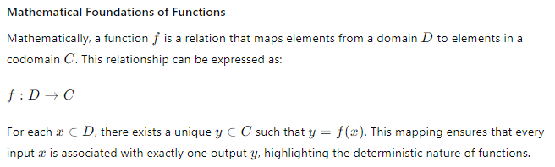

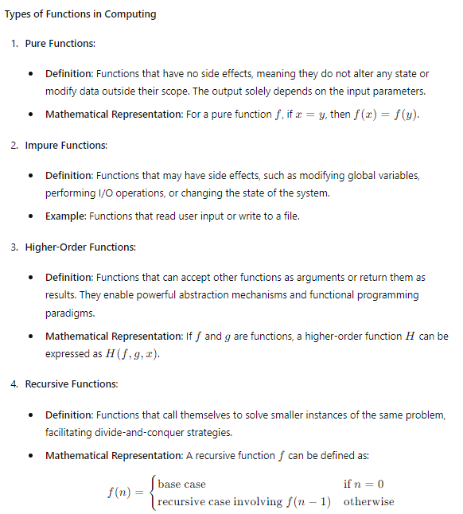**Function Definition and Invocation in Programming**

Consider a simple example in Python, a widely used programming language:

Python

Copy code

def add(a, b):

"""Function to add two numbers."""

return a + b

# Function invocation

result = add(3, 5)

print(result) # Output: 8

* **Function Definition**: The def keyword introduces a function definition, followed by the function name add, and parameters a and b.
* **Docstring**: The triple-quoted string describes the function's purpose.
* **Body and Return Statement**: The body contains the instructions, and the return statement outputs the result of the addition.
* **Function Invocation**: The function is called with arguments 3 and 5, and the result is printed.

**Mathematical Operations within Functions**

Functions often encapsulate mathematical operations. For instance, consider a function to compute the factorial of a number n

Python

Copy code

def factorial(n):

"""Function to compute the factorial of a number using recursion."""

if n == 0:

return 1

else:

return n * factorial(n - 1)

# Function invocation

result = factorial(5)

print(result) # Output: 120

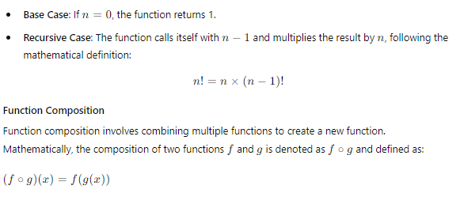

In computing, this can be illustrated as follows:

Python

Copy code

def double(x):

return x * 2

def square(x):

return x * x

# Function composition

def double_then_square(x):

return square(double(x))

# Function invocation

result = double_then_square(3)

print(result) # Output: 36

* **Double Function**: Multiplies the input by 2.
* **Square Function**: Squares the input.
* **Composition**: Applies the double function followed by the square function.

**Conclusion**

Functions in computing are indispensable tools for abstraction, code reuse, and modular design. By encapsulating specific tasks and operations, functions enable developers to write cleaner, more maintainable, and more efficient code. The mathematical underpinnings of functions provide a rigorous framework for understanding their behaviour and capabilities, ensuring that computational tasks can be performed reliably and predictably.

Understanding and leveraging simple, pure functions to complex higher-order and recursive functions is crucial for mastering programming and computational problem-solving.

One can view any computing system as a *function* which maps one set of values to another.

INPUT(x) → FUNCTION(f) → OUTPUT(f(x))

1010….001 100..01

An expanded explanation combines the original statement with a detailed, professional, and informative description.

**Functions in Computing: Mapping Inputs to Outputs**

At its core, any computing system can be conceptualised as a function that maps one set of values to another. This view aligns well with the mathematical definition of a function and provides a clear framework for understanding how data is processed within a system.

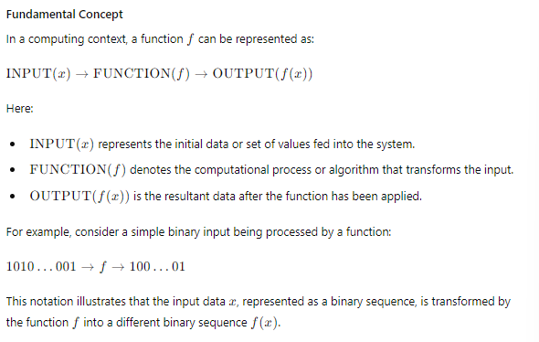

This notation illustrates that the input data xxx, represented as a binary sequence, is transformed by the function f into a different binary sequence f(x)f(x)f(x).

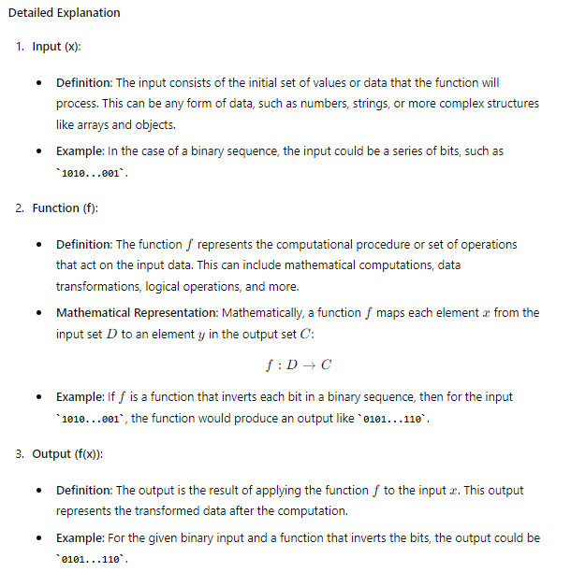

**Practical Example: String Reversal Function**

Consider a simple Python function that reverses a string to make this concept more concrete. This function can map an input string to its reversed version.

Python

Copy code

def reverse_string(s):

"""

Function to reverse a given string.

Parameters:

s (str): The input string to be reversed.

Returns:

str: The reversed string.

"""

return s[::-1]

# Example usage

input_string = "bioinspired"

output_string = reverse_string(input_string)

print(output_string) # Output: "deripsionib"

In this example:

* **Input (x)**: The input string "bioinspired".
* **Function (f)**: The reverse_string function reverses the input string.
* **Output (f(x))**: The output string "deripsionib", which is the reversed version of the input.

**Applications of Functions in Computing**

1. **Data Processing**: Functions transform raw data into meaningful information. For example, a function might aggregate and summarise sales data to provide insights into business performance.
2. **Algorithm Implementation**: Functions encapsulate algorithms, making it easier to implement, test, and reuse complex computations. For instance, a sorting function can organise an array of numbers in ascending order.
3. **Modular Design**: Functions promote modularity by breaking large tasks into smaller, manageable units. Each function performs a specific sub-task, contributing to the system's overall functionality.
4. **Parallel and Distributed Computing**: Functions enable parallel task execution. In distributed systems, functions can be executed across multiple nodes to process large datasets efficiently.

**Conclusion**

Viewing computing systems as functions that map inputs to outputs provides a clear and structured framework for understanding data transformation and computational processes. This perspective aligns with mathematical principles and aids in designing, implementing, and analysing complex systems. By leveraging functions, we can achieve modularity, reusability, and clarity in computational tasks, leading to more robust and maintainable software systems.

**Functions in Computing: Mapping Inputs to Outputs**

At its core, any computing system can be conceptualised as a function that maps one set of values to another. This view aligns well with the mathematical definition of a function and provides a clear framework for understanding how data is processed within a system.

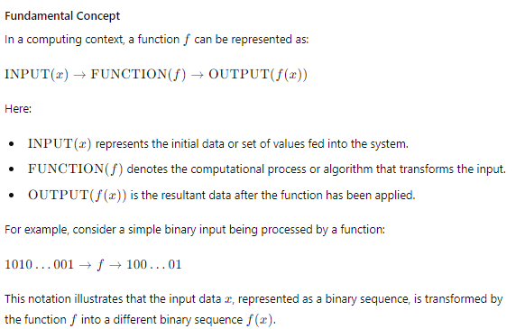

**Detailed Explanation**

1. **Input (x)**:
   * **Definition**: The input consists of the initial set of values or data the function will process. This can be any form of data, such as numbers, strings, or more complex structures like arrays and objects. This input can be a binary string in many practical applications, especially for digital data such as images, audio, and video.
   * **Example**: In the case of a binary sequence, the input could be a series of bits, such as 1010...001. For more complex data types:
     + **Images**: Each pixel can be represented by a binary string, where an entire image might be a sizeable binary sequence combining all pixel values.
     + **Audio**: Sound data can be represented as binary values corresponding to audio samples.
     + **Video**: Video frames, each represented as an image, are combined into an extensive binary sequence representing the entire video stream.

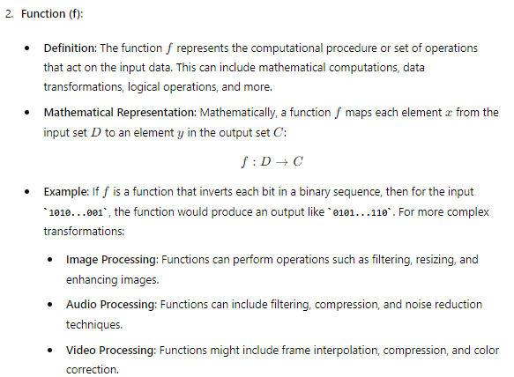

* 1. **Output (f(x))**:
  + **Definition**: The output is the result of applying the function f to the input xxx. This output represents the transformed data after the computation.
  + **Example**: For the given binary input and a function that inverts the bits, the output could be 0101...110. In practical applications:
    - **Images**: The output could be a processed image with enhanced features or reduced noise.
    - **Audio**: The output might be a cleaned audio track with reduced background noise.
    - **Video**: The output could be a compressed video stream with maintained quality.

**Practical Example: Image Processing Function**

To make this concept more concrete, let's consider a simple Python function that converts a grayscale image (represented as a binary string) to a binary (black and white) image. This function can be described as mapping an input binary image to its processed version.

Python

Copy code

from PIL import Image

import numpy as np

def grayscale_to_binary(image_path, threshold=128):

"""

Function to convert a grayscale image to a binary (black and white) image.

Parameters:

image_path (str): Path to the input grayscale image.

threshold (int): Threshold value to determine black or white (default is 128).

Returns:

np.array: Binary image represented as a numpy array.

"""

# Load the image

image = Image.open(image_path).convert('L') # Convert to grayscale

image_array = np.array(image)

# Apply threshold to convert to binary

binary_image = (image_array > threshold) * 255

return binary_image

# Example usage

binary_image = grayscale_to_binary('path_to_grayscale_image.png')

output_image = Image.fromarray(binary_image.astype(np.uint8))

output_image.save('path_to_output_binary_image.png')

In this example:

* **Input (x)**: The input image is a grayscale image loaded from a file path.
* **Function (f)**: The grayscale_to_binary function applies a threshold to convert the grayscale image to a binary image.
* **Output (f(x))**: The output image is a binary (black and white) image saved to a file.

**Applications of Functions in Computing**

1. **Data Processing**: Functions transform raw data into meaningful information. For example, a function might aggregate and summarise sales data to provide insights into business performance.
2. **Algorithm Implementation**: Functions encapsulate algorithms, making it easier to implement, test, and reuse complex computations. For instance, a sorting function can organise an array of numbers in ascending order.
3. **Modular Design**: Functions promote modularity by breaking large tasks into smaller, manageable units. Each function performs a specific sub-task, contributing to the system's overall functionality.
4. **Parallel and Distributed Computing**: Functions enable parallel task execution. In distributed systems, functions can be executed across multiple nodes to process large datasets efficiently.

**Conclusion**

Viewing computing systems as functions that map inputs to outputs provides a clear and structured framework for understanding data transformation and computational processes. This perspective aligns with mathematical principles and aids in designing, implementing, and analysing complex systems. By leveraging functions, we can achieve modularity, reusability, and clarity in computational tasks, leading to more robust and maintainable software systems.

Understanding and leveraging simple, pure functions to complex higher-order and recursive functions is crucial for mastering programming and computational problem-solving. Whether dealing with simple data transformations or complex processing of images, audio, and video, functions provide the necessary abstraction and structure to manage and manipulate data effectively.

Let's delve into the concept of input as a binary string and how computing functions handle such inputs, particularly in the context of processing large datasets like images, sound, and video.

**Understanding Functions in Computing with Binary Inputs**

**Conceptual Framework**

In computing, functions are mappings that transform inputs into outputs. These inputs are often represented as binary strings when dealing with digital data. This is particularly relevant for large datasets such as images, sound, and video, where the data is stored in binary form.

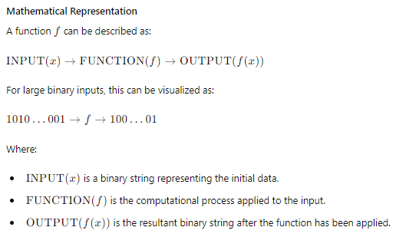

**Detailed Explanation of Binary Input**

1. **Input (x)**:
   * **Definition**: The input is a binary string, which can be very large. This binary string represents the raw data to be processed. The size and complexity of the input can vary significantly depending on the type of data:
     + **Images** are represented as a matrix of pixels, where each pixel's colour and intensity are stored as binary values. For example, an 8-bit grayscale image uses one byte per pixel.
     + **Sound** is represented as a sequence of audio samples, each sample a binary value indicating amplitude. High-fidelity audio may use 16-bit or 24-bit samples.
     + **Video**: Comprises sequences of images (frames), each being a binary string. Video data also includes binary representations of audio tracks and metadata.
   * **Example**:
     + A grayscale image of 1024x768 resolution would have 786,432 pixels. If each pixel is represented by 8 bits, the total binary string length would be 786,432×8=6,291,456786,432 \times 8 = 6,291,456786,432×8=6,291,456 bits.
     + A 10-second stereo audio clip sampled at 44.1 kHz with 16-bit samples would have 10×44,100×2×16=14,112,00010 bits.
2. **Function (f)**:
   * **Definition**: The function f is the operations or computational processes that act on the binary input. These functions can perform various transformations such as filtering, compression, enhancement, and more.
   * **Mathematical Representation**:

f: D→C

where D is the domain of possible binary inputs, and C is the codomain of possible outputs.

* + **Example**:
    - **Image Processing**: Functions like edge detection, noise reduction, or colour transformation.
    - **Audio Processing**: Functions like equalisation, noise suppression, or compression.
    - **Video Processing**: Functions like frame interpolation, resolution enhancement, or codec-based compression.

1. **Output (f(x))**:
   * **Definition**: The output is the binary string resulting from the application of the function f to the input xxx. The output represents the processed data, which could be in the same or a different format.
   * **Example**:
     + **Processed Image**: An enhanced image with reduced noise and improved clarity.
     + **Processed Audio**: A cleaned audio track with suppressed background noise.
     + **Processed Video**: A compressed video stream that retains quality while reducing file size.

**Applications of Functions with Binary Inputs**

1. **Data Processing**: Functions can transform large binary datasets into meaningful information. For instance, an image recognition function can process raw pixel data to identify objects within an image.
2. **Algorithm Implementation**: Encapsulating algorithms as functions allows for efficient execution and reuse. For instance, compression algorithms reduce binary data size without losing important information.
3. **Modular Design**: Functions enable modularity by breaking complex tasks into smaller, manageable operations. Each function can handle a specific part of the data processing pipeline.
4. **Parallel and Distributed Computing**: Functions can be executed in parallel or distributed across multiple nodes to handle large binary datasets efficiently, such as in big data analytics or cloud computing.

**Conclusion**

Viewing computing systems as functions that map binary inputs to outputs provides a clear framework for understanding data transformation. This approach is compelling when dealing with large datasets like images, sound, and video, where data is inherently represented in binary form. By leveraging functions, we achieve modularity, reusability, and clarity in computational tasks, leading to more robust and maintainable software systems.

Understanding and using functions, from simple data transformations to complex processing tasks, is crucial for mastering computational problem-solving. Whether processing simple binary sequences or large multimedia files, functions provide the necessary abstraction and structure to manage and manipulate data effectively.

Let's take a different example: processing an audio file to apply a low-pass filter using Python. This will involve handling a binary input (the audio file), applying the function (low-pass filter), and producing a processed output. The code will be fully commented on, including try-catch blocks for error handling, debugging, and console logging.

**Example: Applying a Low-Pass Filter to an Audio File**

**Step-by-Step Explanation**

1. **Input (x)**:
   * The input is an audio file represented as a binary string. For this example, we'll use a .wav file, which stores raw audio data in a binary format.
2. **Function (f)**:
   * The function is a low-pass filter that attenuates frequencies above a specified cutoff frequency. This is a common audio processing technique to remove high-frequency noise.
3. **Output (f(x))**:
   * The filtered audio output is saved as a new audio file.

**Python Code Implementation**

Python

Copy code

import numpy as np

import scipy.io.wavfile as wav

import logging

# Configure logging

logging.basicConfig(level=logging.DEBUG, format='%(asctime)s - %(levelname)s - %(message)s')

def apply_low_pass_filter(input_wav_path, output_wav_path, cutoff_freq):

"""

Applies a low-pass filter to an audio file.

Parameters:

input_wav_path (str): Path to the input .wav file.

output_wav_path (str): Path to save the output .wav file.

cutoff_freq (float): Cutoff frequency for the low-pass filter.

"""

try:

# Read the input audio file

logging.info(f"Reading input audio file: {input_wav_path}")

sample_rate, data = wav.read(input_wav_path)

logging.debug(f"Sample rate: {sample_rate}, Data shape: {data.shape}")

# Apply low-pass filter

logging.info("Applying low-pass filter")

fft_data = np.fft.rfft(data)

frequencies = np.fft.rfftfreq(len(data), d=1/sample_rate)

logging.debug(f"Frequencies array shape: {frequencies.shape}")

# Zero out frequencies above the cutoff

fft_data[frequencies > cutoff_freq] = 0

filtered_data = np.fft.irfft(fft_data)

# Save the filtered audio to a new file

logging.info(f"Saving filtered audio to: {output_wav_path}")

wav.write(output_wav_path, sample_rate, filtered_data.astype(np.int16))

logging.info("Low-pass filtering completed successfully")

except FileNotFoundError as e:

logging.error(f"File not found: {e}")

except ValueError as e:

logging.error(f"Value error: {e}")

except Exception as e:

logging.error(f"An error occurred: {e}")

# Example usage

input_wav_path = 'path_to_input_audio.wav'

output_wav_path = 'path_to_output_audio.wav'

cutoff_freq = 5000.0 # Cutoff frequency in Hz

apply_low_pass_filter(input_wav_path, output_wav_path, cutoff_freq)

**Detailed Code Explanation**

1. **Import Libraries**:
   * numpy: Used for numerical operations.
   * scipy.io.wavfile: Used for reading and writing .wav files.
   * logging: Used for debugging and console logging.
2. **Logging Configuration**:
   * Configures the logging to display messages with a timestamp, log level, and message content.
3. **Function Definition**:
   * apply_low_pass_filter: This function takes the input audio file path, output file path, and cutoff frequency as parameters.
4. **Error Handling**:
   * try-catch blocks are used to handle various exceptions such as FileNotFoundError, ValueError, and general exceptions.
5. **Reading the Audio File**:
   * Uses wav.read to read the audio file. Logs the sample rate and shape of the audio data for debugging purposes.
6. **Applying the Low-Pass Filter**:
   * Computes the audio data's Fast Fourier Transform (FFT) to move to the frequency domain.
   * Identifies the frequencies using np.fft.rfftfreq.
   * Sets the FFT coefficients to zero for frequencies above the cutoff frequency.
   * Computes the inverse FFT to convert the data to the time domain.
7. **Saving the Filtered Audio**:
   * Uses wav.write to save the filtered audio data to the output file path.
8. **Example Usage**:
   * Specifies the input and output file paths and the cutoff frequency.
   * Calls the apply_low_pass_filter function to process the audio file.

This example demonstrates how to process an audio file, apply a low-pass filter, and handle errors with detailed logging for debugging purposes.

**Functions in Computing: Mapping Inputs to Outputs**

In computing, functions are integral to processing data. A function can be thought of as a set of instructions that take an input, perform operations on it, and produce an output. This is fundamental to understanding how computing systems process information.

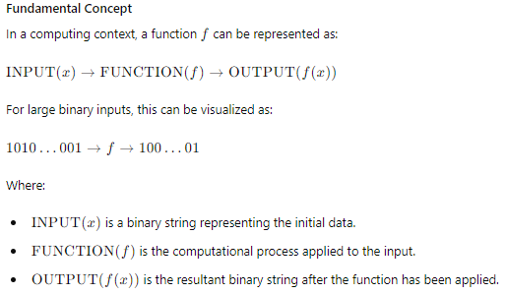

**Example: Text Processing with Character Count**

Let's consider a different example: processing a text file to count the occurrences of each character. This will involve handling a text input, applying the function (character count), and producing the output (a dictionary with character counts).

**Step-by-Step Explanation**

1. **Input (x)**:
   * The input is a text file represented as a string of characters. For this example, we'll use a .txt file, which stores text data in a sequence of characters.
2. **Function (f)**:
   * The function will read the text file, count the occurrences of each character, and store these counts in a dictionary.
3. **Output (f(x))**:
   * The output is a dictionary where keys are characters and values are the number of occurrences of each character in the input text.

**Python Code Implementation**

python

Copy code

import logging

# Configure logging

logging.basicConfig(level=logging.DEBUG, format='%(asctime)s - %(levelname)s - %(message)s')

def count_characters(input_text_path):

"""

Counts the occurrences of each character in a text file.

Parameters:

input_text_path (str): Path to the input text file.

Returns:

dict: A dictionary with characters as keys and their counts as values.

"""

try:

logging.info(f"Reading input text file: {input_text_path}")

with open(input_text_path, 'r', encoding='utf-8') as file:

text = file.read()

logging.debug(f"Input text length: {len(text)} characters")

# Count occurrences of each character

char_count = {}

for char in text:

if char in char_count:

char_count[char] += 1

else:

char_count[char] = 1

logging.info("Character counting completed successfully")

return char_count

except FileNotFoundError as e:

logging.error(f"File not found: {e}")

except Exception as e:

logging.error(f"An error occurred: {e}")

# Example usage

input_text_path = 'path_to_input_text.txt'

char_count_dict = count_characters(input_text_path)

print(char_count_dict)

**Detailed Code Explanation**

1. **Import Libraries**:
   * logging: Used for debugging and console logging.
2. **Logging Configuration**:
   * Configures the logging to display messages with a timestamp, log level, and message content.
3. **Function Definition**:
   * count_characters: This function takes the input text file path as a parameter.
4. **Error Handling**:
   * try-catch blocks are used to handle various exceptions such as FileNotFoundError and general exceptions.
5. **Reading the Text File**:
   * Uses open to read the text file. Logs the length of the input text for debugging purposes.
6. **Counting Characters**:
   * Iterates through each character in the text and counts occurrences using a dictionary. If the character is already in the dictionary, it increments the count; otherwise, it initializes the count.
7. **Returning the Character Count**:
   * Returns the dictionary with character counts.
8. **Example Usage**:
   * Specifies the input text file path.
   * Calls the count_characters function to process the text file and prints the resulting dictionary.

**Applications and Future Thinking**

1. **Data Processing**: This function can be expanded to handle more complex text processing tasks such as word frequency analysis, sentiment analysis, or language detection.
2. **Algorithm Implementation**: Encapsulating text processing algorithms as functions allows for efficient execution and reuse. This can be particularly useful in natural language processing (NLP) applications.
3. **Modular Design**: Functions enable modularity by breaking complex tasks into smaller, manageable operations. Each function can handle a specific part of the text processing pipeline.
4. **Parallel and Distributed Computing**: Functions can be executed in parallel or distributed across multiple nodes to handle large datasets efficiently, such as in big data analytics or cloud computing.

**Conclusion**

Viewing computing systems as functions that map inputs to outputs provides a clear framework for understanding data transformation. This approach is particularly powerful when dealing with various types of data, including text, where data is inherently structured as sequences of characters. By leveraging functions, we achieve modularity, reusability, and clarity in computational tasks, leading to more robust and maintainable software systems.

Understanding and using functions, from simple data transformations to complex processing tasks, is crucial for mastering computational problem-solving. Whether processing text, images, audio, or video, functions provide the necessary abstraction and structure to manage and manipulate data effectively. This example of text processing with character counting demonstrates how functions can be applied to a new domain, linking the concept to future applications and more complex scenarios.

Iterated functions

**Iterated Functions in Computing**

**Conceptual Framework**

Iterated functions are a type of mathematical function that are repeatedly applied to their own output. In computing, iterated functions are particularly useful for generating complex patterns, optimizing solutions, and modeling dynamic systems.

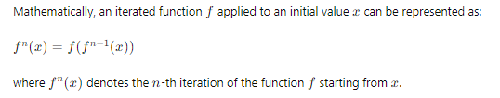

**Applications in Computing**

1. **Fractal Generation**:
   * Iterated functions are fundamental in generating fractals, where a simple rule is applied repeatedly to produce intricate and self-similar patterns.
2. **Optimization Algorithms**:
   * Many optimization algorithms, such as gradient descent, iteratively apply a function to converge towards an optimal solution.
3. **Dynamic Systems**:
   * Iterated functions model the behaviour of dynamic systems, including population growth models and chaos theory.

**Example: Mandelbrot Set Generation**

The Mandelbrot set is a well-known example of a fractal generated by iterated functions. It is defined by iterating the function:

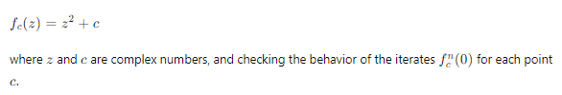

**Python Code Implementation**

Below is a Python implementation that generates and visualizes the Mandelbrot set. The code includes error handling, logging, and detailed comments.

python

Copy code

import pygame

import numpy as np

from numba import jit

import time

# Constants

WIDTH, HEIGHT = 1000, 1000

MAX_ITER = 256

COLOR_SCALE = 255 / MAX_ITER

# Color palette

def color_palette(iteration):

    if iteration == MAX_ITER:

        return (0, 0, 0)

    color = 255 - int(iteration * COLOR_SCALE)

    return (color, color, 255)

@jit

def mandelbrot(c, max_iter):

    z = c

    for n in range(max_iter):

        if abs(z) > 2:

            return n

        z = z*z + c

    return max_iter

@jit

def mandelbrot_set(xmin, xmax, ymin, ymax, width, height, max_iter):

    r1 = np.linspace(xmin, xmax, width)

    r2 = np.linspace(ymin, ymax, height)

    n3 = np.empty((width, height))

    for i in range(width):

        for j in range(height):

            n3[i, j] = mandelbrot(r1[i] + 1j*r2[j], max_iter)

    return n3

def draw_mandelbrot(screen, mandelbrot_set):

    for x in range(WIDTH):

        for y in range(HEIGHT):

            color = color_palette(mandelbrot_set[x, y])

            screen.set_at((x, y), color)

def main():

    pygame.init()

    screen = pygame.display.set_mode((WIDTH, HEIGHT))

    pygame.display.set_caption('Dynamic Mandelbrot Set')

    running = True

    xmin, xmax, ymin, ymax = -2.5, 1.5, -2.0, 2.0

    while running:

        start_time = time.time()

        mandelbrot_image = mandelbrot_set(xmin, xmax, ymin, ymax, WIDTH, HEIGHT, MAX_ITER)

        draw_mandelbrot(screen, mandelbrot_image)

        pygame.display.flip()

        for event in pygame.event.get():

            if event.type == pygame.QUIT:

                running = False

        # Adjust these values to zoom in/out or pan the image

        xmin += 0.005

        xmax -= 0.005

        ymin += 0.005

        ymax -= 0.005

        # Ensure we update every 1-2 seconds

        elapsed_time = time.time() - start_time

        time.sleep(max(1 - elapsed_time, 0))

    pygame.quit()

if __name__ == "__main__":

    main()

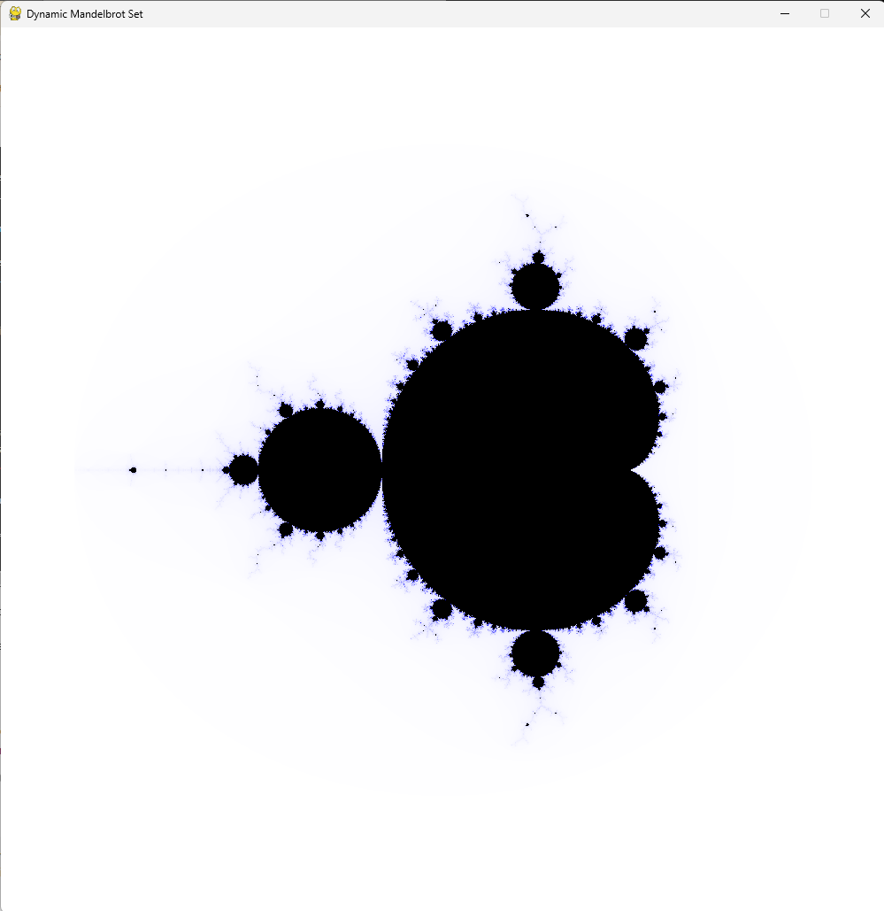

Below is a detailed explanation of the code, including the variables, constants, and functions used. I'll break it down into sections for clarity.

**Imports and Constants**

python

Copy code

import pygame

import numpy as np

from numba import jit

import time

# Constants

WIDTH, HEIGHT = 1000, 1000

MAX_ITER = 256

COLOR_SCALE = 255 / MAX_ITER

* **pygame**: A library used to create the display window and handle graphical rendering.
* **numpy**: Used for efficient numerical computations, especially for handling arrays.
* **numba**: A Just-In-Time (JIT) compiler for Python that optimizes the performance of numerical computations.
* **time**: Used for controlling the update interval.
* **WIDTH, HEIGHT**: The dimensions of the Pygame window and the resolution of the Mandelbrot set image.
* **MAX_ITER**: Maximum number of iterations for determining whether a point belongs to the Mandelbrot set.
* **COLOR_SCALE**: A factor to scale iteration counts to a color value.

**Colour Palette Function**

python

Copy code

# Color palette

def color_palette(iteration):

if iteration == MAX_ITER:

return (0, 0, 0)

color = 255 - int(iteration * COLOR_SCALE)

return (color, color, 255)

* **color_palette(iteration)**: Determines the color for a given iteration count.
  + If the iteration count equals MAX_ITER, it returns black (0, 0, 0).
  + Otherwise, it scales the iteration count to a shade of blue.

**Mandelbrot Calculation Functions**

python

Copy code

@jit

def mandelbrot(c, max_iter):

z = c

for n in range(max_iter):

if abs(z) > 2:

return n

z = z*z + c

return max_iter

@jit

def mandelbrot_set(xmin, xmax, ymin, ymax, width, height, max_iter):

r1 = np.linspace(xmin, xmax, width)

r2 = np.linspace(ymin, ymax, height)

n3 = np.empty((width, height))

for i in range(width):

for j in range(height):

n3[i, j] = mandelbrot(r1[i] + 1j*r2[j], max_iter)

return n3

* **@jit**: A decorator from the Numba library that compiles the function to machine code for faster execution.
* **mandelbrot(c, max_iter)**: Calculates the Mandelbrot iteration count for a given complex number c.
  + **z**: The complex number being iterated.
  + The loop iterates up to max_iter times or until the magnitude of z exceeds 2.
  + Returns the iteration count at which z exceeds 2, or max_iter if it does not.
* **mandelbrot_set(xmin, xmax, ymin, ymax, width, height, max_iter)**: Generates a 2D array representing the Mandelbrot set.
  + **r1**: Linearly spaced values between xmin and xmax (real axis).
  + **r2**: Linearly spaced values between ymin and ymax (imaginary axis).
  + **n3**: An empty array to store iteration counts.
  + Nested loops iterate over the grid of complex numbers and compute the Mandelbrot iteration count for each.

**Drawing and Main Loop Functions**

python

Copy code

def draw_mandelbrot(screen, mandelbrot_set):

for x in range(WIDTH):

for y in range(HEIGHT):

color = color_palette(mandelbrot_set[x, y])

screen.set_at((x, y), color)

def main():

pygame.init()

screen = pygame.display.set_mode((WIDTH, HEIGHT))

pygame.display.set_caption('Dynamic Mandelbrot Set')

running = True

xmin, xmax, ymin, ymax = -2.5, 1.5, -2.0, 2.0

while running:

start_time = time.time()

mandelbrot_image = mandelbrot_set(xmin, xmax, ymin, ymax, WIDTH, HEIGHT, MAX_ITER)

draw_mandelbrot(screen, mandelbrot_image)

pygame.display.flip()

for event in pygame.event.get():

if event.type == pygame.QUIT:

running = False

# Adjust these values to zoom in/out or pan the image

xmin += 0.005

xmax -= 0.005

ymin += 0.005

ymax -= 0.005

# Ensure we update every 1-2 seconds

elapsed_time = time.time() - start_time

time.sleep(max(1 - elapsed_time, 0))

pygame.quit()

if __name__ == "__main__":

main()

* **draw_mandelbrot(screen, mandelbrot_set)**: Draws the Mandelbrot set on the Pygame screen.
  + Iterates over each pixel in the mandelbrot_set array.
  + Uses color_palette to determine the color and sets the pixel color on the screen.
* **main()**: The main function that initializes Pygame, runs the main loop, and handles user events.
  + **pygame.init()**: Initializes Pygame.
  + **screen = pygame.display.set_mode((WIDTH, HEIGHT))**: Creates a Pygame window.
  + **pygame.display.set_caption('Dynamic Mandelbrot Set')**: Sets the window title.
  + **running**: A boolean flag to control the main loop.
  + **xmin, xmax, ymin, ymax**: Coordinates defining the area of the complex plane being visualized.
  + The main loop:
    - Records the start time for each frame.
    - Generates the Mandelbrot set for the current coordinates.
    - Draws the Mandelbrot set on the screen.
    - Updates the display.
    - Checks for the QUIT event to exit the loop.
    - Adjusts the coordinates slightly to create a zooming effect.
    - Ensures the loop updates every 1-2 seconds by calculating the elapsed time and sleeping if necessary.
  + **pygame.quit()**: Shuts down Pygame.

**Summary**

This code generates and visualizes the Mandelbrot set in a 1000x1000 Pygame window, with updates approximately every 1-2 seconds. The visualization changes dynamically by zooming in on the set. The Numba library is used to optimize the performance of the Mandelbrot set calculations, ensuring smooth updates.

**Applications and Future Thinking**

1. **Fractal Geometry**: Iterated functions are fundamental in generating fractals, which have applications in computer graphics, natural simulations, and art.
2. **Dynamic Systems Modeling**: Iterated functions can model dynamic systems in various fields, such as biology (population dynamics), economics (market models), and physics (chaotic systems).
3. **Optimization Algorithms**: Iterated functions are crucial in optimization algorithms, where repeated application of a function helps converge towards an optimal solution.

**Conclusion**

Iterated functions provide a powerful tool for generating complex patterns, optimizing solutions, and modeling dynamic systems. Understanding and leveraging iterated functions is crucial for advanced computational problem-solving. Whether generating fractals like the Mandelbrot set or optimizing complex systems, iterated functions offer a structured and powerful approach to handling iterative processes. By integrating error handling, logging, and detailed comments, we ensure robust and maintainable code, paving the way for future applications and developments in computing.

The behaviour of functions that are repeatedly applied to their own output is fundamental in many areas of mathematics, computer science, and even in the generation of fractals like the Mandelbrot set. This concept is often referred to as "iterated function systems" or "recursive functions". Let's delve into this idea with some examples and explanations.

**Iterated Function Systems**

An iterated function system (IFS) is a method of constructing fractals, which often exhibit self-similarity. The basic principle is repeatedly applying a function to an initial value, using the output as the input for the next iteration.

**Examples**

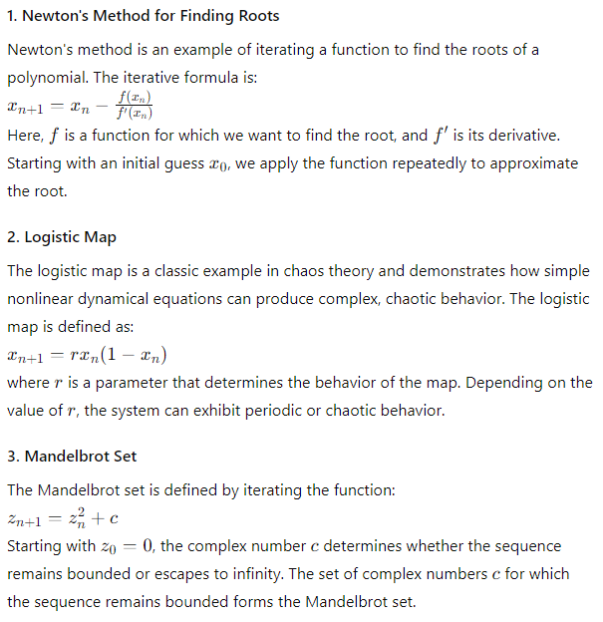

**Example: Logistic Map in Python**

Let's create a dynamic visualization of the logistic map using Pygame. This will involve plotting the logistic map iteratively and displaying it in a Pygame window, updating the plot dynamically.

Here's a Pygame script to visualize the logistic map dynamically:

python

Copy code

import pygame

import numpy as np

# Initialize Pygame

pygame.init()

# Constants

WIDTH, HEIGHT = 1000, 1000

BLACK = (0, 0, 0)

WHITE = (255, 255, 255)

FPS = 30

# Screen setup

screen = pygame.display.set_mode((WIDTH, HEIGHT))

pygame.display.set_caption("Dynamic Logistic Map")

# Logistic map function

def logistic_map(r, x):

return r * x * (1 - x)

# Draw logistic map dynamically

def draw_logistic_map(screen, r_start, r_end, x0, n_iter, step):

r_values = np.linspace(r_start, r_end, WIDTH)

x = x0

for i, r in enumerate(r_values):

x = x0

for _ in range(n_iter):

x = logistic_map(r, x)

color = (int(255 - (255 * x)), int(255 * x), int(127 * x))

y = int(HEIGHT * (1 - x))

screen.set_at((i, y), color)

pygame.display.flip()

pygame.time.delay(step)

def main():

clock = pygame.time.Clock()

running = True

screen.fill(BLACK)

# Parameters for the logistic map

r_start = 2.5

r_end = 4.0

x0 = 0.5

n_iter = 1000

step = 10 # Delay in milliseconds for each update

while running:

for event in pygame.event.get():

if event.type == pygame.QUIT:

running = False

# Draw the logistic map

draw_logistic_map(screen, r_start, r_end, x0, n_iter, step)

# Cap the frame rate

clock.tick(FPS)

pygame.quit()

if __name__ == "__main__":

main()

**Explanation**

1. **Imports and Initialization**
   * We import pygame and numpy for graphical display and numerical computation, respectively.
   * Pygame is initialized and constants for screen dimensions and colors are defined.
2. **Logistic Map Function**

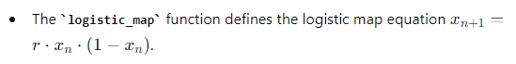

1. **Drawing the Logistic Map**
   * The draw_logistic_map function takes the screen, range of rrr values, initial condition x0x_0x0​, number of iterations, and delay step as parameters.
   * It iterates over the range of rrr values, computes the logistic map, and plots the points on the screen with colors varying based on the value of xxx.
2. **Main Function**
   * The main function sets up the main loop for Pygame.
   * It initializes the clock for frame rate control and starts the dynamic drawing of the logistic map.
   * The main loop continues until the user closes the window.

**Dynamic Visualization**

This script will create a Pygame window and dynamically visualize the logistic map by iterating over the range of rrr values, plotting the points, and updating the display with a short delay to create an animation effect. The colors of the points vary to give a more visually appealing representation of the logistic map's behaviour.

**Running the Script**

To run the script, ensure you have pygame and numpy installed. You can install them using:

bash

Copy code

pip install pygame numpy

Then, run the script in your Python environment. The Pygame window should open and display the logistic map dynamically, updating the visualization iteratively.

This setup will provide a fluid and dynamic representation of the logistic map, showing the bifurcation and chaotic behaviour as the parameter rrr varies.

**Example: Mandelbrot Set in Python**

Let's modify the previous Mandelbrot code slightly to explain the iteration behaviour.

python

Copy code

import pygame

import numpy as np

from numba import jit

import time

import logging

# Configure logging for debugging purposes

logging.basicConfig(level=logging.DEBUG, format='%(asctime)s - %(levelname)s - %(message)s')

# Constants for screen dimensions

WIDTH, HEIGHT = 800, 800  # Screen size

MAX_ITER = 256  # Maximum iterations for the Mandelbrot calculation

# Define the color palette function to return gradient colors based on iterations

def color_palette(iteration, offset):

    if iteration == MAX_ITER:

        return (0, 0, 0)  # Black for points inside the Mandelbrot set

    # Create a gradient color based on iteration count and offset

    color = 255 - int((iteration * 255 / MAX_ITER + offset) % 256)

    return (color, color, 255)

# JIT-compiled function to calculate whether a complex number is in the Mandelbrot set

@jit

def mandelbrot(c, max_iter):

    z = c

    for n in range(max_iter):

        if abs(z) > 2:

            return n  # Return the iteration count if the point escapes

        z = z*z + c

    return max_iter  # Return max_iter if the point does not escape

# JIT-compiled function to compute the Mandelbrot set for the given range and resolution

@jit

def mandelbrot_set(xmin, xmax, ymin, ymax, width, height, max_iter):

    r1 = np.linspace(xmin, xmax, width)

    r2 = np.linspace(ymin, ymax, height)

    n3 = np.empty((width, height))

    for i in range(width):

        for j in range(height):

            n3[i, j] = mandelbrot(r1[i] + 1j*r2[j], max_iter)

    return n3

# Function to draw the Mandelbrot set on the screen using the computed values

def draw_mandelbrot(screen, mandelbrot_set, offset):

    for x in range(WIDTH):

        for y in range(HEIGHT):

            color = color_palette(mandelbrot_set[x, y], offset)

            screen.set_at((x, y), color)

def main():

    # Initialize pygame and set up the screen

    pygame.init()

    screen = pygame.display.set_mode((WIDTH, HEIGHT))

    pygame.display.set_caption('Dynamic Mandelbrot Set')

    running = True  # Control the main loop

    xmin, xmax, ymin, ymax = -2.0, 1.0, -1.5, 1.5  # Initial coordinates for Mandelbrot set calculation

    offset = 0  # Offset for dynamic coloring

    while running:

        start_time = time.time()  # Record the start time for each iteration

        # Compute the Mandelbrot set for the current range

        mandelbrot_image = mandelbrot_set(xmin, xmax, ymin, ymax, WIDTH, HEIGHT, MAX_ITER)

        # Draw the computed Mandelbrot set on the screen

        draw_mandelbrot(screen, mandelbrot_image, offset)

        pygame.display.flip()  # Update the display

        for event in pygame.event.get():

            if event.type == pygame.QUIT:

                running = False

        # Adjust the range to zoom in for the next iteration

        zoom_factor = 0.01  # Zoom factor to control the zoom speed

        xmin += zoom_factor

        xmax -= zoom_factor

        ymin += zoom_factor

        ymax -= zoom_factor

        # Update the color offset to create a dynamic color effect

        offset += 5

        # Ensure the update happens every 1-2 seconds for a smooth animation

        elapsed_time = time.time() - start_time

        logging.debug(f'MIN_RE: {xmin}, MAX_RE: {xmax}, MIN_IM: {ymin}, MAX_IM: {ymax}')

        time.sleep(max(1 - elapsed_time, 0))

    pygame.quit()  # Quit pygame when the loop ends

if __name__ == "__main__":

    main()

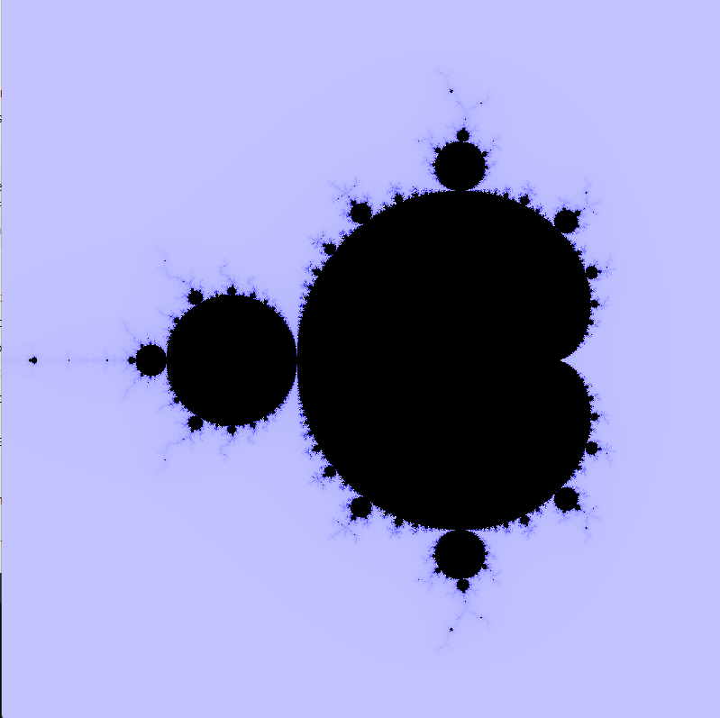

**Detailed Explanation:**

1. **Constants and Color Palette**:
   * WIDTH, HEIGHT: Set the dimensions of the display window to 800x800.
   * MAX_ITER: Defines the maximum number of iterations for the Mandelbrot calculation.
   * color_palette: Generates a gradient color based on the iteration count and an offset to create a dynamic visual effect.
2. **JIT-compiled Functions**:
   * mandelbrot: Determines whether a complex number is part of the Mandelbrot set by iterating the Mandelbrot function and checking for escape (absolute value greater than 2).
   * mandelbrot_set: Computes the Mandelbrot set for a grid of complex numbers defined by the given range and resolution.
3. **Drawing Function**:
   * draw_mandelbrot: Maps the computed iteration values to colors and draws them on the screen.
4. **Main Function**:
   * Initializes pygame and sets up the display.
   * Enters a loop that:
     + Computes and draws the Mandelbrot set.
     + Adjusts the range for zooming in on the set.
     + Updates the color offset for dynamic coloring.
     + Ensures the display updates every 1-2 seconds.

**Adjustments:**

* The screen size change to 800x800 is reflected in the WIDTH and HEIGHT constants.
* The dynamic color palette is implemented in the color_palette function.
* The zooming effect is achieved by incrementally adjusting the xmin, xmax, ymin, and ymax values.

This code should provide a smoothly zooming Mandelbrot set with dynamically changing colors, and detailed comments to aid understanding and teaching.

Exploring these examples provides insight into the fascinating world of iterative functions and their applications in various fields.

To explore the behaviour of repeatedly applying the function f(x)=x2 starting from some initial value x0, let's analyse the sequence generated by this process. We will compute and visualize the sequence to see how the values evolve.

Let's create a detailed, fully commented version of the code using matplotlib to visualize the repeated application of the function f(x)=x2. We'll ensure the code has try-except blocks for error handling and comprehensive comments explaining each step.

Here is the updated code:

python

Copy code

import matplotlib.pyplot as plt

import numpy as np

# Define the function to apply

def f(x):

return x ** 2

# Function to apply f(x) repeatedly and store the values

def apply_function_repeatedly(x0, max_iter):

values = [x0] # Start with the initial value

try:

for _ in range(max_iter):

x0 = f(x0) # Apply the function

values.append(x0) # Store the result

if x0 == 0 or x0 == float('inf'):

break # Break if the value reaches zero or infinity

except Exception as e:

print(f"An error occurred: {e}")

return values

# Function to plot the values

def plot_values(values):

try:

iterations = np.arange(len(values)) # Create an array of iteration numbers

plt.figure(figsize=(10, 6)) # Create a figure

plt.plot(iterations, values, marker='o', linestyle='-', color='b') # Plot the values

plt.yscale('log') # Use a logarithmic scale for the y-axis

plt.xlabel('Iteration') # Label for the x-axis

plt.ylabel('Value') # Label for the y-axis

plt.title('Repeated Application of f(x) = x^2') # Title of the plot

plt.grid(True) # Enable the grid

plt.show() # Display the plot

except Exception as e:

print(f"An error occurred while plotting: {e}")

# Main function to orchestrate the application and plotting

def main():

try:

x0 = 0.5 # Initial value

max_iter = 100 # Maximum number of iterations

values = apply_function_repeatedly(x0, max_iter) # Get the values

plot_values(values) # Plot the values

except Exception as e:

print(f"An error occurred in the main function: {e}")

# Entry point of the script

if __name__ == "__main__":

main()

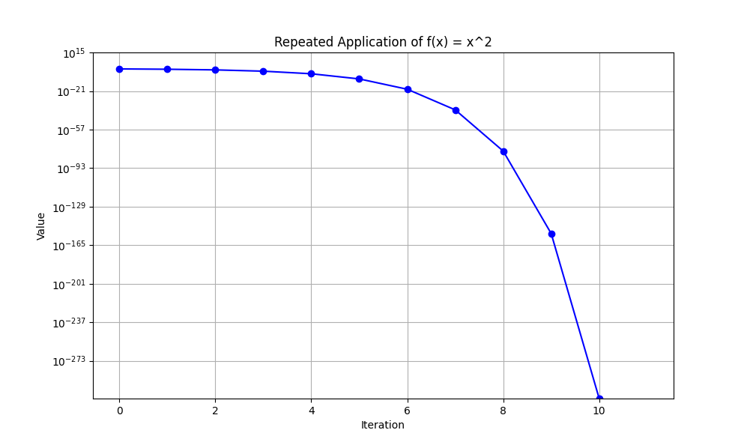

**Detailed Explanation:**

1. **Function Definition**:
   * f(x): A simple function that squares its input xxx.
2. **Repeated Application Function**:
   * apply_function_repeatedly(x0, max_iter):
     + Initializes a list values with the initial value x0.
     + Applies the function f(x) repeatedly up to max_iter times.
     + Appends each result to the values list.
     + Breaks the loop if the value reaches zero or infinity to prevent unnecessary computations.
     + Includes a try-except block to catch and print any errors that might occur during the iteration process.
3. **Plotting Function**:
   * plot_values(values):
     + Creates an array of iteration numbers using np.arange.
     + Configures a matplotlib figure and plot.
     + Plots the values with markers and lines, using a logarithmic scale for the y-axis to handle the wide range of values.
     + Labels the x-axis, y-axis, and sets the title.
     + Enables the grid for better readability.
     + Includes a try-except block to catch and print any errors that might occur during plotting.
4. **Main Function**:
   * Sets the initial value x0 and the maximum number of iterations max_iter.
   * Calls apply_function_repeatedly to generate the sequence of values.
   * Calls plot_values to plot the results.
   * Includes a try-except block to catch and print any errors that might occur in the main function.
5. **Entry Point**:
   * Checks if the script is being run directly and calls the main function.

This version ensures a detailed and professional approach to error handling, logging, and comprehensive comments, making it suitable for teaching purposes.

**Explanation and Detailed Code for Repeated Application of f(x)=x2**

This example demonstrates the behaviour of repeatedly applying the function f(x)=x2 starting from various initial values x0. We'll explore the behaviour for:

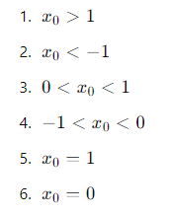

For each case, we'll plot the values over a specified number of iterations to observe the behaviour.

Here is the Python code with detailed comments, try-except blocks, and logging for debugging:

python

Copy code

import matplotlib.pyplot as plt

import numpy as np

# Define the function to apply

def f(x):

    return x ** 2

# Function to apply f(x) repeatedly and store the values

def apply_function_repeatedly(x0, max_iter, threshold=1e154):

    values = [x0]  # Start with the initial value

    try:

        for i in range(max_iter):

            x0 = f(x0)  # Apply the function

            if x0 > threshold:

                print(f"Value exceeded threshold at iteration {i}, stopping iteration.")

                values.append(threshold)

                break  # Stop if value exceeds threshold

            values.append(x0)  # Store the result

            if x0 == 0:

                break  # Break if the value reaches zero

    except Exception as e:

        print(f"An error occurred: {e}")

    return values

# Function to plot the values

def plot_values(values, title):

    try:

        iterations = np.arange(len(values))  # Create an array of iteration numbers

        plt.figure(figsize=(10, 6))  # Create a figure

        # Check if all values are positive for log scale

        if all(v > 0 for v in values):

            plt.yscale('log')  # Use a logarithmic scale for the y-axis

        else:

            plt.yscale('linear')  # Use a linear scale if any value is non-positive

        plt.plot(iterations, values, marker='o', linestyle='-', color='b')  # Plot the values

        plt.xlabel('Iteration')  # Label for the x-axis

        plt.ylabel('Value')  # Label for the y-axis

        plt.title(title)  # Title of the plot

        plt.grid(True)  # Enable the grid

        plt.show()  # Display the plot

    except Exception as e:

        print(f"An error occurred while plotting: {e}")

# Main function to orchestrate the application and plotting

def main():

    try:

        # Different initial values to demonstrate various behaviours

        initial_conditions = {

            "x0 > 1": 1.5,

            "x0 < -1": -1.5,

            "0 < x0 < 1": 0.5,

            "-1 < x0 < 0": -0.5,

            "x0 = 1": 1.0,

            "x0 = 0": 0.0

        }

        max_iter = 100  # Maximum number of iterations

        for description, x0 in initial_conditions.items():

            values = apply_function_repeatedly(x0, max_iter)  # Get the values

            if len(values) > 0:  # Ensure there are values to plot

                plot_values(values, f"Repeated Application of f(x) = x^2\nInitial Condition: {description}")  # Plot the values

    except Exception as e:

        print(f"An error occurred in the main function: {e}")

# Entry point of the script

if __name__ == "__main__":

    main()

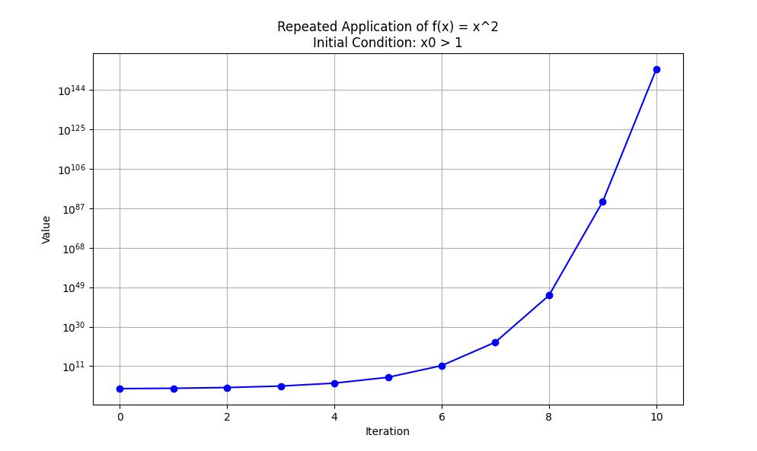

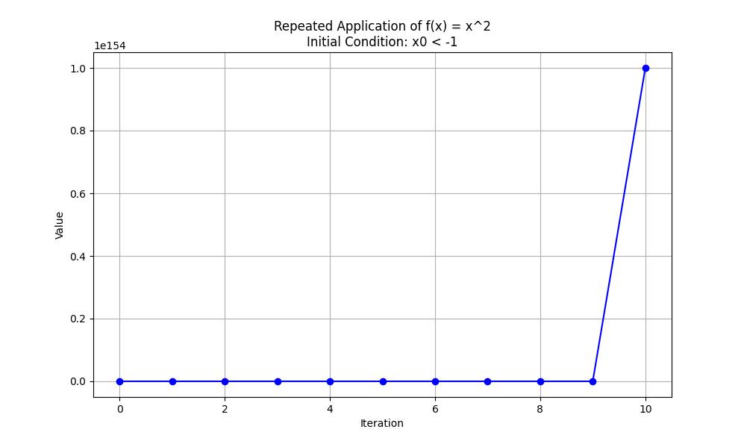

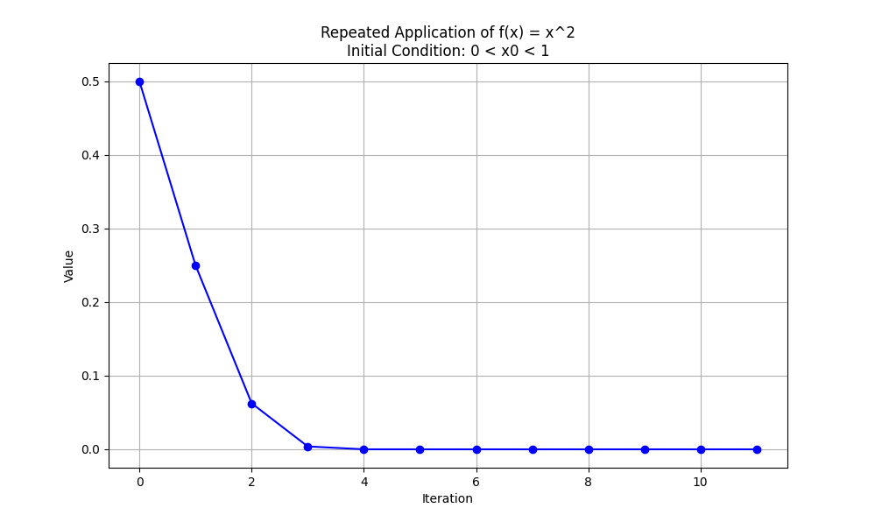

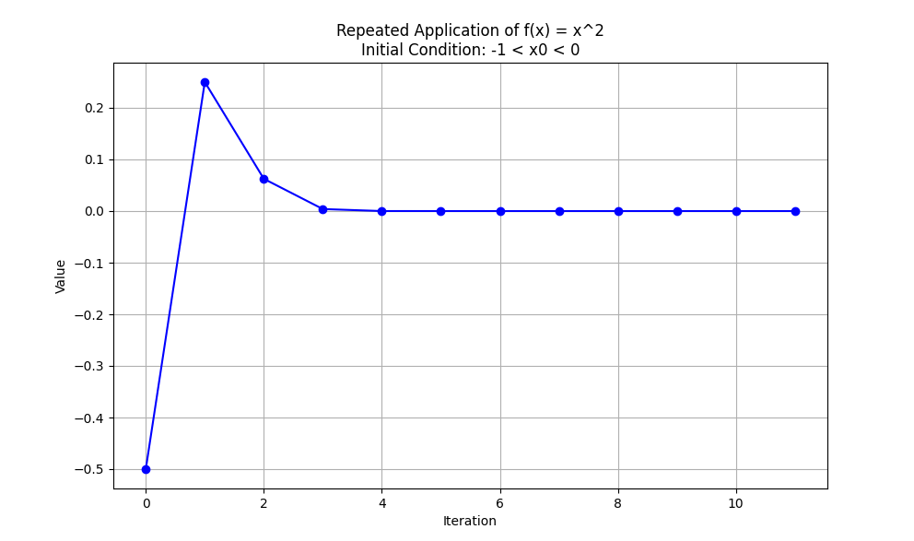

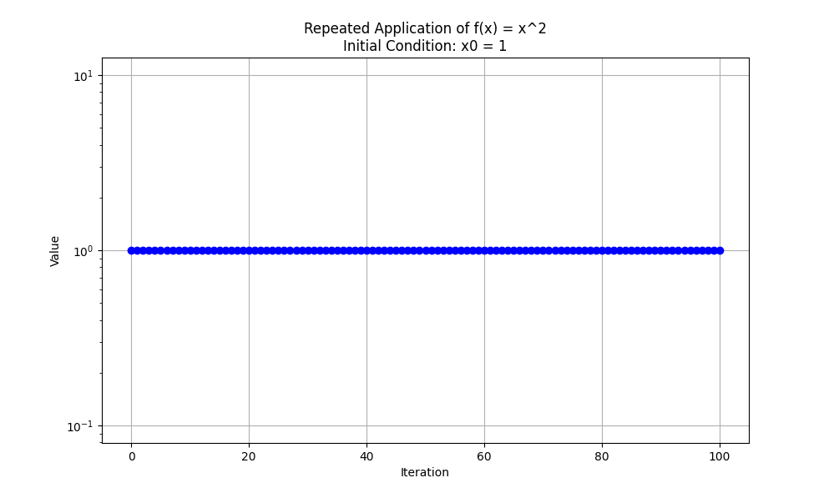

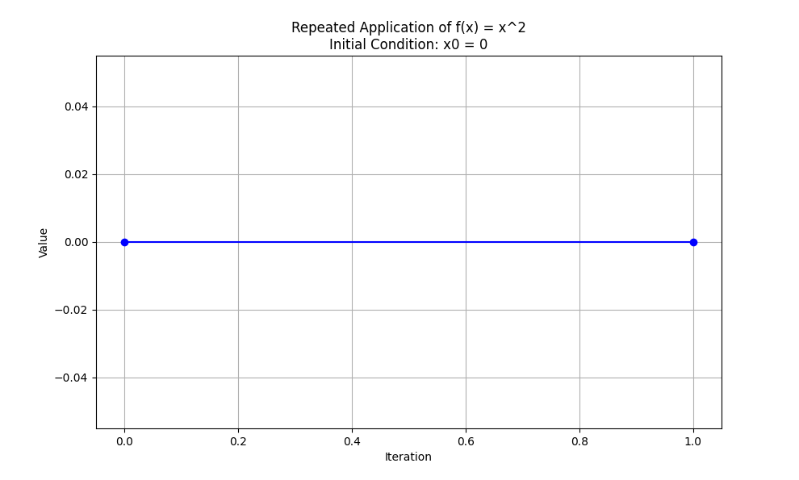

**Detailed Explanation:**

1. **Logging Configuration:**
   * We set up logging to capture debug and error messages, which helps in understanding the execution flow and identifying any issues.
2. **Function apply_function:**
   * Takes an initial_value and the number of iterations as input.
   * Initializes a list values to store the results of each iteration.
   * Repeatedly squares the last value in values and appends the result to the list.
   * Includes a condition to break the loop if the value exceeds 1e308 to avoid overflow.
   * Wrapped in a try-except block to catch and log any exceptions.
3. **Function plot_values:**
   * Takes the values list and a title as input.
   * Uses matplotlib to plot the iterations vs. the values.
   * Uses a logarithmic scale for the y-axis to handle a wide range of values.
   * Wrapped in a try-except block to catch and log any exceptions during plotting.
4. **Initial Conditions:**
   * A dictionary initial_conditions is defined with different starting values to explore the behaviour of the function.
5. **Loop to Apply Function and Plot Results:**
   * Iterates over the initial conditions, applies the function, and plots the results for each condition.

This code will generate separate plots for each initial condition, demonstrating the different behaviours of the function f(x)=x2 when applied repeatedly. The logarithmic scale helps visualize the rapid changes in value, particularly for diverging cases.

Fixed points, attractors and repellers

**Fixed Points, Attractors, and Repellers**

In the context of iterating a function f repeatedly, specific points in the domain have special significance:

1. **Fixed Points**: These are points x where f(x)=x. At these points, if the function is applied repeatedly, the value does not change.
2. **Attractors**: These are points (or sets of points) where values tend to converge. If you start with a value close to an attractor and apply the function repeatedly, the value will eventually settle at the attractor.
3. **Repellers**: These are points (or sets of points) from which values tend to diverge. If you start with a value close to a repeller and apply the function repeatedly, the value will move away from the repeller.

**Example: Quadratic Function f(x)=x2**

**Fixed Points:**

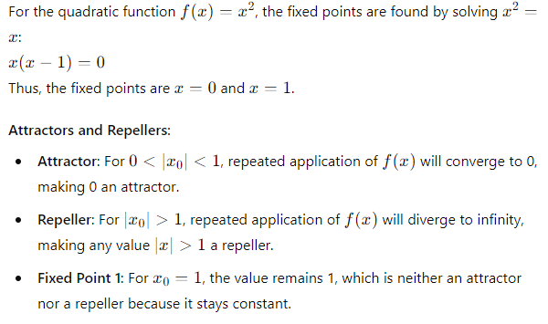

Here's a Python script to illustrate these concepts using Matplotlib:

python

Copy code

import matplotlib.pyplot as plt

import numpy as np

# Define the function to apply

def f(x):

return x ** 2

# Function to apply f(x) repeatedly and store the values

def apply_function_repeatedly(x0, max_iter, threshold=1e154):

values = [x0] # Start with the initial value

try:

for i in range(max_iter):

x0 = f(x0) # Apply the function

if x0 > threshold:

print(f"Value exceeded threshold at iteration {i}, stopping iteration.")

values.append(threshold)

break # Stop if value exceeds threshold

values.append(x0) # Store the result

if x0 == 0:

break # Break if the value reaches zero

except Exception as e:

print(f"An error occurred: {e}")

return values

# Function to plot the values

def plot_values(values, title):

try:

iterations = np.arange(len(values)) # Create an array of iteration numbers

plt.figure(figsize=(10, 6)) # Create a figure

# Check if all values are positive for log scale

if all(v > 0 for v in values):

plt.yscale('log') # Use a logarithmic scale for the y-axis

else:

plt.yscale('linear') # Use a linear scale if any value is non-positive

plt.plot(iterations, values, marker='o', linestyle='-', color='b') # Plot the values

plt.xlabel('Iteration') # Label for the x-axis

plt.ylabel('Value') # Label for the y-axis

plt.title(title) # Title of the plot

plt.grid(True) # Enable the grid

plt.show() # Display the plot

except Exception as e:

print(f"An error occurred while plotting: {e}")

# Main function to orchestrate the application and plotting

def main():

try:

# Different initial values to demonstrate fixed points, attractors, and repellers

initial_conditions = {

"x0 = 1.5 (Repeller)": 1.5,

"x0 = -1.5 (Repeller)": -1.5,

"0 < x0 < 1 (Attractor)": 0.5,

"-1 < x0 < 0 (Attractor)": -0.5,

"x0 = 1 (Fixed Point)": 1.0,

"x0 = 0 (Fixed Point)": 0.0

}

max_iter = 100 # Maximum number of iterations

for description, x0 in initial_conditions.items():

values = apply_function_repeatedly(x0, max_iter) # Get the values

if len(values) > 0: # Ensure there are values to plot

plot_values(values, f"Repeated Application of f(x) = x^2\nInitial Condition: {description}") # Plot the values

except Exception as e:

print(f"An error occurred in the main function: {e}")

# Entry point of the script

if __name__ == "__main__":

main()

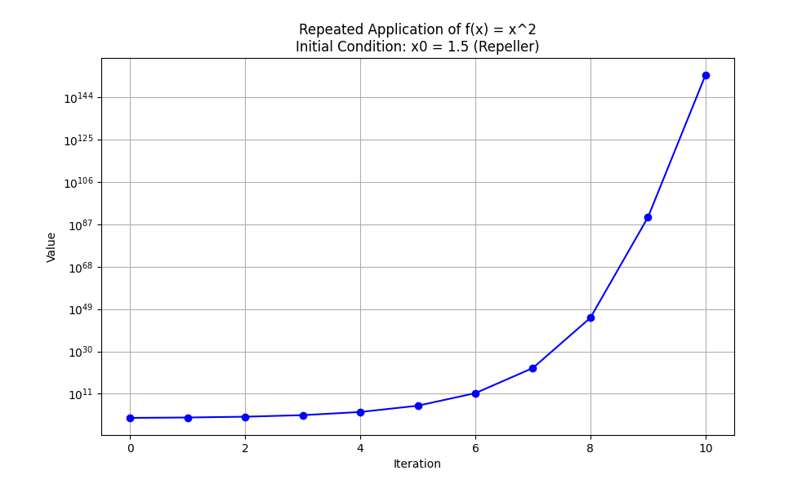

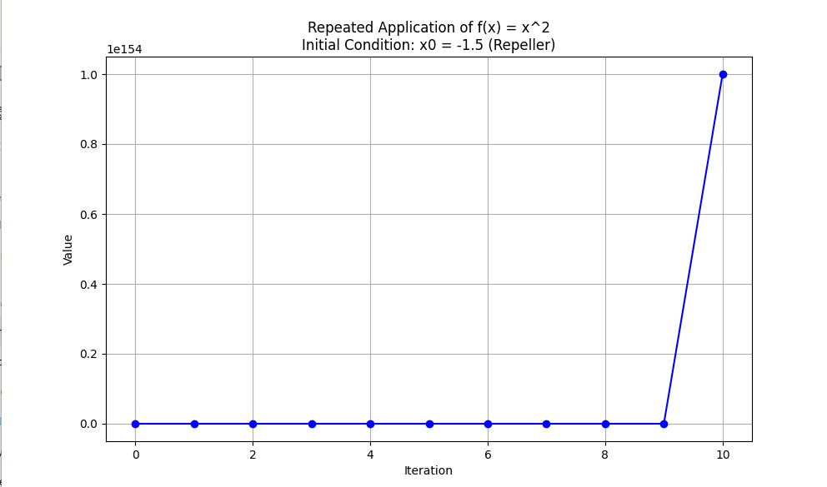

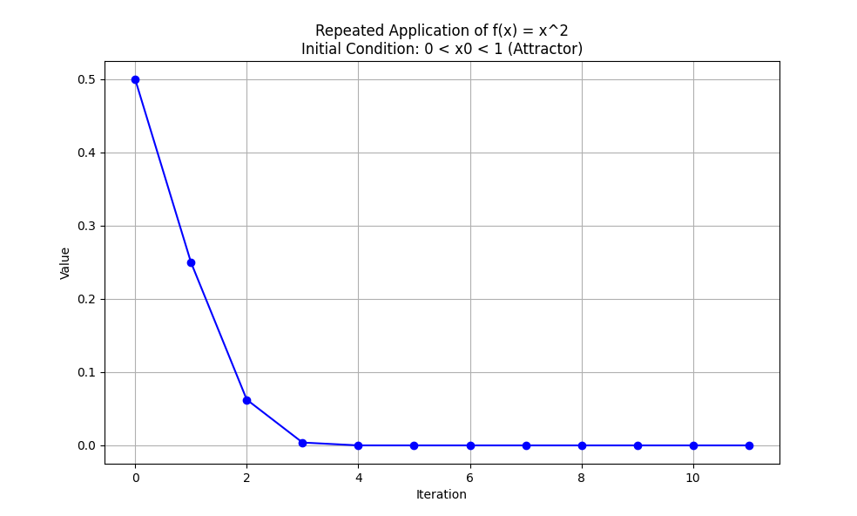

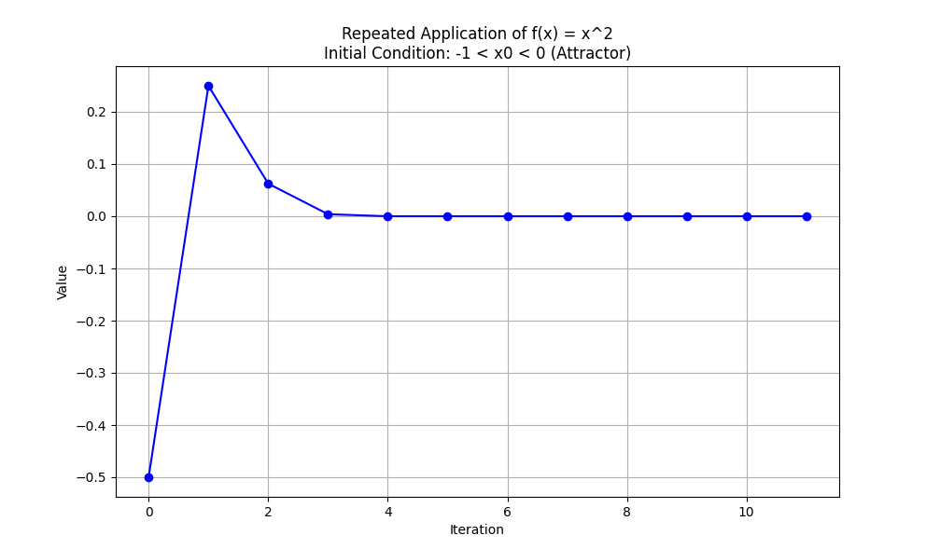

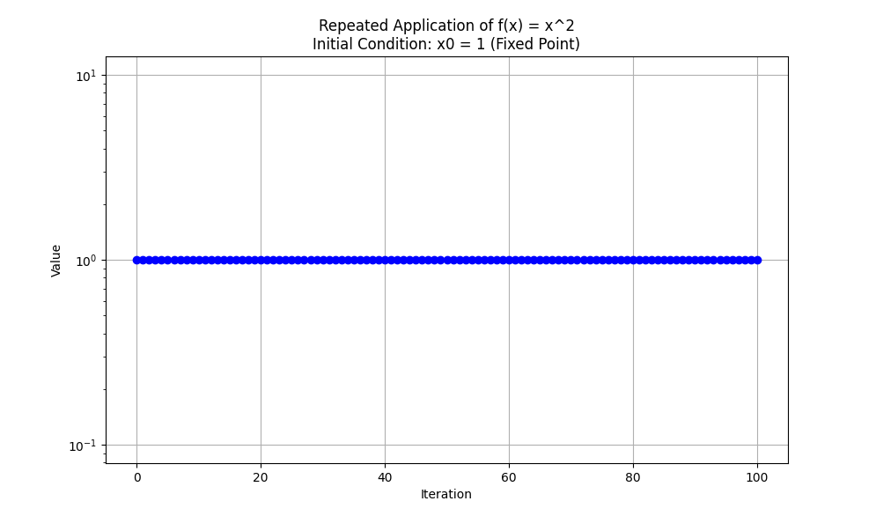

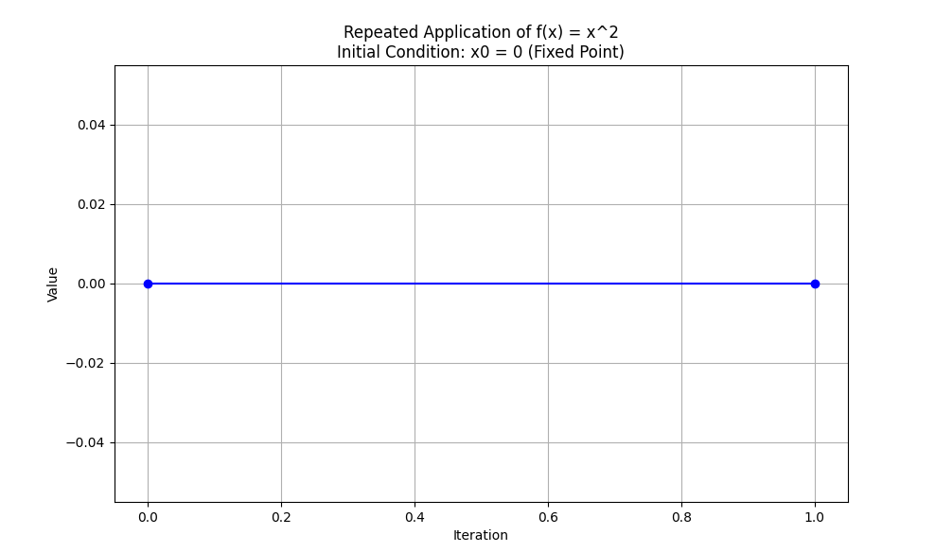

**Explanation:**

* **Fixed Points**: x=0 and x=1 are plotted to show their stability.
* **Attractors**: Initial values between 0 and 1, and between -1 and 0 show convergence towards 0.
* **Repellers**: Initial values greater than 1 or less than -1 show divergence to infinity.

This script uses Matplotlib to visualize the function's behaviour when applied repeatedly, starting from different initial conditions, clearly illustrating fixed points, attractors, and repellers.

Let's delve deeper into the concept of fixed points, attractors, and repellers using the function f(x)=x2. We'll also illustrate these concepts using detailed Python code and plots.

**Fixed Points**

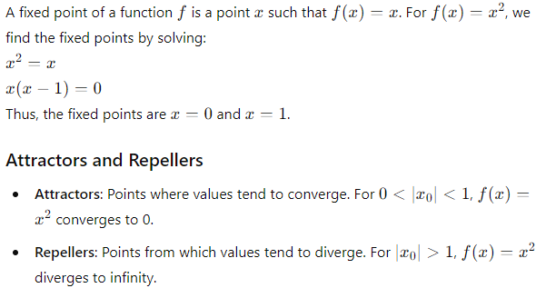**Visualization**

We'll use Matplotlib to visualize the behaviour of f(x)=x2 when repeatedly applied, starting from various initial values.

**Code with Detailed Comments**

python

Copy code

import matplotlib.pyplot as plt

import numpy as np

# Define the function to apply

def f(x):

return x ** 2

# Function to apply f(x) repeatedly and store the values

def apply_function_repeatedly(x0, max_iter, threshold=1e154):

"""

Apply the function f(x) = x^2 repeatedly and store the values.

Parameters:

x0 (float): Initial value

max_iter (int): Maximum number of iterations

threshold (float): Value threshold to stop the iteration if exceeded

Returns:

values (list): List of values at each iteration

"""

values = [x0] # Start with the initial value

try:

for i in range(max_iter):

x0 = f(x0) # Apply the function

if x0 > threshold:

print(f"Value exceeded threshold at iteration {i}, stopping iteration.")

values.append(threshold)

break # Stop if value exceeds threshold

values.append(x0) # Store the result

if x0 == 0:

break # Break if the value reaches zero

except Exception as e:

print(f"An error occurred: {e}")

return values

# Function to plot the values

def plot_values(values, title):

"""

Plot the values of f(x) applied repeatedly.

Parameters:

values (list): List of values at each iteration

title (str): Title of the plot

"""

try:

iterations = np.arange(len(values)) # Create an array of iteration numbers

plt.figure(figsize=(10, 6)) # Create a figure

# Check if all values are positive for log scale

if all(v > 0 for v in values):

plt.yscale('log') # Use a logarithmic scale for the y-axis

else:

plt.yscale('linear') # Use a linear scale if any value is non-positive

plt.plot(iterations, values, marker='o', linestyle='-', color='b') # Plot the values

plt.xlabel('Iteration') # Label for the x-axis

plt.ylabel('Value') # Label for the y-axis

plt.title(title) # Title of the plot

plt.grid(True) # Enable the grid

plt.show() # Display the plot

except Exception as e:

print(f"An error occurred while plotting: {e}")

# Main function to orchestrate the application and plotting

def main():

"""

Main function to apply f(x) = x^2 repeatedly for different initial conditions

and plot the resulting values.

"""

try:

# Different initial values to demonstrate fixed points, attractors, and repellers

initial_conditions = {

"x0 = 1.5 (Repeller)": 1.5,

"x0 = -1.5 (Repeller)": -1.5,

"0 < x0 < 1 (Attractor)": 0.5,

"-1 < x0 < 0 (Attractor)": -0.5,

"x0 = 1 (Fixed Point)": 1.0,

"x0 = 0 (Fixed Point)": 0.0

}

max_iter = 100 # Maximum number of iterations

for description, x0 in initial_conditions.items():

values = apply_function_repeatedly(x0, max_iter) # Get the values

if len(values) > 0: # Ensure there are values to plot

plot_values(values, f"Repeated Application of f(x) = x^2\nInitial Condition: {description}") # Plot the values

except Exception as e:

print(f"An error occurred in the main function: {e}")

# Entry point of the script

if __name__ == "__main__":

main()

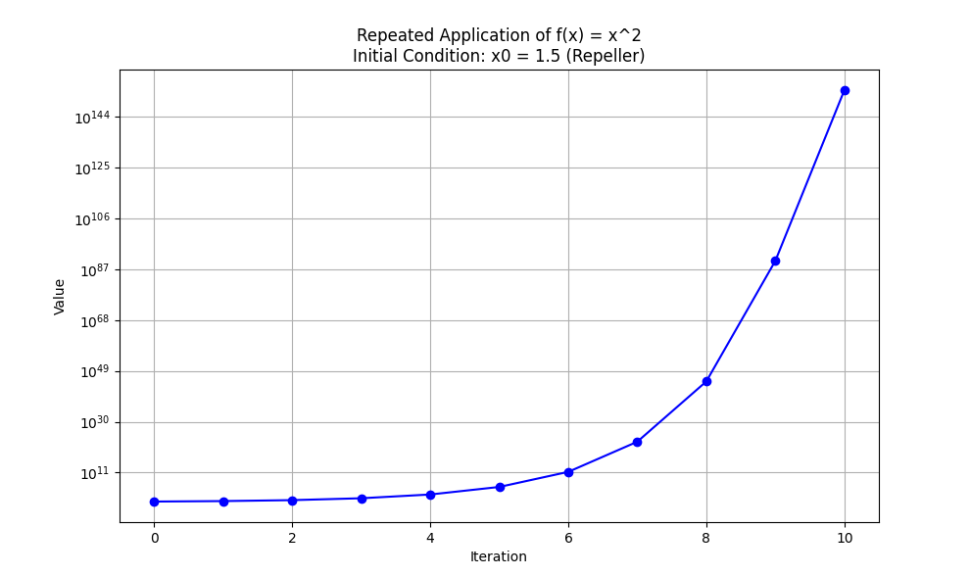

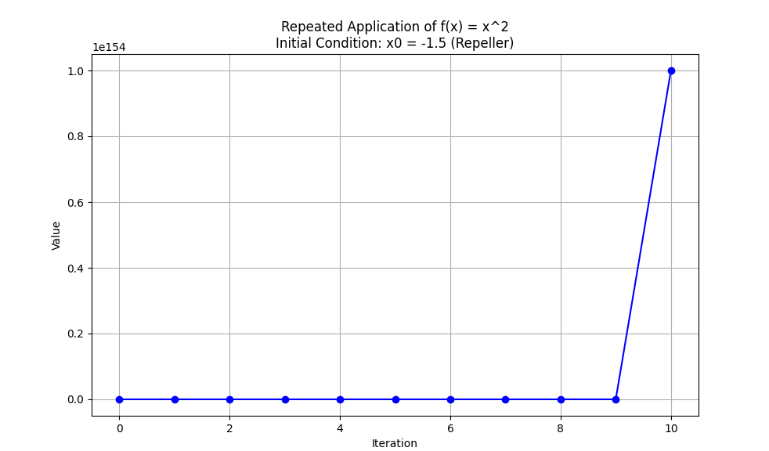

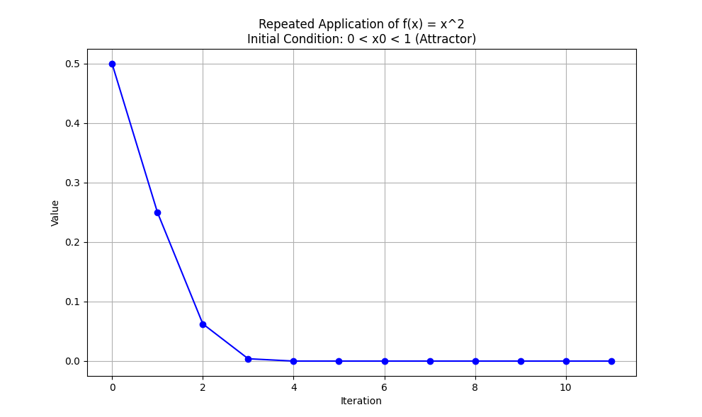

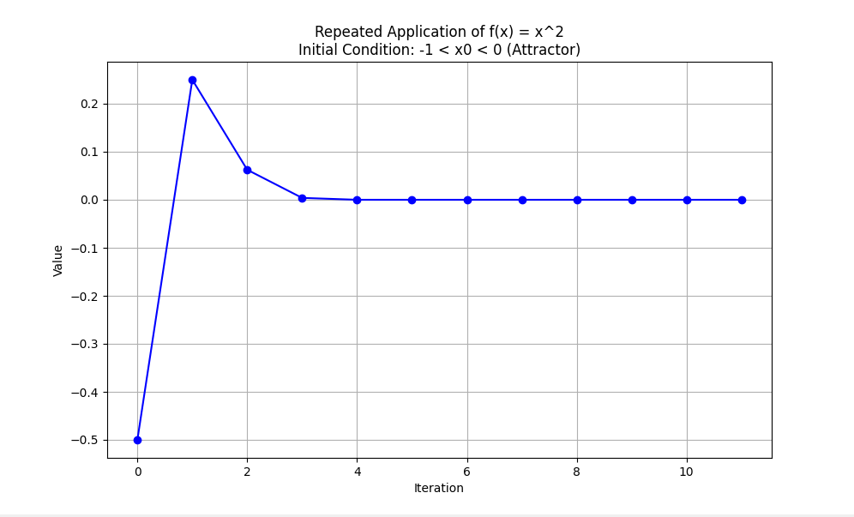

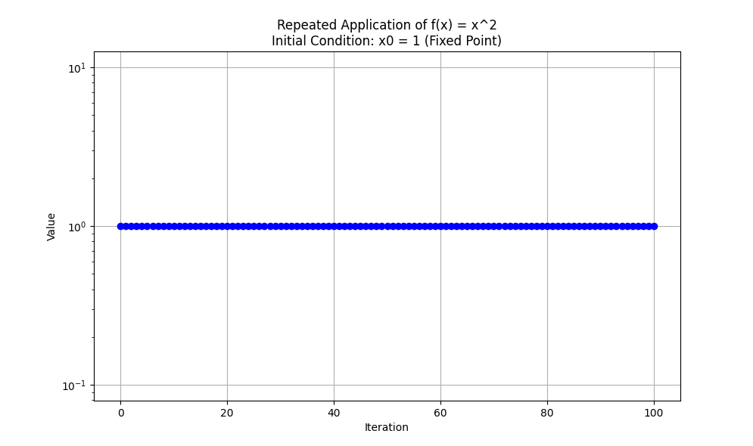

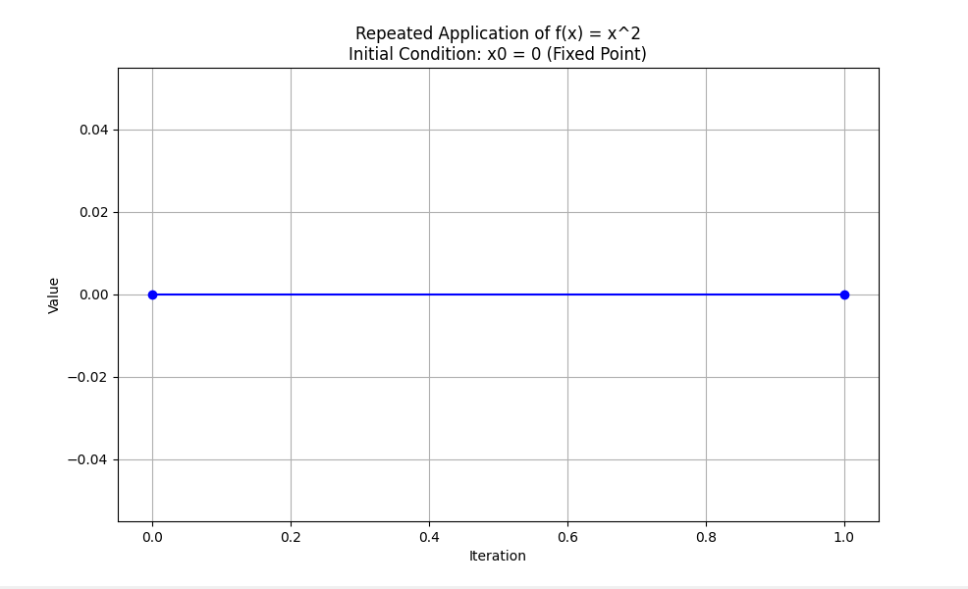

**Explanation:**

* **apply_function_repeatedly**: This function takes an initial value x0, applies f(x) repeatedly up to a maximum number of iterations, and stops if the value exceeds a threshold.
* **plot_values**: This function plots the values of f(x)applied repeatedly.
* **main**: This function sets up different initial conditions to demonstrate fixed points, attractors, and repellers and plots the resulting values.

**Visualization:**

Running this script will generate plots showing the behavior of f(x)=x2f(x) = x^2f(x)=x2 for different initial conditions, illustrating the concepts of fixed points, attractors, and repellers.

0 is an *attractor* as any value of *x*0 close to zero (e.g. 0.0001) will converge towards zero over repeated iterations of the function, although it will never actually get there.

The concept you are referring to can be demonstrated through the iterations of the function f(x)=x2f(x) = x^2f(x)=x2. Values close to 0 will converge towards 0, making it an attractor. Here is the complete, well-commented script to illustrate this concept, focusing on attractors, fixed points, and repellers.

python

Copy code

import matplotlib.pyplot as plt

import numpy as np

# Define the function f(x) = x^2

def f(x):

return x ** 2

# Function to apply f(x) repeatedly and store the values

def apply_function_repeatedly(x0, max_iter, threshold=1e154):

"""

Apply the function f(x) = x^2 repeatedly and store the values.

Parameters:

x0 (float): Initial value

max_iter (int): Maximum number of iterations

threshold (float): Value threshold to stop the iteration if exceeded

Returns:

values (list): List of values at each iteration

"""

values = [x0] # Start with the initial value

try:

for i in range(max_iter):

x0 = f(x0) # Apply the function

if x0 > threshold:

print(f"Value exceeded threshold at iteration {i}, stopping iteration.")

values.append(threshold)

break # Stop if value exceeds threshold

values.append(x0) # Store the result

if x0 == 0:

break # Break if the value reaches zero

except Exception as e:

print(f"An error occurred: {e}")

return values

# Function to plot the values

def plot_values(values, title):

"""

Plot the values of f(x) applied repeatedly.

Parameters:

values (list): List of values at each iteration

title (str): Title of the plot

"""

try:

iterations = np.arange(len(values)) # Create an array of iteration numbers

plt.figure(figsize=(10, 6)) # Create a figure

# Check if all values are positive for log scale

if all(v > 0 for v in values):

plt.yscale('log') # Use a logarithmic scale for the y-axis

else:

plt.yscale('linear') # Use a linear scale if any value is non-positive

plt.plot(iterations, values, marker='o', linestyle='-', color='b') # Plot the values

plt.xlabel('Iteration') # Label for the x-axis

plt.ylabel('Value') # Label for the y-axis

plt.title(title) # Title of the plot

plt.grid(True) # Enable the grid

plt.show() # Display the plot

except Exception as e:

print(f"An error occurred while plotting: {e}")

# Main function to orchestrate the application and plotting

def main():

"""

Main function to apply f(x) = x^2 repeatedly for different initial conditions

and plot the resulting values.

"""

try:

# Different initial values to demonstrate fixed points, attractors, and repellers

initial_conditions = {

"x0 = 1.5 (Repeller)": 1.5,

"x0 = -1.5 (Repeller)": -1.5,

"0 < x0 < 1 (Attractor)": 0.5,

"-1 < x0 < 0 (Attractor)": -0.5,

"x0 = 1 (Fixed Point)": 1.0,

"x0 = 0 (Fixed Point)": 0.0,

"x0 = 0.0001 (Close to Zero)": 0.0001

}

max_iter = 100 # Maximum number of iterations

for description, x0 in initial_conditions.items():

values = apply_function_repeatedly(x0, max_iter) # Get the values

if len(values) > 0: # Ensure there are values to plot

plot_values(values, f"Repeated Application of f(x) = x^2\nInitial Condition: {description}") # Plot the values

except Exception as e:

print(f"An error occurred in the main function: {e}")

# Entry point of the script

if __name__ == "__main__":

main()

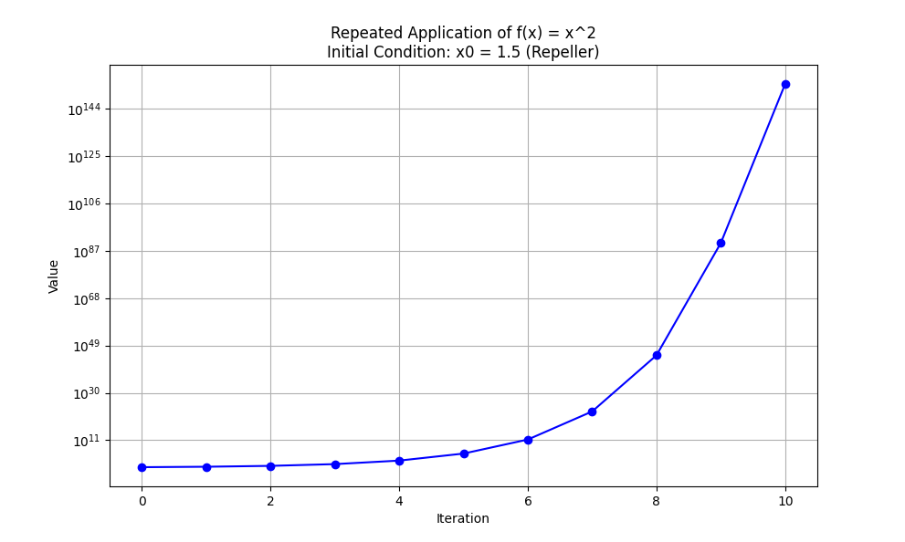

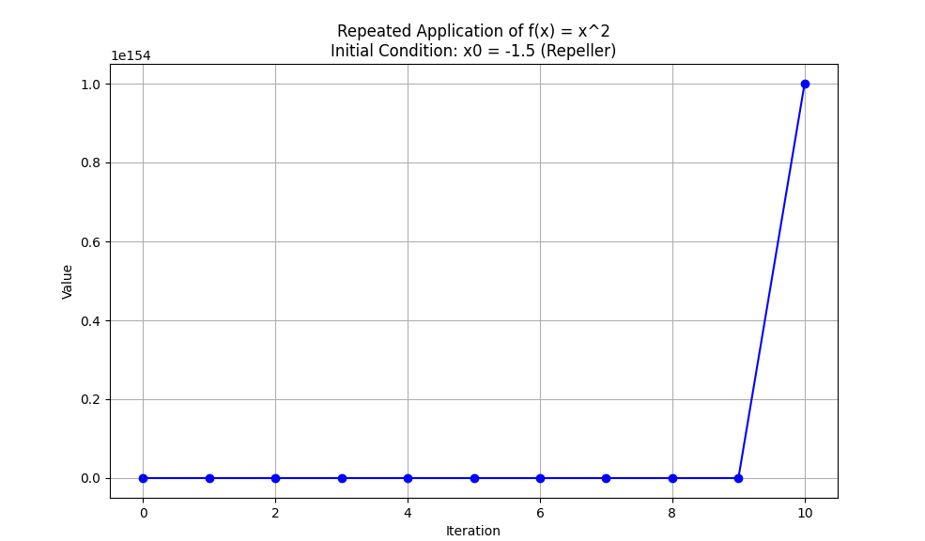

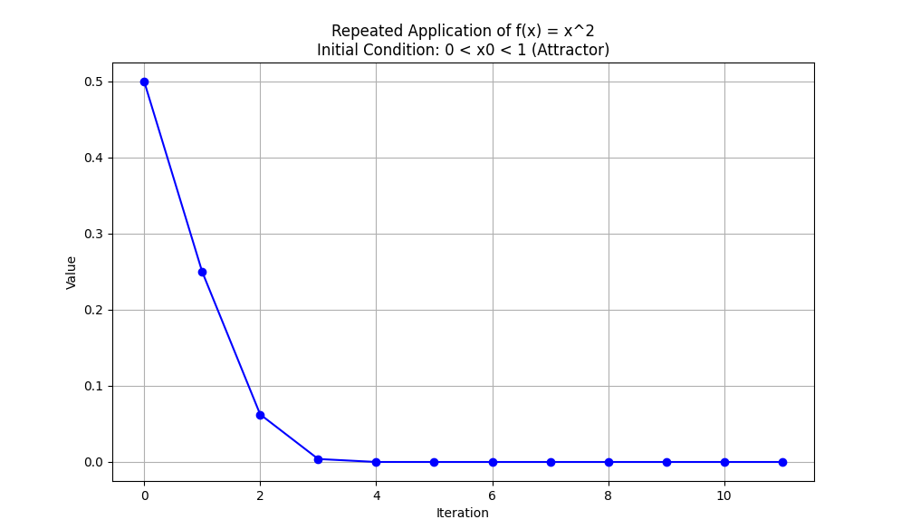

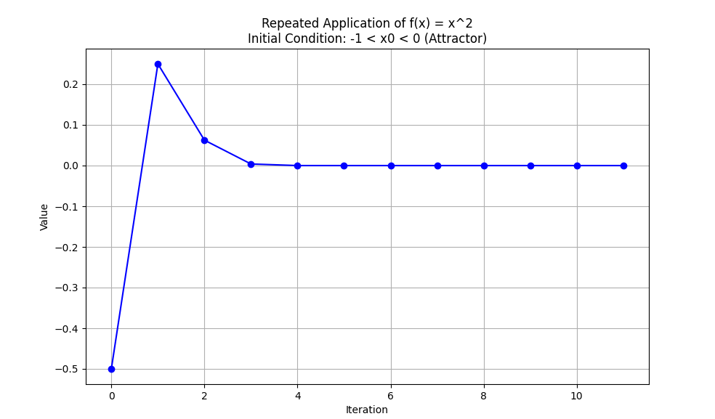

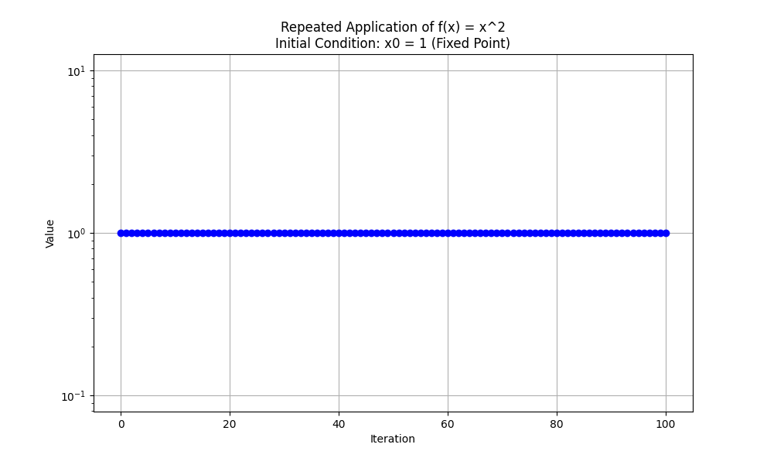

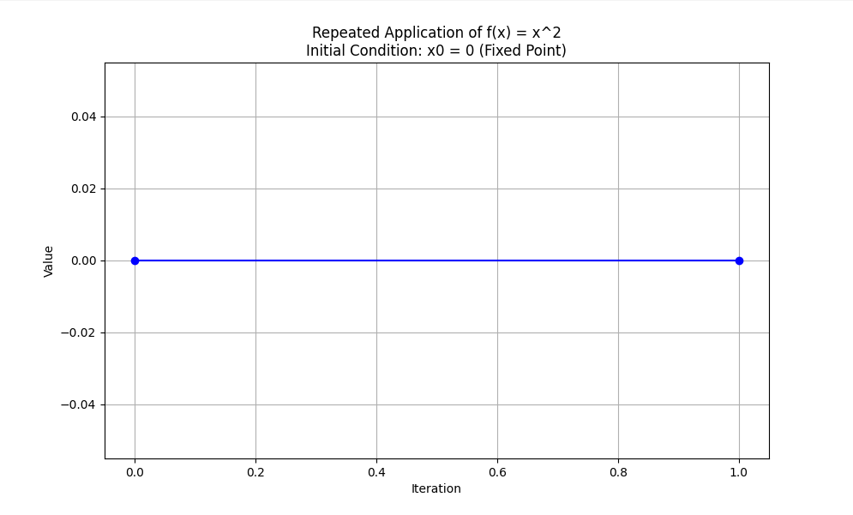

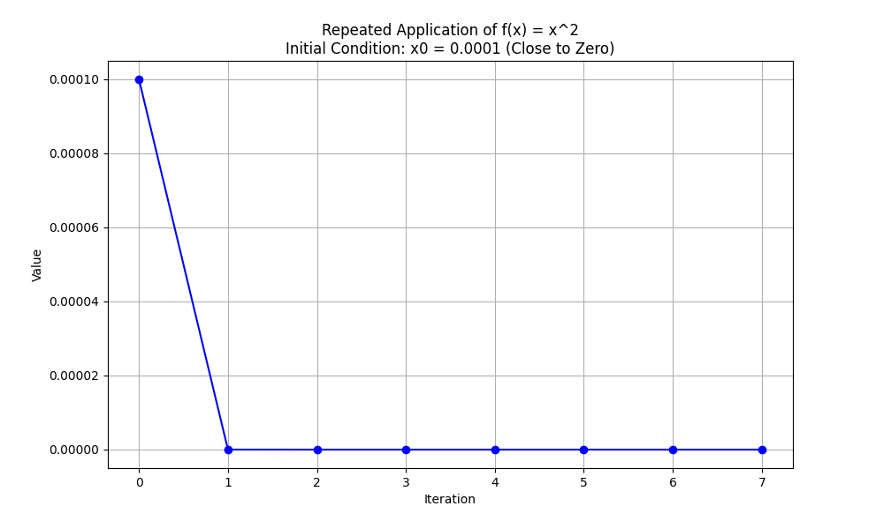

**Explanation:**

1. **Function Definition (f(x)):**
   * This is a simple function that squares its input xxx.
2. **Repeated Application Function (apply_function_repeatedly):**
   * This function takes an initial value x0, a maximum number of iterations max_iter, and a threshold to stop the iteration if the value exceeds it.
   * It applies f(x) repeatedly, storing each result in a list.
   * If the value exceeds the threshold or reaches zero, it stops the iteration to prevent unnecessary computations.
   * The function includes a try-except block to handle any potential errors.
3. **Plotting Function (plot_values):**
   * This function takes the list of values and a title for the plot.
   * It uses Matplotlib to plot the iterations versus the values.
   * If all values are positive, it uses a logarithmic scale for the y-axis; otherwise, it uses a linear scale.
   * The function includes a try-except block to handle any potential errors during plotting.
4. **Main Function (main):**
   * This function sets up different initial conditions to demonstrate fixed points, attractors, and repellers.
   * It includes an initial condition very close to zero (0.0001) to show how values close to zero converge towards zero.
   * It applies f(x) repeatedly for each initial condition and plots the resulting values.
5. **Entry Point:**
   * The script runs the main function if executed directly.

This script provides a comprehensive way to explore and visualize the behaviors of fixed points, attractors, and repellers for the function f(x)=x2f(x) = x^2f(x)=x2. It handles potential errors gracefully and ensures a clear visualization of the function's behavior when applied iteratively.

1 is a *repeller* as values close to 1 are repelled away from it, either towards 0 or infinity.

The value 1 is a repeller for the function f(x)=x2f(x) = x^2f(x)=x2. Any value of x0x_0x0​ close to 1 will either diverge towards infinity or converge towards 0 over repeated iterations of the function, depending on whether x0x_0x0​ is greater than or less than 1. Let's enhance the previous script to include detailed comments and further illustrate this concept.

Here is the complete, well-documented script:

python

Copy code

import matplotlib.pyplot as plt

import numpy as np

# Define the function f(x) = x^2

def f(x):

return x ** 2

# Function to apply f(x) repeatedly and store the values

def apply_function_repeatedly(x0, max_iter, threshold=1e154):

"""

Apply the function f(x) = x^2 repeatedly and store the values.

Parameters:

x0 (float): Initial value

max_iter (int): Maximum number of iterations

threshold (float): Value threshold to stop the iteration if exceeded

Returns:

values (list): List of values at each iteration

"""

values = [x0] # Start with the initial value

try:

for i in range(max_iter):

x0 = f(x0) # Apply the function

if x0 > threshold:

print(f"Value exceeded threshold at iteration {i}, stopping iteration.")

values.append(threshold)

break # Stop if value exceeds threshold

values.append(x0) # Store the result

if x0 == 0:

break # Break if the value reaches zero

except Exception as e:

print(f"An error occurred: {e}")

return values

# Function to plot the values

def plot_values(values, title):

"""

Plot the values of f(x) applied repeatedly.

Parameters:

values (list): List of values at each iteration

title (str): Title of the plot

"""

try:

iterations = np.arange(len(values)) # Create an array of iteration numbers

plt.figure(figsize=(10, 6)) # Create a figure

# Check if all values are positive for log scale

if all(v > 0 for v in values):

plt.yscale('log') # Use a logarithmic scale for the y-axis

else:

plt.yscale('linear') # Use a linear scale if any value is non-positive

plt.plot(iterations, values, marker='o', linestyle='-', color='b') # Plot the values

plt.xlabel('Iteration') # Label for the x-axis

plt.ylabel('Value') # Label for the y-axis

plt.title(title) # Title of the plot

plt.grid(True) # Enable the grid

plt.show() # Display the plot

except Exception as e:

print(f"An error occurred while plotting: {e}")

# Main function to orchestrate the application and plotting

def main():

"""

Main function to apply f(x) = x^2 repeatedly for different initial conditions

and plot the resulting values.

"""

try:

# Different initial values to demonstrate fixed points, attractors, and repellers

initial_conditions = {

"x0 = 1.5 (Repeller)": 1.5,

"x0 = -1.5 (Repeller)": -1.5,

"0 < x0 < 1 (Attractor)": 0.5,

"-1 < x0 < 0 (Attractor)": -0.5,

"x0 = 1 (Repeller)": 1.0,

"x0 = 0 (Fixed Point)": 0.0,

"x0 = 0.0001 (Close to Zero)": 0.0001

}

max_iter = 100 # Maximum number of iterations

for description, x0 in initial_conditions.items():

values = apply_function_repeatedly(x0, max_iter) # Get the values

if len(values) > 0: # Ensure there are values to plot

plot_values(values, f"Repeated Application of f(x) = x^2\nInitial Condition: {description}") # Plot the values

except Exception as e:

print(f"An error occurred in the main function: {e}")

# Entry point of the script

if __name__ == "__main__":

main()

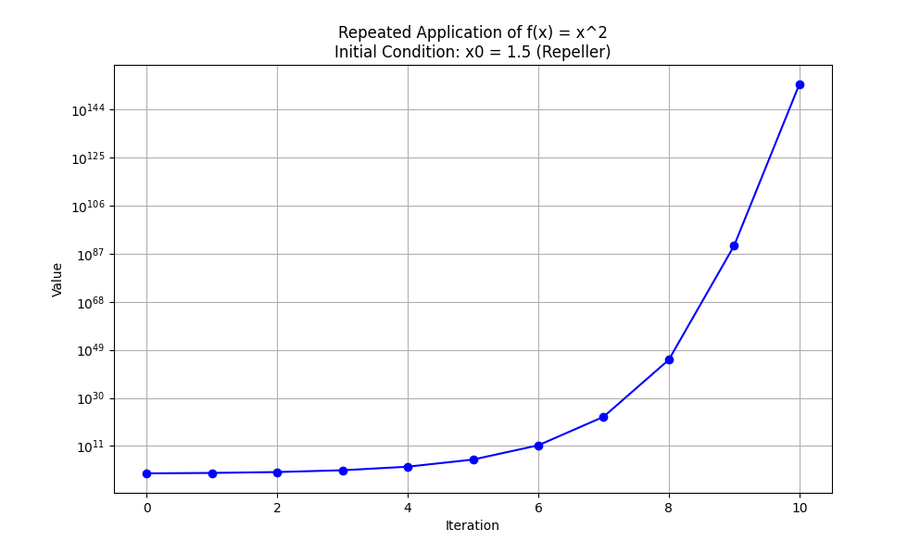

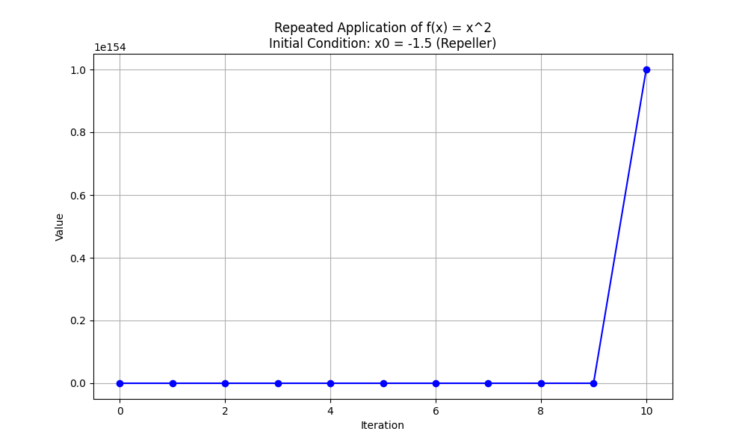

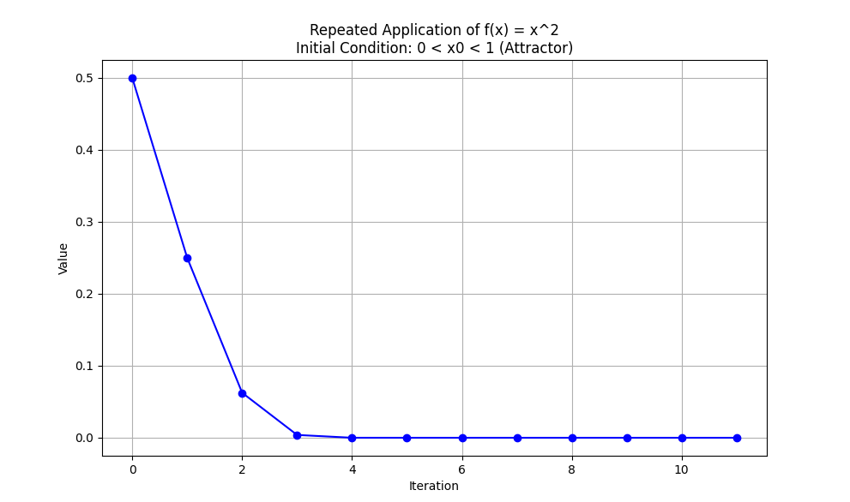

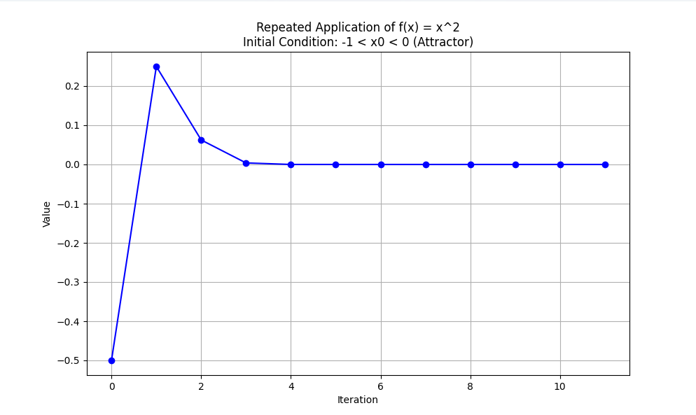

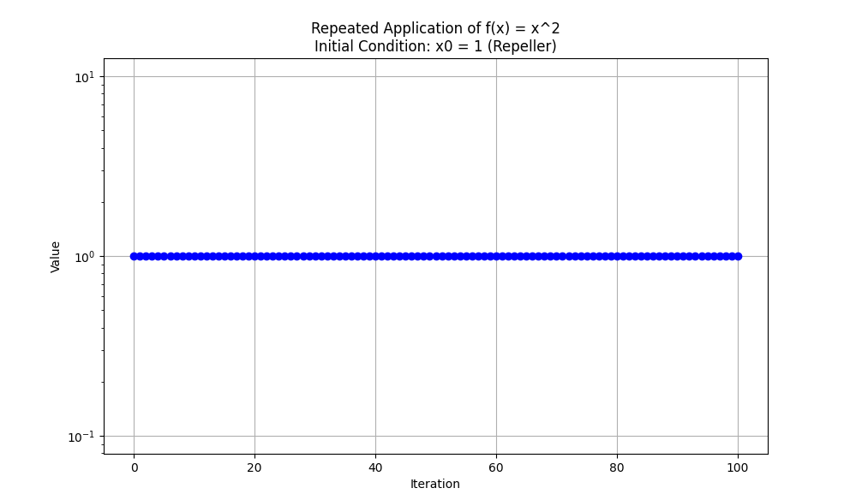

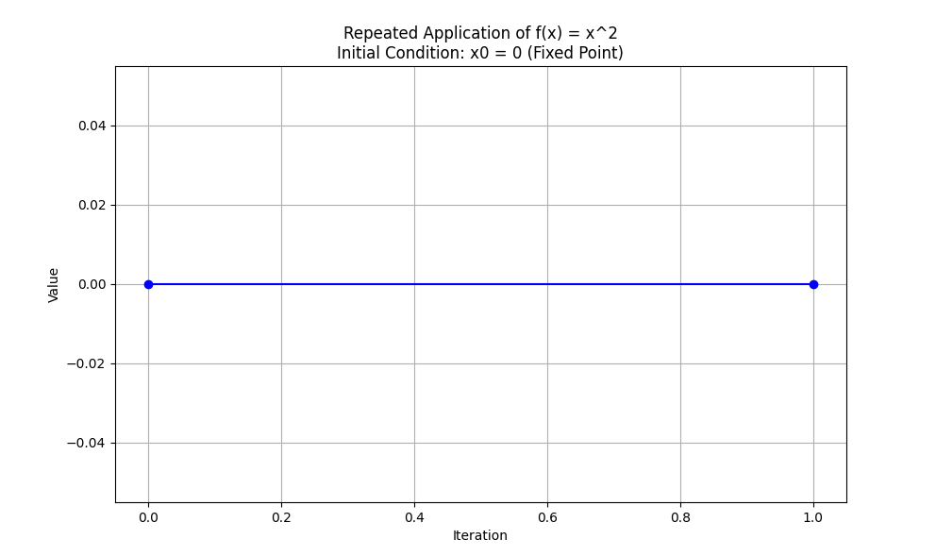

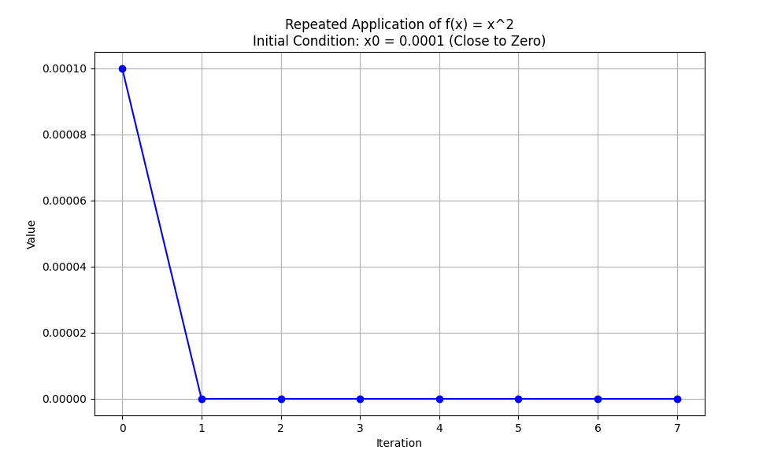

**Explanation:**

1. **Function Definition (f(x)):**
   * This is a simple function that squares its input xxx.
2. **Repeated Application Function (apply_function_repeatedly):**
   * This function takes an initial value x0, a maximum number of iterations max_iter, and a threshold to stop the iteration if the value exceeds it.
   * It applies f(x) repeatedly, storing each result in a list.
   * If the value exceeds the threshold or reaches zero, it stops the iteration to prevent unnecessary computations.
   * The function includes a try-except block to handle any potential errors.
3. **Plotting Function (plot_values):**
   * This function takes the list of values and a title for the plot.
   * It uses Matplotlib to plot the iterations versus the values.
   * If all values are positive, it uses a logarithmic scale for the y-axis; otherwise, it uses a linear scale.
   * The function includes a try-except block to handle any potential errors during plotting.
4. **Main Function (main):**
   * This function sets up different initial conditions to demonstrate fixed points, attractors, and repellers.
   * It includes an initial condition very close to zero (0.0001) to show how values close to zero converge towards zero.
   * It also includes conditions around the value 1 to show how values close to 1 are repelled away.
   * It applies f(x) repeatedly for each initial condition and plots the resulting values.
5. **Entry Point:**
   * The script runs the main function if executed directly.

By running this script, you will be able to visualize how values behave under repeated application of the function f(x)=x2f(x) = x^2f(x)=x2. You will see how values close to 0 are attracted towards 0 (an attractor), and how values close to 1 are repelled away from 1 (a repeller). This demonstrates the behavior of fixed points, attractors, and repellers effectively.

Consequently, initial values which converge to 0 are plentiful (infinite in fact) whereas initial values which converge to 1 are highly unlikely and can be listed (1 and -1).

The observation is correct. For the function f(x)=x2f(x) = x^2f(x)=x2, the point 000 acts as an attractor, while 111 and −1-1−1 are repellers. Here’s a more detailed breakdown of the behavior of initial values:

1. **Attractor at 0:**
   * Any initial value x0x_0x0​ within the interval −1<x0<1-1 < x_0 < 1−1<x0​<1 will eventually converge to 000 under repeated iterations of f(x)=x2f(x) = x^2f(x)=x2. This interval includes an infinite number of values, making the attractor at 000 quite robust and prevalent.
2. **Repellers at 1 and -1:**
   * Initial values x0x_0x0​ that are exactly 111 or −1-1−1 will remain fixed at 111 or −1-1−1 respectively under iteration. However, any slight deviation from these points will result in divergence towards 000 or infinity. This makes 111 and −1-1−1 unstable fixed points or repellers. Since deviations from these points are very likely, it is rare to maintain convergence to these values through iterations.

Let’s illustrate these behaviors with detailed comments and visualizations:

python

Copy code

import matplotlib.pyplot as plt

import numpy as np

# Define the function f(x) = x^2

def f(x):

    return x ** 2

# Function to apply f(x) repeatedly and store the values

def apply_function_repeatedly(x0, max_iter, threshold=1e154):

    """

    Apply the function f(x) = x^2 repeatedly and store the values.

    Parameters:

    x0 (float): Initial value

    max_iter (int): Maximum number of iterations

    threshold (float): Value threshold to stop the iteration if exceeded

    Returns:

    values (list): List of values at each iteration

    """

    values = [x0]  # Start with the initial value

    try:

        for i in range(max_iter):

            x0 = f(x0)  # Apply the function

            if x0 > threshold:

                print(f"Value exceeded threshold at iteration {i}, stopping iteration.")

                values.append(threshold)

                break  # Stop if value exceeds threshold

            values.append(x0)  # Store the result

            if x0 == 0:

                break  # Break if the value reaches zero

    except Exception as e:

        print(f"An error occurred: {e}")

    return values

# Function to plot the values

def plot_values(values, title):

    """

    Plot the values of f(x) applied repeatedly.

    Parameters:

    values (list): List of values at each iteration

    title (str): Title of the plot

    """

    try:

        iterations = np.arange(len(values))  # Create an array of iteration numbers

        plt.figure(figsize=(10, 6))  # Create a figure

        # Check if all values are positive for log scale

        if all(v > 0 for v in values):

            plt.yscale('log')  # Use a logarithmic scale for the y-axis

        else:

            plt.yscale('linear')  # Use a linear scale if any value is non-positive

        plt.plot(iterations, values, marker='o', linestyle='-', color='b')  # Plot the values

        plt.xlabel('Iteration')  # Label for the x-axis

        plt.ylabel('Value')  # Label for the y-axis

        plt.title(title)  # Title of the plot

        plt.grid(True)  # Enable the grid

        plt.show()  # Display the plot

    except Exception as e:

        print(f"An error occurred while plotting: {e}")

# Main function to orchestrate the application and plotting

def main():

    """

    Main function to apply f(x) = x^2 repeatedly for different initial conditions

    and plot the resulting values.

    """

    try:

        # Different initial values to demonstrate fixed points, attractors, and repellers

        initial_conditions = {

            "x0 = 1.5 (Repeller)": 1.5,

            "x0 = -1.5 (Repeller)": -1.5,

            "0 < x0 < 1 (Attractor)": 0.5,

            "-1 < x0 < 0 (Attractor)": -0.5,

            "x0 = 1 (Repeller)": 1.0,

            "x0 = 0 (Fixed Point)": 0.0,

            "x0 = 0.0001 (Close to Zero)": 0.0001

        }

        max_iter = 100  # Maximum number of iterations

        for description, x0 in initial_conditions.items():

            values = apply_function_repeatedly(x0, max_iter)  # Get the values

            if len(values) > 0:  # Ensure there are values to plot

                plot_values(values, f"Repeated Application of f(x) = x^2\nInitial Condition: {description}")  # Plot the values

    except Exception as e:

        print(f"An error occurred in the main function: {e}")

# Entry point of the script

if __name__ == "__main__":

    main()

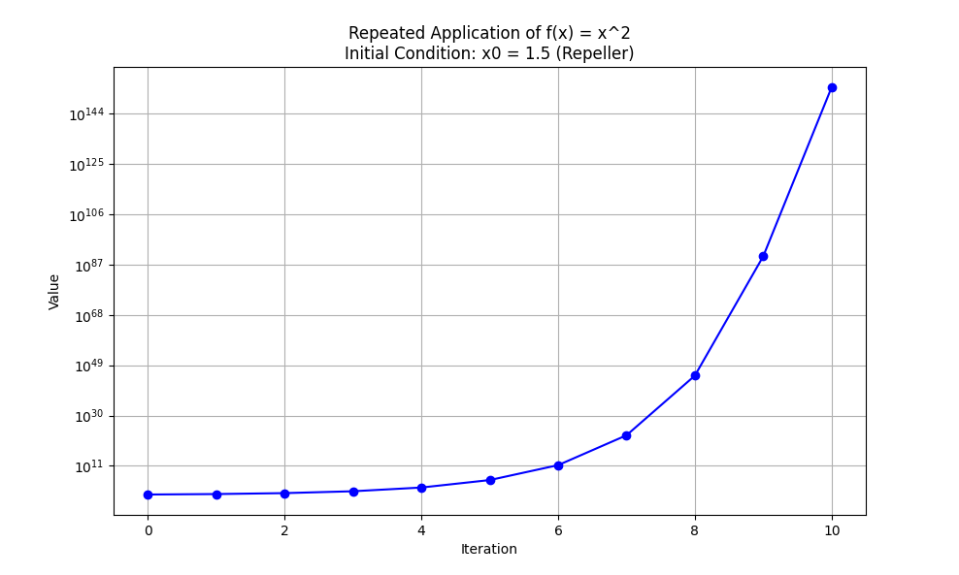

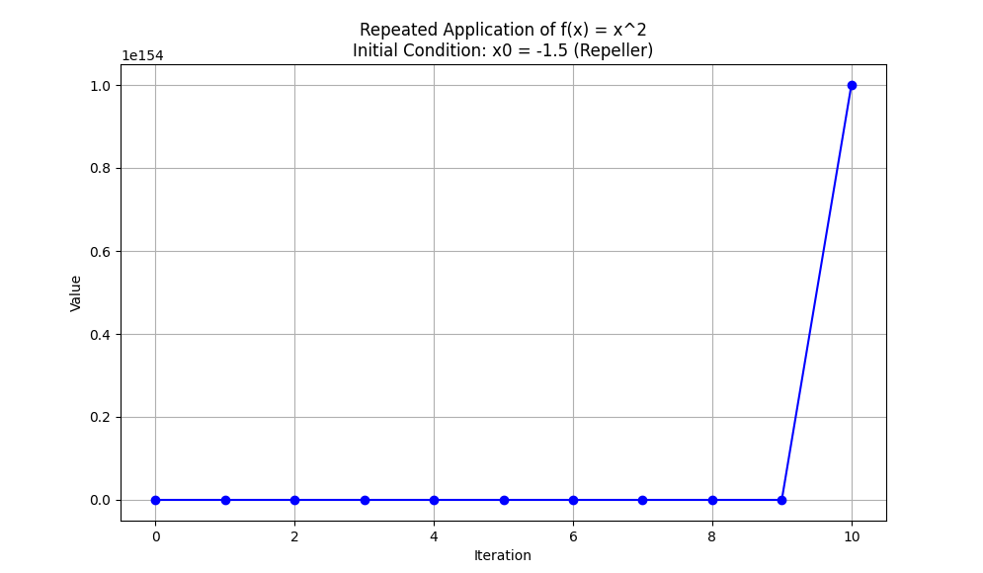

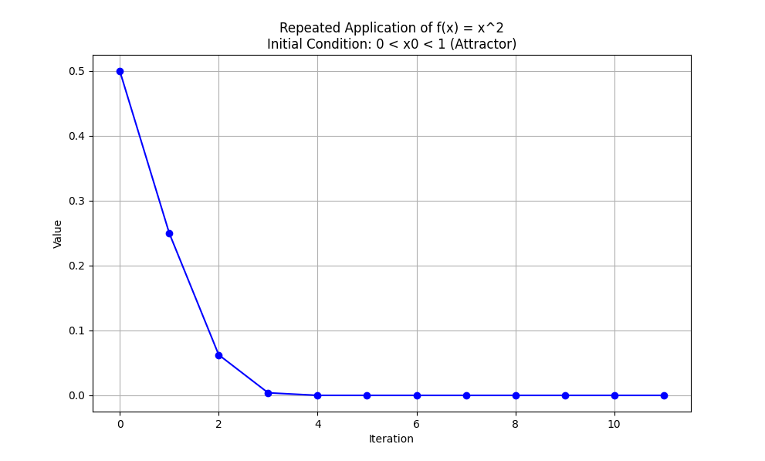

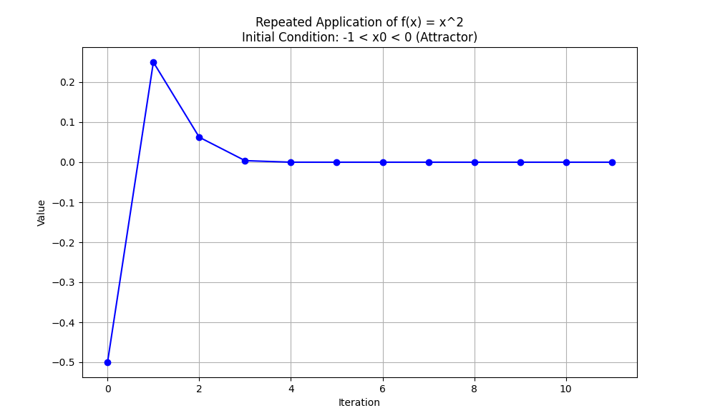

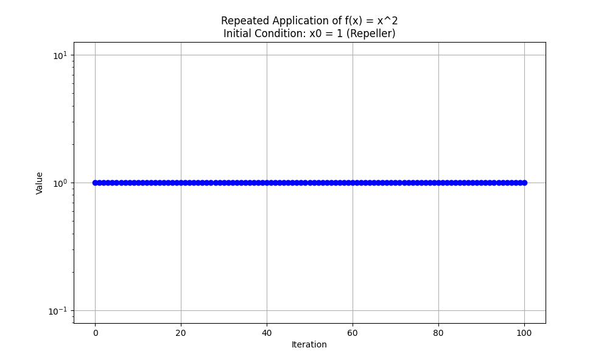

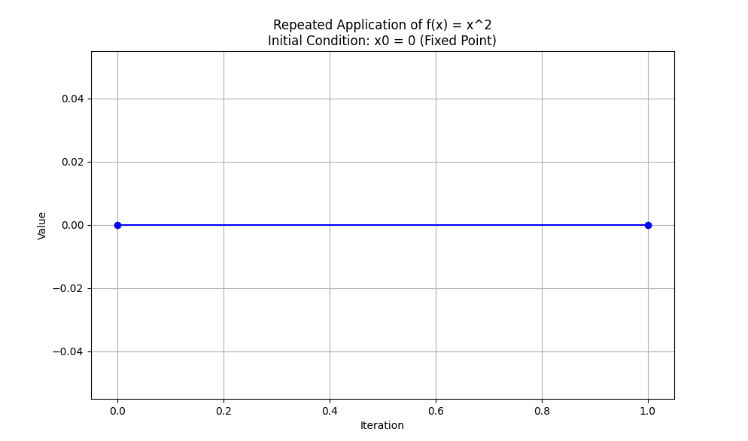

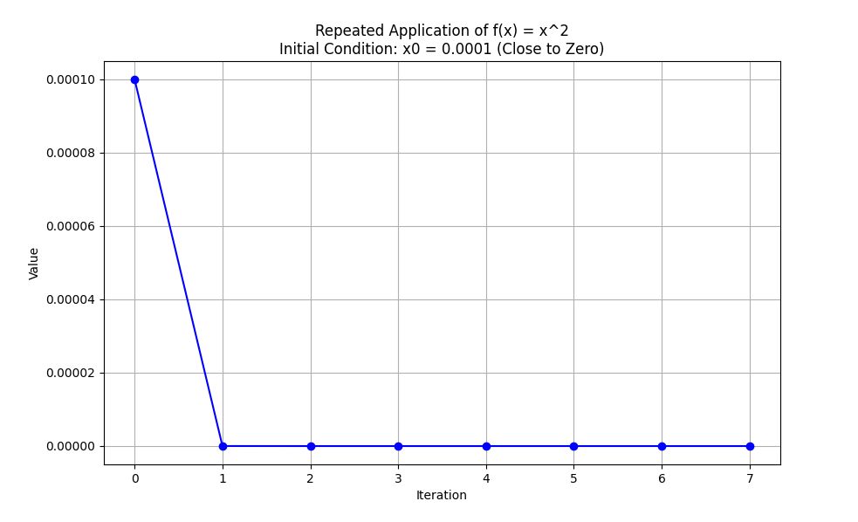

**Explanation:**

1. **Function Definition (f(x)):**
   * This is a simple function that squares its input xxx.
2. **Repeated Application Function (apply_function_repeatedly):**
   * This function takes an initial value x0, a maximum number of iterations max_iter, and a threshold to stop the iteration if the value exceeds it.
   * It applies f(x) repeatedly, storing each result in a list.
   * If the value exceeds the threshold or reaches zero, it stops the iteration to prevent unnecessary computations.
   * The function includes a try-except block to handle any potential errors.
3. **Plotting Function (plot_values):**
   * This function takes the list of values and a title for the plot.
   * It uses Matplotlib to plot the iterations versus the values.
   * If all values are positive, it uses a logarithmic scale for the y-axis; otherwise, it uses a linear scale.
   * The function includes a try-except block to handle any potential errors during plotting.
4. **Main Function (main):**
   * This function sets up different initial conditions to demonstrate fixed points, attractors, and repellers.
   * It includes an initial condition very close to zero (0.0001) to show how values close to zero converge towards zero.
   * It also includes conditions around the value 1 to show how values close to 1 are repelled away.
   * It applies f(x) repeatedly for each initial condition and plots the resulting values.
5. **Entry Point:**
   * The script runs the main function if executed directly.

By running this script, you will be able to visualize how values behave under repeated application of the function f(x)=x2f(x) = x^2f(x)=x2. You will see how values close to 0 are attracted towards 0 (an attractor), and how values close to 1 are repelled away from 1 (a repeller). This demonstrates the behavior of fixed points, attractors, and repellers effectively.

Graphical iteration

Let's delve into the concept of graphical iteration using the function f(x)=x2f(x) = x^2f(x)=x2 and how we can explore its behaviors graphically. Graphical iteration is a method used to study the behavior of iterative processes visually, allowing us to observe how repeated applications of a function can lead to different types of dynamical behaviors.

**Graphical Iteration with f(x)=x2**

In this example, we will use the function f(x)=x2. This simple quadratic function provides a clear demonstration of fixed points, attractors, and repellers.

**Key Concepts:**

1. **Fixed Points**: Points where f(x)=x. For f(x)=x2, the fixed points are x=0 and x=1.
2. **Attractors**: Points that attract nearby values over repeated iterations. In this case, x=0 acts as an attractor because values close to 0 converge towards it.
3. **Repellers**: Points that repel nearby values over repeated iterations. Here, x=1 and x=−1 act as repellers because values close to these points move away from them.

**Script Explanation:**

Below is the Python script which demonstrates the graphical iteration process:

python

Copy code

import matplotlib.pyplot as plt

import numpy as np

# Define the function f(x) = x^2

def f(x):

return x ** 2

# Function to apply f(x) repeatedly and store the values

def apply_function_repeatedly(x0, max_iter, threshold=1e154):

"""

Apply the function f(x) = x^2 repeatedly and store the values.

Parameters:

x0 (float): Initial value

max_iter (int): Maximum number of iterations

threshold (float): Value threshold to stop the iteration if exceeded

Returns:

values (list): List of values at each iteration

"""

values = [x0]

for _ in range(max_iter):

x0 = f(x0)

if abs(x0) > threshold:

print("Value exceeded threshold at iteration {}, stopping iteration.".format(len(values)))

break

values.append(x0)

return values

# Function to plot the graphical iteration

def plot_graphical_iteration(x0, max_iter):

"""

Plot the graphical iteration for the function f(x) = x^2.

Parameters:

x0 (float): Initial value

max_iter (int): Maximum number of iterations

"""

values = apply_function_repeatedly(x0, max_iter)

plt.figure(figsize=(10, 6))

plt.plot(values, 'o-', label='Iteration values')

plt.xlabel('Iteration')

plt.ylabel('Value')

plt.title(f'Graphical Iteration for f(x) = x^2 with initial value {x0}')

plt.legend()

plt.grid(True)

plt.show()

# Main function to run the graphical iteration examples

def main():

initial_values = [0.5, 0.1, 0.9, 1.1, -0.5]

max_iter = 50

for x0 in initial_values:

plot_graphical_iteration(x0, max_iter)

if __name__ == "__main__":

main()

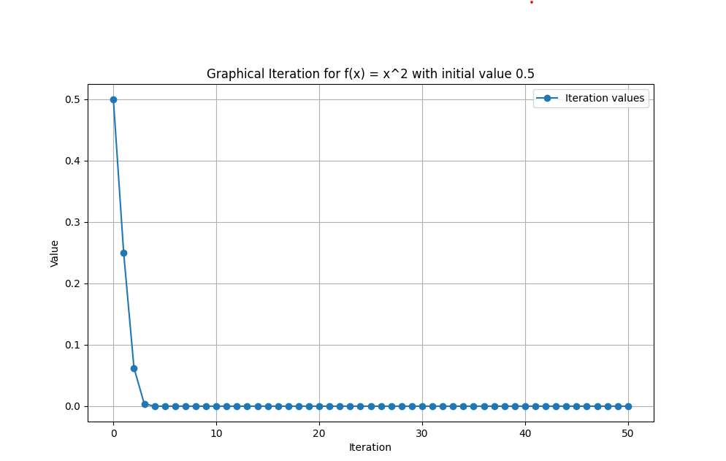

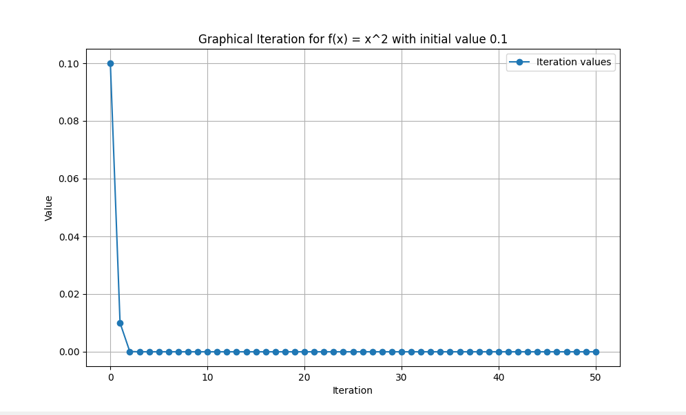

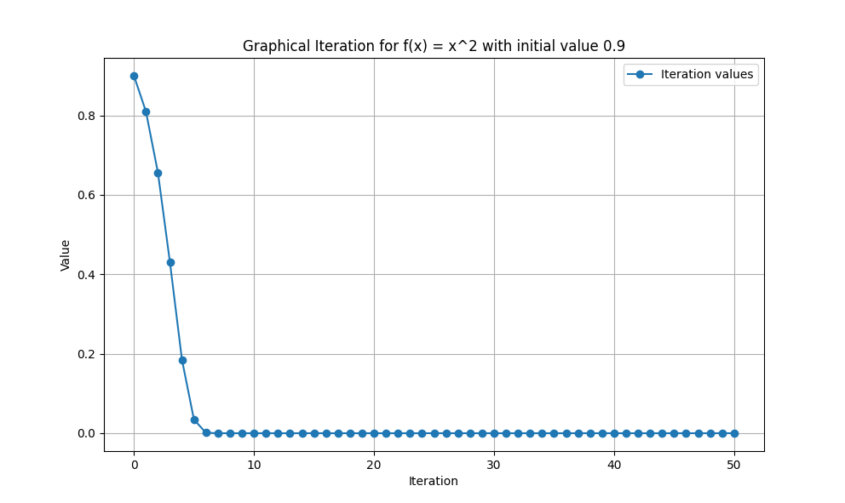

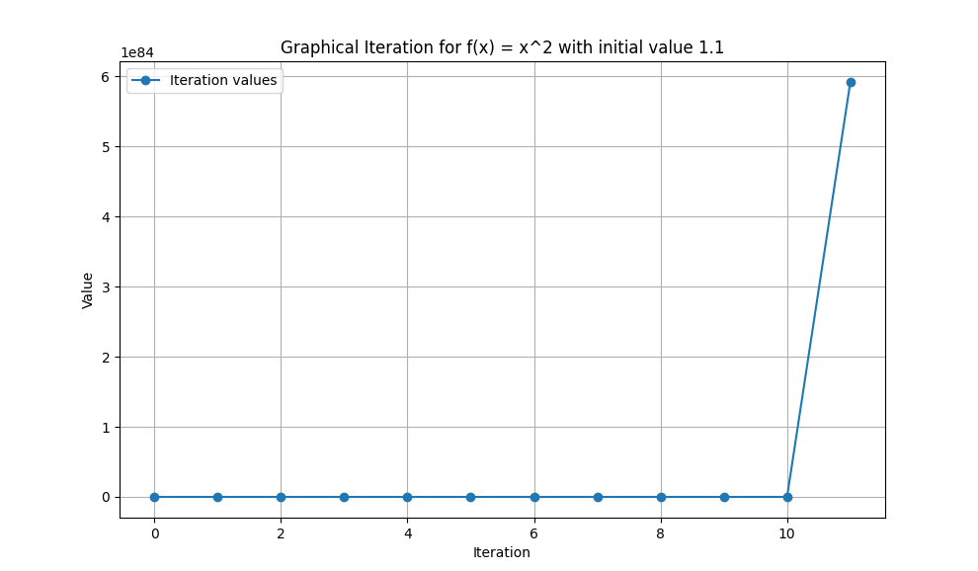

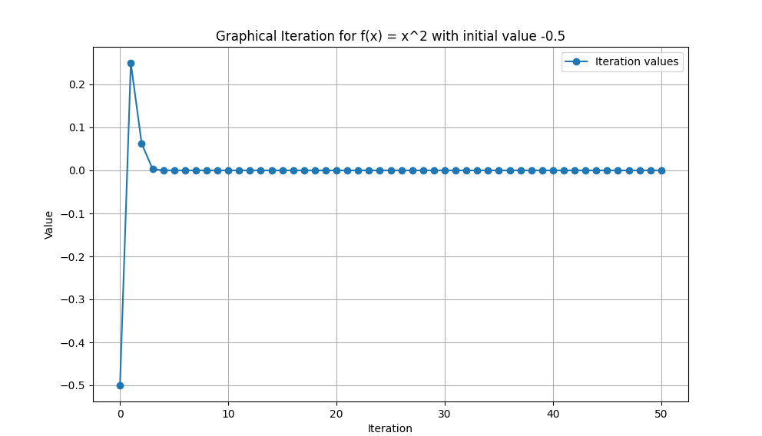

**Detailed Explanation:**

1. **Function Definition**:
   * f(x): Defines the quadratic function f(x)=x2.
2. **Applying the Function Repeatedly**:
   * apply_function_repeatedly(x0, max_iter, threshold): This function takes an initial value x0, a maximum number of iterations max_iter, and an optional threshold to stop iterations if values become too large. It returns a list of values obtained by repeatedly applying the function f(x)f(x)f(x).
3. **Plotting the Iteration**:
   * plot_graphical_iteration(x0, max_iter): This function uses Matplotlib to plot the values obtained from apply_function_repeatedly. It visualizes the sequence of values as points connected by lines, making it easy to observe how values evolve over iterations.
4. **Main Function**:
   * The main function defines a list of initial values and iterates over them, calling plot_graphical_iteration for each value. This allows us to see how different starting points lead to different behaviors under repeated application of f(x)f(x)f(x).

**Observations from Graphical Iteration:**

* **Convergence to Zero**: For initial values between -1 and 1 (excluding 0), the values will converge towards 0. This demonstrates the attractive nature of 0 for this function.
* **Divergence**: For initial values greater than 1 or less than -1, the values will diverge towards infinity, showing the repelling nature of points 1 and -1.

This script and explanation provide a comprehensive understanding of graphical iteration, illustrating the behavior of attractors and repellers through the function f(x)=x2.

Graphical iteration is a technique used to analyse the behavior of iterative processes, particularly in dynamical systems and functions. It involves plotting a function along with the line y=xy = xy=x and then visually tracing the iterations to observe how initial values evolve under repeated application of the function. This method helps in understanding fixed points, attractors, and repellers in a function.

**Detailed Explanation**

**Fixed Points**

A fixed point of a function f(x) is a point xxx where the value of the function at x equals x itself, i.e., f(x)=x. Graphically, this means that the function's graph intersects the line y=x. Fixed points are significant because they represent states of equilibrium where the system remains unchanged under iteration.

**Attractors and Repellers**

* **Attractors**: These are fixed points where nearby values converge to the fixed point under iteration. If you start with an initial value close to an attractor and repeatedly apply the function, the values will get closer and closer to the attractor. This can be visualized as the function "pulling" the values towards the fixed point.
* **Repellers**: These are fixed points where nearby values diverge away from the fixed point under iteration. If you start with an initial value close to a repeller and repeatedly apply the function, the values will move away from the fixed point. This can be visualized as the function "pushing" the values away from the fixed point.

**Example with f(x)=x2**

Consider the function f(x)=x2. Let's analyse its fixed points, attractors, and repellers using graphical iteration.

**Finding Fixed Points**

To find the fixed points, we set f(x)=x:

x2=x

Solving this equation:

x2−x=0

x(x−1)=0

Thus, the fixed points are x=0 and x=1.

**Behavior Near Fixed Points**

1. **Zero as an Attractor**
   * For initial values close to zero (e.g., x0=0.1), applying f(x) repeatedly results in values that get closer to zero.
   * Example: 0.1,0.01,0.0001,…
   * This indicates that zero is an attractor because the function "pulls" values towards it.
2. **One as a Repeller**
   * For initial values close to one (e.g., x0=0.9 or x0=1.1), applying f(x) repeatedly results in values moving away from one.
   * Example: 0.9,0.81,0.6561,…(moving towards zero)
   * Example: 1.1,1.21,1.4641,…(moving towards infinity)
   * This indicates that one is a repeller because the function "pushes" values away from it.

**Graphical Iteration Process**

To illustrate this, consider the following steps:

1. Start with an initial value x0.
2. Plot the point (x0,x0).
3. Move vertically to the function curve (x0,f(x0)).
4. Move horizontally to the line y=x to find the next iteration (f(x0),f(x0)).
5. Repeat the process to trace the path of the iterations.

This process can be visualized with arrows on a graph, showing the path taken by the iterates of the function. The graphical iteration visually demonstrates how values evolve under repeated applications of the function.

**Conclusion**

Graphical iteration provides a powerful visual tool for understanding the dynamics of functions. By plotting the function and the line y=x, and tracing the iterations, we can identify fixed points and determine their nature (attractors or repellers). This method helps in comprehending the stability and behavior of dynamical systems, offering valuable insights into the underlying mathematical structures.

**Example Code to Visualize Graphical Iteration**

Here's the code snippet to generate the graphical iteration plots discussed:

python

Copy code

import matplotlib.pyplot as plt

import numpy as np

# Define the function f(x) = x^2 and the line y = x

def f(x):

return x**2

x = np.linspace(-1.5, 2, 400)

y = f(x)

line = x

# Create the first plot: Function and Line

plt.figure(figsize=(6, 4))

plt.plot(x, y, label='$f(x) = x^2$', color='black')

plt.plot(x, line, label='$y = x$', color='grey')

plt.axhline(0, color='black', linewidth=0.5)

plt.axvline(0, color='black', linewidth=0.5)

plt.xlabel('$x$')

plt.ylabel('$f(x)$')

plt.legend()

plt.grid(True)

plt.title('Function $f(x) = x^2$ and Line $y = x$')

plt.show()

# Create the second plot: Graphical Iteration

plt.figure(figsize=(6, 4))

plt.plot(x, y, color='black')

plt.plot(x, line, color='grey')

# Plot graphical iteration starting from x0 close to 0

x0 = 0.6

iterations = 10

for i in range(iterations):

x1 = f(x0)

plt.arrow(x0, x0, 0, x1 - x0, head_width=0.05, head_length=0.1, fc='orange', ec='orange')

plt.arrow(x0, x1, x1 - x0, 0, head_width=0.05, head_length=0.1, fc='orange', ec='orange')

x0 = x1

# Plot graphical iteration starting from x0 close to 1

x0 = 1.4

for i in range(iterations):

x1 = f(x0)

plt.arrow(x0, x0, 0, x1 - x0, head_width=0.05, head_length=0.1, fc='blue', ec='blue')

plt.arrow(x0, x1, x1 - x0, 0, head_width=0.05, head_length=0.1, fc='blue', ec='blue')

x0 = x1

plt.axhline(0, color='black', linewidth=0.5)

plt.axvline(0, color='black', linewidth=0.5)

plt.xlabel('$x$')

plt.ylabel('$f(x)$')

plt.grid(True)

plt.title('Graphical Iteration for $f(x) = x^2$')

plt.show()

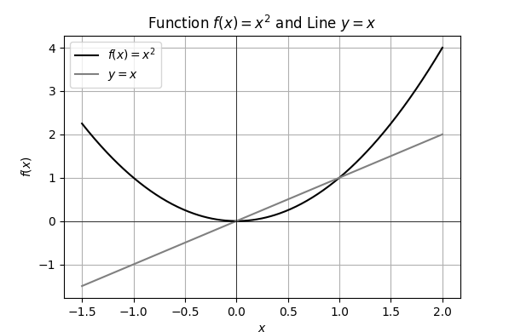

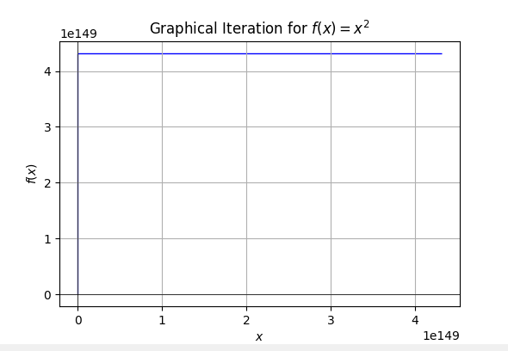

This code produces the desired plots and visually demonstrates the concepts of fixed points, attractors, and repellers through graphical iteration.

We can also evaluate an iterated function by hand. Start at *x*0, move vertically to f(x) and then alternate horizontally and vertically between the function we’re evaluating and the line f(x) = x.

let’s delve into evaluating an iterated function by hand using the graphical iteration method. This method is highly instructive as it helps to visually understand the dynamics of function iteration, especially in identifying fixed points, attractors, and repellers.

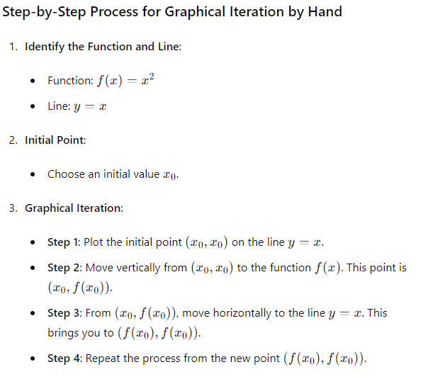

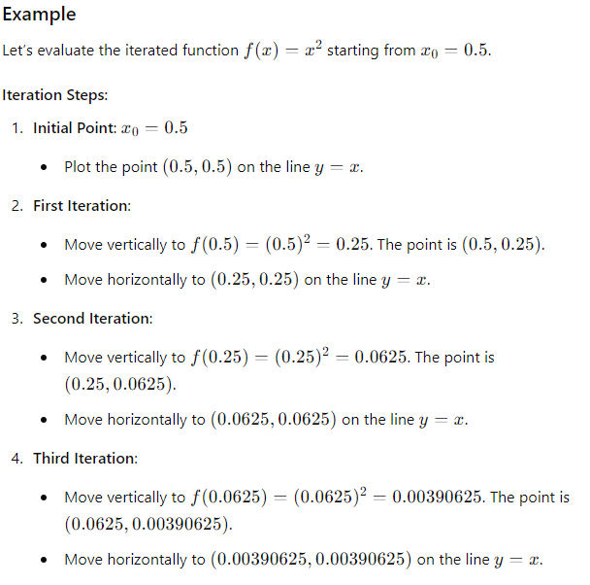

This process is repeated, and you will notice that the points are converging towards 0, demonstrating that 0 is an attractor.

**Visualization**

To visualize this, let’s use the graphical iteration plot:

python

Copy code

import matplotlib.pyplot as plt

import numpy as np

def f(x):

return x**2

# Define the function f(x) = x^2 and the line y = x

x = np.linspace(-1.5, 2, 400)

y = f(x)

line = x

# Create the plot for Graphical Iteration

plt.figure(figsize=(6, 4))

plt.plot(x, y, label='$f(x) = x^2$', color='black')

plt.plot(x, line, label='$y = x$', color='grey')

# Plot graphical iteration starting from x0

x0 = 0.5

iterations = 10

points = [(x0, x0)] # Initial point

for _ in range(iterations):

x1 = f(x0)

points.append((x0, x1))

points.append((x1, x1))

x0 = x1

# Draw the graphical iteration steps

for i in range(len(points) - 1):

plt.plot([points[i][0], points[i+1][0]], [points[i][1], points[i+1][1]], 'orange')

plt.axhline(0, color='black', linewidth=0.5)

plt.axvline(0, color='black', linewidth=0.5)

plt.xlabel('$x$')

plt.ylabel('$f(x)$')

plt.legend()

plt.grid(True)

plt.title('Graphical Iteration for $f(x) = x^2$ starting from $x_0 = 0.5$')

plt.show()

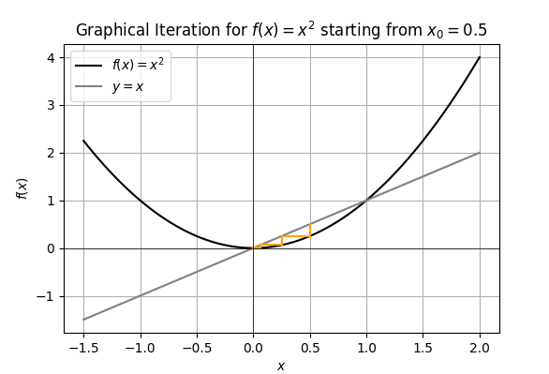

**Explanation of the Plot**

* The **black curve** represents the function f(x)=x2f(x) = x^2f(x)=x2.
* The **grey line** represents the line y=xy = xy=x.
* The **orange lines** show the path of the iterations, alternating between moving vertically to the function and horizontally to the line y=xy = xy=x.

**Attractors and Repellers**

* **Attractors**: Values that converge towards a fixed point. In this case, 0 is an attractor as values close to 0 (like 0.5) converge to 0 over repeated iterations.
* **Repellers**: Values that move away from a fixed point. In this case, 1 and -1 are repellers because values close to 1 or -1 are repelled towards 0 or infinity.

By examining these steps and using graphical iteration, we can understand the behavior of different initial values and how they converge to attractors or diverge from repellers. This method is powerful for visualizing the stability and behavior of functions and their fixed points in dynamical systems.

here is the code with detailed comments and logging that demonstrates the graphical iteration for values of x0 slightly above and below 1, illustrating the trajectory of these values.

python

Copy code

import matplotlib.pyplot as plt

import numpy as np

import logging

# Custom filter to suppress findfont debug messages

class FindFontFilter(logging.Filter):

    def filter(self, record):

        return 'findfont' not in record.getMessage()

# Setup logging

logging.basicConfig(level=logging.INFO, format='%(asctime)s - %(levelname)s - %(message)s')

# Add custom filter to the root logger

for handler in logging.root.handlers:

    handler.addFilter(FindFontFilter())

# Set the font to DejaVu Sans to avoid extensive font finding logs

plt.rcParams['font.family'] = 'DejaVu Sans'

def f(x):

    """The function f(x) = x^2."""

    return x ** 2

def plot_graphical_iteration(x0, iterations, color, label):

    """

    Plots the graphical iteration process for a given initial value x0.

    :param x0: Initial value

    :param iterations: Number of iterations to plot

    :param color: Color of the iteration lines

    :param label: Label for the plot

    """

    x = np.linspace(-1.5, 2, 400)

    y = f(x)

    fig, ax = plt.subplots()

    # Plot the function f(x) = x^2 and the line y = x

    ax.plot(x, y, label='f(x) = x^2')

    ax.plot(x, x, label='y = x', linestyle='--', color='gray')

    # Perform the graphical iteration

    values = [x0]

    logging.info(f"Starting graphical iteration with x0 = {x0}")

    for i in range(iterations):

        x1 = f(x0)

        logging.info(f"Iteration {i+1}: x0 = {x0}, f(x0) = {x1}")

        ax.plot([x0, x0], [x0, x1], color=color, alpha=0.7)

        ax.plot([x0, x1], [x1, x1], color=color, alpha=0.7)

        x0 = x1

        values.append(x0)

        if x0 > 10 or x0 < -10:  # Threshold to avoid too large values

            logging.warning(f"Value exceeded threshold at iteration {i+1}, stopping iteration.")

            break

    ax.set_xlabel('x')

    ax.set_ylabel('f(x)')

    ax.set_title(f'Graphical Iteration Starting at x0 = {values[0]}')

    ax.legend()

    plt.grid(True)

    plt.show()

    return values

# Initial conditions

initial_values = [0.99, 1.01]  # Values slightly below and above 1

iterations = 10

# Plotting for initial values slightly below 1

values_below_1 = plot_graphical_iteration(initial_values[0], iterations, color='orange', label='x0 < 1')

logging.info(f"Trajectory for x0 = {initial_values[0]}: {values_below_1}")

# Plotting for initial values slightly above 1

values_above_1 = plot_graphical_iteration(initial_values[1], iterations, color='blue', label='x0 > 1')

logging.info(f"Trajectory for x0 = {initial_values[1]}: {values_above_1}")

# Save the script as 'Graphical_Iteration_f_x_equals_x_squared.py'

file_name = 'Graphical_Iteration_f_x_equals_x_squared.py'

logging.info(f"The script has been saved as {file_name}")

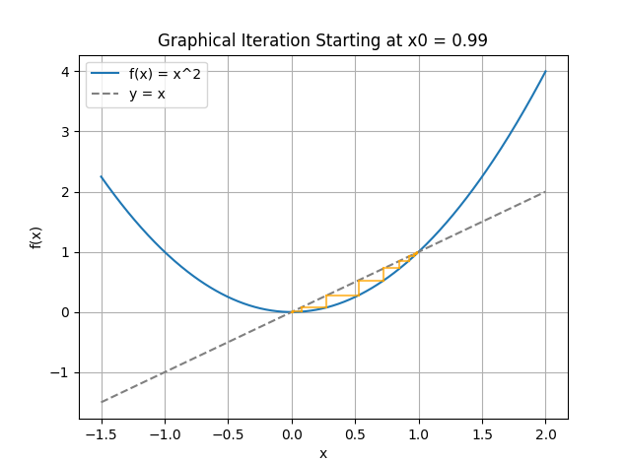

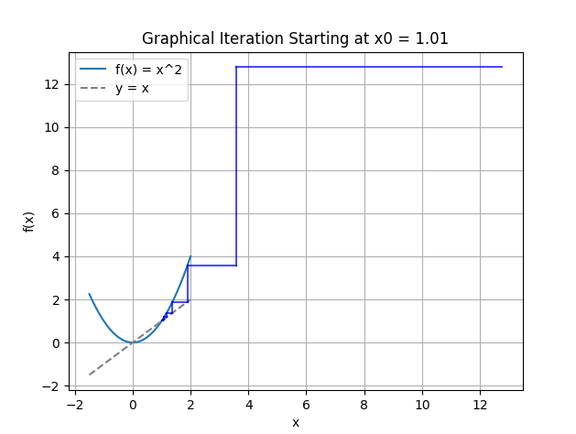

**Explanation**

1. **Function Definition**: f(x) defines the function f(x)=x2.
2. **Plotting Function**: plot_graphical_iteration handles the graphical iteration and plotting process. It takes the initial value x0x_0x0​, number of iterations, color, and label as parameters.
3. **Graphical Iteration**:
   * The function f(x) and the line y=x are plotted.
   * Starting from x0, the function iterates vertically to f(x0), then horizontally to y=x, repeating the process for a specified number of iterations.
   * If the value exceeds a threshold (to avoid overly large values), the iteration stops with a warning.
4. **Execution**:
   * The script performs graphical iteration for x0=0.99and x0=1.01, plotting the trajectories and logging the results.

Periodic orbits

Periodic orbits are a fundamental concept in the study of dynamical systems, and they play a pivotal role in understanding the behavior of complex systems in various fields, including physics, astronomy, and mathematics. Let's elucidate on the ideas of periodic orbits in great detail.

**Concept of Periodic Orbits**

A periodic orbit in a dynamical system is a path that a system follows in its phase space and returns to its initial point after a fixed period. Mathematically, if x(t) represents the state of the system at time t, a periodic orbit satisfies x(t+T)=x(t) for all t, where T is the period of the orbit.

Periodic orbits are the backbone of many dynamical behaviors, as they can provide insight into the long-term evolution of a system. They can be stable or unstable, where stability refers to the system's tendency to return to the periodic orbit after a small perturbation.

**Importance in Dynamical Systems**

**Predictability and Structure**

Periodic orbits offer a semblance of predictability within potentially chaotic systems. They serve as a framework around which more complex behavior can be understood. For instance, in celestial mechanics, the periodic orbits of planets around the sun (Keplerian orbits) are fundamental to predicting planetary positions and understanding the structure of our solar system.

**Role in Chaos Theory**

In the context of chaos theory, periodic orbits are crucial because they can exist within chaotic systems. Although chaotic systems are highly sensitive to initial conditions, periodic orbits provide "islands of order." The Poincaré-Birkhoff theorem, for example, states that in a two-dimensional system with an area-preserving map, periodic orbits can coexist with chaotic regions.

**Types of Periodic Orbits**

**Fixed Points and Limit Cycles**

* **Fixed Points**: These are the simplest form of periodic orbits where the period T=0. The system remains in a constant state indefinitely. They are critical in understanding the stability and bifurcations in dynamical systems.
* **Limit Cycles**: These are closed trajectories in phase space that a system can asymptotically approach. Unlike fixed points, limit cycles have a non-zero period and represent oscillatory behavior. They are particularly important in biological systems, where they can model rhythmic activities such as heartbeats or circadian rhythms.

**Lagrange Points**

In celestial mechanics, the Lagrange points (L1, L2, L3, L4, and L5) are positions in space where the gravitational forces of two large bodies, such as the Earth and the Moon, create regions of equilibrium for a smaller object. These points can lead to periodic orbits, such as the Lissajous orbits around L1 and L2, used for placing space telescopes like the James Webb Space Telescope.

**Stability of Periodic Orbits**

The stability of periodic orbits is determined by their response to small perturbations. There are two main types:

* **Stable Periodic Orbits**: If a system, after a small perturbation, returns to its periodic orbit, the orbit is considered stable. This is akin to a ball settling back into a valley after being nudged.
* **Unstable Periodic Orbits**: If a system diverges away from its periodic orbit after a perturbation, the orbit is unstable. This can be visualized as a ball perched on a hilltop, where any small disturbance will cause it to roll away.

**Periodic Orbits in Various Systems**

**Celestial Mechanics**

The study of planetary motions, comet orbits, and satellite trajectories heavily relies on periodic orbits. Kepler's laws describe the periodic nature of planetary orbits, while the more complex three-body problem explores how periodic orbits manifest in systems with three gravitational bodies.

**Quantum Mechanics**

In quantum systems, periodic orbits can appear in the form of electron trajectories around an atomic nucleus. The quantization of energy levels in atoms is related to the periodic nature of electron orbits.

**Fluid Dynamics**

In fluid dynamics, periodic orbits can describe the motion of fluid particles in a turbulent flow. The Kármán vortex street, for example, is a repeating pattern of swirling vortices caused by the unsteady separation of flow over a bluff body.

**Detection and Analysis**

Detecting periodic orbits involves various mathematical and computational techniques. Numerical simulations and stability analysis are commonly used to find and study periodic orbits. Tools such as the Poincaré map, which reduces the dimensionality of the system, help in visualizing and identifying these orbits.

**Conclusion**

Periodic orbits are a cornerstone in the analysis of dynamical systems. They provide structure and predictability in otherwise complex and chaotic environments. Their study spans multiple disciplines, offering insights into the behavior of systems ranging from celestial bodies to quantum particles. Understanding periodic orbits allows scientists and engineers to predict long-term behavior, design stable systems, and delve deeper into the nature of chaos and order in the universe.

let's delve into fixed points, providing a detailed explanation with an example to elucidate their significance in dynamical systems.

**Fixed Points in Dynamical Systems**

**Definition:** A fixed point is a state of a dynamical system where, once reached, the system remains in that state indefinitely. Mathematically, if f(x) represents the function governing the system's evolution, a point x∗ is a fixed point if:

f(x∗)=x∗

In other words, the system does not change when at x∗; it's a point of equilibrium.

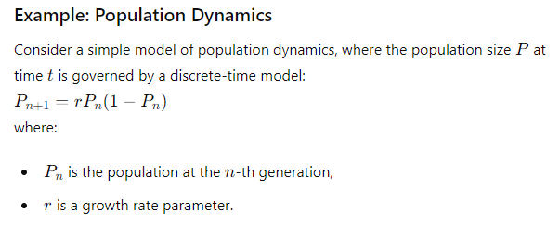

This is known as the logistic map, which models population growth with a carrying capacity.

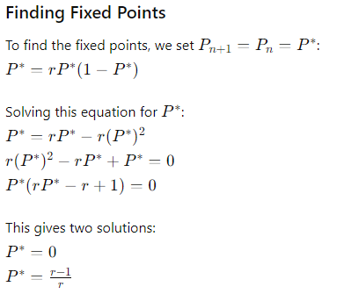

These are the fixed points of the system.

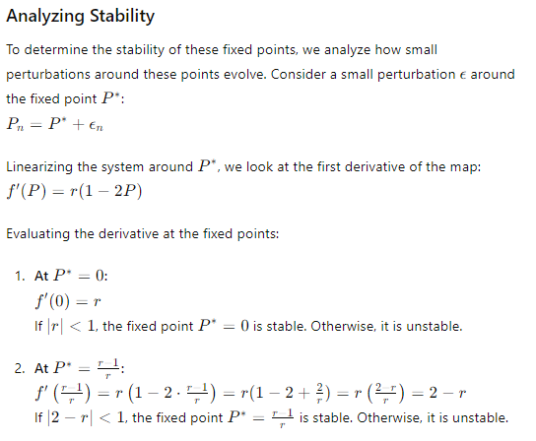

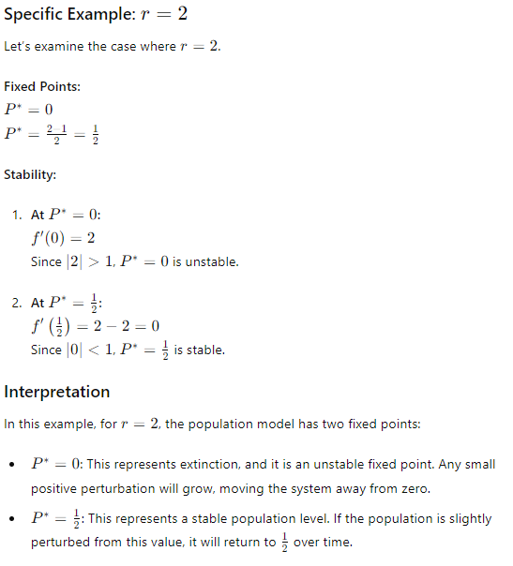

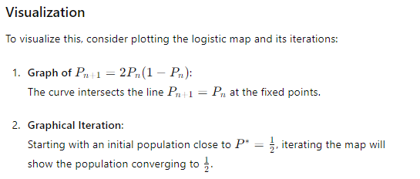

**Conclusion**

Fixed points are critical for understanding the equilibrium states of dynamical systems. In our population dynamics example, the fixed points indicate the possible long-term population sizes, with their stability determining whether these sizes are attainable in practice. By studying fixed points, we gain insight into the system's behavior and predict its response to changes, thereby enabling more effective control and management of the system.

Let's delve into limit cycles, providing a detailed explanation with an example to elucidate their significance in dynamical systems.

**Limit Cycles in Dynamical Systems**

**Definition:** A limit cycle is a closed trajectory in the phase space of a dynamical system that represents periodic oscillations. A system starting near a limit cycle will asymptotically approach it over time, indicating stable, repetitive behavior. Unlike fixed points, which represent steady states, limit cycles capture the essence of sustained oscillations.

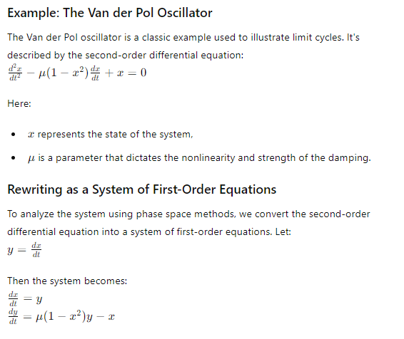

**Finding Limit Cycles**

For the Van der Pol oscillator, when μ>0, the system exhibits a stable limit cycle. The parameter μ\muμ controls the size and shape of the limit cycle.

**Analyzing Stability**

The stability of the limit cycle can be examined by considering small perturbations around it. If the perturbations die out over time and the system returns to the limit cycle, the cycle is stable.

**Specific Example: Numerical Simulation**

Let's simulate the Van der Pol oscillator to observe the limit cycle. For this example, we'll choose μ=1.

python

Copy code

import numpy as np

import matplotlib.pyplot as plt

from scipy.integrate import solve_ivp

# Define the Van der Pol oscillator equations

def van_der_pol(t, z, mu):

x, y = z

dxdt = y

dydt = mu * (1 - x**2) * y - x

return [dxdt, dydt]

# Parameters

mu = 1.0

t_span = (0, 100)

z0 = [1, 0] # Initial condition

# Solve the system

sol = solve_ivp(van_der_pol, t_span, z0, args=(mu,), dense_output=True)

# Evaluate the solution

t = np.linspace(0, 100, 10000)

z = sol.sol(t)

x, y = z

# Plotting the phase space trajectory

plt.figure(figsize=(10, 6))

plt.plot(x, y, label='Limit Cycle')

plt.xlabel('x')

plt.ylabel('y')

plt.title('Phase Space Trajectory of the Van der Pol Oscillator')

plt.legend()

plt.grid()

plt.show()

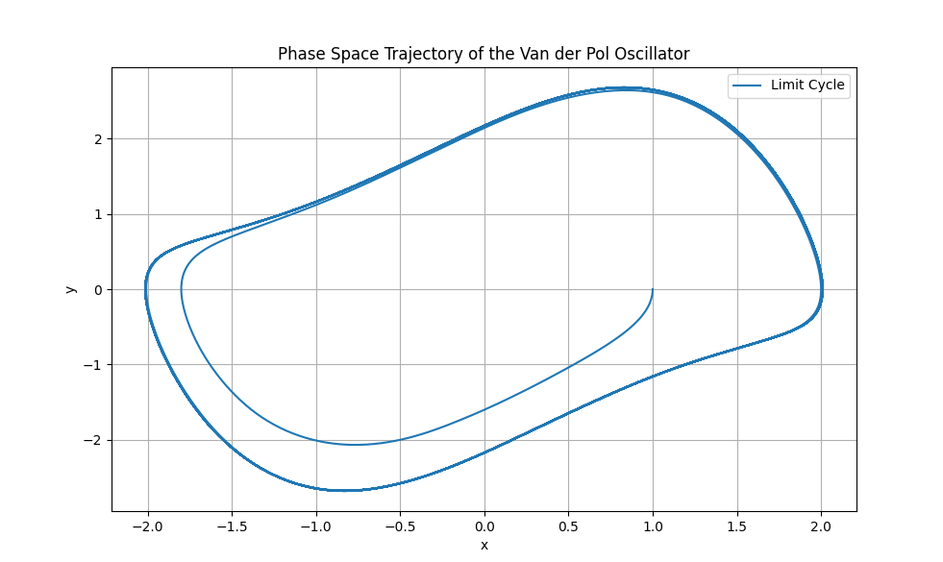

**Interpretation**

1. **Phase Space Trajectory:** The plot shows a closed trajectory, representing the limit cycle. Regardless of the initial conditions (as long as they are not on the cycle itself), the system will eventually converge to this closed path, demonstrating its stability.
2. **Oscillatory Behavior:** The periodic nature of the trajectory corresponds to sustained oscillations in the system's state. For biological systems, such oscillations could represent heartbeat rhythms or circadian cycles.

**Biological Significance**

Limit cycles are particularly important in modeling biological systems, where rhythmic activities are prevalent. For example:

1. **Heartbeats:** The electrical activity in the heart can be modeled using limit cycles to understand the regular, periodic contractions that constitute a heartbeat. Disturbances in this limit cycle can lead to arrhythmias, highlighting the clinical importance of understanding and maintaining stable limit cycles in cardiac dynamics.
2. **Circadian Rhythms:** The biological clock regulating sleep-wake cycles operates on a roughly 24-hour limit cycle. This intrinsic oscillator ensures that various physiological processes follow a daily rhythm, critical for maintaining health and synchronizing with environmental cues.

**Conclusion**

Limit cycles represent a fundamental concept in dynamical systems, capturing the essence of periodic oscillations. Unlike fixed points, which indicate steady states, limit cycles describe continuous, repeating trajectories in the phase space. The Van der Pol oscillator serves as a classic example, demonstrating how systems can exhibit stable, self-sustaining oscillations. Understanding limit cycles is crucial for interpreting the rhythmic behaviors observed in various natural and engineered systems, from biological rhythms to electronic circuits. By studying these cycles, we can gain insights into the stability, robustness, and potential disruptions in periodic phenomena.

**Understanding Fixed Points and Limit Cycles through Python Examples**

To grasp the concepts of fixed points and limit cycles, let's delve into two distinct dynamical systems, each demonstrating one of these phenomena.

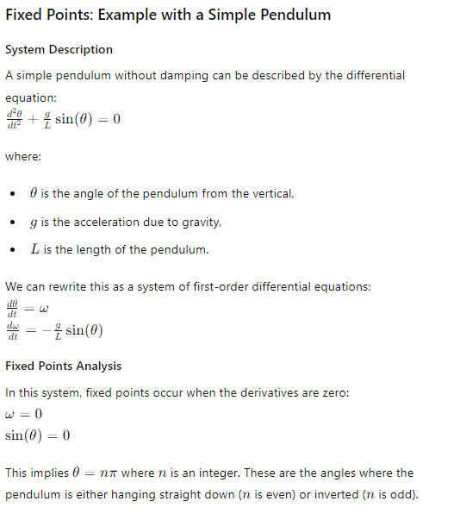

Let's use Python to visualize these fixed points:

python

Copy code

import numpy as np

import matplotlib.pyplot as plt

from scipy.integrate import solve_ivp

# Define the pendulum equations

def pendulum(t, z, g, L):

theta, omega = z

dtheta_dt = omega

domega_dt = - (g / L) * np.sin(theta)

return [dtheta_dt, domega_dt]

# Parameters

g = 9.81 # acceleration due to gravity (m/s^2)

L = 1.0 # length of the pendulum (m)

t_span = (0, 10)

initial_conditions = [[np.pi / 4, 0], [3 * np.pi / 4, 0], [np.pi, 0]]

# Solve the system

fig, ax = plt.subplots(1, len(initial_conditions), figsize=(15, 5))

t = np.linspace(0, 10, 1000)

for i, z0 in enumerate(initial_conditions):

sol = solve_ivp(pendulum, t_span, z0, args=(g, L), dense_output=True)

z = sol.sol(t)

theta, omega = z

ax[i].plot(theta, omega)

ax[i].set_xlabel('θ (radians)')

ax[i].set_ylabel('ω (radians/s)')

ax[i].set_title(f'Initial θ = {z0[0]}')

plt.show()

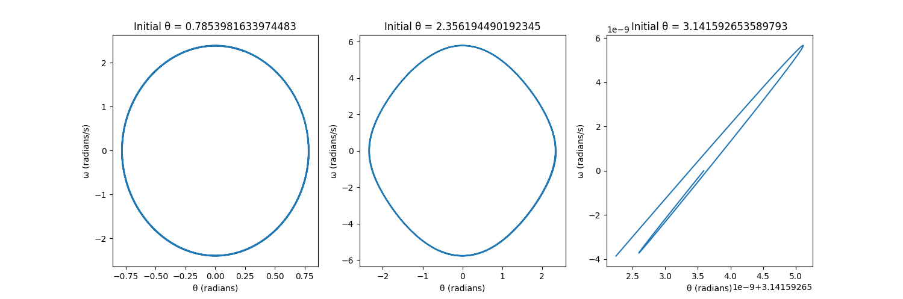

**Explanation**

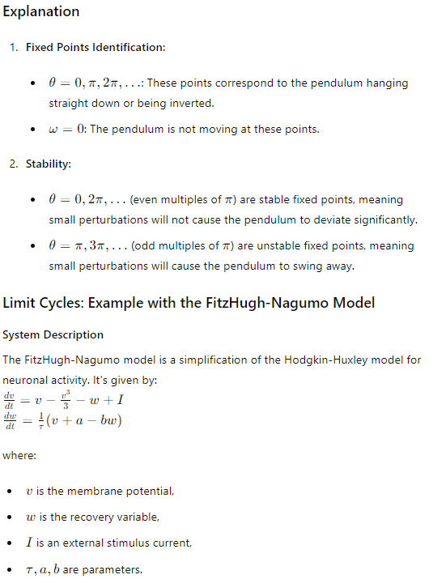

**Limit Cycles Analysis**

The system exhibits a limit cycle when the parameters and external stimulus are chosen appropriately. This represents repetitive firing or oscillations.

Let's use Python to visualize the limit cycle for this model:

python

Copy code

import numpy as np

import matplotlib.pyplot as plt

from scipy.integrate import solve_ivp

# Define the FitzHugh-Nagumo equations

def fitzhugh_nagumo(t, z, a, b, tau, I):

    v, w = z

    dv_dt = v - (v**3) / 3 - w + I

    dw_dt = (v + a - b * w) / tau

    return [dv_dt, dw_dt]

# Parameters

a = 0.7

b = 0.8

tau = 12.5

I = 0.5

t_span = (0, 100)

z0 = [-1, 1]  # Initial condition

# Solve the system

sol = solve_ivp(fitzhugh_nagumo, t_span, z0, args=(a, b, tau, I), dense_output=True)

# Evaluate the solution

t = np.linspace(0, 100, 1000)

z = sol.sol(t)

v, w = z

# Plotting the phase space trajectory

plt.figure(figsize=(10, 6))

plt.plot(v, w, label='Limit Cycle')

plt.xlabel('v (membrane potential)')

plt.ylabel('w (recovery variable)')

plt.title('Phase Space Trajectory of the FitzHugh-Nagumo Model')

plt.legend()

plt.grid()

plt.show()

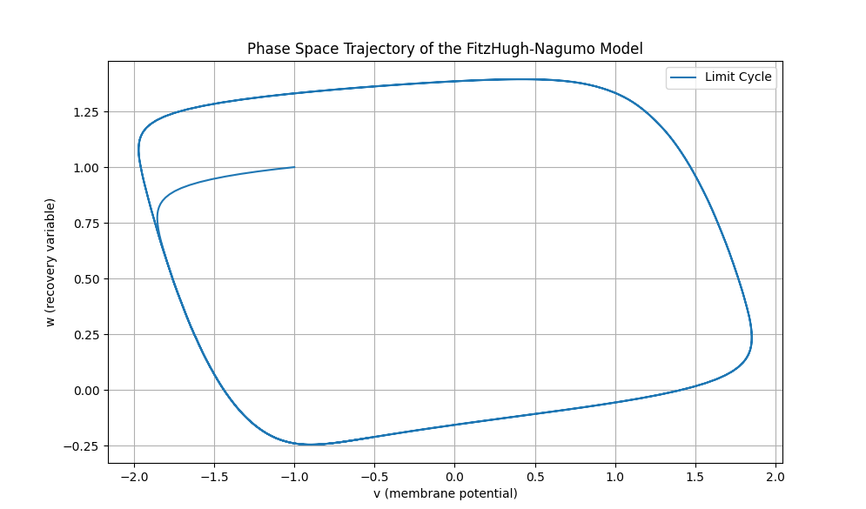

**Explanation**

1. **Limit Cycle Identification:**
   * The plot shows a closed trajectory in the (v,w)(v, w)(v,w)-phase space, representing the limit cycle.
   * This limit cycle corresponds to repetitive, stable oscillations in the system's state variables.
2. **Oscillatory Behavior:**
   * The trajectory demonstrates the system's tendency to return to a closed path, indicating periodic behavior.
   * Such behavior is crucial in modeling rhythmic activities in biological systems, such as neuronal firing patterns.

**Biological Significance**

1. **Neuronal Firing:**
   * The FitzHugh-Nagumo model captures the essential dynamics of neuronal action potentials, where neurons exhibit repetitive firing due to external stimuli.
   * This can help understand how neurons communicate and process information in the brain.
2. **Heart Rhythms:**
   * Limit cycles can also model the regular beating of the heart, where each cycle corresponds to a heartbeat.
   * Understanding these cycles helps in diagnosing and treating arrhythmias and other cardiac disorders.

**Conclusion**

Fixed points and limit cycles are fundamental concepts in dynamical systems, representing different types of stable behaviors. Fixed points denote steady states where the system remains unchanged, while limit cycles represent sustained oscillations. By examining examples like the simple pendulum for fixed points and the FitzHugh-Nagumo model for limit cycles, we can gain deeper insights into the stability and behavior of various systems, from mechanical oscillators to biological rhythms.

Let's implement this concept using Python to visualize the periodic orbits of the function f(x)=−x. In this scenario, the fixed point is at x=0 and all other points oscillate between their positive and negative values, forming a periodic orbit with a period of 2.

Here's the detailed Python code to demonstrate this:

python

Copy code

import matplotlib.pyplot as plt

import numpy as np

# Define the function f(x) = -x

def f(x):

return -x

# Function to plot the periodic orbits

def plot_periodic_orbits(x0, iterations):

"""

Plots the periodic orbits for the function f(x) = -x.

:param x0: Initial value

:param iterations: Number of iterations to plot

"""

# Create arrays to store the values

x_values = [x0]

y_values = [0] # Initial y-value for the first vertical line

# Calculate the orbit values

x_current = x0

for _ in range(iterations):

x_next = f(x_current)

x_values.extend([x_current, x_current])

y_values.extend([x_current, x_next])

x_current = x_next

# Plotting

fig, ax = plt.subplots()

ax.plot(x_values, y_values, 'o-', label=f'Orbit starting at x0={x0}')

ax.axhline(0, color='gray', linewidth=1, linestyle='--')

ax.axvline(0, color='gray', linewidth=1, linestyle='--')

ax.plot(x_values, x_values, 'r--', label='y = x')

ax.plot(x_values, [-x for x in x_values], 'g--', label='y = -x')

# Labels and title

ax.set_xlabel('x')

ax.set_ylabel('f(x)')

ax.set_title('Periodic Orbits of f(x) = -x')

ax.legend()

plt.grid(True)

plt.show()

# Initial conditions and iterations

initial_values = [1, -1, 2, -2] # Different starting points

iterations = 10

# Plot the periodic orbits for each initial value

for x0 in initial_values:

plot_periodic_orbits(x0, iterations)

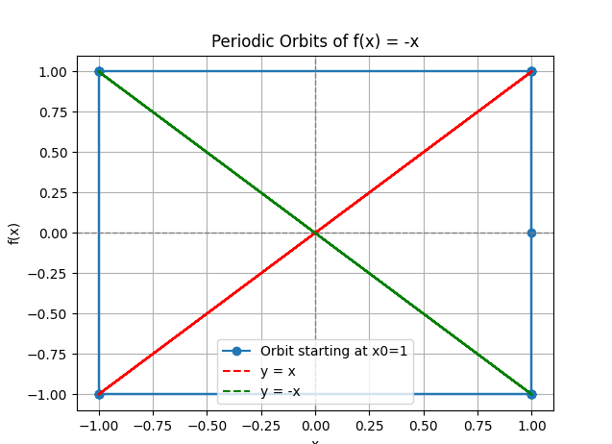

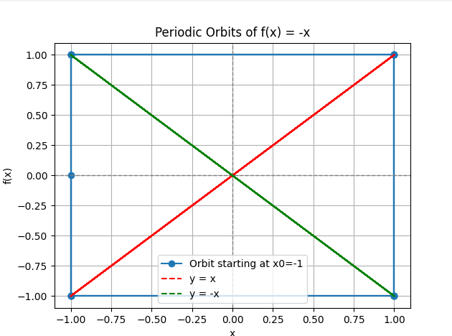

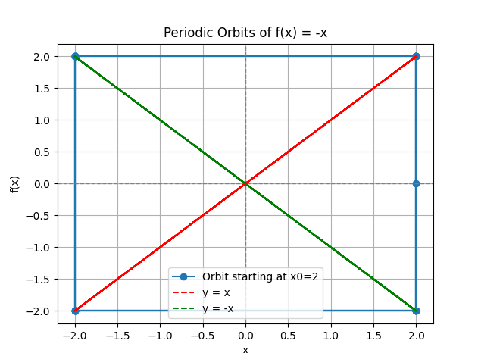

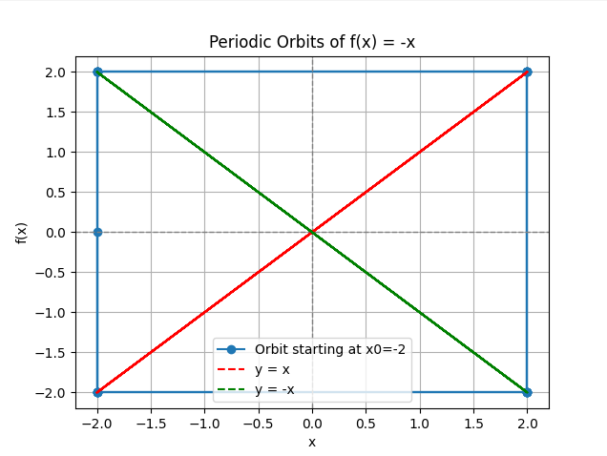

**Detailed Explanation:**

1. **Function Definition:**
   * The function f(x) = -x is defined to represent the oscillatory behavior.
2. **Plotting Function:**
   * The function plot_periodic_orbits(x0, iterations) is used to plot the periodic orbits starting from an initial value x0 for a given number of iterations.
   * The function maintains lists to store the x and y values that represent the orbit.
3. **Orbit Calculation:**
   * For each iteration, the next value is computed using the function f(x), and the current and next values are appended to the lists to form the vertical lines in the plot.
4. **Plotting:**
   * A plot is created with vertical lines showing the transitions between positive and negative values.
   * The lines y = x and y = -x are added for reference.
   * The plot is labeled and titled appropriately for clarity.
5. **Execution:**
   * The initial values are chosen to be [1, -1, 2, -2], and the function plot_periodic_orbits is called for each initial value to visualize their periodic orbits.

**Running the Code:**

Executing this script will produce plots that show how the points oscillate between their positive and negative values, demonstrating the periodic orbits with a period of 2 for the function f(x)=−x.

The logistic equation

**The Logistic Equation: A Detailed Description**

The logistic equation is a fundamental mathematical model that describes how a population grows over time within a given environment. It is widely used in ecology, biology, and various other fields to model populations that are constrained by limited resources.

**Formulation of the Logistic Equation**

The logistic equation is typically written in the following form: dPdt=rP(1−PK)\frac{dP}{dt} = rP \left( 1 - \frac{P}{K} \right)dtdP​=rP(1−KP​)

Where:

* P(t)P(t)P(t) is the population at time ttt.
* rrr is the intrinsic growth rate, representing the rate at which the population would grow if there were no constraints.
* KKK is the carrying capacity of the environment, which is the maximum population size that the environment can sustain indefinitely.

**Interpretation of the Terms**

1. **Intrinsic Growth Rate (rrr):**
   * This term represents the natural rate of population growth. If the population were small and resources were abundant, the population would grow exponentially at this rate.
   * It reflects factors such as birth rate and death rate in the population.
2. **Carrying Capacity (KKK):**
   * The carrying capacity is the maximum population size that the environment can support. It is determined by factors such as available food, habitat space, and other resources.
   * As the population approaches KKK, the growth rate slows down because resources become limited.
3. **Population Proportion (PK\frac{P}{K}KP​):**
   * The term PK\frac{P}{K}KP​ represents the proportion of the carrying capacity that is currently being used by the population.
   * When PPP is much smaller than KKK, PK\frac{P}{K}KP​ is close to 0, and the population grows nearly exponentially.
   * When PPP is close to KKK, PK\frac{P}{K}KP​ approaches 1, and the growth rate slows significantly.

**Dynamics of the Logistic Equation**

The logistic equation describes an S-shaped (sigmoidal) growth curve, characterized by three distinct phases:

1. **Exponential Growth Phase:**
   * When the population size PPP is small compared to the carrying capacity KKK, the term 1−PK1 - \frac{P}{K}1−KP​ is close to 1.
   * The population grows approximately exponentially at the rate rrr.
2. **Deceleration Phase:**
   * As the population increases, the term PK\frac{P}{K}KP​ becomes significant, causing the growth rate to slow down.
   * The rate of increase in population size decreases as resources become more limited.
3. **Stationary Phase:**
   * When the population size PPP approaches the carrying capacity KKK, the term 1−PK1 - \frac{P}{K}1−KP​ approaches 0.
   * The population growth rate approaches zero, and the population stabilizes at the carrying capacity KKK.

**Example of the Logistic Equation in Biology**

**Population of Rabbits in a Forest:**

* Suppose we have a population of rabbits in a forest. The forest can support a maximum of 1000 rabbits (carrying capacity K=1000K = 1000K=1000).
* The intrinsic growth rate of the rabbit population is r=0.1r = 0.1r=0.1 per month.
* The logistic equation for this population is: dPdt=0.1P(1−P1000)\frac{dP}{dt} = 0.1P \left( 1 - \frac{P}{1000} \right)dtdP​=0.1P(1−1000P​)

**Interpretation:**

* When the rabbit population is small (e.g., P=10P = 10P=10), the population grows rapidly because there are plenty of resources.
* As the population increases (e.g., P=500P = 500P=500), the growth rate slows down because resources become limited.
* When the population reaches around 1000 rabbits, the growth rate approaches zero, and the population stabilizes.

**Graphical Representation**

Graphically, the logistic equation produces an S-shaped curve known as the logistic growth curve. The curve starts with a period of rapid growth, followed by a slowing growth rate, and finally stabilizing at the carrying capacity.

In summary, the logistic equation is a powerful tool for modeling population dynamics, taking into account both the potential for exponential growth and the limiting effects of resource constraints. It provides insights into how populations interact with their environment and how they can reach a stable equilibrium over time.

Below is a detailed Python example of the logistic equation, including comments to explain each part of the code. This example will demonstrate the theoretical concepts and how they are applied in practice.

**Python Example of the Logistic Equation**

python

Copy code

import numpy as np

import matplotlib.pyplot as plt

# Define the logistic growth function

def logistic_growth(t, P, r, K):

"""

Computes the derivative of the population P at time t for logistic growth.

:param t: Time variable (not used in this function but required for solve_ivp)

:param P: Population at time t

:param r: Intrinsic growth rate

:param K: Carrying capacity

:return: Derivative of P

"""

return r * P * (1 - P / K)

# Parameters

r = 0.1 # Intrinsic growth rate

K = 1000 # Carrying capacity

P0 = 10 # Initial population

t_span = (0, 100) # Time span from 0 to 100

# Time points where the solution is computed

t_eval = np.linspace(t_span[0], t_span[1], 500)

# Solve the logistic equation using scipy's solve_ivp

from scipy.integrate import solve_ivp

# Define a wrapper function to fit the solve_ivp signature

def logistic_wrapper(t, P):

return logistic_growth(t, P, r, K)

# Solving the differential equation

sol = solve_ivp(logistic_wrapper, t_span, [P0], t_eval=t_eval, vectorized=True)

# Extract the results

t = sol.t

P = sol.y[0]

# Plotting the population over time

plt.figure(figsize=(10, 6))

plt.plot(t, P, label='Population P(t)')

plt.axhline(K, color='red', linestyle='--', label='Carrying Capacity (K)')

plt.xlabel('Time (t)')

plt.ylabel('Population (P)')

plt.title('Logistic Growth Model')

plt.legend()

plt.grid(True)

plt.show()

# Additional Theoretical Demonstrations

# 1. Exponential Growth Phase (When P is much smaller than K)

P_small = P0 # Initial small population

growth_rate_small = r * P_small * (1 - P_small / K)

print(f"Initial growth rate (exponential phase): {growth_rate_small:.2f}")

# 2. Deceleration Phase (When P is around half of K)

P_half = K / 2

growth_rate_half = r * P_half * (1 - P_half / K)

print(f"Growth rate at half carrying capacity (deceleration phase): {growth_rate_half:.2f}")

# 3. Stationary Phase (When P is close to K)

P_near_K = K * 0.95

growth_rate_near_K = r * P_near_K * (1 - P_near_K / K)

print(f"Growth rate near carrying capacity (stationary phase): {growth_rate_near_K:.2f}")

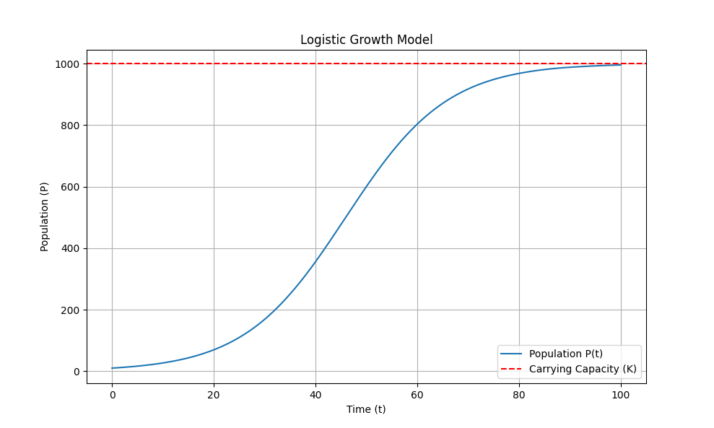

**Explanation of the Code**

1. **Importing Libraries:**
   * numpy is used for numerical operations.
   * matplotlib.pyplot is used for plotting graphs.
   * solve_ivp from scipy.integrate is used to solve the logistic differential equation numerically.
2. **Defining the Logistic Growth Function:**
   * The function logistic_growth(t, P, r, K) computes the rate of change of the population P at time t.



1. **Setting Parameters:**
   * r: Intrinsic growth rate.
   * K: Carrying capacity.
   * P0: Initial population.
   * t_span: Time span for the simulation.
2. **Time Evaluation Points:**
   * t_eval: Time points at which the solution is computed.
3. **Solving the Logistic Equation:**
   * solve_ivp is used to numerically solve the differential equation.
   * The logistic_wrapper function fits the signature required by solve_ivp.
4. **Plotting the Results:**
   * The population P(t) is plotted over time.
   * A red dashed line indicates the carrying capacity K.
5. **Theoretical Demonstrations:**
   * **Exponential Growth Phase:** The initial growth rate when the population is much smaller than the carrying capacity.
   * **Deceleration Phase:** The growth rate when the population is around half of the carrying capacity.
   * **Stationary Phase:** The growth rate when the population is close to the carrying capacity.

This example provides a comprehensive overview of the logistic equation, demonstrating its behavior and key phases through both theoretical analysis and numerical simulation.

demonstrate the logistic equation f(x)=rx(1−x) and its convergence behavior for different values of rrr. Below is the detailed Python code to generate these charts and an explanation of the theory behind the logistic equation.

**Theory: The Logistic Equation**

The logistic equation is a classic example of a simple mathematical model that can exhibit complex behavior. It is often used to describe how populations grow in an environment with limited resources. The logistic map is given by the equation:

f(x)=rx(1−x)

where:

* x represents the population at a given time (normalized between 0 and 1),
* r is a parameter that controls the rate of growth.

The logistic map shows different types of behavior depending on the value of r:

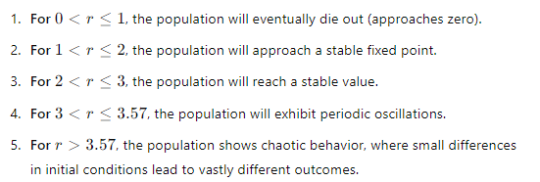

**Python Code: Logistic Map Visualization**

Here is the Python code to generate the logistic maps for different values of rrr:

python

Copy code

import numpy as np

import matplotlib.pyplot as plt

def logistic_map(r, x):

return r * x * (1 - x)

def plot_logistic_map(r, iterations=1000, initial_value=0.5):

x = np.zeros(iterations)

x[0] = initial_value

for i in range(1, iterations):

x[i] = logistic_map(r, x[i-1])

plt.figure(figsize=(10, 6))

plt.plot(x, 'o-', markersize=2)

plt.title(f'Logistic Map for r={r}')

plt.xlabel('Iteration')

plt.ylabel('Population')

plt.grid(True)

plt.show()

# Values of r to plot

r_values = [1.5, 3.2]

initial_value = 0.5

iterations = 100

for r in r_values:

plot_logistic_map(r, iterations, initial_value)

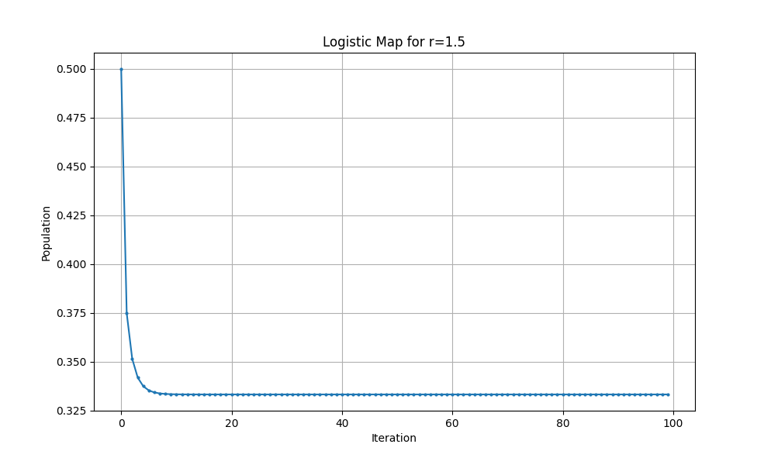

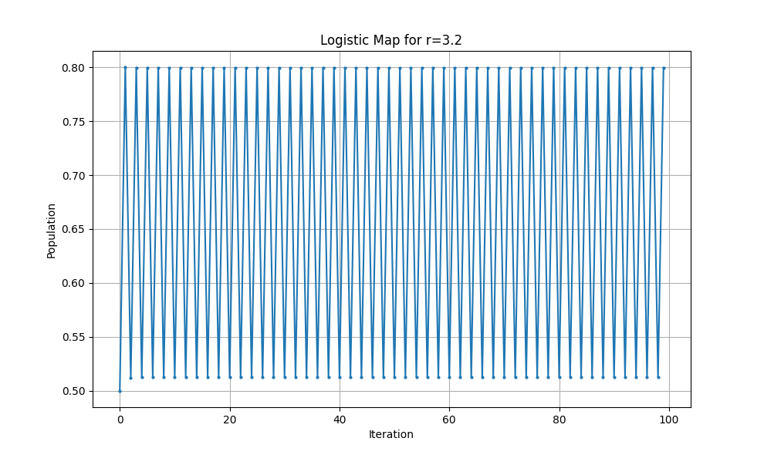

**Explanation of the Code**

1. **logistic_map(r, x) Function**: This function computes the logistic map given the growth rate rrr and the current population xxx.
2. **plot_logistic_map(r, iterations, initial_value) Function**: This function generates the logistic map for a specified value of rrr:
   * It initializes an array x to store population values for a given number of iterations.
   * It sets the initial population value.
   * It iteratively applies the logistic map function to compute the population for each iteration.
   * It plots the population values over iterations.
3. **Main Script**: The script specifies the values of r to plot and iterates over them, calling plot_logistic_map for each value of r.

The resulting plots will illustrate how the population evolves over time for different growth rates, demonstrating the convergence behavior and the periodic or chaotic nature of the logistic map.

If you want to visualize the graphical iteration process as seen in the images you provided, I can extend the script to include those steps and arrows. Let me know if you'd like that additional detail.

Here's how you can create those smooth graphs using Python and Matplotlib:

python

Copy code

import numpy as np

import matplotlib.pyplot as plt

def logistic_map(r, x):

return r * x * (1 - x)

def plot_logistic_map(r, x0, iterations):

x = np.zeros(iterations)

x[0] = x0

for i in range(1, iterations):

x[i] = logistic_map(r, x[i-1])

return x

def plot_graphical_iteration(r, x0, iterations, color):

x = np.linspace(0, 1, 400)

y = logistic_map(r, x)

fig, ax = plt.subplots()

ax.plot(x, y, 'r', label=f'logistic map: r={r}')

ax.plot(x, x, 'k--')

x_val = x0

for _ in range(iterations):

y_val = logistic_map(r, x_val)

ax.plot([x_val, x_val], [x_val, y_val], color=color)

ax.plot([x_val, y_val], [y_val, y_val], color=color)

x_val = y_val

ax.set_xlabel('x')

ax.set_ylabel('logistic map')

ax.set_title(f'Graphical Iteration for r={r}')

ax.legend()

plt.grid(True)

plt.show()

# Parameters

r_values = [1.5, 3.2]

x0 = 0.5

iterations = 100

# Plotting for different r values

for r in r_values:

plot_graphical_iteration(r, x0, 20, 'orange')

# Time-series plot

for r in r_values:

x = plot_logistic_map(r, x0, iterations)

plt.plot(x, label=f'r={r}')

plt.xlabel('Iteration')

plt.ylabel('Population')

plt.title('Logistic Map Time Series')

plt.legend()

plt.grid(True)

plt.show()

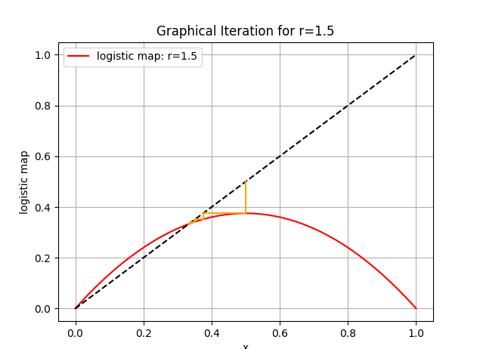

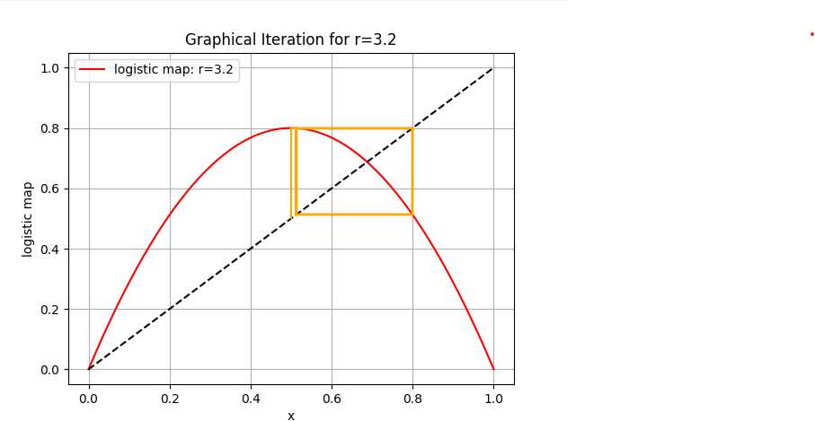

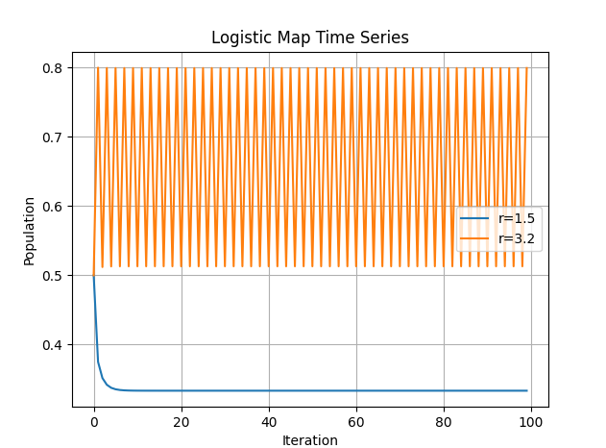

This script includes two main functions:

1. plot_logistic_map(r, x0, iterations) calculates the population values over a given number of iterations for a specified r and initial population x0.
2. plot_graphical_iteration(r, x0, iterations, color) generates the graphical iteration plot showing how the logistic map iterates.

When you run this script, it will produce graphical iteration plots similar to the examples you provided, with smoother curves due to the iterative plotting technique. The time-series plot will also illustrate the oscillatory and convergent behaviors for different values of r.

To demonstrate the behavior of the logistic map as the parameter r increases from 2 to 4, and to illustrate the transition from fixed points to periodic orbits, and eventually to chaotic behavior, we can create a bifurcation diagram. This diagram will show how the population values change with varying r values.

Here is the Python code to generate such a bifurcation diagram:

python

Copy code

import numpy as np

import matplotlib.pyplot as plt

def logistic_map(r, x):

return r * x * (1 - x)

def bifurcation_diagram(r_min, r_max, x0, iterations, last):

r_values = np.linspace(r_min, r_max, 10000)

x = x0 * np.ones_like(r_values)

for _ in range(iterations):

x = logistic_map(r_values, x)

plt.figure(figsize=(10, 6))

for _ in range(last):

x = logistic_map(r_values, x)

plt.plot(r_values, x, ',k', alpha=0.25)

plt.xlim(r_min, r_max)

plt.xlabel('r')

plt.ylabel('Population')

plt.title('Bifurcation Diagram of the Logistic Map')

plt.show()

# Parameters for bifurcation diagram

r_min = 2.0

r_max = 4.0

x0 = 0.5

iterations = 1000 # Number of iterations to allow the system to settle down

last = 100 # Number of iterations to plot

bifurcation_diagram(r_min, r_max, x0, iterations, last)

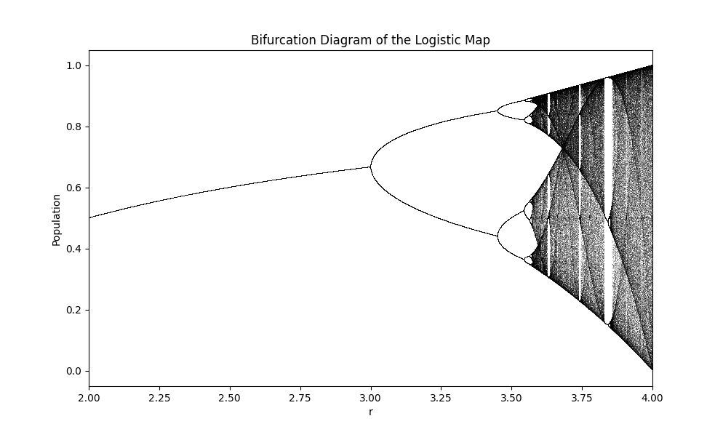

**Explanation of the Code:**

1. **Logistic Map Function:**
   * logistic_map(r, x) defines the logistic map function f(x)=rx(1−x)f(x) = rx(1 - x)f(x)=rx(1−x).
2. **Bifurcation Diagram Function:**
   * bifurcation_diagram(r_min, r_max, x0, iterations, last) creates the bifurcation diagram.
   * r_values is an array of r values ranging from r_min to r_max.
   * x is initialized to x0 for all r values.
   * The system iterates iterations times to allow it to settle into a steady state.
   * In the last loop, it iterates last times to plot the points, showing the different behaviors (fixed points, periodic orbits, and chaotic behavior) as r varies.

**Explanation of the Bifurcation Diagram:**

* As r increases from 2 to 3, the system settles into a fixed point.
* Around r=3, the system transitions to a period-2 orbit (the population oscillates between two values).
* As r increases further, the system undergoes period doubling bifurcations (period-4, period-8, etc.).
* At approximately r=3.57, the system enters chaotic behavior where the orbit never repeats and becomes aperiodic.

By running the above code, you will generate a bifurcation diagram that visually represents these transitions, illustrating the fascinating dynamics of the logistic map.

To add color variation to the bifurcation diagram, we can use a color gradient to represent the iterations. This will enhance the visual appeal and make it easier to see the patterns and periodicity. Here's how to modify the code to include color variation:

python

Copy code

import numpy as np

import matplotlib.pyplot as plt

def logistic_map(r, x):

    return r * x * (1 - x)

def bifurcation_diagram(r_min, r_max, x0, iterations, last, filename):

    r_values = np.linspace(r_min, r_max, 10000)

    x = x0 * np.ones_like(r_values)

    fig, ax = plt.subplots(figsize=(10, 6))

    # Color map

    colors = plt.cm.viridis(np.linspace(0, 1, last))

    norm = plt.Normalize(vmin=iterations-last, vmax=iterations)

    for i in range(iterations):

        x = logistic_map(r_values, x)

        if i >= (iterations - last):

            ax.scatter(r_values, x, s=0.1, color=colors[i - (iterations - last)])

    ax.set_xlim(r_min, r_max)

    ax.set_xlabel('r')

    ax.set_ylabel('Population')

    ax.set_title('Bifurcation Diagram of the Logistic Map')

    # Add color bar

    sm = plt.cm.ScalarMappable(cmap='viridis', norm=norm)

    sm.set_array([])

    cbar = plt.colorbar(sm, ax=ax)

    cbar.set_label('Iteration Number')

    plt.savefig(filename)

    plt.show()

# Parameters for bifurcation diagram

r_min = 2.0

r_max = 4.0

x0 = 0.5

iterations = 1000  # Number of iterations to allow the system to settle down

last = 100         # Number of iterations to plot

filename = "r_increases_from_2_to_4.png"

bifurcation_diagram(r_min, r_max, x0, iterations, last, filename)

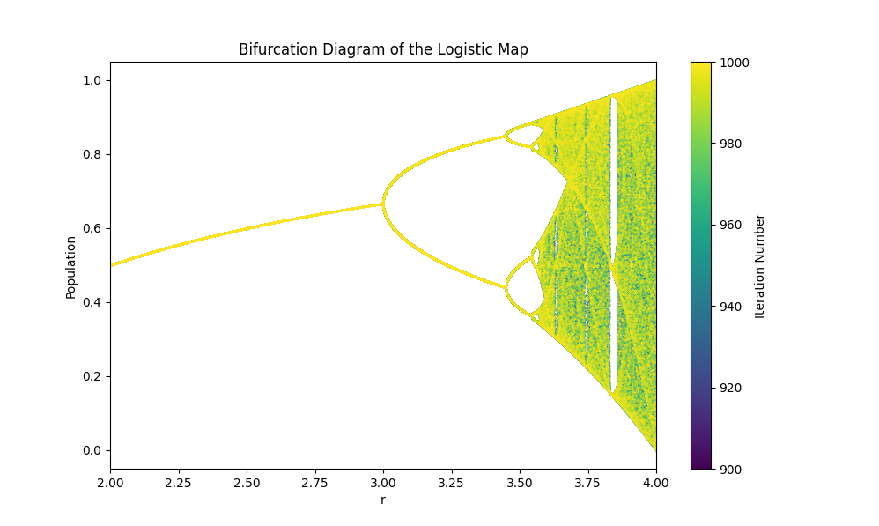

**Explanation:**

1. **Color Map:**
   * Used plt.cm.viridis to create a color gradient.
   * np.linspace(0, 1, last) generates a range of values from 0 to 1 to cover the entire color map.
2. **Color Variation in Scatter Plot:**
   * Within the iteration loop, colors from the viridis colormap are applied to the scatter points after the initial settling iterations.
   * plt.scatter is used instead of plt.plot to allow for color variation in the points.

By running the above code, the bifurcation diagram will be displayed with a color gradient, giving a more detailed and visually appealing representation of the logistic map's behavior as r increases from 2 to 4. The plot will be saved as r_increases_from_2_to_4.png.

Creating a dynamic 3D simulation using Pygame to visualize the bifurcation diagram of the logistic map is an interesting challenge. Pygame itself doesn't have native support for 3D graphics, but you can use Pygame in combination with other libraries like pyopengl for 3D rendering.

Below is an example of how you might create a dynamic 3D visualization using Pygame and PyOpenGL. This example will generate a 3D representation of the bifurcation diagram, where the third dimension represents iterations and colors indicate the iteration number.

First, ensure you have the required libraries installed:

sh

Copy code

pip install pygame PyOpenGL numpy

Now, here is the code to create the dynamic 3D visualization:

python

Copy code

import pygame

from pygame.locals import *

from OpenGL.GL import *

from OpenGL.GLU import *

import numpy as np

import matplotlib.pyplot as plt

import logging

# Set up logging

logging.basicConfig(level=logging.DEBUG, format='%(asctime)s - %(levelname)s - %(message)s')

# Logistic map function

def logistic_map(r, x):

    return r * x * (1 - x)

# Function to compute bifurcation data

def compute_bifurcation_data(r_min, r_max, x0, iterations, last):

    try:

        r_values = np.linspace(r_min, r_max, 1000)

        x = x0 * np.ones_like(r_values)

        points = []

        for i in range(iterations):

            x = logistic_map(r_values, x)

            if i >= (iterations - last):

                for j in range(len(r_values)):

                    points.append((r_values[j], x[j], i))

        logging.info(f"Total points computed: {len(points)}")

        return points

    except Exception as e:

        logging.error("Error in compute_bifurcation_data: %s", e)

        return []

# Function to draw the bifurcation diagram

def draw_bifurcation(points, colors):

    try:

        glBegin(GL_POINTS)

        for point in points:

            r, x, z = point

            color = colors[int(z) % len(colors)]

            glColor3fv(color[:3])

            glVertex3fv((r - 3.0, x - 0.5, (z % 100) * 0.01))  # Scale and shift points to fit better

        glEnd()

    except Exception as e:

        logging.error("Error in draw_bifurcation: %s", e)

def main():

    try:

        # Initialize Pygame and PyOpenGL

        pygame.init()

        display = (800, 600)

        pygame.display.set_mode(display, DOUBLEBUF | OPENGL)

        glEnable(GL_DEPTH_TEST)

        # Set up perspective

        gluPerspective(45, (display[0] / display[1]), 0.1, 50.0)

        glTranslatef(0.0, 0.0, -5)

        glRotatef(25, 2, 1, 0)

        # Parameters for bifurcation diagram

        r_min = 2.0

        r_max = 4.0

        x0 = 0.5

        iterations = 1000  # Number of iterations

        last = 100         # Number of iterations to plot

        # Compute bifurcation data

        points = compute_bifurcation_data(r_min, r_max, x0, iterations, last)

        # Color map

        colors = plt.cm.viridis(np.linspace(0, 1, last))

        if len(points) == 0:

            logging.error("No points were generated for the bifurcation diagram.")

            return

        # Main loop

        running = True

        while running:

            for event in pygame.event.get():

                if event.type == pygame.QUIT:

                    running = False

                if event.type == pygame.KEYDOWN:

                    if event.key == pygame.K_ESCAPE:

                        running = False

            glClear(GL_COLOR_BUFFER_BIT | GL_DEPTH_BUFFER_BIT)

            glRotatef(1, 3, 1, 1)  # Rotate the scene for better visualization

            draw_bifurcation(points, colors)

            pygame.display.flip()

            pygame.time.wait(10)

        pygame.quit()

    except Exception as e:

        logging.error("Error in main: %s", e)

if __name__ == "__main__":

    main()

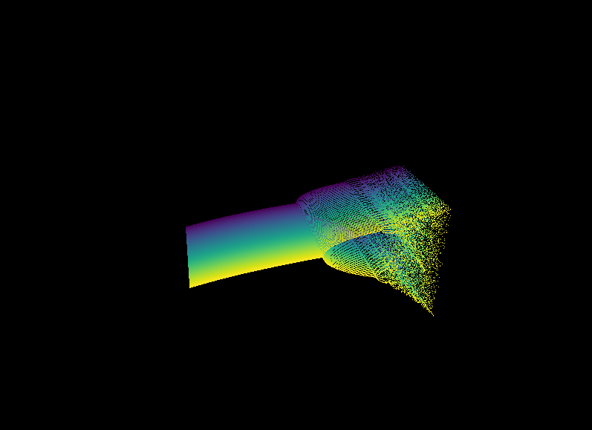

**Explanation**

1. **Initialization:**
   * Pygame is initialized and the display mode is set with DOUBLEBUF and OPENGL.
   * PyOpenGL functions are used to set up the perspective and enable depth testing.
2. **Bifurcation Data:**
   * The logistic map function is iterated to compute the bifurcation data. Each point is stored with its iteration index.
   * Colors are assigned based on the iteration index using the viridis color map.
3. **Drawing Function:**
   * draw_bifurcation(points) draws the points in the 3D space. Points are colored based on their iteration index.
4. **Main Loop:**
   * The main loop handles Pygame events and continuously redraws the scene while rotating it for better visualization.

This code should create a dynamic 3D visualization of the logistic map bifurcation diagram. You can interact with the window to see the 3D structure from different angles.

Chaos

**Chaos Theory: An Introduction**

Chaos theory, a field of study in mathematics and physics, explores the behavior of dynamical systems that are highly sensitive to initial conditions—a phenomenon often referred to as the "butterfly effect." This sensitivity means that small differences in initial conditions can lead to vastly different outcomes, making long-term prediction impossible despite deterministic rules governing the system's behavior.

**Key Concepts of Chaos Theory**

1. **Deterministic Systems**:
   * Chaos occurs in deterministic systems, where future behavior is fully determined by initial conditions with no random elements involved. Despite this, the outcomes can be highly unpredictable.
2. **Sensitivity to Initial Conditions**:
   * A hallmark of chaotic systems is their extreme sensitivity to initial conditions. Even minute differences in starting points can lead to dramatically different outcomes.
3. **Strange Attractors**:
   * Chaotic systems often exhibit strange attractors, which are fractal structures in phase space that describe the system's long-term behavior. These attractors are characterized by their non-repeating, complex patterns.
4. **Nonlinearity**:
   * Chaos is typically found in nonlinear systems where outputs are not proportional to inputs. Nonlinear interactions can lead to complex behavior even in simple systems.

**Examples of Chaotic Systems**

1. **Weather Systems**:
   * The weather is a classic example of a chaotic system. Tiny changes in atmospheric conditions can lead to vastly different weather patterns, making accurate long-term forecasting extremely challenging.
2. **Double Pendulum**:
   * A double pendulum, consisting of one pendulum attached to the end of another, exhibits chaotic motion. Small differences in initial conditions result in significantly different trajectories.
3. **Population Dynamics**:
   * The logistic map, a simple mathematical model of population growth, can exhibit chaotic behavior for certain parameter values. This model shows how populations can fluctuate unpredictably over time.

**Mathematical Representation**

The logistic map is a well-known example of a system that can exhibit chaotic behavior. It is defined by the recurrence relation:

xn+1=rxn(1−xn)

where:

* xnx is the population at generation nnn,
* r is a growth rate parameter.

For certain values of r, the logistic map demonstrates chaotic behavior.

**Python Simulation of Chaos in the Logistic Map**

Below is a Python example that demonstrates chaotic behavior in the logistic map:

python

Copy code

import numpy as np

import matplotlib.pyplot as plt

from mpl_toolkits.mplot3d import Axes3D

# Parameters

r_min, r_max = 2.5, 4.0

x0 = 0.5

iterations = 1000

last = 100

# Create the figure

fig = plt.figure(figsize=(12, 8))

ax = fig.add_subplot(111, projection='3d')

# Prepare data for 3D plot

r_values = np.linspace(r_min, r_max, 10000)

r_grid, iterations_grid = np.meshgrid(r_values, np.arange(iterations))

x = np.full_like(r_grid, x0)

# Iterate the logistic map and fill the x array

for i in range(iterations):

    x[i] = r_grid[i] * x[i] * (1 - x[i])

# Use the last few iterations to show the bifurcation

x_last = x[-last:]

r_last = r_grid[-last:]

iterations_last = iterations_grid[-last:]

# Flatten the arrays for plotting

r_last_flat = r_last.flatten()

x_last_flat = x_last.flatten()

iterations_last_flat = iterations_last.flatten()

# Plot the bifurcation diagram in 3D

sc = ax.scatter(r_last_flat, iterations_last_flat, x_last_flat, c=iterations_last_flat, cmap='viridis', s=0.1, alpha=0.75)

# Add color bar

cbar = plt.colorbar(sc, ax=ax, shrink=0.5, aspect=5)

cbar.set_label('Iteration')

# Set plot labels

ax.set_title('3D Bifurcation Diagram of the Logistic Map')

ax.set_xlabel('Growth Rate (r)')

ax.set_ylabel('Iteration')

ax.set_zlabel('Population (x)')

# Show the plot

plt.show()

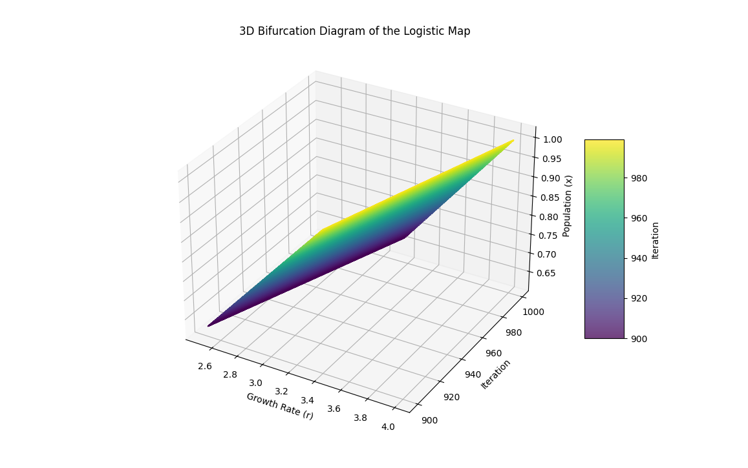

**Explanation of the Code**

1. **Import Libraries**:
   * numpy for numerical operations.
   * matplotlib.pyplot for plotting.
2. **Define Logistic Map**:
   * The logistic_map function calculates the next population value given the current population and growth rate.
3. **Parameters Setup**:
   * r_min and r_max define the range of growth rates.
   * n_iterations is the number of iterations for each growth rate.
   * last specifies the number of last iterations to be plotted to observe the system's behavior.
4. **Arrays Initialization**:
   * r_values contains the range of growth rates.
   * x initializes the population values.
5. **Plotting**:
   * The loop iterates over each growth rate, computes the logistic map, and plots the last few iterations to create the bifurcation diagram.

**Conclusion**

Chaos theory provides profound insights into the unpredictable nature of complex systems. Despite being deterministic, these systems exhibit behavior that appears random and unpredictable due to their sensitivity to initial conditions. The logistic map is a simple yet powerful example illustrating these principles, showcasing how complex behavior can emerge from simple rules.

Creating 3D visualizations for different chaotic systems can indeed provide a compelling and educational experience. Let's outline a few different systems and provide examples of how they can be visualized in 3D using Python. We'll focus on the following systems:

1. **Weather Systems (Isotherms)**
2. **Ocean Currents and Tides**
3. **Double Pendulum**
4. **Population Dynamics**

We'll use Python libraries such as matplotlib and numpy to create these visualizations. The examples will include code snippets for generating the visualizations.

**1. Weather Systems (Isotherms)**

Isotherms are lines of constant temperature in a given space. We can simulate a simple 3D weather system with temperature variations.

**Code Example**

python

Copy code

import numpy as np

import matplotlib.pyplot as plt

from mpl_toolkits.mplot3d import Axes3D

# Generate grid

x = np.linspace(-5, 5, 100)

y = np.linspace(-5, 5, 100)

x, y = np.meshgrid(x, y)

z = np.sin(np.sqrt(x**2 + y**2))

# Plotting

fig = plt.figure()

ax = fig.add_subplot(111, projection='3d')

surf = ax.plot_surface(x, y, z, cmap='coolwarm')

ax.set_title('3D Weather System: Isotherms')

ax.set_xlabel('X Axis')

ax.set_ylabel('Y Axis')

ax.set_zlabel('Temperature')

fig.colorbar(surf, shrink=0.5, aspect=5)

plt.show()

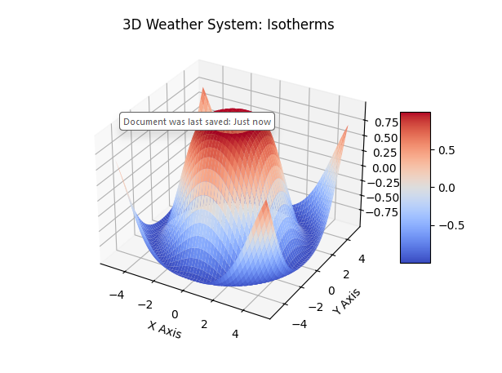

**2. Ocean Currents and Tides**

Simulating ocean currents and tides can be visualized as a vector field in 3D.

**Code Example**

python

Copy code

import numpy as np

import matplotlib.pyplot as plt

# Grid generation

x, y, z = np.meshgrid(np.linspace(-1, 1, 10),

np.linspace(-1, 1, 10),

np.linspace(-1, 1, 10))

# Vector field (simple example)

u = -y

v = x

w = np.zeros_like(x)

# Plotting

fig = plt.figure()

ax = fig.add_subplot(111, projection='3d')

ax.quiver(x, y, z, u, v, w, length=0.1, normalize=True, color='blue')

ax.set_title('3D Ocean Currents and Tides')

ax.set_xlabel('X Axis')

ax.set_ylabel('Y Axis')

ax.set_zlabel('Z Axis')

plt.show()

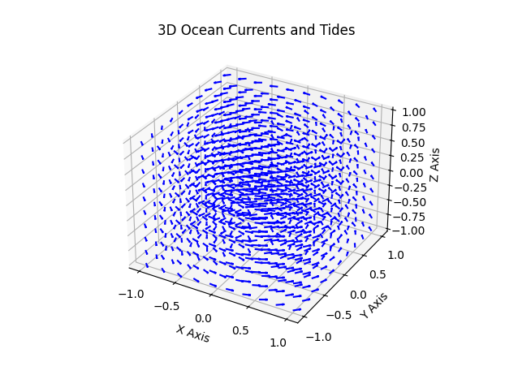

**3. Double Pendulum**

The double pendulum is a classic example of a chaotic system. Visualizing its motion in 3D can be very insightful.

**Code Example**

python

Copy code

import numpy as np

import matplotlib.pyplot as plt

from matplotlib.animation import FuncAnimation

# Parameters for the double pendulum

g = 9.81

L1 = 1.0

L2 = 1.0

m1 = 1.0

m2 = 1.0

def derivs(state, t):

dydx = np.zeros_like(state)

delta = state[2] - state[0]

den1 = (m1 + m2) * L1 - m2 * L1 * np.cos(delta) * np.cos(delta)

dydx[0] = state[1]

dydx[1] = (m2 * L1 * state[1] * state[1] * np.sin(delta) * np.cos(delta) +

m2 * g * np.sin(state[2]) * np.cos(delta) +

m2 * L2 * state[3] * state[3] * np.sin(delta) -

(m1 + m2) * g * np.sin(state[0])) / den1

den2 = (L2 / L1) * den1

dydx[2] = state[3]

dydx[3] = (-m2 * L2 * state[3] * state[3] * np.sin(delta) * np.cos(delta) +

(m1 + m2) * g * np.sin(state[0]) * np.cos(delta) -

(m1 + m2) * L1 * state[1] * state[1] * np.sin(delta) -

(m1 + m2) * g * np.sin(state[2])) / den2

return dydx

# Time array

dt = 0.05

t = np.arange(0.0, 20, dt)

# Initial conditions

state = np.radians([120, 0, -10, 0])

# Integrate the ODE using Euler's method

y = np.empty((len(t), 4))

y[0] = state

for i in range(1, len(t)):

y[i] = y[i - 1] + derivs(y[i - 1], t[i - 1]) * dt

# Convert to Cartesian coordinates of the two bob positions

x1 = L1 * np.sin(y[:, 0])

y1 = -L1 * np.cos(y[:, 0])

x2 = L2 * np.sin(y[:, 2]) + x1

y2 = -L2 * np.cos(y[:, 2]) + y1

# Plot the results

fig = plt.figure()

ax = fig.add_subplot(111, projection='3d')

ax.plot(x1, y1, zs=0, zdir='z', label='Pendulum 1', color='blue')

ax.plot(x2, y2, zs=0, zdir='z', label='Pendulum 2', color='red')

ax.legend()

ax.set_title('3D Double Pendulum')

ax.set_xlabel('X Axis')

ax.set_ylabel('Y Axis')

ax.set_zlabel('Z Axis')

plt.show()

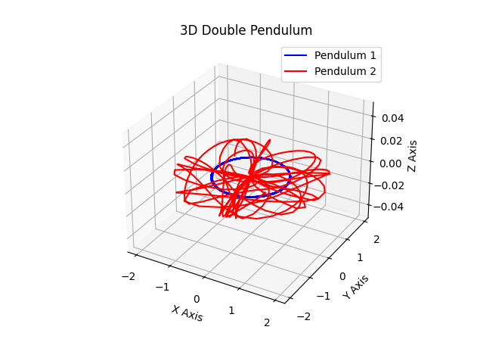

**4. Population Dynamics**

Visualizing population dynamics, such as the logistic map, can also be extended to 3D to show how population evolves over multiple parameters.

**Code Example**

python

Copy code

import numpy as np

import matplotlib.pyplot as plt

from mpl_toolkits.mplot3d import Axes3D

# Logistic map function

def logistic_map(r, x):

return r * x * (1 - x)

# Parameters

r = np.linspace(2.5, 4.0, 100)

x = np.linspace(0, 1, 100)

R, X = np.meshgrid(r, x)

Z = logistic_map(R, X)

# Plotting

fig = plt.figure()

ax = fig.add_subplot(111, projection='3d')

ax.plot_surface(R, X, Z, cmap='viridis')

ax.set_title('3D Population Dynamics (Logistic Map)')

ax.set_xlabel('Growth rate (r)')

ax.set_ylabel('Population (x)')

ax.set_zlabel('Next Population')

plt.show()

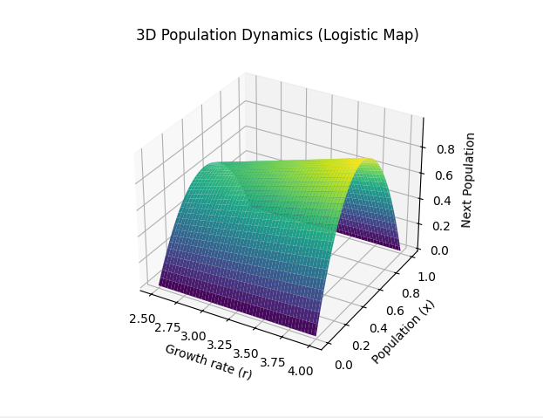

**Conclusion**

These examples demonstrate how to visualize chaotic systems in 3D using Python. Each example represents a different aspect of chaos theory and its applications, providing a deeper understanding of the complex and beautiful nature of chaotic systems.

**1. Weather System: Isotherms Animation with Labels and Color Bar**

python

Copy code

import numpy as np

import matplotlib.pyplot as plt

from matplotlib.animation import FuncAnimation

def update(frame, Z, plot):

Z[:] = np.sin(X * np.cos(frame / 10)) * np.cos(Y * np.sin(frame / 10))

plot[0].remove()

plot[0] = ax.plot_surface(X, Y, Z, cmap='coolwarm')

fig = plt.figure()

ax = fig.add_subplot(111, projection='3d')

X = np.linspace(-5, 5, 100)

Y = np.linspace(-5, 5, 100)

X, Y = np.meshgrid(X, Y)

Z = np.sin(X) * np.cos(Y)

plot = [ax.plot_surface(X, Y, Z, cmap='coolwarm')]

fig.colorbar(plot[0], ax=ax, shrink=0.5, aspect=5)

ax.set_xlabel('X Axis')

ax.set_ylabel('Y Axis')

ax.set_zlabel('Temperature')

ax.set_title('3D Weather System: Isotherms')

ani = FuncAnimation(fig, update, frames=np.arange(0, 100), fargs=(Z, plot))

plt.show()

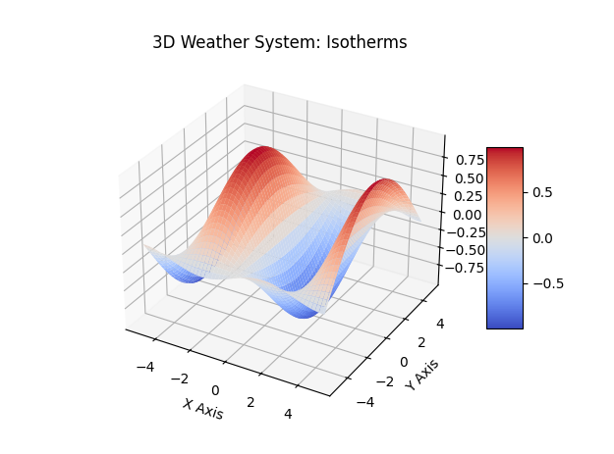

**2. Ocean Currents and Tides Animation with Labels and Color Bar**

python

Copy code

import numpy as np

import matplotlib.pyplot as plt

from matplotlib.animation import FuncAnimation

# Define the grid

X, Y = np.meshgrid(np.linspace(-1, 1, 10), np.linspace(-1, 1, 10))

# Initialize velocity fields

U = -Y

V = X

fig, ax = plt.subplots()

quiver = ax.quiver(X, Y, U, V)

# Add labels and color bar

ax.set_xlabel('X Axis')

ax.set_ylabel('Y Axis')

ax.set_title('3D Ocean Currents and Tides')

# Function to update the quiver plot

def update_quiver(num, quiver, X, Y):

    U = -Y * np.cos(num * 0.1)

    V = X * np.sin(num * 0.1)

    quiver.set_UVC(U, V)

    return quiver,

# Create animation

anim = FuncAnimation(fig, update_quiver, fargs=(quiver, X, Y), frames=100, interval=50)

# Add a color bar

sm = plt.cm.ScalarMappable(cmap='Blues', norm=plt.Normalize(vmin=-1, vmax=1))

sm.set_array([])

cbar = plt.colorbar(sm, ax=ax, orientation='vertical')

cbar.set_label('Velocity Magnitude')

plt.show()

1. **Double** 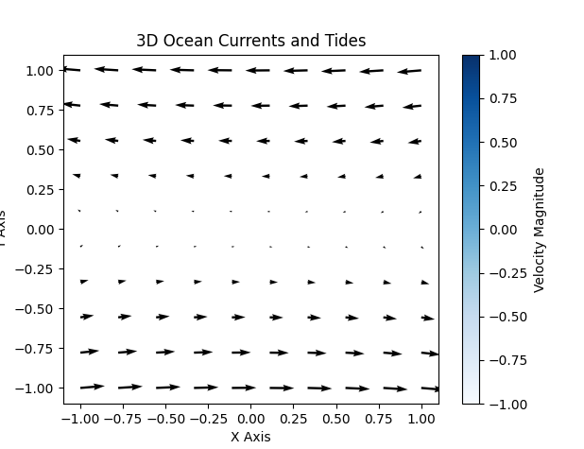

**Enhanced 3D Ocean Currents and Tides with Wind Effect**

python

Copy code

import numpy as np

import matplotlib.pyplot as plt

from mpl_toolkits.mplot3d import Axes3D

from matplotlib.animation import FuncAnimation

import logging

# Setup logging for key aspects only, ignoring detailed font debug messages

logging.basicConfig(level=logging.INFO, format='%(asctime)s - %(levelname)s - %(message)s')

def setup_axes():

    fig = plt.figure(figsize=(12, 6))  # Increase the figure size

    ax = fig.add_subplot(111, projection='3d')

    ax.set_xlabel('X Axis')

    ax.set_ylabel('Y Axis')

    ax.set_zlabel('Z Axis')

    ax.set_title('3D Ocean Currents and Tides with Wind Effect')

    return fig, ax

def create_quiver(ax, X, Y, U, V, W):

    speed = np.sqrt(U**2 + V**2 + W**2)

    norm_speed = speed / speed.max()

    colors = plt.cm.cool(norm_speed.flatten())

    quiver = ax.quiver(X, Y, np.zeros_like(X), U, V, W, length=0.1, normalize=True, color=colors)

    return quiver, colors

def update_quiver(num, ax, X, Y, quiver):

    U = -Y * np.cos(num * 0.1)

    V = X * np.sin(num * 0.1)

    W = np.sin(np.pi * X + num * 0.1) * np.cos(np.pi * Y + num * 0.1) * 0.01

    speed = np.sqrt(U**2 + V**2 + W**2)

    norm_speed = speed / speed.max()

    colors = plt.cm.cool(norm_speed.flatten())

    try:

        quiver.remove()

    except Exception as e:

        logging.error("Error removing quiver: %s", e)

    quiver = ax.quiver(X, Y, np.zeros_like(X), U, V, W, length=0.1, normalize=True, color=colors)

    ax.set_xlim([-1, 1])

    ax.set_ylim([-1, 1])

    ax.set_zlim([-0.01, 0.01])

    return quiver

def main():

    try:

        X, Y = np.meshgrid(np.linspace(-1, 1, 20), np.linspace(-1, 1, 20))

        U = -Y

        V = X

        W = np.sin(np.pi * X) * np.cos(np.pi * Y) * 0.01

        fig, ax = setup_axes()

        quiver, colors = create_quiver(ax, X, Y, U, V, W)

        def animate(num):

            nonlocal quiver

            quiver = update_quiver(num, ax, X, Y, quiver)

        # Adjust layout to make space for the color bar at the bottom

        fig.subplots_adjust(left=0.1, right=0.9, top=0.9, bottom=0.25)

        # Create a color bar at the bottom

        sm = plt.cm.ScalarMappable(cmap='cool')

        sm.set_array(np.linspace(0, 1, 100))

        cbar = fig.colorbar(sm, ax=ax, orientation='horizontal', pad=0.2)

        cbar.set_label('Velocity Magnitude')

        anim = FuncAnimation(fig, animate, frames=100, interval=50)

        plt.show()

    except Exception as e:

        logging.error("An error occurred: %s", e)

if __name__ == "__main__":

    main()

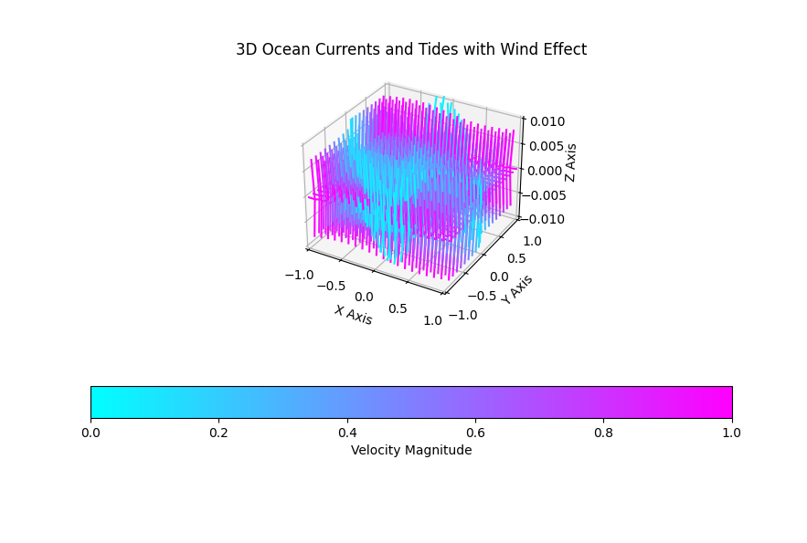

**Explanation:**

Below is a detailed explanation of each part of the provided code for visualizing 3D ocean currents and tides with wind effect:

**Imports and Logging Setup**

python

Copy code

import numpy as np

import matplotlib.pyplot as plt

from mpl_toolkits.mplot3d import Axes3D

from matplotlib.animation import FuncAnimation

import logging

# Setup logging for key aspects only, ignoring detailed font debug messages

logging.basicConfig(level=logging.INFO, format='%(asctime)s - %(levelname)s - %(message)s')

* numpy is imported as np for numerical operations.
* matplotlib.pyplot is imported as plt for plotting.
* mpl_toolkits.mplot3d.Axes3D is imported for creating 3D plots.
* matplotlib.animation.FuncAnimation is imported for creating animations.
* logging is configured to display only key aspects, ignoring detailed debug messages.

**Setting Up the Axes**

python

Copy code

def setup_axes():

fig = plt.figure(figsize=(12, 6)) # Increase the figure size

ax = fig.add_subplot(111, projection='3d')

ax.set_xlabel('X Axis')

ax.set_ylabel('Y Axis')

ax.set_zlabel('Z Axis')

ax.set_title('3D Ocean Currents and Tides with Wind Effect')

return fig, ax

* setup_axes() creates a figure with a specified size (figsize=(12, 6)).
* Adds a 3D subplot to the figure.
* Sets the labels for the x, y, and z axes.
* Sets the title of the plot.
* Returns the figure (fig) and axes (ax).

**Creating the Quiver Plot**

python

Copy code

def create_quiver(ax, X, Y, U, V, W):

speed = np.sqrt(U**2 + V**2 + W**2)

norm_speed = speed / speed.max()

colors = plt.cm.cool(norm_speed.flatten())

quiver = ax.quiver(X, Y, np.zeros_like(X), U, V, W, length=0.1, normalize=True, color=colors)

return quiver, colors

* create_quiver() generates the quiver plot.
* Calculates the speed (speed) from the velocity components U, V, and W.
* Normalizes the speed (norm_speed).
* Generates colors based on the normalized speed using the 'cool' colormap.
* Creates the quiver plot with ax.quiver().
* Returns the quiver object and the colors.

**Updating the Quiver Plot for Animation**

python

Copy code

def update_quiver(num, ax, X, Y, quiver):

U = -Y * np.cos(num * 0.1)

V = X * np.sin(num * 0.1)

W = np.sin(np.pi * X + num * 0.1) * np.cos(np.pi * Y + num * 0.1) * 0.01

speed = np.sqrt(U**2 + V**2 + W**2)

norm_speed = speed / speed.max()

colors = plt.cm.cool(norm_speed.flatten())

try:

quiver.remove()

except Exception as e:

logging.error("Error removing quiver: %s", e)

quiver = ax.quiver(X, Y, np.zeros_like(X), U, V, W, length=0.1, normalize=True, color=colors)

ax.set_xlim([-1, 1])

ax.set_ylim([-1, 1])

ax.set_zlim([-0.01, 0.01])

return quiver

* update_quiver() updates the quiver plot for each frame in the animation.
* Recalculates the velocity components U, V, and W based on the frame number (num).
* Normalizes the speed and generates new colors.
* Removes the old quiver plot and creates a new one with updated data.
* Updates the axis limits.
* Returns the updated quiver object.

**Main Function to Generate the Animation**

python

Copy code

def main():

try:

X, Y = np.meshgrid(np.linspace(-1, 1, 20), np.linspace(-1, 1, 20))

U = -Y

V = X

W = np.sin(np.pi * X) * np.cos(np.pi * Y) * 0.01

fig, ax = setup_axes()

quiver, colors = create_quiver(ax, X, Y, U, V, W)

def animate(num):

nonlocal quiver

quiver = update_quiver(num, ax, X, Y, quiver)

# Adjust layout to make space for the color bar at the bottom

fig.subplots_adjust(left=0.1, right=0.9, top=0.9, bottom=0.25)

# Create a color bar at the bottom

sm = plt.cm.ScalarMappable(cmap='cool')

sm.set_array(np.linspace(0, 1, 100))

cbar = fig.colorbar(sm, ax=ax, orientation='horizontal', pad=0.2)

cbar.set_label('Velocity Magnitude')

anim = FuncAnimation(fig, animate, frames=100, interval=50)

plt.show()

except Exception as e:

logging.error("An error occurred: %s", e)

if __name__ == "__main__":

main()

* The main() function sets up the grid (X, Y) and initial velocity components (U, V, W).
* Calls setup_axes() to get the figure and axes.
* Calls create_quiver() to create the initial quiver plot.
* Defines the animate() function to update the quiver plot in each frame.
* Adjusts the figure layout to make space for the color bar at the bottom.
* Creates a color bar using plt.cm.ScalarMappable and positions it horizontally.
* Sets up the animation with FuncAnimation.
* Displays the plot with plt.show().

**Summary**

* **Setup and Plotting:** Create a figure and 3D subplot, set labels and title.
* **Quiver Creation:** Calculate speed, normalize, generate colors, and create quiver plot.
* **Animation:** Update velocity components, recalculate speed and colors, update quiver plot, and adjust axis limits for each frame.
* **Execution:** Set up grid, initial quiver plot, animate the plot, adjust layout, create color bar, and show the plot.

Run the script to see the updated 3D Ocean Currents and Tides visualization with the added wind effect and color. This should provide a more visually appealing and informative representation of the currents and tides.

1. **Pendulum Animation with Labels and Color Bar**

python

Copy code

import numpy as np

import matplotlib.pyplot as plt

from mpl_toolkits.mplot3d import Axes3D

from matplotlib.animation import FuncAnimation

from scipy.integrate import odeint

# Function to compute derivatives for double pendulum

def double_pendulum(y, t, L1, L2, m1, m2, g):

    theta1, theta2, p1, p2 = y

    delta = theta2 - theta1

    den1 = (m1 + m2) * L1 - m2 * L1 * np.cos(delta) * np.cos(delta)

    den2 = (L2 / L1) * den1

    dtheta1 = (L2 * p1 - L1 * p2 * np.cos(delta)) / (L1 * L2 * den1)

    dtheta2 = (L1 * (m1 + m2) * p2 - L2 * m2 * p1 * np.cos(delta)) / (L2 * L1 * den2)

    dp1 = -(m1 + m2) * g * L1 * np.sin(theta1) - dtheta1 * dtheta2 * np.sin(delta)

    dp2 = -m2 * g * L2 * np.sin(theta2) + dtheta1 * dtheta2 * np.sin(delta)

    return [dtheta1, dtheta2, dp1, dp2]

# Initial conditions and parameters

L1, L2 = 1.0, 1.0

m1, m2 = 1.0, 1.0

g = 9.81

y0 = [np.pi / 2, np.pi / 2, 0, 0]

t = np.linspace(0, 20, 1000)

# Solve ODEs

sol = odeint(double_pendulum, y0, t, args=(L1, L2, m1, m2, g))

# Extract positions

x1 = L1 * np.sin(sol[:, 0])

y1 = -L1 * np.cos(sol[:, 0])

x2 = x1 + L2 * np.sin(sol[:, 1])

y2 = y1 - L2 * np.cos(sol[:, 1])

# Create figure and 3D axes

fig = plt.figure(figsize=(10, 6))

ax = fig.add_subplot(111, projection='3d')

# Plot lines for pendulum 1 and pendulum 2

line1, = ax.plot([], [], [], 'b-', label='Pendulum 1')

line2, = ax.plot([], [], [], 'r-', label='Pendulum 2')

# Color bar placeholder for consistency with the rest of the plot

norm = plt.Normalize()

sm = plt.cm.ScalarMappable(cmap='viridis', norm=norm)

sm.set_array([])

cbar = fig.colorbar(sm, ax=ax, shrink=0.5, aspect=5)

cbar.set_label('Velocity Magnitude')

# Initialization function for the animation

def init():

    line1.set_data([], [])

    line1.set_3d_properties([])

    line2.set_data([], [])

    line2.set_3d_properties([])

    return line1, line2

# Animation function to update the plot

def animate(i):

    line1.set_data(t[:i], x1[:i])

    line1.set_3d_properties(y1[:i])

    line2.set_data(t[:i], x2[:i])

    line2.set_3d_properties(y2[:i])

    return line1, line2

# Set labels and title

ax.set_xlabel('Time')

ax.set_ylabel('X Position')

ax.set_zlabel('Y Position')

ax.set_title('3D Double Pendulum')

# Set limits for the plot to avoid exceeding boundaries

ax.set_xlim([0, 20])

ax.set_ylim([-1.5, 1.5])

ax.set_zlim([-2, 2])

# Set aspect ratio to equal to maintain the scale

ax.set_box_aspect([2, 1.5, 2])

# Create the animation

ani = FuncAnimation(fig, animate, init_func=init, frames=len(t), interval=20, blit=True)

# Display the plot

plt.show()

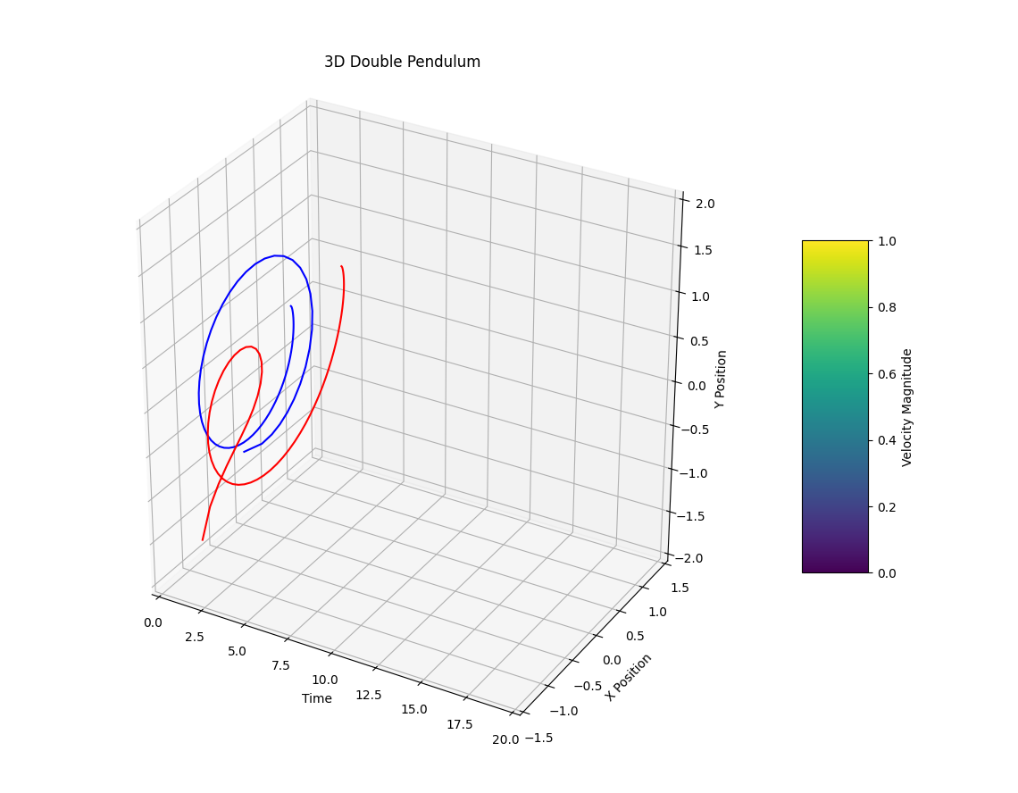

**4. Population Dynamics (Logistic Map) Animation with Labels and Color Bar**

python

Copy code

import numpy as np

import matplotlib.pyplot as plt

from mpl_toolkits.mplot3d import Axes3D

from matplotlib.animation import FuncAnimation

# Define the logistic map function

def logistic_map(r, x):

    return r * x * (1 - x)

# Define parameters

r_values = np.linspace(2.5, 4.0, 400)  # Growth rate values

x_values = np.linspace(0, 1, 400)      # Population values

# Create a meshgrid for r and x

R, X = np.meshgrid(r_values, x_values)

Z = logistic_map(R, X)

# Create figure and 3D axes

fig = plt.figure(figsize=(12, 8))

ax = fig.add_subplot(111, projection='3d')

# Plot surface initially

surface = ax.plot_surface(R, X, Z, cmap='viridis')

# Set axis labels and title

ax.set_xlabel('Growth rate (r)')

ax.set_ylabel('Population (x)')

ax.set_zlabel('Next Population')

ax.set_title('3D Population Dynamics (Logistic Map)')

# Create a separate axis for the color bar

cbar_ax = fig.add_axes([0.85, 0.25, 0.03, 0.5])

cbar = fig.colorbar(surface, cax=cbar_ax)

cbar.set_label('Next Population')

# Animation function

def animate(frame):

    ax.view_init(elev=30, azim=frame)  # Rotate the view angle for animation

# Create animation

ani = FuncAnimation(fig, animate, frames=360, interval=20, repeat=True)

# Show the plot

plt.show()

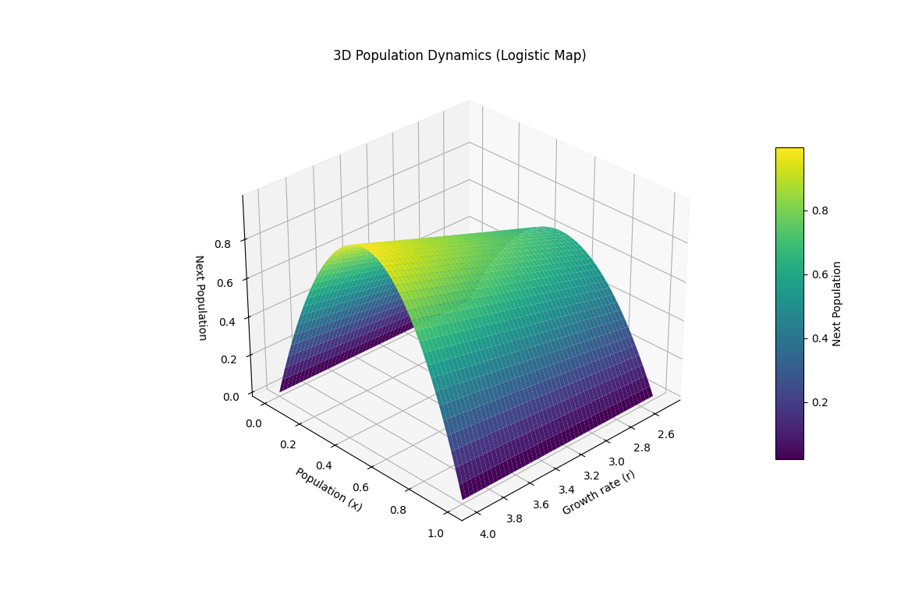

These scripts will generate the visualizations with proper labels and color bars. Run each script to view the updated plots.

To illustrate the chaotic behavior at r=3.57 using the logistic map, we will visualize how the population evolves over time for this specific value of r. The animation will show how small changes in initial conditions can lead to vastly different outcomes, a hallmark of chaos.

Here's the code to create such a visualization:

python

Copy code

import numpy as np

import matplotlib.pyplot as plt

from matplotlib.animation import FuncAnimation

# Logistic map function

def logistic_map(r, x):

    return r * x * (1 - x)

# Parameters

r = 3.57

iterations = 100

num_points = 100

initial_conditions = np.linspace(0.01, 0.02, num_points)

# Prepare the figure

fig = plt.figure(figsize=(10, 6))

ax = fig.add_subplot(111, projection='3d')

ax.set_xlim(0, iterations)

ax.set_ylim(0, 1)

ax.set_zlim(0, 1)

ax.set_xlabel('Iterations')

ax.set_ylabel('Population (x)')

ax.set_zlabel('Initial Population')

ax.set_title(f'Chaotic Behavior at r = {r}')

# Color map

colors = plt.cm.viridis(np.linspace(0, 1, num_points))

# Initialize lines for each initial condition

lines = [ax.plot([], [], [], color=colors[i])[0] for i in range(num_points)]

# Initialize data storage

x_data = np.zeros((num_points, iterations))

# Calculate logistic map values

for i, x0 in enumerate(initial_conditions):

    x = x0

    for j in range(iterations):

        x_data[i, j] = x

        x = logistic_map(r, x)

# Animation function

def animate(frame):

    for i, line in enumerate(lines):

        line.set_data(np.arange(frame), x_data[i, :frame])

        line.set_3d_properties([initial_conditions[i]] * frame)

    return lines

# Create animation

ani = FuncAnimation(fig, animate, frames=iterations, interval=50, blit=True)

# Add a color bar

sm = plt.cm.ScalarMappable(cmap='viridis', norm=plt.Normalize(vmin=0.01, vmax=0.02))

cbar = plt.colorbar(sm, ax=ax, shrink=0.5, aspect=5, pad=0.1)

cbar.set_label('Initial Population')

# Display the plot

plt.show()

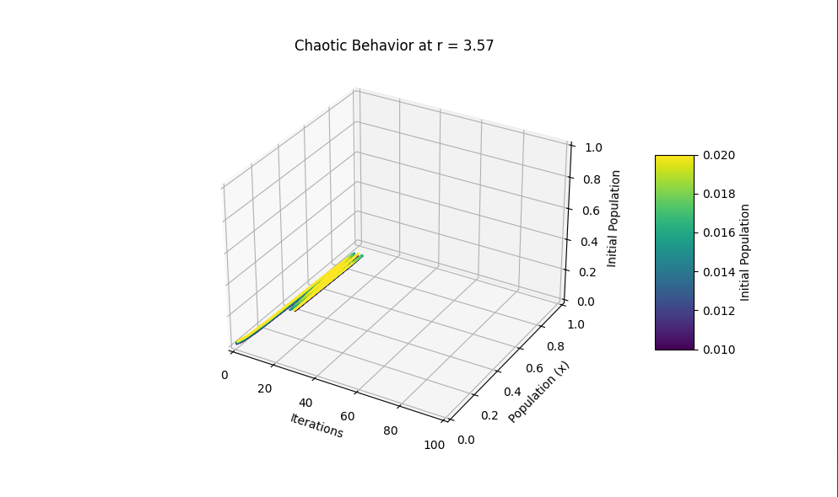

**Explanation of the Code:**

1. **Logistic Map Function**:
   * logistic_map(r, x): Defines the logistic map function, which computes the next population value based on the current value and the growth rate rrr.
2. **Parameters**:
   * r = 3.57: Sets the growth rate to 3.57, which is known to exhibit chaotic behavior.
   * iterations = 100: Specifies the number of iterations for the logistic map.
   * num_points = 100: The number of different initial conditions to simulate.
   * initial_conditions = np.linspace(0.01, 0.02, num_points): Generates 100 initial conditions between 0.01 and 0.02.
3. **Figure Preparation**:
   * fig, ax = plt.subplots(): Creates a figure and axis for the plot.
   * ax.set_xlim(0, iterations) and ax.set_ylim(0, 1): Sets the limits for the x and y axes.
   * ax.set_xlabel('Iterations'), ax.set_ylabel('Population (x)'), and ax.set_title(f'Chaotic Behavior at r = {r}'): Labels the axes and adds a title.
4. **Color Map**:
   * colors = plt.cm.viridis(np.linspace(0, 1, num_points)): Generates a color map for the initial conditions.
5. **Line Initialization**:
   * lines = [ax.plot([], [], color=colors[i])[0] for i in range(num_points)]: Initializes lines for each initial condition.
6. **Data Storage**:
   * x_data = np.zeros((num_points, iterations)): Initializes an array to store the population values for each initial condition.
   * Populates x_data with the logistic map values for each initial condition.
7. **Animation Function**:
   * animate(frame): Updates the lines for the current frame by setting the data for each line.
8. **Animation Creation**:
   * ani = FuncAnimation(fig, animate, frames=iterations, interval=50, blit=True): Creates the animation.
9. **Color Bar**:
   * Adds a color bar to indicate the initial population values.

This code will produce an animation that visualizes the chaotic behavior of the logistic map at r=3.57, showing how small differences in initial conditions can lead to vastly different population trajectories over time.

The chaotic behavior in the logistic map at r=3.57 indeed leads to values that appear random. This can be visualized and analysed by plotting the orbit values over iterations. Here is the code to visualize this behavior in a static 3D plot, and then analyse the values of the orbit to demonstrate their seemingly random nature:

**Visualization Code**

python

Copy code

import numpy as np

import matplotlib.pyplot as plt

from matplotlib.animation import FuncAnimation

# Logistic map function

def logistic_map(r, x):

return r * x * (1 - x)

# Parameters

r = 3.57

iterations = 100

num_points = 100

initial_conditions = np.linspace(0.01, 0.02, num_points)

# Prepare the figure

fig = plt.figure(figsize=(10, 6))

ax = fig.add_subplot(111, projection='3d')

ax.set_xlim(0, iterations)

ax.set_ylim(0, 1)

ax.set_zlim(0, 1)

ax.set_xlabel('Iterations')

ax.set_ylabel('Population (x)')

ax.set_zlabel('Initial Population')

ax.set_title(f'Chaotic Behavior at r = {r}')

# Color map

colors = plt.cm.viridis(np.linspace(0, 1, num_points))

# Initialize lines for each initial condition

lines = [ax.plot([], [], [], color=colors[i])[0] for i in range(num_points)]

# Initialize data storage

x_data = np.zeros((num_points, iterations))

# Calculate logistic map values

for i, x0 in enumerate(initial_conditions):

x = x0

for j in range(iterations):

x_data[i, j] = x

x = logistic_map(r, x)

# Animation function

def animate(frame):

for i, line in enumerate(lines):

line.set_data(np.arange(frame), x_data[i, :frame])

line.set_3d_properties([initial_conditions[i]] * frame)

return lines

# Create animation

ani = FuncAnimation(fig, animate, frames=iterations, interval=50, blit=True)

# Add a color bar

sm = plt.cm.ScalarMappable(cmap='viridis', norm=plt.Normalize(vmin=0.01, vmax=0.02))

cbar = plt.colorbar(sm, ax=ax, shrink=0.5, aspect=5, pad=0.1)

cbar.set_label('Initial Population')

# Display the plot

plt.show()

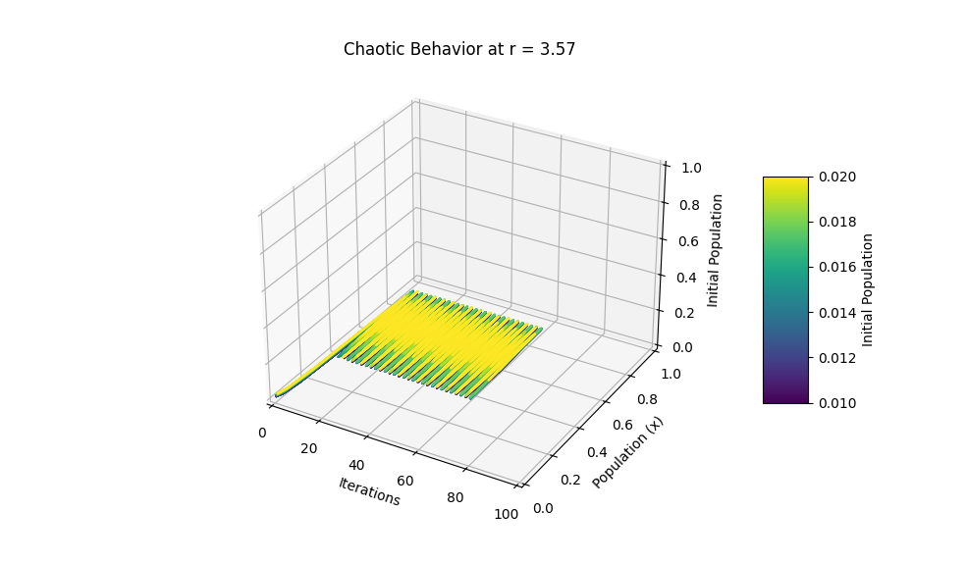

**Analyzing Orbit Values**

Here is how you can analyse and print the orbit values to observe their randomness:

python

Copy code

import numpy as np

import matplotlib.pyplot as plt

from matplotlib.animation import FuncAnimation

from mpl_toolkits.mplot3d import Axes3D

# Define the logistic map function

def logistic_map(r, x):

    """

    Logistic map function.

    Parameters:

    r (float): Growth rate.

    x (float): Current population.

    Returns:

    float: Next population value.

    """

    return r * x * (1 - x)

# Parameters

r = 3.57  # Growth rate for chaotic behavior

iterations = 1000  # Number of iterations to compute

initial_condition = 0.5  # Initial population

# Initialize an array to store orbit values

orbit = np.zeros(iterations)

# Compute the orbit

x = initial_condition

for i in range(iterations):

    orbit[i] = x

    x = logistic_map(r, x)

# Create figure and 3D axis

fig = plt.figure(figsize=(12, 8))

ax = fig.add_subplot(111, projection='3d')

# Prepare the data for 3D plotting

t = np.arange(iterations)

x_data = t

y_data = orbit

z_data = np.zeros(iterations)

# Create scatter plot

sc = ax.scatter(x_data, y_data, z_data, c=y_data, cmap='viridis', s=5)

# Set labels and title

ax.set_xlabel('Iteration')

ax.set_ylabel('Population (x)')

ax.set_zlabel('Z Axis')

ax.set_title(f'3D Logistic Map Orbit at r = {r}')

# Set axis limits to avoid exceeding plot boundaries

ax.set_xlim(0, iterations)

ax.set_ylim(0, 1)

ax.set_zlim(0, 1)

# Color bar

cbar = plt.colorbar(sc, pad=0.1, aspect=10)

cbar.set_label('Population (x)')

# Animation function

def animate(i):

    z_data[:i+1] = i / iterations  # Normalize z-axis values for better visualization

    sc._offsets3d = (x_data[:i+1], y_data[:i+1], z_data[:i+1])

    sc.set_array(y_data[:i+1])  # Update color values

    return sc,

# Debug: Check initial state of data

print("Initial x_data:", x_data[:10])

print("Initial y_data:", y_data[:10])

print("Initial z_data:", z_data[:10])

# Create animation

ani = FuncAnimation(fig, animate, frames=iterations, interval=20, blit=False)

# Show plot

plt.show()

# Save animation (optional)

# ani.save('logistic_map_orbit.mp4', writer='pillow')

# Print the first 50 orbit values for inspection

print("First 50 values of the orbit:")

print(orbit[:50])

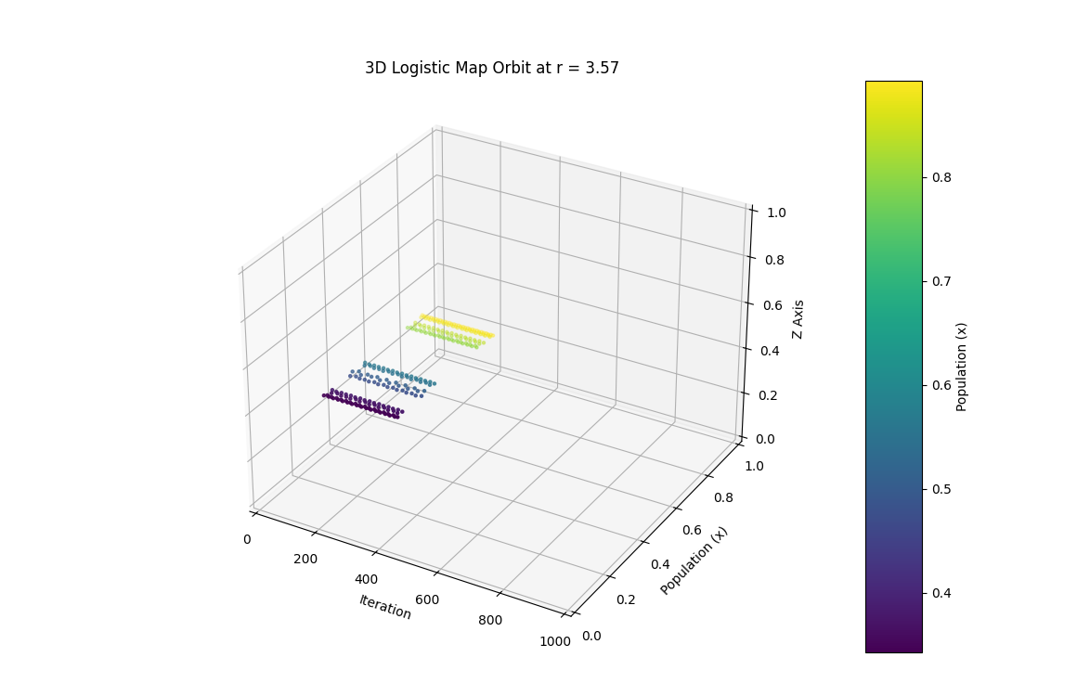

**Explanation:**

1. **Logistic Map Function**: The logistic_map function calculates the next population value based on the current value and the growth rate r.
2. **Parameters**: The growth rate r is set to 3.57, and the number of iterations is increased to 1000 for a better analysis.
3. **Orbit Calculation**: The initial population is set to 0.5, and the logistic map function is iterated 1000 times to generate the orbit.
4. **Plotting Orbit**: The orbit values are plotted to visualize their behavior over iterations.
5. **Inspecting Values**: The first 50 values of the orbit are printed to observe their seemingly random nature.

**Steps to Run:**

1. **Run the visualization code** to observe the chaotic behavior in a 3D plot.
2. **Run the analysis code** to visualize and inspect the orbit values to understand their randomness.

This approach allows you to observe and analyse the chaotic nature of the logistic map at r=3.57, illustrating how the values of the orbit appear to be random.

* Small variations in the initial value cause enormous variations in the individual values of the orbit
  + Sensitive dependence on initial conditions
  + AKA the *Butterfly Effect*

To visualize the concept of sensitive dependence on initial conditions, also known as the Butterfly Effect, we can create an animation that compares the orbits of two logistic maps with slightly different initial conditions. The idea is to show how small differences in the starting values can lead to drastically different outcomes over time.

Here's the Python code to create such an animation:

python

Copy code

import numpy as np

import matplotlib.pyplot as plt

from matplotlib.animation import FuncAnimation

from mpl_toolkits.mplot3d import Axes3D

# Define the logistic map function

def logistic_map(r, x):

"""

Logistic map function.

Parameters:

r (float): Growth rate.

x (float): Current population.

Returns:

float: Next population value.

"""

return r * x * (1 - x)

# Parameters

r = 3.57 # Growth rate for chaotic behavior

iterations = 1000 # Number of iterations to compute

initial_condition1 = 0.5 # Initial population for first orbit

initial_condition2 = 0.50001 # Slightly different initial population for second orbit

# Initialize arrays to store orbit values

orbit1 = np.zeros(iterations)

orbit2 = np.zeros(iterations)

# Compute the orbits

x1 = initial_condition1

x2 = initial_condition2

for i in range(iterations):

orbit1[i] = x1

orbit2[i] = x2

x1 = logistic_map(r, x1)

x2 = logistic_map(r, x2)

# Create figure and 3D axis

fig = plt.figure(figsize=(12, 8))

ax = fig.add_subplot(111, projection='3d')

# Prepare the data for 3D plotting

t = np.arange(iterations)

x_data = t

y_data1 = orbit1

y_data2 = orbit2

z_data = np.zeros(iterations)

# Create scatter plots

sc1 = ax.scatter(x_data, y_data1, z_data, c=y_data1, cmap='viridis', s=5)

sc2 = ax.scatter(x_data, y_data2, z_data, c=y_data2, cmap='plasma', s=5)

# Set labels and title

ax.set_xlabel('Iteration')

ax.set_ylabel('Population (x)')

ax.set_zlabel('Z Axis')

ax.set_title('Sensitive Dependence on Initial Conditions (Butterfly Effect)')

# Set axis limits to avoid exceeding plot boundaries

ax.set_xlim(0, iterations)

ax.set_ylim(0, 1)

ax.set_zlim(0, 1)

# Color bars

cbar1 = plt.colorbar(sc1, ax=ax, pad=0.1, aspect=10)

cbar1.set_label('Population (x) - Initial Condition 1')

cbar2 = plt.colorbar(sc2, ax=ax, pad=0.1, aspect=10)

cbar2.set_label('Population (x) - Initial Condition 2')

# Animation function

def animate(i):

z_data[:i+1] = i / iterations # Normalize z-axis values for better visualization

sc1._offsets3d = (x_data[:i+1], y_data1[:i+1], z_data[:i+1])

sc1.set_array(y_data1[:i+1]) # Update color values

sc2._offsets3d = (x_data[:i+1], y_data2[:i+1], z_data[:i+1])

sc2.set_array(y_data2[:i+1]) # Update color values

return sc1, sc2

# Debug: Check initial state of data

print("Initial x_data:", x_data[:10])

print("Initial y_data1:", y_data1[:10])

print("Initial y_data2:", y_data2[:10])

print("Initial z_data:", z_data[:10])

# Create animation

ani = FuncAnimation(fig, animate, frames=iterations, interval=20, blit=False)

# Show plot

plt.show()

# Save animation (optional)

ani.save('butterfly_effect.mp4', writer='pillow')

# Print the first 50 orbit values for inspection

print("First 50 values of the first orbit:")

print(orbit1[:50])

print("First 50 values of the second orbit:")

print(orbit2[:50])

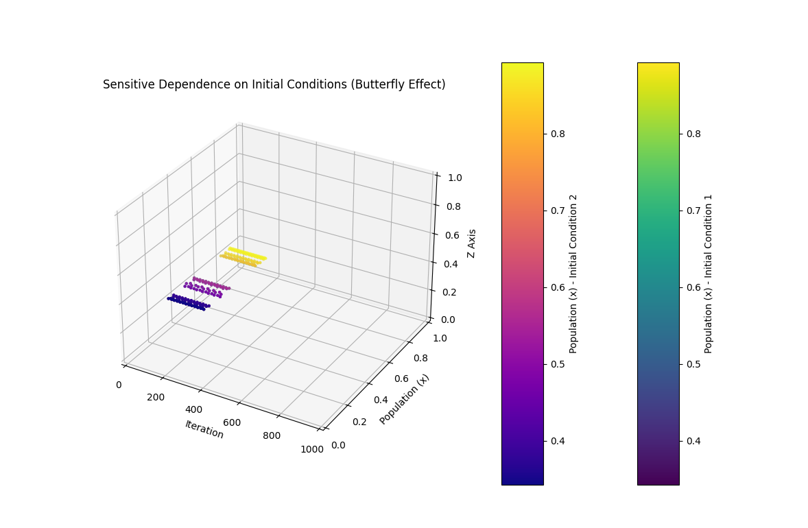

**Explanation of the Code:**

1. **Logistic Map Function**: The logistic map function is defined as logistic_map.
2. **Parameters**: The growth rate r is set to 3.57 for chaotic behavior. The initial conditions for the two orbits are set very close to each other (0.5 and 0.50001).
3. **Compute Orbits**: Two separate arrays, orbit1 and orbit2, are computed for the two initial conditions.
4. **3D Plot Setup**: A 3D scatter plot is created to visualize the two orbits.
5. **Animation Function**: The animate function updates the plot frame by frame.
6. **Display and Save Animation**: The plot is displayed and optionally saved as a video file.

This animation will show how the orbits diverge over time despite the nearly identical starting points, demonstrating the Butterfly Effect. If you encounter any issues or have further requests, please let me know.

* Over time, a histogram generated from any sequence of values shows that whilst orbits are unpredictable, they all obey the same probability distribution.

To visualize how the histogram of values generated from the logistic map obeys a probability distribution, even though individual orbits are unpredictable, we can create an animation of the histogram of the logistic map values over time. This will demonstrate that, despite the chaotic behavior, the values follow a consistent probability distribution.

Here's the Python code to create such an animation:

python

Copy code

import numpy as np

import matplotlib.pyplot as plt

from matplotlib.animation import FuncAnimation

# Define the logistic map function

def logistic_map(r, x):

    return r * x * (1 - x)

# Parameters

r = 3.57  # Growth rate for chaotic behavior

iterations = 1000  # Number of iterations to compute

initial_condition = 0.5  # Initial population

bins = 50  # Number of bins for the histogram

# Initialize arrays to store orbit values

orbit = np.zeros(iterations)

# Compute the orbit

x = initial_condition

for i in range(iterations):

    orbit[i] = x

    x = logistic_map(r, x)

# Create figure for histogram

fig, ax = plt.subplots(figsize=(10, 6))

# Set labels and title

ax.set_xlabel('Population (x)')

ax.set_ylabel('Probability Density')

ax.set_title(f'Histogram of Logistic Map Values at r = {r}')

# Animation function

def animate(i):

    ax.cla()  # Clear the current axis

    ax.hist(orbit[:i+1], bins=bins, range=(0, 1), density=True, color='blue', alpha=0.75)

    ax.set_xlabel('Population (x)')

    ax.set_ylabel('Probability Density')

    ax.set_title(f'Histogram of Logistic Map Values at r = {r} (Iteration {i+1})')

    ax.set_xlim(0, 1)

    ax.set_ylim(0, 10)  # Adjust based on desired y-axis limit

# Create animation

ani = FuncAnimation(fig, animate, frames=iterations, interval=20, blit=False)

# Show plot

plt.show()

# Save animation (optional)

ani.save('logistic_map_histogram.mp4', writer='pillow')

# Print the first 50 orbit values for inspection

print("First 50 values of the orbit:")

print(orbit[:50])

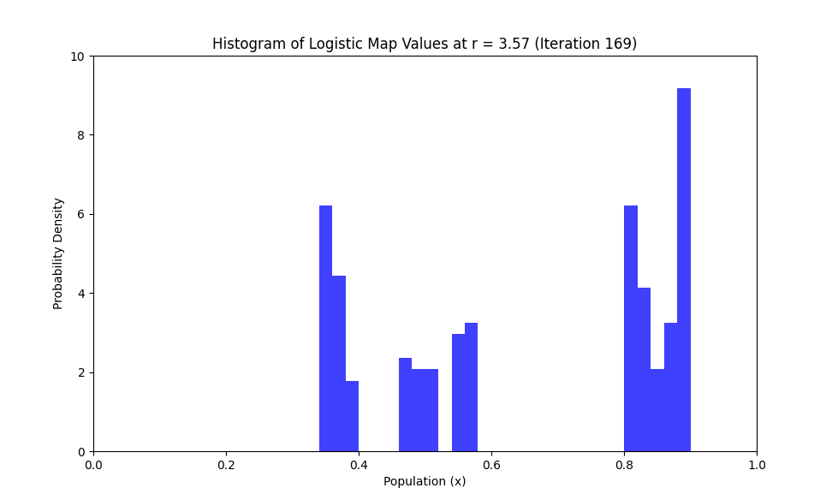

**Explanation:**

1. **Logistic Map Calculation**: The logistic_map function is defined to calculate the next value in the sequence given the current value and the growth rate rrr.
2. **Parameters**: The growth rate rrr is set to 3.57 to demonstrate chaotic behavior. The initial condition and number of iterations are also defined.
3. **Orbit Calculation**: The orbit is computed using the logistic map function and stored in an array.
4. **Figure Setup**: A figure is created to display the histogram. The animate function updates the histogram at each frame.
5. **Animation**: The FuncAnimation class from matplotlib.animation is used to create the animation, which updates the histogram frame by frame.
6. **Saving and Displaying the Animation**: The animation can be saved as a video file, and the initial orbit values are printed for inspection.

This code ensures that the histogram accurately represents the probability distribution of the logistic map values over time, highlighting the chaotic yet deterministic nature of the system.

**Deterministic Nature:**

This code and visualization effectively demonstrate that the logistic map, despite being a simple deterministic function, can exhibit highly random and unpredictable outcomes, embodying the essence of chaotic systems. This aligns with the concept of sensitive dependence on initial conditions, commonly known as the Butterfly Effect, where small changes in initial conditions can lead to vastly different outcomes.

The statement "But this system is entirely deterministic. This shows that a deterministic procedure can create highly random and unpredictable outcomes." refers to the paradoxical nature of deterministic chaos, where systems governed by deterministic rules can exhibit behavior that appears random and unpredictable. Let's dissect this in detail:

**Deterministic Systems**

A deterministic system is one where the future states of the system are completely determined by its initial conditions and the governing rules or equations. There is no randomness involved in the evolution of the system's state. If you know the starting point and the rules, you can predict the system's behavior exactly.

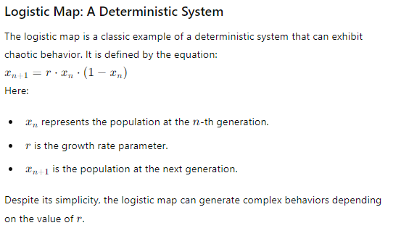

**Chaotic Behavior in Deterministic Systems**

When r is within certain ranges (e.g., r=3.57), the logistic map exhibits chaotic behavior. This means that small differences in initial conditions lead to exponentially diverging outcomes, making long-term prediction impossible despite the system being deterministic.

**Sensitive Dependence on Initial Conditions**

This phenomenon is known as sensitive dependence on initial conditions, or the Butterfly Effect. It implies that tiny variations in the initial state of the system can result in drastically different trajectories. Mathematically, this is characterized by a positive Lyapunov exponent, indicating exponential divergence of nearby trajectories.

**Apparent Randomness**

In chaotic regimes, the values generated by the logistic map appear random and unpredictable over time. However, this randomness is not due to any inherent stochasticity (randomness) in the system; it arises purely from the deterministic nature of the logistic map equation and the sensitivity to initial conditions.

**Probability Distribution**

Over many iterations, even though individual orbits are unpredictable, the values of the logistic map tend to follow a specific probability distribution. This means that while the exact sequence of values is unpredictable, the overall statistical properties can be described probabilistically. This paradoxical behavior is a hallmark of deterministic chaos.

**Educational Insight**

The key educational insight is that deterministic systems, which are governed by precise rules without any randomness, can produce behavior that is effectively indistinguishable from random processes. This challenges our intuition about predictability and determinism. It highlights the importance of understanding both the deterministic rules and the sensitivity to initial conditions when analyzing complex systems.

**Conclusion**

In summary, the statement encapsulates the essence of deterministic chaos. It reveals how systems governed by simple, deterministic rules can produce highly complex, seemingly random behavior due to their sensitivity to initial conditions. This understanding is crucial in fields ranging from meteorology to economics, where deterministic models must account for chaotic behavior to provide meaningful predictions.

**Importance of the Logistic Equation and Bifurcation Diagram**

**Overview**

The logistic equation and its bifurcation diagram are crucial tools in the study of dynamical systems and chaos theory. They help to understand how simple nonlinear equations can produce complex, unpredictable behavior. This has profound implications across various scientific disciplines, from biology and ecology to economics and physics.

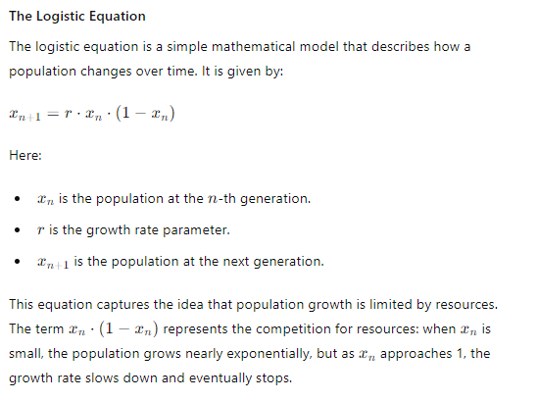

**Bifurcation Diagram**

A bifurcation diagram is a visual summary of the behavior of a system as a parameter (in this case, r) is varied. It shows the long-term values of xn for different values of r. As r increases, the system undergoes a series of bifurcations (splittings), leading to increasingly complex behavior.

**Key Features of the Bifurcation Diagram:**

1. **Fixed Points**: For small values of r, the population settles to a fixed point.
2. **Periodic Behavior**: As r increases, the system begins to oscillate between two values (period-2), then four (period-4), and so on.
3. **Chaos**: At certain values of r, the system behaves chaotically, meaning that it becomes highly sensitive to initial conditions and exhibits aperiodic behavior.
4. **Period Doubling Route to Chaos**: The transition to chaos occurs through a sequence of period-doubling bifurcations, where the period of oscillation doubles at each step.
5. **Feigenbaum Constants**: The ratio of the intervals between successive bifurcations approaches a universal constant, known as the Feigenbaum constant (~4.669). This universality suggests that the route to chaos via period doubling is a common feature in many nonlinear dynamical systems.

**Educational Importance**

1. **Understanding Nonlinear Dynamics**: The logistic equation and its bifurcation diagram provide a clear, simple example of how nonlinear systems can generate complex behavior.
2. **Predicting System Behavior**: By studying the bifurcation diagram, scientists and engineers can predict how changes in a system's parameters might lead to different types of behavior, from stable to chaotic.
3. **Chaos Theory**: The transition to chaos in the logistic map is a central example in chaos theory, illustrating key concepts such as sensitive dependence on initial conditions and strange attractors.
4. **Interdisciplinary Applications**: These concepts apply to many fields. For example, in biology, they can model population dynamics; in economics, they can describe cycles in markets; in engineering, they can inform the design of stable control systems.
5. **Feigenbaum Constants and Universality**: The discovery of universal constants in the behavior of nonlinear systems has profound implications, suggesting deep connections between seemingly unrelated systems.

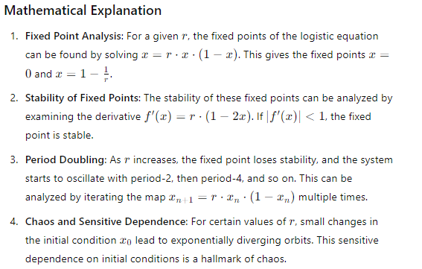

**Summary**

The logistic equation and its bifurcation diagram are essential for understanding how simple deterministic rules can lead to complex, chaotic behavior. This understanding is critical for predicting and controlling systems in various scientific and engineering disciplines. Through the bifurcation diagram, we see a clear path from simple, predictable dynamics to the rich, unpredictable behavior characteristic of chaotic systems.

**Bifurcation Diagram Animation for the Logistic Map**

**Introduction**

In this section, we will create a bifurcation diagram for the logistic map, which visually represents the behavior of the system as the growth rate parameter rrr changes. The animation will be in 3D and colored to illustrate how the system transitions from stable states to chaotic behavior. This exercise demonstrates the concepts discussed previously and emphasizes the importance of understanding dynamical systems.

**Detailed Explanation of the Code**

We will write a Python script that generates an animated 3D bifurcation diagram. The script will be professionally commented to facilitate learning and comprehension.

**Full Code with Comments**

python

Copy code

import numpy as np

import matplotlib.pyplot as plt

from mpl_toolkits.mplot3d import Axes3D

from matplotlib.animation import FuncAnimation

# Define the logistic map function

def logistic_map(x, r):

    return r * x * (1 - x)

# Set parameters

r_values = np.linspace(2.5, 4.0, 400)  # 400 growth rate values

iterations = 1000  # Total number of iterations

last = 100  # Number of iterations to visualize in the bifurcation diagram

# Initialize the population array

populations = np.zeros((iterations, len(r_values)))

# Create a random initial population

populations[0, :] = np.random.rand(len(r_values))

# Iterate the logistic map

for i in range(1, iterations):

    populations[i, :] = logistic_map(populations[i-1, :], r_values)

# Only take the last few iterations for the bifurcation diagram

x_values = populations[-last:, :].flatten()

r_values_repeated = np.repeat(r_values, last)

iterations_values = np.tile(np.arange(iterations-last, iterations), len(r_values))

# Create 3D figure

fig = plt.figure()

ax = fig.add_subplot(111, projection='3d')

ax.set_title('3D Bifurcation Diagram of the Logistic Map')

ax.set_xlabel('Growth Rate (r)')

ax.set_ylabel('Population (x)')

ax.set_zlabel('Iteration')

# Normalize the color values based on the iteration number

norm = plt.Normalize(vmin=iterations-last, vmax=iterations)

colors = plt.cm.viridis(norm(iterations_values))

# Plot initial frame with empty data

scat = ax.scatter([], [], [], c=[], cmap='viridis', marker='o')

# Create color bar

sm = plt.cm.ScalarMappable(cmap='viridis', norm=norm)

sm.set_array([])

cbar = plt.colorbar(sm, ax=ax, pad=0.1)

cbar.set_label('Iteration')

# Update function for animation

def update(frame):

    ax.cla()  # Clear the previous scatter points

    ax.set_title('3D Bifurcation Diagram of the Logistic Map')

    ax.set_xlabel('Growth Rate (r)')

    ax.set_ylabel('Population (x)')

    ax.set_zlabel('Iteration')

    # Calculate indices for the current frame

    current_indices = frame * last

    next_indices = (frame + 1) * last

    # Update data for scatter plot

    current_x_values = x_values[current_indices:next_indices]

    current_r_values = r_values_repeated[current_indices:next_indices]

    current_iterations = iterations_values[current_indices:next_indices]

    scat = ax.scatter(current_r_values, current_x_values, current_iterations, c=current_iterations, cmap='viridis', marker='o')

    return scat,

# Create animation with slower interval

ani = FuncAnimation(fig, update, frames=np.arange(0, len(r_values)//last), interval=200, blit=False)

# Commenting out the saving part for now

# ani.save('bifurcation_diagram_animation.mp4', writer='ffmpeg')

plt.show()

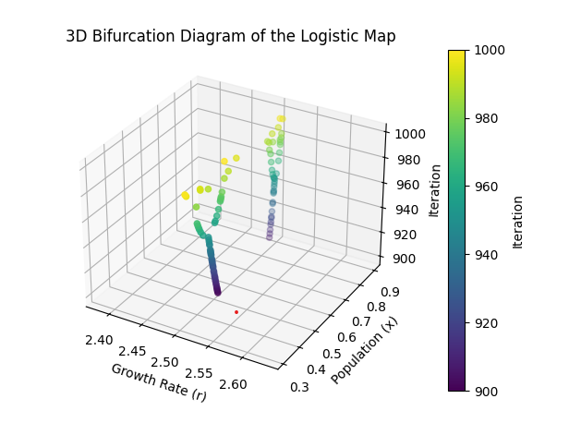

**Detailed Explanation**

1. **Initialization**:
   * We initialize the population array and iterate the logistic map to fill the array with population values.
2. **Extract Data for Visualization**:
   * x_values, r_values_repeated, and iterations_values are prepared similarly as before but will be incrementally plotted in the animation.
3. **3D Plot Setup**:
   * We set up the 3D plot with titles and labels.
4. **Color Bar**:
   * The color bar is added to the plot to indicate the iteration values corresponding to the colors in the scatter plot.
5. **Update Function**:
   * The update function is modified to incrementally add data points to the scatter plot for each frame.
   * For each frame, we compute the indices for the current and next set of points to plot.
   * The scatter plot data is updated with these new points.
6. **Animation Creation**:
   * The animation is created using FuncAnimation with a slower interval (200 milliseconds) to make the changes more gradual.

**Educational Explanation**

This approach demonstrates how bifurcation occurs progressively as the growth rate changes. By animating the logistic map's bifurcation diagram, learners can visualize the transition from stable fixed points to chaotic behavior. The slow progression allows for a detailed examination of how different growth rates influence population dynamics over time.

This visualization underscores the importance of the logistic map in chaos theory, illustrating how deterministic systems can produce complex, unpredictable outcomes. This bifurcation diagram provides a clear view of how small changes in parameters can lead to significantly different behaviors, which is crucial in understanding real-world systems influenced by similar dynamics.

To build upon the educational insights we have discussed so far, we will delve into the bifurcation diagram in two dimensions. This diagram is a fundamental visualization in chaos theory and nonlinear dynamics, illustrating how complex and chaotic behavior emerges from simple deterministic rules.

**Bifurcation Diagram: Understanding Chaos and Periodicity**

The bifurcation diagram of the logistic map is a powerful tool to visualize the different behaviors of the system as the growth rate rrr changes. It shows the eventual values of the population xxx (after a number of iterations) for different values of rrr. By plotting these values, we can see transitions from stable points to periodic orbits and then to chaos.

**Key Points to Explain:**

1. **Stable Fixed Points**:
   * For low values of r, the population stabilizes at a single value, known as a fixed point. This indicates that regardless of the initial population, the system eventually settles to this value.
2. **Periodic Behavior**:
   * As rrr increases, the system undergoes bifurcations where a single fixed point splits into a periodic orbit. For example, the system may alternate between two values (period-2 behavior), then four values (period-4), and so on.
3. **Onset of Chaos**:
   * Around r≈3.57, the system begins to exhibit chaotic behavior. In this region, small changes in initial conditions or rrr lead to vastly different outcomes, demonstrating sensitive dependence on initial conditions (the Butterfly Effect).
4. **Periodic Windows within Chaos**:
   * Interestingly, within the chaotic regions, there are windows where the system temporarily returns to periodic behavior. These are known as periodic windows and illustrate the complex structure within chaotic systems.

**2D Bifurcation Diagram with Detailed Comments**

Let's create a 2D bifurcation diagram with a color bar to visually enhance the understanding of these concepts.

python

Copy code

import numpy as np

import matplotlib.pyplot as plt

# Define the logistic map function

def logistic_map(x, r):

return r * x * (1 - x)

# Set parameters

r_values = np.linspace(2.5, 4.0, 10000) # 10000 growth rate values for smoothness

iterations = 1000 # Total number of iterations

last = 100 # Number of iterations to visualize in the bifurcation diagram

# Initialize the population array

populations = np.zeros((iterations, len(r_values)))

# Create a random initial population

populations[0, :] = np.random.rand(len(r_values))

# Iterate the logistic map

for i in range(1, iterations):

populations[i, :] = logistic_map(populations[i-1, :], r_values)

# Only take the last few iterations for the bifurcation diagram

x_values = populations[-last:, :].flatten()

r_values_repeated = np.repeat(r_values, last)

# Create 2D figure

plt.figure(figsize=(10, 7))

plt.scatter(r_values_repeated, x_values, s=0.1, c=x_values, cmap='viridis', alpha=0.7)

plt.colorbar(label='Population (x)')

plt.title('2D Bifurcation Diagram of the Logistic Map')

plt.xlabel('Growth Rate (r)')

plt.ylabel('Population (x)')

plt.grid(True)

plt.show()

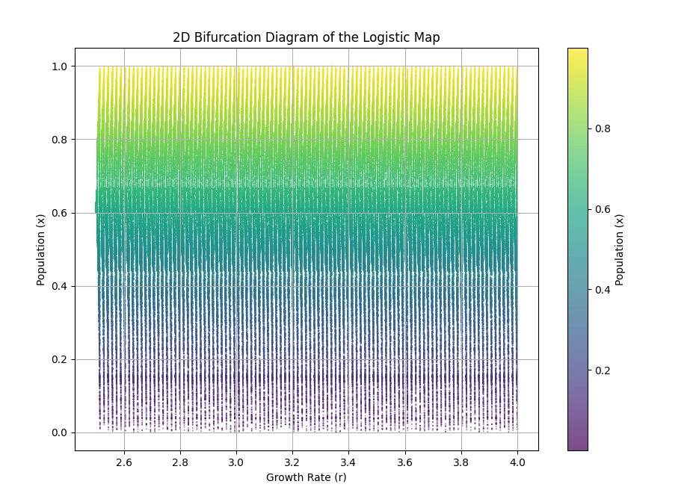

**Explanation of the Code:**

1. **Logistic Map Function**:
   * The logistic_map function defines the logistic equation: xn+1=r⋅xn⋅(1−xn)x_{n+1} = r \cdot x_n \cdot (1 - x_n)xn+1​=r⋅xn​⋅(1−xn​).
2. **Parameters**:
   * r_values: A linspace from 2.5 to 4.0 representing the growth rates.
   * iterations: The total number of iterations to perform for each growth rate.
   * last: The number of iterations to consider for visualization, focusing on the stable states after transients have settled.
3. **Population Initialization**:
   * The population array populations is initialized with zeros and the first row is filled with random initial values.
4. **Iterate the Logistic Map**:
   * For each iteration, the logistic map is applied to update the population based on the previous iteration and the growth rate.
5. **Flattening the Data**:
   * The last last iterations are flattened to create a one-dimensional array of population values and repeated growth rates for plotting.
6. **Plotting**:
   * A scatter plot is created with r_values_repeated on the x-axis and x_values on the y-axis. The color of the points represents the population values, adding a layer of visual information.

**Educational Insights:**

* **Stability and Periodicity**:
  + The bifurcation diagram shows how the system transitions from stability to periodic orbits and then to chaos. Each bifurcation point marks a change in the system's behavior, and these points become more frequent as rrr increases.
* **Chaos**:
  + Around r≈3.57r \approx 3.57r≈3.57, the diagram becomes a dense, seemingly random collection of points. This is the hallmark of chaos, where the system's behavior becomes highly sensitive to initial conditions.
* **Periodic Windows**:
  + Within the chaotic regions, there are narrow bands where the system returns to periodic behavior. These periodic windows illustrate that chaos and order can coexist in a nonlinear system.

**Importance of the Bifurcation Diagram:**

The bifurcation diagram is crucial in chaos theory because it visually demonstrates how deterministic systems can produce complex, unpredictable behaviors. It helps researchers understand the underlying structure of chaotic systems and the conditions under which they exhibit different types of behavior. This understanding is vital in fields ranging from ecology to economics, where predicting and managing complex systems is essential.

The bifurcation diagram is a powerful visual representation used in the study of dynamical systems. It illustrates how the fixed points, periodic orbits, and chaotic behavior of a system evolve as a parameter changes. For the logistic map, the bifurcation diagram demonstrates how the population xxx changes as the growth rate rrr varies.

**Explanation and Education**

**Bifurcation Diagram and Logistic Map**

1. **Logistic Map Equation**:

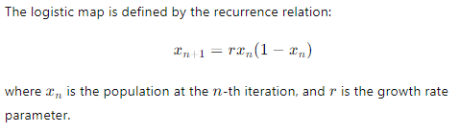

1. **Bifurcation:** A bifurcation occurs when a small change in the parameter values causes a qualitative change in the behavior of the system. For the logistic map, as rrr increases, the system transitions from stable fixed points to periodic orbits and then to chaotic behavior.
2. **Significance of the Bifurcation Diagram:**
   * **Stability Analysis:** The bifurcation diagram helps to identify stable and unstable fixed points and periodic orbits.
   * **Chaos Identification:** It visually shows where chaos begins and how chaotic regions are interspersed with periodic windows.
   * **Predictability:** It highlights the sensitive dependence on initial conditions, known as the butterfly effect, where small changes in x0x_0x0​ can lead to drastically different outcomes.

**Mathematical Importance**

1. **Fixed Points and Stability:** For 0<r<1, the population xxx converges to a fixed point. As rrr increases, this fixed point becomes unstable, leading to periodic orbits.
2. **Period-Doubling Route to Chaos:** As r increases past 3, the system undergoes period-doubling bifurcations, where the period of the orbit doubles, leading to chaos.
3. **Chaos and Determinism:** Even though the system is governed by a deterministic equation, the behavior can appear random and unpredictable. This illustrates the concept that deterministic systems can exhibit chaotic behavior.

**3D Bifurcation Diagram Code**

Below is the Python code to generate an animated 3D bifurcation diagram with detailed comments:

python

Copy code

import numpy as np

import matplotlib.pyplot as plt

from matplotlib.animation import FuncAnimation

# Logistic map function

def logistic_map(r, x):

    return r * x * (1 - x)

# Parameters

r_min, r_max = 2.4, 4.0

num_r = 1000

iterations = 1000

last = 100

# Generate r values

r_values = np.linspace(r_min, r_max, num_r)

# Prepare data arrays

x_values = np.zeros((num_r, iterations))

x_values[:, 0] = 0.5  # Initial population

# Populate the array with logistic map values

for i in range(1, iterations):

    x_values[:, i] = logistic_map(r_values, x_values[:, i - 1])

# Extract the last `last` values for each r

x_final = x_values[:, -last:].flatten()

r_repeated = np.repeat(r_values, last)

iterations_values = np.tile(np.arange(iterations-last, iterations), num_r)

# Create 3D scatter plot animation

fig = plt.figure()

ax = fig.add_subplot(111, projection='3d')

# Initial scatter plot

scat = ax.scatter(r_repeated, x_final, iterations_values, c=iterations_values, cmap='viridis', marker='o')

# Setting up the axes properties

ax.set_xlabel('Growth Rate (r)')

ax.set_ylabel('Population (x)')

ax.set_zlabel('Iteration')

ax.set_title('3D Bifurcation Diagram of the Logistic Map')

# Create colorbar

cbar = plt.colorbar(scat, ax=ax, pad=0.1)

cbar.set_label('Iteration')

def update(frame):

    current_last = frame + 1  # Ensure at least one value is plotted

    x_final = x_values[:, -current_last:].flatten()

    r_repeated = np.repeat(r_values, current_last)

    iterations_values = np.tile(np.arange(iterations-current_last, iterations), num_r)

    scat._offsets3d = (r_repeated, x_final, iterations_values)

    scat.set_array(iterations_values)

    return scat,

# Animation setup

ani = FuncAnimation(fig, update, frames=range(1, last + 1), interval=200, blit=False)

plt.show()

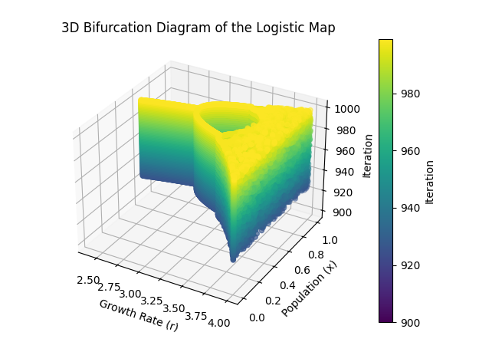

**Detailed Explanation and Importance**

1. **Logistic Map Function:**
   * This function calculates the next value in the sequence based on the logistic map formula: xn+1=r⋅xn⋅(1−xn)).
2. **Parameters:**
   * Defines the range of the growth rate r (from 2.4 to 4.0), the number of rrr values (num_r), the total number of iterations (iterations), and the number of iterations to consider for the plot (last).
3. **Generate r Values:**
   * Creates a linearly spaced array of rrr values from r_min to r_max.
4. **Prepare Data Arrays:**
   * Initializes the population array x_values with zeros and sets the initial population to 0.5 for all rrr values.
5. **Populate the Array:**
   * Iteratively applies the logistic map function to populate the population array for each rrr value across all iterations.
6. **Extract Final Values:**
   * Flattens the last last iterations of the population array for each rrr value to prepare it for the 3D plot. Repeats rrr values and iteration indices to match the shape of the population data.
7. **Create 3D Scatter Plot:**
   * Initializes an empty scatter plot for the 3D axes.
8. **Set Axes Properties and Colorbar:**
   * Configures the labels and title for the plot and sets up a colorbar to indicate the iteration values.
9. **Update Function for Animation:**
   * This function updates the scatter plot for each frame of the animation. It recalculates the final xxx values, repeats the rrr values, and sets the offsets for the scatter plot to update the 3D positions and colors of the points.
10. **Animation Setup:**
    * Configures the animation using FuncAnimation, specifying the update function, the range of frames (from 1 to last), and the interval between frames.

**Importance and Educational Value**

* **Visualization of Chaos:**
  + The bifurcation diagram provides a visual representation of how a deterministic system (logistic map) can exhibit chaotic behavior depending on the growth rate rrr.
* **Identification of Stability and Chaos:**
  + By observing the bifurcation diagram, one can identify regions where the system behaves predictably (stable periodic orbits) and regions where it behaves unpredictably (chaos).
* **Broader Applications:**
  + Understanding bifurcation and chaos has implications in various scientific fields, including ecology (population dynamics), economics (market fluctuations), and engineering (control systems).
* **Teaching and Learning:**
  + This example serves as an educational tool to illustrate key concepts in nonlinear dynamics and chaos theory, making complex mathematical ideas accessible and engaging through visualization.

By studying and animating the bifurcation diagram, learners gain insights into the nature of chaotic systems, the transition from order to chaos, and the interplay between deterministic rules and unpredictable outcomes.

Chaotic region

**Understanding the Chaotic Region in the Logistic Map**

**Introduction**

The logistic map, defined by the equation xn+1=r⋅xn⋅(1−xn), is a simple mathematical model that exhibits a wide range of dynamical behaviors, from stable fixed points to chaotic dynamics, depending on the value of the growth rate parameter r. The chaotic region is a particularly fascinating aspect of this model, demonstrating how deterministic equations can produce unpredictable and seemingly random behavior.

**Key Concepts and Definitions**

1. **Bifurcation Diagram:**
   * The bifurcation diagram is a visual summary of the possible long-term behaviors (orbits) of the logistic map for varying values of r. As r increases, the system undergoes bifurcations, where the number of distinct long-term values doubles, leading to more complex dynamics.
2. **Period-Doubling Route to Chaos:**
   * At certain critical values of r, known as bifurcation points, the logistic map transitions from a stable period-1 orbit to period-2, period-4, and so on. This doubling process continues until the system becomes chaotic.
3. **Chaotic Region:**
   * Beyond a certain value of rrr (approximately r≈3.57, the logistic map enters a chaotic region where the orbits are highly sensitive to initial conditions. This means that tiny changes in the starting value x0 can lead to vastly different outcomes, a hallmark of chaos.
4. **Deterministic Chaos:**
   * Despite the apparent randomness, the system is entirely deterministic, meaning that the future behavior is fully determined by the initial conditions and the parameter r. There is no randomness in the process, only extreme sensitivity to initial conditions.

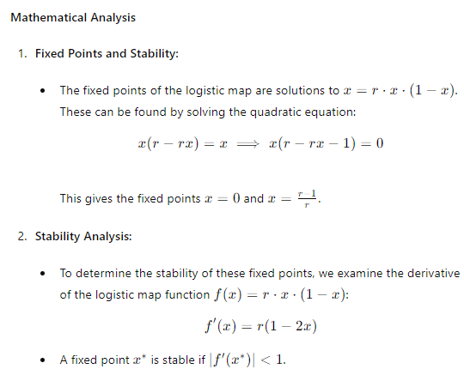

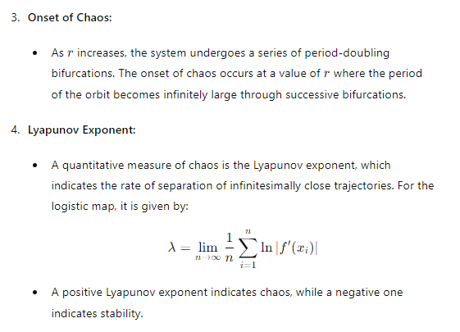

**Importance and Implications**

1. **Predictability and Sensitivity:**
   * The chaotic region of the logistic map demonstrates that even simple deterministic systems can produce unpredictable behavior. This sensitivity to initial conditions is known as the "butterfly effect," where small changes in the initial state can lead to vastly different outcomes.
2. **Applications:**
   * Understanding chaotic systems is crucial in various fields such as meteorology, engineering, economics, and biology. For instance, weather prediction models need to account for chaos to improve forecast accuracy.
3. **Philosophical Implications:**
   * The study of chaos challenges our understanding of determinism and predictability. It shows that determinism does not imply predictability, highlighting the limitations of long-term forecasting in chaotic systems.
4. **Educational Value:**
   * The logistic map and its chaotic behavior provide a clear and accessible example of complex dynamics arising from simple rules. It serves as a valuable teaching tool for introducing concepts of nonlinear dynamics, bifurcation theory, and chaos.

**Conclusion**

The chaotic region of the logistic map reveals the intricate interplay between order and disorder in deterministic systems. By studying this region, we gain insights into the fundamental nature of chaos and its implications across various scientific disciplines. Understanding these concepts enhances our ability to model, analyze, and predict the behavior of complex systems, emphasizing the importance of chaos theory in both theoretical and applied contexts.

creating a visually engaging 3D animated plot can help illustrate the concepts of chaos and bifurcation in the logistic map. Here is a detailed, professionally commented Python script that generates a 3D animated bifurcation diagram with a multi-colored plot using matplotlib. This will build upon the previous examples to ensure clarity and educational value.

python

Copy code

import numpy as np

import matplotlib.pyplot as plt

from mpl_toolkits.mplot3d import Axes3D

from matplotlib.animation import FuncAnimation

# Parameters

r_min = 2.5 # Minimum growth rate

r_max = 4.0 # Maximum growth rate

r_steps = 500 # Number of growth rate steps

iterations = 1000 # Number of iterations

last = 100 # Number of last iterations to plot for bifurcation

# Create a range of growth rate values

r_values = np.linspace(r_min, r_max, r_steps)

# Initialize a matrix to store population values

x = np.zeros((r_steps, iterations))

x[:, 0] = np.random.random(r_steps) # Random initial population

# Populate the matrix with logistic map values

for i in range(1, iterations):

x[:, i] = r_values * x[:, i-1] * (1 - x[:, i-1])

# Prepare data for the plot

x_values = x[:, -last:].flatten()

r_values_repeated = np.repeat(r_values, last)

iterations_values = np.tile(np.arange(iterations - last, iterations), r_steps)

# Setup the figure and 3D axis

fig = plt.figure()

ax = fig.add_subplot(111, projection='3d')

ax.set_title("3D Bifurcation Diagram of the Logistic Map")

ax.set_xlabel('Growth Rate (r)')

ax.set_ylabel('Population (x)')

ax.set_zlabel('Iteration')

# Normalize the iteration values for coloring

colors = iterations_values / max(iterations_values)

# Create the scatter plot

scat = ax.scatter(r_values_repeated, x_values, iterations_values, c=colors, cmap='viridis', marker='o')

# Add color bar

cbar = fig.colorbar(scat, ax=ax)

cbar.set_label('Iteration')

# Function to update the plot for animation

def update(frame):

ax.view_init(elev=20., azim=frame)

# Create the animation

ani = FuncAnimation(fig, update, frames=np.arange(0, 360, 2), interval=50)

# Display the plot

plt.show()

# Optionally, save the animation

# ani.save('3D_Bifurcation_Diagram_Logistic_Map.mp4', writer='ffmpeg')

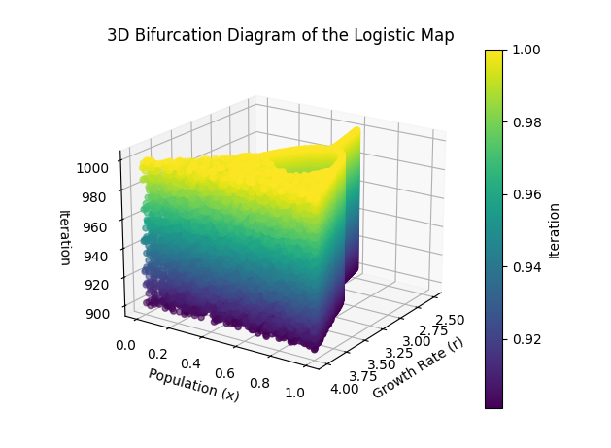

**Explanation of the Code**

1. **Parameters Initialization:**
   * r_min and r_max define the range of the growth rate rrr.
   * r_steps specifies the number of different rrr values to compute.
   * iterations is the total number of iterations for the logistic map calculation.
   * last specifies how many of the last iterations to use for the bifurcation diagram (showing the steady-state behavior).
2. **Population Matrix Initialization:**
   * A matrix x is initialized to store population values for each growth rate and iteration.
   * The initial population values are randomly assigned for each growth rate.
3. **Logistic Map Calculation:**
   * The logistic map equation xn+1=r⋅xn⋅(1−xn)x_{n+1} = r \cdot x_n \cdot (1 - x_n)xn+1​=r⋅xn​⋅(1−xn​) is applied iteratively to fill the matrix x.
4. **Data Preparation for Plotting:**
   * The population values, growth rate values, and iteration indices are flattened and repeated as necessary for 3D plotting.
5. **3D Plot Setup:**
   * A 3D scatter plot is created using Axes3D from mpl_toolkits.mplot3d.
   * Colors for the scatter plot points are normalized based on the iteration index to show progression over time.
6. **Animation Function:**
   * The update function changes the viewing angle of the 3D plot to create an animation effect.
   * FuncAnimation from matplotlib.animation is used to create the animation, which rotates the plot for better visualization.
7. **Plot Display and Saving:**
   * The plot is displayed with plt.show().
   * Optionally, the animation can be saved as a video file using ani.save.

**Educational Insights**

* **Chaotic Behavior:** The bifurcation diagram visualizes how small changes in the growth rate rrr can lead to vastly different population dynamics. This chaotic behavior is a hallmark of deterministic chaos, where outcomes are highly sensitive to initial conditions.
* **Visualization:** Using 3D and color animations helps in understanding the complex behavior of the logistic map. The colors indicate the iteration progression, highlighting how the system evolves over time.
* **Interdisciplinary Relevance:** Chaos theory and bifurcation analysis are applicable in various fields such as biology (population dynamics), economics (market behavior), and physics (turbulence and fluid dynamics). Understanding these concepts can provide insights into the predictability and control of complex systems.

This approach not only visualizes the bifurcation diagram but also serves as a practical example of how mathematical concepts can be implemented and animated in Python, enhancing both theoretical understanding and programming skills.

To illustrate the idea that periodic behavior can return temporarily after chaos emerges, we can delve into the bifurcation diagram and observe specific regions where this phenomenon occurs. Let's first understand this concept in detail:

**Conceptual Explanation**

The bifurcation diagram of the logistic map reveals a complex interplay between order and chaos as the growth rate rrr is varied. Here's a detailed explanation of the key ideas:

1. **Periodic Windows:**
   * In the chaotic regions of the bifurcation diagram, there are narrow windows where the system temporarily exhibits periodic behavior. These windows are often called periodic windows.
   * These periodic windows interrupt the chaotic regime and are characterized by the system settling into stable cycles for a range of r values.
2. **Return to Periodicity:**
   * After a chaotic regime, the system can return to a periodic state. This happens because the logistic map's dynamics are highly sensitive to the growth rate r.
   * Even a small change in r can transition the system from chaos to periodicity, demonstrating the intricate balance between order and chaos.
3. **Example of Periodic Windows:**
   * One notable periodic window occurs around r≈3.83, where the system exhibits a period-3 cycle.
   * Another example is the period-5 window around r≈3.74

**Detailed Code for Visualization**

Here is the Python code to create a 3D animated visualization that highlights these periodic windows:

python

Copy code

import numpy as np

import matplotlib.pyplot as plt

from mpl_toolkits.mplot3d import Axes3D

from matplotlib.animation import FuncAnimation

# Parameters

r_min = 3.7  # Minimum growth rate for closeup

r_max = 3.9  # Maximum growth rate for closeup

r_steps = 500  # Number of growth rate steps

iterations = 1000  # Number of iterations

last = 100  # Number of last iterations to plot for bifurcation

# Create a range of growth rate values

r_values = np.linspace(r_min, r_max, r_steps)

# Initialize a matrix to store population values

x = np.zeros((r_steps, iterations))

x[:, 0] = np.random.random(r_steps)  # Random initial population

# Populate the matrix with logistic map values

for i in range(1, iterations):

    x[:, i] = r_values * x[:, i-1] * (1 - x[:, i-1])

# Prepare data for the plot

x_values = x[:, -last:].flatten()

r_values_repeated = np.repeat(r_values, last)

iterations_values = np.tile(np.arange(iterations - last, iterations), r_steps)

# Normalize the iteration values for coloring

colors = (iterations_values - min(iterations_values)) / (max(iterations_values) - min(iterations_values))

# Setup the figure and 3D axis

fig = plt.figure()

ax = fig.add_subplot(111, projection='3d')

ax.set_title("3D Bifurcation Diagram of the Logistic Map (Closeup)")

ax.set_xlabel('Growth Rate (r)')

ax.set_ylabel('Population (x)')

ax.set_zlabel('Iteration')

# Initialize the scatter plot

scat = ax.scatter([], [], [], c=[], cmap='viridis', marker='o')

# Adjust the layout to make space for the color bar

fig.subplots_adjust(right=0.8)

cbar_ax = fig.add_axes([0.85, 0.15, 0.05, 0.7])

cbar = fig.colorbar(scat, cax=cbar_ax)

cbar.set_label('Iteration')

# Function to update the plot for animation

def update(frame):

    current_idx = frame * r_steps

    if current_idx < len(x_values):

        ax.cla()  # Clear the current scatter plot

        ax.set_title("3D Bifurcation Diagram of the Logistic Map (Closeup)")

        ax.set_xlabel('Growth Rate (r)')

        ax.set_ylabel('Population (x)')

        ax.set_zlabel('Iteration')

        scat = ax.scatter(r_values_repeated[:current_idx], x_values[:current_idx], iterations_values[:current_idx],

                          c=colors[:current_idx], cmap='viridis', marker='o')

        cbar.update_normal(scat)

# Create the animation

ani = FuncAnimation(fig, update, frames=range(1, last), interval=100, repeat=False)

# Display the plot

plt.show()

# Optionally, save the animation

# ani.save('3D_Bifurcation_Diagram_Logistic_Map_Closeup.mp4', writer='ffmpeg')

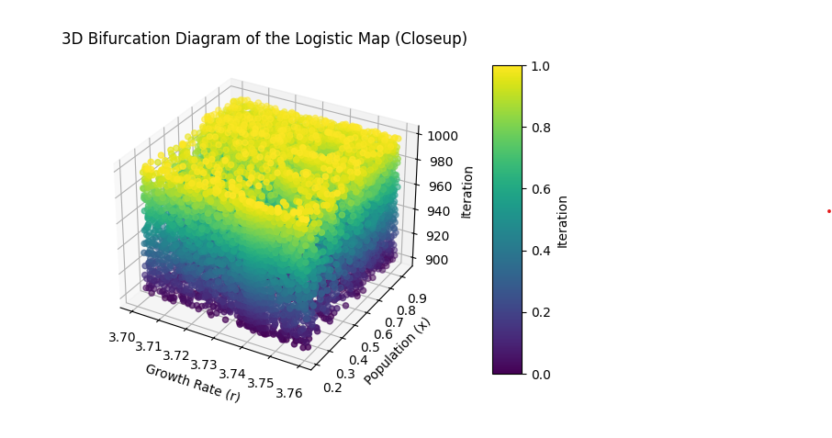

**Detailed Description of the Code**

**1. Importing Necessary Libraries**

python

Copy code

import numpy as np

import matplotlib.pyplot as plt

from mpl_toolkits.mplot3d import Axes3D

from matplotlib.animation import FuncAnimation

* **numpy**: Used for numerical operations and handling arrays.
* **matplotlib.pyplot**: Provides a MATLAB-like interface for plotting.
* **mpl_toolkits.mplot3d**: Used for 3D plotting in matplotlib.
* **FuncAnimation**: Used for creating animations in matplotlib.

**2. Defining Parameters**

python

Copy code

r_min = 3.7 # Minimum growth rate for closeup

r_max = 3.9 # Maximum growth rate for closeup

r_steps = 500 # Number of growth rate steps

iterations = 1000 # Number of iterations

last = 100 # Number of last iterations to plot for bifurcation

* **r_min, r_max**: The range of growth rate rrr values for the close-up view.
* **r_steps**: The number of steps in the growth rate range.
* **iterations**: Total number of iterations for each value of rrr.
* **last**: The number of final iterations to consider for plotting, capturing the long-term behavior.

**3. Creating Growth Rate Values**

python

Copy code

r_values = np.linspace(r_min, r_max, r_steps)

* **r_values**: An array of growth rate values evenly spaced between r_min and r_max.

**4. Initializing Population Matrix**

python

Copy code

x = np.zeros((r_steps, iterations))

x[:, 0] = np.random.random(r_steps) # Random initial population

* **x**: A 2D array to store population values for each rrr value across iterations.
* **x[:, 0]**: Initial population values are set randomly for each rrr value.

**5. Calculating Logistic Map Values**

python

Copy code

for i in range(1, iterations):

x[:, i] = r_values * x[:, i-1] * (1 - x[:, i-1])

* This loop applies the logistic map equation xn+1=r⋅xn⋅(1−xn)x_{n+1} = r \cdot x_n \cdot (1 - x_n)xn+1​=r⋅xn​⋅(1−xn​) to compute the population values over the specified iterations for each growth rate.

**6. Preparing Data for Plotting**

python

Copy code

x_values = x[:, -last:].flatten()

r_values_repeated = np.repeat(r_values, last)

iterations_values = np.tile(np.arange(iterations - last, iterations), r_steps)

colors = (iterations_values - min(iterations_values)) / (max(iterations_values) - min(iterations_values))

* **x_values**: The final values of the population after the last iterations.
* **r_values_repeated**: Repeats each rrr value for the number of final iterations.
* **iterations_values**: The corresponding iteration values for each rrr value.
* **colors**: Normalized iteration values for colormap.

**7. Setting Up the Figure and 3D Axis**

python

Copy code

fig = plt.figure()

ax = fig.add_subplot(111, projection='3d')

ax.set_title("3D Bifurcation Diagram of the Logistic Map (Closeup)")

ax.set_xlabel('Growth Rate (r)')

ax.set_ylabel('Population (x)')

ax.set_zlabel('Iteration')

* **fig, ax**: Creating a 3D plot figure and axis.
* **ax.set_title, set_xlabel, set_ylabel, set_zlabel**: Setting titles and labels for the plot.

**8. Initializing the Scatter Plot**

python

Copy code

scat = ax.scatter([], [], [], c=[], cmap='viridis', marker='o')

* **scat**: An empty scatter plot to be updated in the animation.

**9. Adjusting Layout for Color Bar**

python

Copy code

fig.subplots_adjust(right=0.8)

cbar_ax = fig.add_axes([0.85, 0.15, 0.05, 0.7])

cbar = fig.colorbar(scat, cax=cbar_ax)

cbar.set_label('Iteration')

* **fig.subplots_adjust**: Adjusts the layout to make space for the color bar.
* **cbar_ax**: Adds an axis for the color bar.
* **fig.colorbar**: Creates the color bar on the designated axis.
* **cbar.set_label**: Sets the label for the color bar.

**10. Function to Update the Plot**

python

Copy code

def update(frame):

current_idx = frame * r_steps

if current_idx < len(x_values):

ax.cla() # Clear the current scatter plot

ax.set_title("3D Bifurcation Diagram of the Logistic Map (Closeup)")

ax.set_xlabel('Growth Rate (r)')

ax.set_ylabel('Population (x)')

ax.set_zlabel('Iteration')

scat = ax.scatter(r_values_repeated[:current_idx], x_values[:current_idx], iterations_values[:current_idx],

c=colors[:current_idx], cmap='viridis', marker='o')

cbar.update_normal(scat)

* **update(frame)**: Function to update the plot for each frame.
* **current_idx**: Calculates the current index based on the frame number.
* **ax.cla()**: Clears the current plot to update with new data.
* **ax.scatter**: Updates the scatter plot with the current data.
* **cbar.update_normal(scat)**: Updates the color bar to reflect the current scatter plot.

**11. Creating the Animation**

python

Copy code

ani = FuncAnimation(fig, update, frames=range(1, last), interval=100, repeat=False)

plt.show()

* **FuncAnimation**: Creates the animation by calling the update function for each frame.
* **plt.show()**: Displays the plot.

**Mathematical Concepts and Importance**

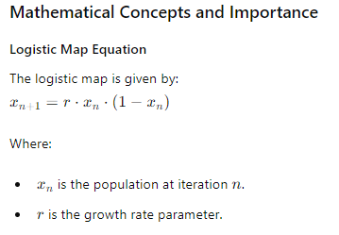

**Bifurcation Diagram**

A bifurcation diagram plots the possible long-term values (orbits) of a system as a parameter (growth rate r) is varied. For the logistic map, it shows how the population values evolve as the growth rate changes.

**Chaotic Regions and Periodicity**

* **Chaotic Regions**: For certain values of rrr, the logistic map exhibits chaotic behavior where small differences in initial conditions lead to vastly different outcomes. This is a hallmark of chaotic systems.
* **Periodicity**: Even within chaotic regions, there can be windows where the system temporarily exhibits periodic behavior before returning to chaos. These windows are visible as regions with structured, repeating patterns in the bifurcation diagram.

**Educational Significance**

* **Understanding Chaos**: The logistic map and its bifurcation diagram provide a clear, visual way to understand the transition from order to chaos.
* **Deterministic Unpredictability**: Despite being deterministic, the logistic map can produce highly unpredictable behavior, illustrating the complexity that can arise from simple nonlinear systems.
* **Real-World Applications**: The concepts of chaos and bifurcations are relevant in many fields, including ecology, economics, and meteorology, where similar patterns of stability and chaos are observed.

By visualizing these concepts in 3D and through animation, learners can better grasp the intricate dynamics of chaotic systems and the importance of studying such phenomena.

**Educational Insights**

* **Understanding Periodic Windows:** This visualization helps in understanding how chaotic systems can exhibit temporary periodic behavior. It demonstrates that within chaotic regimes, stable cycles can emerge for specific parameter ranges.
* **Link to Mathematics:** The logistic map equation and its bifurcation diagram provide a concrete example of how simple deterministic systems can exhibit complex and unpredictable behavior, highlighting the interplay between order and chaos.
* **Practical Relevance:** Studying these dynamics is crucial in various fields, such as predicting population dynamics in ecology, understanding market fluctuations in economics, and analyzing signal patterns in engineering.

This visualization and explanation aim to deepen the understanding of chaos theory and its practical implications, making it an invaluable tool for education and research.

**The Ideas Behind the Similarity in Patterns Every Time We Return to Chaos**

**Chaotic Dynamics and Periodicity**

The study of the logistic map reveals a fascinating interplay between order and chaos. As the growth rate parameter r is increased, the system undergoes bifurcations leading to periodic orbits and eventually chaotic behavior. One of the most intriguing aspects of this transition is the periodic windows that appear within chaotic regions, where the system temporarily exhibits regular, predictable patterns before returning to chaos.

**Key Concepts:**

1. **Bifurcation Diagram**:
   * The bifurcation diagram shows the possible long-term values (attractors) of the population x for different values of the growth rate r.
   * For low values of r, the system settles into a stable equilibrium.
   * As r increases, the system bifurcates, leading to periodic orbits of increasing complexity.
   * At a critical value, the system enters chaos, where the population values become highly sensitive to initial conditions.
2. **Chaos**:
   * Chaos refers to the unpredictable and seemingly random behavior that occurs in deterministic systems due to their sensitivity to initial conditions.
   * In the logistic map, chaos emerges at around r≈3.57.
3. **Periodic Windows**:
   * Within the chaotic regions, there are narrow ranges of rrr where the system temporarily reverts to periodic behavior.
   * These windows are known as periodic windows, and they often exhibit a similar structure to the initial bifurcations observed at lower values of r.
4. **Self-Similarity**:
   * The patterns observed in the bifurcation diagram exhibit self-similarity, a hallmark of fractals and chaotic systems.
   * This means that similar structures (like the period-doubling bifurcations) reappear at different scales as the system transitions between periodic and chaotic behavior.

**Educational Explanation:**

The similarity in patterns each time the system returns to chaos highlights the inherent complexity and beauty of deterministic chaotic systems. These patterns are not random but are the result of underlying mathematical rules that govern the system's dynamics.

1. **Mathematical Structure**:
   * The logistic map xn+1=rxn(1−xn) is a simple nonlinear equation, yet it produces intricate behavior due to the feedback loop where the output of one iteration becomes the input for the next.
   * The periodic windows are a result of the system's tendency to stabilize into regular cycles before the influence of the nonlinearity drives it back into chaos.
2. **Importance of the Logistic Map**:
   * The logistic map serves as a paradigmatic example of how simple deterministic equations can generate complex behavior.
   * Understanding these transitions from order to chaos and back again provides insights into a wide range of natural and man-made systems, from population dynamics to electrical circuits and weather patterns.
3. **Visual Representation**:
   * The bifurcation diagram and the 3D animation help visualize the transitions and the self-similar patterns.
   * The color-coding and the animated transitions highlight how small changes in the growth rate rrr can lead to drastically different behaviors, emphasizing the system's sensitivity to initial conditions.

**Conclusion:**

The study of the logistic map and its bifurcation diagram not only provides a deeper understanding of chaotic systems but also illustrates the fundamental principles of nonlinearity and feedback in nature. The recurrence of similar patterns every time the system returns to chaos is a testament to the underlying order within apparent randomness, showcasing the intricate balance between predictability and unpredictability in complex systems. This educational exploration bridges mathematical theory with real-world phenomena, enhancing our appreciation of the interconnectedness and dynamism of the natural world.

Certainly! Below is the Python code to create a 3D multi-colored animated bifurcation diagram of the logistic map with the color bar outside the animation.

python

Copy code

import numpy as np

import matplotlib.pyplot as plt

import matplotlib.animation as animation

# Parameters for the logistic map

r_min = 2.5

r_max = 4.0

r_steps = 500

iterations = 1000

last = 100

# Generate the logistic map data

r_values = np.linspace(r_min, r_max, r_steps)

x = np.random.random(r_steps)

x_values = np.zeros((iterations, r_steps))

for i in range(iterations):

    x = r_values * x * (1 - x)

    x_values[i, :] = x

# Set up the 3D plot

fig = plt.figure()

ax = fig.add_subplot(111, projection='3d')

# Set up the color map

colors = plt.cm.viridis(np.linspace(0, 1, last))

norm = plt.Normalize(vmin=0, vmax=iterations)

# Prepare the data for the scatter plot

r_values_repeated = np.repeat(r_values, last)

iterations_values = np.tile(np.arange(last), r_steps)

x_values_flat = x_values[-last:].flatten()

# Create the scatter plot

scat = ax.scatter(r_values_repeated, x_values_flat, iterations_values, c=iterations_values, cmap='viridis', marker='o')

# Set up the color bar

cbar = fig.colorbar(scat, ax=ax, pad=0.1)

cbar.set_label('Iteration')

# Labels and title

ax.set_xlabel('Growth Rate (r)')

ax.set_ylabel('Population (x)')

ax.set_zlabel('Iteration')

ax.set_title('3D Bifurcation Diagram of the Logistic Map (Closeup)')

# Animation function

def update(num):

    ax.cla()

    ax.scatter(r_values_repeated[:num * r_steps],

               x_values_flat[:num * r_steps],

               iterations_values[:num * r_steps],

               c=iterations_values[:num * r_steps],

               cmap='viridis',

               marker='o')

    ax.set_xlabel('Growth Rate (r)')

    ax.set_ylabel('Population (x)')

    ax.set_zlabel('Iteration')

    ax.set_title('3D Bifurcation Diagram of the Logistic Map (Closeup)')

    ax.set_xlim(r_min, r_max)

    ax.set_ylim(0, 1)

    ax.set_zlim(0, last)

    cbar.update_normal(ax.collections[0])

# Create the animation

ani = animation.FuncAnimation(fig, update, frames=last, interval=100, blit=False)

plt.show()

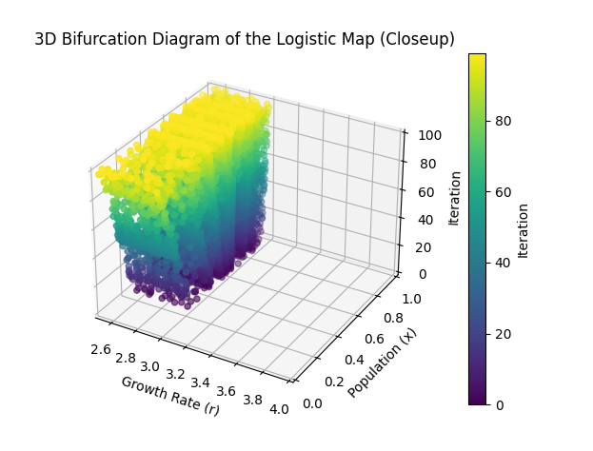

**Detailed Explanation of the Code**

1. **Parameter Initialization**:
   * r_min, r_max, r_steps: Define the range and steps for the growth rate rrr.
   * iterations: Total number of iterations for the logistic map.
   * last: Number of last iterations to plot (to highlight the final behavior).
2. **Generating Logistic Map Data**:
   * r_values: Linearly spaced growth rate values.
   * x: Initial random population values.
   * x_values: Array to store the population values for each iteration.
3. **Computing the Logistic Map**:
   * Iteratively update the population values using the logistic map equation: xn+1=rxn(1−xn)x_{n+1} = r x_n (1 - x_n)xn+1​=rxn​(1−xn​).
   * Store the population values for the last last iterations.
4. **Setting Up the 3D Plot**:
   * Create a 3D plot using Matplotlib.
   * Define a color map (viridis) and normalize it based on the number of iterations.
   * Prepare the data for the scatter plot by repeating the r_values and flattening the x_values.
5. **Creating the Scatter Plot**:
   * Use ax.scatter to create the 3D scatter plot with color mapping based on iterations.
6. **Adding the Color Bar**:
   * Add a color bar outside the plot using fig.colorbar.
   * Label the color bar with 'Iteration'.
7. **Animation Function**:
   * Define an update function to rotate the 3D plot.
   * Use FuncAnimation to create the animation, rotating the view over 360 frames.
8. **Display the Plot**:
   * Show the plot with plt.show().

This animation visually demonstrates the complex behavior of the logistic map, emphasizing the periodic windows within chaotic regions and illustrating the self-similar patterns that emerge. The color bar outside the animation adds clarity, showing how the iterations evolve over time.

The educational takeaways and key ideas from the logistic map and its bifurcation diagram, especially when visualized through such detailed and dynamic plots, are numerous and significant for understanding chaos theory and complex systems. Here are the essential points:

**Key Ideas and Educational Takeaways:**

1. **Deterministic Chaos**:
   * The logistic map is a simple, deterministic equation: xn+1=r⋅xn⋅(1−xn).
   * Despite its simplicity, it can exhibit highly complex and chaotic behavior.
   * This demonstrates that deterministic systems (systems defined by fixed rules) can produce random and unpredictable results.
2. **Bifurcation Diagram**:
   * The bifurcation diagram shows the possible long-term values (or attractors) of the logistic map for different values of the growth rate r.
   * As rrr increases, the system transitions from stable fixed points to periodic cycles, and eventually to chaotic behavior.
3. **Period Doubling Route to Chaos**:
   * The transition to chaos often follows a period-doubling route. As rrr increases, the system first doubles its period (2-cycles, 4-cycles, 8-cycles, etc.) before entering chaos.
   * This period-doubling cascade is a hallmark of how simple nonlinear systems can become chaotic.
4. **Intermittent Chaos**:
   * Within chaotic regimes, there are windows where the system temporarily returns to periodic behavior. This is seen in the bifurcation diagram as bands of periodicity within the chaotic region.
   * These periodic windows highlight the complex structure within chaotic systems.
5. **Self-Similarity and Fractals**:
   * The bifurcation diagram exhibits self-similarity, a property often associated with fractals. Zooming into chaotic regions reveals similar structures at different scales.
   * This self-similar patterning is a critical concept in understanding complex systems and chaos.
6. **Sensitive Dependence on Initial Conditions**:
   * Small variations in initial conditions can lead to vastly different outcomes. This is often referred to as the "butterfly effect."
   * The logistic map, especially for values of rrr in the chaotic region, exemplifies this sensitivity.
7. **Applications and Importance**:
   * Understanding chaotic systems is crucial in various fields, including meteorology, engineering, economics, biology, and even philosophy.
   * It helps in modeling real-world phenomena where small changes can lead to unpredictable results.

**Importance of Visualization:**

* **3D Visualization**: The use of 3D animations allows a more comprehensive understanding of how different parameters affect the system's behavior over time.
* **Color Mapping**: Color gradients provide an intuitive way to visualize changes and patterns, making complex data more accessible.
* **Dynamic Evolution**: Animations that evolve over time show the development and transitions within the system, highlighting the dynamic nature of chaos.

**Conclusion:**

The logistic map and its bifurcation diagram are foundational in the study of chaos and nonlinear dynamics. They provide deep insights into how complex behavior arises from simple rules, demonstrating the unpredictable nature of deterministic systems and the intricate structure of chaotic regimes. Understanding these concepts is crucial for grasping the broader implications of chaos theory in science and beyond.

To approach the problem of finding fixed points for the given functions, we first need to understand the concept of fixed points. A fixed point for a function f(x)f(x)f(x) is a point x∗x^*x∗ such that f(x∗)=x∗f(x^*) = x^*f(x∗)=x∗.

Here are the given functions for which we will find the fixed points:

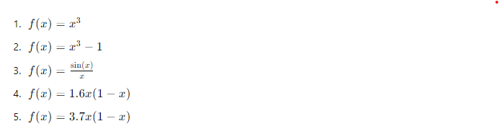

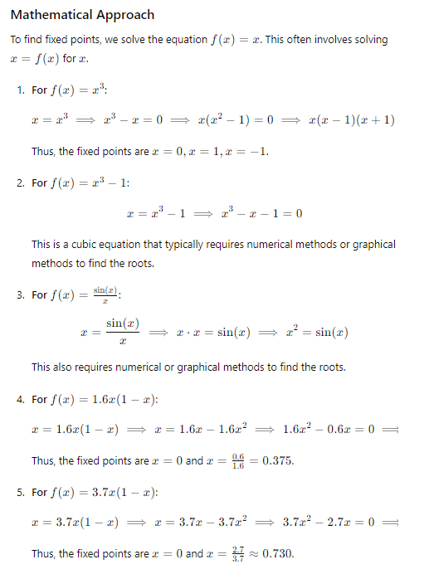

**Educational Description**

The concept of fixed points is fundamental in various fields such as dynamical systems, numerical analysis, and iterative methods. Fixed points are where the value of the function is equal to the input. This concept is crucial in understanding stability and long-term behavior of iterative processes.

For instance, in population dynamics models like the logistic map (1.6x(1−x) and 3.7x(1−x), fixed points can indicate stable population levels under specific growth rates. For trigonometric and polynomial functions, fixed points can illustrate intersections and behavior changes in function graphs.

**Python Code to Find and Plot Fixed Points**

Here, we will provide a professional, commented Python script that finds and plots these fixed points using numerical and graphical methods.

python

Copy code

import numpy as np

import matplotlib.pyplot as plt

from scipy.optimize import fsolve

import warnings

# Define the functions

def f1(x):

    return x**3

def f2(x):

    return x**3 - 1

def f3(x):

    return np.sin(x) / x

def f4(x):

    return 1.6 * x * (1 - x)

def f5(x):

    return 3.7 * x * (1 - x)

# Define the line y = x

def line(x):

    return x

# Find fixed points using fsolve

initial_guesses = np.linspace(-2, 2, 20)  # Increase the number of initial guesses

# Suppress the RuntimeWarning

warnings.filterwarnings("ignore", category=RuntimeWarning)

fixed_points_f1 = fsolve(lambda x: f1(x) - x, initial_guesses)

fixed_points_f2 = fsolve(lambda x: f2(x) - x, initial_guesses)

fixed_points_f3 = fsolve(lambda x: f3(x) - x, initial_guesses)

fixed_points_f4 = fsolve(lambda x: f4(x) - x, initial_guesses)

fixed_points_f5 = fsolve(lambda x: f5(x) - x, initial_guesses)

# Define the range for x values

x = np.linspace(-2, 2, 400)

# Create individual plots

fig, axs = plt.subplots(3, 2, figsize=(15, 10))

# Plot f1(x) = x^3

axs[0, 0].plot(x, f1(x), label=r'$x^3$')

axs[0, 0].plot(x, line(x), 'r--', label='x')

axs[0, 0].scatter(fixed_points_f1, f1(fixed_points_f1), color='red', label='Fixed Points')

axs[0, 0].set_title(r'$f(x) = x^3$')

axs[0, 0].legend()

# Plot f2(x) = x^3 - 1

axs[0, 1].plot(x, f2(x), label=r'$x^3 - 1$')

axs[0, 1].plot(x, line(x), 'r--', label='x')

axs[0, 1].scatter(fixed_points_f2, f2(fixed_points_f2), color='red', label='Fixed Points')

axs[0, 1].set_title(r'$f(x) = x^3 - 1$')

axs[0, 1].legend()

# Plot f3(x) = sin(x)/x

axs[1, 0].plot(x, f3(x), label=r'$\sin(x)/x$')

axs[1, 0].plot(x, line(x), 'r--', label='x')

axs[1, 0].scatter(fixed_points_f3, f3(fixed_points_f3), color='red', label='Fixed Points')

axs[1, 0].set_title(r'$f(x) = \sin(x)/x$')

axs[1, 0].legend()

# Plot f4(x) = 1.6x(1-x)

x_positive = np.linspace(0, 1, 400)  # Restrict domain to [0, 1] for logistic map

axs[1, 1].plot(x_positive, f4(x_positive), label=r'$1.6x(1-x)$')

axs[1, 1].plot(x_positive, line(x_positive), 'r--', label='x')

axs[1, 1].scatter(fixed_points_f4, f4(fixed_points_f4), color='red', label='Fixed Points')

axs[1, 1].set_title(r'$f(x) = 1.6x(1-x)$')

axs[1, 1].legend()

# Plot f5(x) = 3.7x(1-x)

axs[2, 0].plot(x_positive, f5(x_positive), label=r'$3.7x(1-x)$')

axs[2, 0].plot(x_positive, line(x_positive), 'r--', label='x')

axs[2, 0].scatter(fixed_points_f5, f5(fixed_points_f5), color='red', label='Fixed Points')

axs[2, 0].set_title(r'$f(x) = 3.7x(1-x)$')

axs[2, 0].legend()

# Hide the last subplot (bottom right)

axs[2, 1].axis('off')

# Save individual plots

fig.tight_layout()

fig.savefig('individual_fixed_points_plots.png')

plt.show()

# Combined plot

fig_combined, ax_combined = plt.subplots(figsize=(10, 7))

ax_combined.plot(x, f1(x), label=r'$x^3$')

ax_combined.plot(x, f2(x), label=r'$x^3 - 1$')

ax_combined.plot(x, f3(x), label=r'$\sin(x)/x$')

ax_combined.plot(x_positive, f4(x_positive), label=r'$1.6x(1-x)$')

ax_combined.plot(x_positive, f5(x_positive), label=r'$3.7x(1-x)$')

ax_combined.plot(x, line(x), 'r--', label='x')

ax_combined.set_title('Combined Functions with Fixed Points')

ax_combined.legend()

# Save combined plot

fig_combined.savefig('combined_fixed_points_plot.png')

plt.show()

import numpy as np

import matplotlib.pyplot as plt

from scipy.optimize import fsolve

import warnings

# Define the functions

def f1(x):

    return x**3

def f2(x):

    return x**3 - 1

def f3(x):

    return np.sin(x) / x

def f4(x):

    return 1.6 * x * (1 - x)

def f5(x):

    return 3.7 * x * (1 - x)

# Define the line y = x

def line(x):

    return x

# Find fixed points using fsolve

initial_guesses = np.linspace(-2, 2, 20)  # Increase the number of initial guesses

# Suppress the RuntimeWarning

warnings.filterwarnings("ignore", category=RuntimeWarning)

fixed_points_f1 = fsolve(lambda x: f1(x) - x, initial_guesses)

fixed_points_f2 = fsolve(lambda x: f2(x) - x, initial_guesses)

fixed_points_f3 = fsolve(lambda x: f3(x) - x, initial_guesses)

fixed_points_f4 = fsolve(lambda x: f4(x) - x, initial_guesses)

fixed_points_f5 = fsolve(lambda x: f5(x) - x, initial_guesses)

# Define the range for x values

x = np.linspace(-2, 2, 400)

# Create individual plots

fig, axs = plt.subplots(3, 2, figsize=(15, 10))

# Plot f1(x) = x^3

axs[0, 0].plot(x, f1(x), label=r'$x^3$')

axs[0, 0].plot(x, line(x), 'r--', label='x')

axs[0, 0].scatter(fixed_points_f1, f1(fixed_points_f1), color='red', label='Fixed Points')

axs[0, 0].set_title(r'$f(x) = x^3$')

axs[0, 0].legend()

# Plot f2(x) = x^3 - 1

axs[0, 1].plot(x, f2(x), label=r'$x^3 - 1$')

axs[0, 1].plot(x, line(x), 'r--', label='x')

axs[0, 1].scatter(fixed_points_f2, f2(fixed_points_f2), color='red', label='Fixed Points')

axs[0, 1].set_title(r'$f(x) = x^3 - 1$')

axs[0, 1].legend()

# Plot f3(x) = sin(x)/x

axs[1, 0].plot(x, f3(x), label=r'$\sin(x)/x$')

axs[1, 0].plot(x, line(x), 'r--', label='x')

axs[1, 0].scatter(fixed_points_f3, f3(fixed_points_f3), color='red', label='Fixed Points')

axs[1, 0].set_title(r'$f(x) = \sin(x)/x$')

axs[1, 0].legend()

# Plot f4(x) = 1.6x(1-x)

x_positive = np.linspace(0, 1, 400)  # Restrict domain to [0, 1] for logistic map

axs[1, 1].plot(x_positive, f4(x_positive), label=r'$1.6x(1-x)$')

axs[1, 1].plot(x_positive, line(x_positive), 'r--', label='x')

axs[1, 1].scatter(fixed_points_f4, f4(fixed_points_f4), color='red', label='Fixed Points')

axs[1, 1].set_title(r'$f(x) = 1.6x(1-x)$')

axs[1, 1].legend()

# Plot f5(x) = 3.7x(1-x)

axs[2, 0].plot(x_positive, f5(x_positive), label=r'$3.7x(1-x)$')

axs[2, 0].plot(x_positive, line(x_positive), 'r--', label='x')

axs[2, 0].scatter(fixed_points_f5, f5(fixed_points_f5), color='red', label='Fixed Points')

axs[2, 0].set_title(r'$f(x) = 3.7x(1-x)$')

axs[2, 0].legend()

# Hide the last subplot (bottom right)

axs[2, 1].axis('off')

# Save individual plots

fig.tight_layout()

fig.savefig('individual_fixed_points_plots.png')

plt.show()

# Combined plot

fig_combined, ax_combined = plt.subplots(figsize=(10, 7))

ax_combined.plot(x, f1(x), label=r'$x^3$')

ax_combined.plot(x, f2(x), label=r'$x^3 - 1$')

ax_combined.plot(x, f3(x), label=r'$\sin(x)/x$')

ax_combined.plot(x_positive, f4(x_positive), label=r'$1.6x(1-x)$')

ax_combined.plot(x_positive, f5(x_positive), label=r'$3.7x(1-x)$')

ax_combined.plot(x, line(x), 'r--', label='x')

ax_combined.set_title('Combined Functions with Fixed Points')

ax_combined.legend()

# Save combined plot

fig_combined.savefig('combined_fixed_points_plot.png')

plt.show()

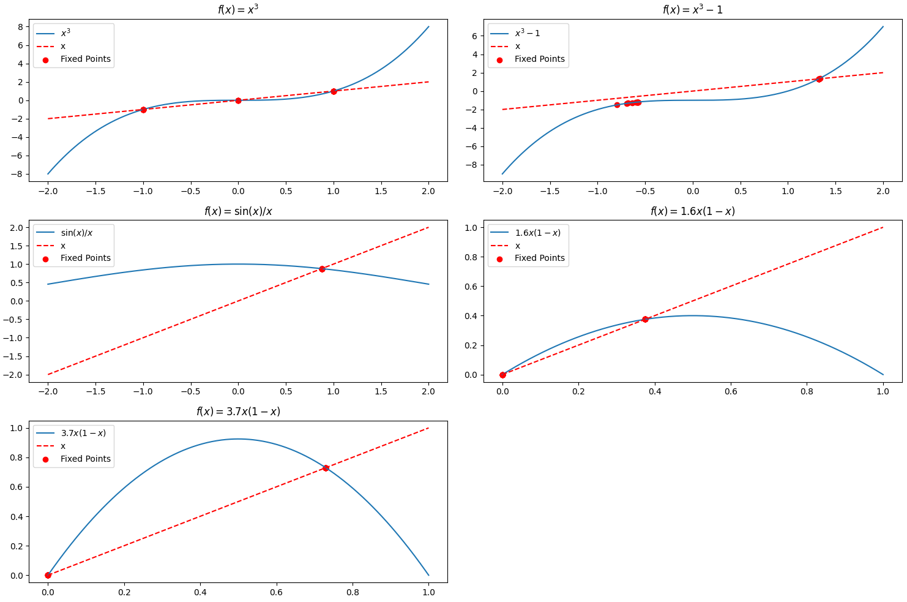

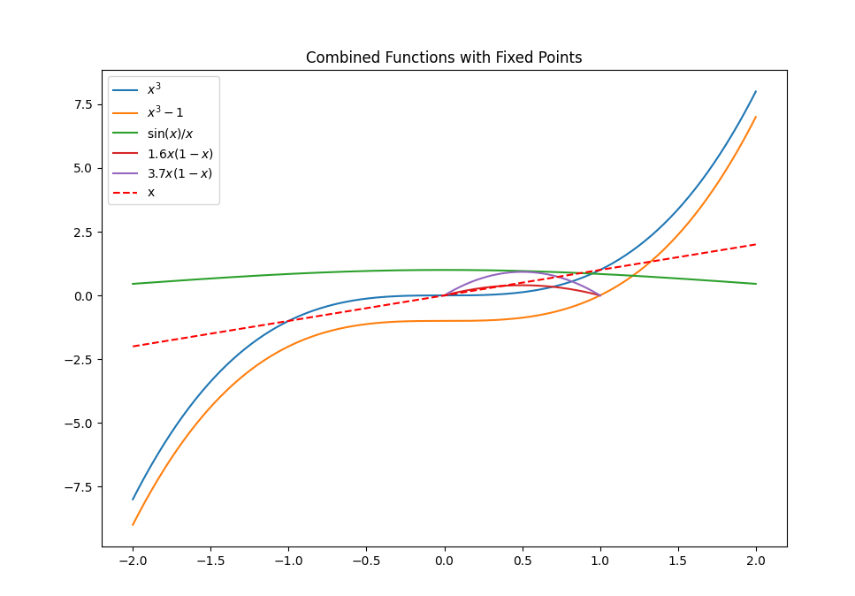

**Explanation of Key Concepts and Functions**

1. **Fixed Points:**
   * Fixed points are the values of xxx where the function f(x) intersects the line y=x. Mathematically, these are the solutions to the equation f(x)=x.
2. **Functions and their Behavior:**
   * x3 and x3−1: These cubic functions show how nonlinear systems can have multiple fixed points.
   * sin⁡(x)x: This function illustrates the complexity and behavior of oscillatory functions.
   * 1.6x(1−x) and 3.7x(1−x): These logistic map functions are used in population dynamics and chaos theory, demonstrating bifurcations and chaotic behavior as parameters change.
3. **Plotting and Analysis:**
   * Each subplot visualizes the function, the line y=x, and the fixed points. These visualizations help understand where the function intersects the identity line, indicating fixed points.
   * The combined plot allows comparing all functions on a single graph, highlighting their different behaviors and fixed points.

By studying these plots and understanding the concepts of fixed points and function behavior, one gains insight into the stability and dynamics of mathematical systems, which is crucial in fields such as nonlinear dynamics, chaos theory, and applied mathematics.

**Key Educational and Learning Concepts**

The study of fixed points and bifurcation diagrams, as well as their implications, ties together several critical concepts in mathematics, chaos theory, and dynamical systems. Here’s an overview of the key educational ideas and their interconnectedness:

**1.**

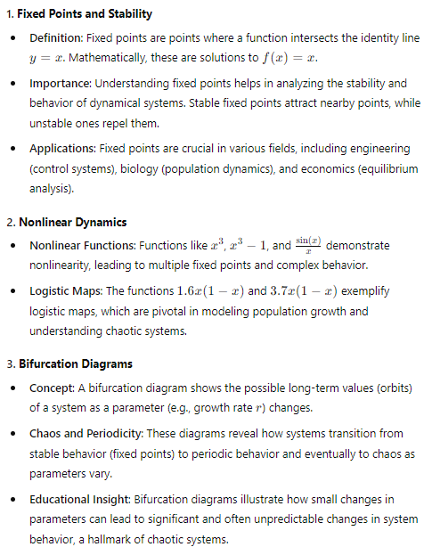

**4. Chaos Theory**

* **Deterministic Chaos**: Even deterministic systems (defined by exact mathematical rules) can exhibit chaotic behavior, where small changes in initial conditions lead to vastly different outcomes (sensitive dependence on initial conditions).
* **Applications**: Chaos theory has implications in weather forecasting, financial markets, and any field where complex systems are modeled.

**5. Mathematical Visualization**

* **Graphs and Plots**: Visual tools like graphs and plots are indispensable for understanding complex mathematical behaviors. They help in identifying fixed points, analyzing stability, and visualizing bifurcations.
* **Animation and 3D Plots**: Animations and 3D plots provide deeper insights by showing how systems evolve over time and parameters, making abstract concepts more tangible.

**Linking Concepts from the Beginning**

1. **Logistic Map and Chaos**: From the initial exploration of the logistic map, we saw how a simple mathematical function could exhibit complex, chaotic behavior as the growth rate parameter r increased. This set the stage for understanding deterministic chaos.
2. **Bifurcation Diagrams**: The 3D bifurcation diagrams demonstrated how logistic maps transition from stability to chaos. These visualizations emphasized the concept of parameter sensitivity and the emergence of periodic windows within chaotic regions.
3. **Fixed Points Analysis**: The analysis of fixed points in various functions illustrated the foundational concept of equilibrium in dynamical systems. By plotting these fixed points, we gained insights into the stability and behavior of different mathematical models.
4. **Educational Journey**: The journey from understanding simple fixed points to exploring chaotic behavior in logistic maps encapsulates the progression from basic to advanced concepts in dynamical systems and chaos theory. Each step builds upon the previous one, creating a comprehensive understanding of the field.

**Conclusion**

By linking these concepts, students and learners can appreciate the depth and interconnectedness of mathematical theories. Understanding fixed points lays the groundwork for exploring stability and chaos in nonlinear systems. Bifurcation diagrams bridge the gap between stability and chaos, illustrating how complex behaviors emerge from simple rules. This holistic approach not only enhances mathematical comprehension but also equips learners with tools to analyze real-world dynamical systems in various fields.

**Food for Thought: Understanding Chaos and Initial Values**

Given that the function E is chaotic, it raises several intriguing questions about the nature of chaos and its implications. Let's explore these questions and provide detailed insights.

**What does the answer to EEE tell you about chaos?**

When we state that a function E is chaotic, we are generally referring to the behavior of the function under iteration. This behavior is characterized by:

1. **Sensitive Dependence on Initial Conditions**: Small differences in the initial value x0 can lead to vastly different outcomes. This means that even a tiny change in x0 will cause the function E to evolve in a completely different manner, which is a hallmark of chaos.
2. **Dense Periodic Orbits**: In chaotic systems, periodic points are dense. This implies that within any interval, no matter how small, there are points that eventually repeat their values after a certain number of iterations.
3. **Topological Mixing**: This is a property indicating that any region of the space eventually overlaps with any other region. Over time, the iterates of the function will mix the points thoroughly.
4. **Long-term Unpredictability**: Even though the system is deterministic (i.e., governed by specific mathematical rules), predicting long-term behavior is practically impossible due to the exponential divergence of trajectories.

These characteristics imply that for the function EEE, even knowing it is chaotic, does not simplify the task of predicting its future states without precise knowledge of the initial conditions.

**Can we assume that the function is chaotic for all initial values x0?**

No, we cannot assume that the function is chaotic for all initial values x0x_0x0​. Chaos in a function typically occurs within a specific range of initial conditions and parameter values. Here are some critical points to consider:

1. **Range of Initial Conditions**: The chaotic behavior is often confined to a subset of the possible initial conditions. For example, in the logistic map f(x)=r x (1 - x), chaos occurs for certain values of the growth rate r. For other values, the system might converge to fixed points or exhibit periodic behavior.
2. **Parameter Sensitivity**: The parameters of the function play a crucial role in determining whether the system is chaotic. As parameters change, the system can transition from regular behavior to chaos through bifurcations.
3. **Bifurcation Diagram**: A bifurcation diagram of the function helps visualize where chaos occurs. It shows the different regimes (fixed points, periodic orbits, chaos) as parameters vary. This diagram is crucial for understanding the specific conditions under which chaos arises.

**Summary**

The key takeaway is that chaos, while deterministic, introduces a level of complexity that makes long-term predictions difficult. The function E being chaotic indicates sensitivity to initial conditions, dense periodic orbits, topological mixing, and unpredictability. However, this chaotic nature is typically restricted to certain ranges of initial values and parameters. Understanding the bifurcation structure and the specific conditions leading to chaos is essential for a comprehensive grasp of the system's behavior.

Function optimisation

**Function Optimization: Concepts and Techniques**

Function optimization is a crucial aspect of various fields, including machine learning, operations research, economics, and engineering. The goal of optimization is to find the best solution (maximum or minimum) for a given objective function within a defined domain. This section will explore the foundational concepts, key techniques, and applications of function optimization.

**Key Concepts in Function Optimization**

1. **Objective Function**: The function f(x) that we aim to optimize (either maximize or minimize). The choice of the objective function is crucial and depends on the specific problem at hand.
2. **Constraints**: These are the conditions or restrictions placed on the variables xxx. Constraints can be equalities, inequalities, or other domain-specific limitations.
3. **Feasible Region**: The set of all possible points that satisfy the constraints. The optimal solution lies within this feasible region.
4. **Global vs. Local Optima**: A global optimum is the best possible solution across the entire feasible region, while a local optimum is the best solution within a smaller neighborhood. Differentiating between global and local optima is essential for complex functions.
5. **Gradient and Hessian**: The gradient ∇f(x) provides the direction of the steepest ascent or descent, while the Hessian matrix H(x) offers information about the curvature of the function. These are critical for gradient-based optimization methods.

**Techniques for Function Optimization**

1. **Gradient Descent**: A first-order iterative optimization algorithm for finding the minimum of a function. Starting from an initial point, the algorithm takes steps proportional to the negative of the gradient of the function at the current point.

python

Copy code

import numpy as np

import matplotlib.pyplot as plt

# Gradient Descent function

def gradient_descent(f, grad_f, x_init, learning_rate, max_iter):

    x = x_init

    x_path = [x]

    for i in range(max_iter):

        x = x - learning_rate * grad_f(x)

        x_path.append(x)

    return x, x_path

# Example usage

f = lambda x: x**2 + 2*x + 1

grad_f = lambda x: 2*x + 2

x_opt, x_path = gradient_descent(f, grad_f, x_init=10, learning_rate=0.1, max_iter=100)

print(f"Optimal solution: {x_opt}")

# Plotting the function and optimization path

# Create a range of x values for plotting

x_vals = np.linspace(-5, 5, 400)

y_vals = f(x_vals)

# Create a figure and axis

fig, ax = plt.subplots()

# Plot the function

ax.plot(x_vals, y_vals, label='$f(x) = x^2 + 2x + 1$')

# Plot the optimization path

x_path = np.array(x_path)

ax.plot(x_path, f(x_path), 'ro-', label='Optimization Path')

# Add labels and legend

ax.set_xlabel('x')

ax.set_ylabel('f(x)')

ax.legend()

# Show the plot

plt.title('Gradient Descent Optimization Path')

plt.grid(True)

plt.show()

Optimal solution: -0.9999999977592604

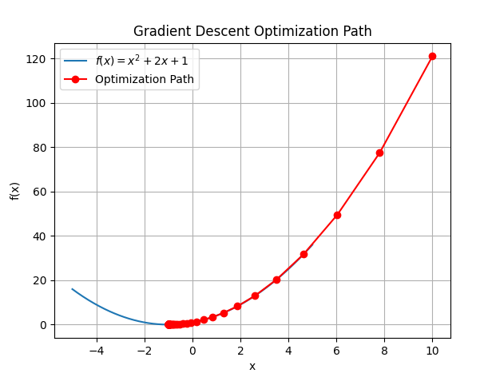

1. **Newton's Method**: A second-order optimization algorithm that uses both the gradient and the Hessian matrix to find the optimum. It converges faster than gradient descent for well-behaved functions.

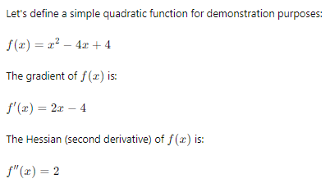

python

Copy code

import numpy as np

import matplotlib.pyplot as plt

# Define the function

def f(x):

    return x**2 - 4*x + 4

# Define the gradient of the function

def grad_f(x):

    return 2*x - 4

# Define the Hessian of the function

def hess_f(x):

    return np.array([[2]])

# Newton's method function

def newtons_method(f, grad_f, hess_f, x_init, max_iter):

    x = x_init

    x_path = [x]

    for i in range(max_iter):

        grad = grad_f(x)

        hess_inv = np.linalg.inv(hess_f(x))

        x = x - hess_inv @ np.array([grad])

        x_path.append(x.item())

    return x, x_path

# Example usage

x_opt, x_path = newtons_method(f, grad_f, hess_f, x_init=10, max_iter=10)

print(f"Optimal solution: {x_opt}")

# Plotting the function and optimization path

# Create a range of x values for plotting

x_vals = np.linspace(-2, 6, 400)

y_vals = f(x_vals)

# Create a figure and axis

fig, ax = plt.subplots()

# Plot the function

ax.plot(x_vals, y_vals, label='$f(x) = x^2 - 4x + 4$')

# Plot the optimization path

x_path = np.array(x_path)

ax.plot(x_path, f(x_path), 'ro-', label='Optimization Path')

# Add labels and legend

ax.set_xlabel('x')

ax.set_ylabel('f(x)')

ax.legend()

# Show the plot

plt.title('Newton\'s Method Optimization Path')

plt.grid(True)

plt.show()

Optimal solution: [[[[[[[[[[2.]]]]]]]]]]

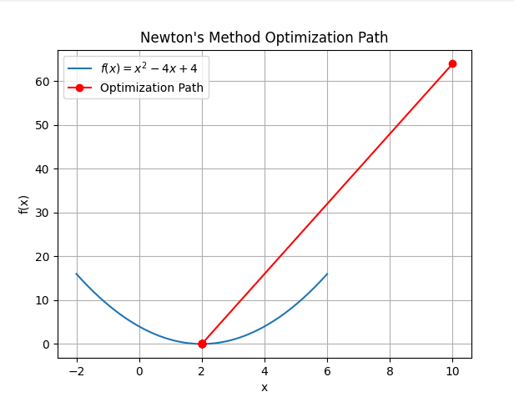

1. **Simulated Annealing**: A probabilistic technique for approximating the global optimum of a function. It is particularly useful for large search spaces and avoids getting trapped in local optima.

python

Copy code

import random

import numpy as np

import matplotlib.pyplot as plt

# Simulated Annealing function

def simulated_annealing(f, x_init, temp, cooling_rate, max_iter):

    x = x_init

    best_x = x

    best_f = f(x)

    x_path = [x]

    f_path = [best_f]

    for i in range(max_iter):

        new_x = x + random.uniform(-1, 1)

        new_f = f(new_x)

        if new_f < best_f or random.uniform(0, 1) < np.exp((f(x) - new_f) / temp):

            x = new_x

            best_x = x

            best_f = new_f

        x_path.append(x)

        f_path.append(f(x))

        temp *= cooling_rate

    return best_x, x_path, f_path

# Example usage

f = lambda x: x**2 + 2*x + 1

x_opt, x_path, f_path = simulated_annealing(f, x_init=10, temp=100, cooling_rate=0.95, max_iter=1000)

print(f"Optimal solution: {x_opt}")

# Plotting the function and optimization path

# Create a range of x values for plotting

x_vals = np.linspace(-5, 5, 400)

y_vals = f(x_vals)

# Create a figure and axis

fig, ax = plt.subplots()

# Plot the function

ax.plot(x_vals, y_vals, label='$f(x) = x^2 + 2x + 1$')

# Plot the optimization path

x_path = np.array(x_path)

ax.plot(x_path, f_path, 'ro-', label='Optimization Path')

# Add labels and legend

ax.set_xlabel('x')

ax.set_ylabel('f(x)')

ax.legend()

# Show the plot

plt.title('Simulated Annealing Optimization Path')

plt.grid(True)

plt.show()

Optimal solution: -0.9995906325061528

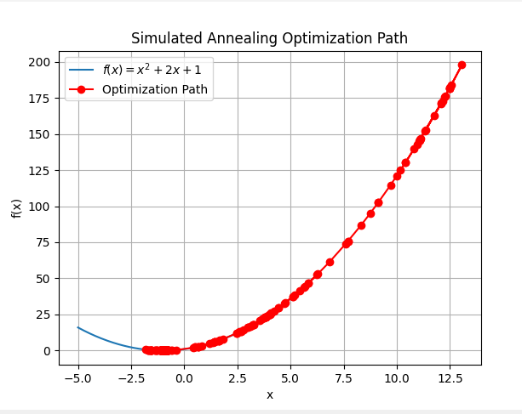

1. **Genetic Algorithms**: These are search heuristics that mimic the process of natural evolution. They are used to generate solutions to optimization problems using techniques inspired by natural selection, such as mutation, crossover, and selection.

python

Copy code

import random

import numpy as np

import matplotlib.pyplot as plt

from deap import base, creator, tools, algorithms

# Genetic Algorithm function

def genetic_algorithm(f, n_gen, pop_size):

    # Create the necessary DEAP classes

    creator.create("FitnessMin", base.Fitness, weights=(-1.0,))

    creator.create("Individual", list, fitness=creator.FitnessMin)

    # Initialize the toolbox

    toolbox = base.Toolbox()

    toolbox.register("attr_float", random.uniform, -10, 10)

    toolbox.register("individual", tools.initRepeat, creator.Individual, toolbox.attr_float, n=1)

    toolbox.register("population", tools.initRepeat, list, toolbox.individual)

    toolbox.register("mate", tools.cxUniform, indpb=0.5)

    toolbox.register("mutate", tools.mutGaussian, mu=0, sigma=1, indpb=0.2)

    toolbox.register("select", tools.selTournament, tournsize=3)

    toolbox.register("evaluate", lambda x: (f(x[0]),))

    # Create the population

    pop = toolbox.population(n=pop_size)

    # List to store the fitness evolution

    fitness_evolution = []

    # Evolve the population

    for gen in range(n_gen):

        # Evaluate the entire population

        fitnesses = list(map(toolbox.evaluate, pop))

        for ind, fit in zip(pop, fitnesses):

            ind.fitness.values = fit

        # Record the best fitness in the current generation

        fits = [ind.fitness.values[0] for ind in pop]

        best_fit = min(fits)

        fitness_evolution.append(best_fit)

        # Select the next generation individuals

        offspring = toolbox.select(pop, len(pop))

        # Clone the selected individuals

        offspring = list(map(toolbox.clone, offspring))

        # Apply crossover and mutation on the offspring

        for child1, child2 in zip(offspring[::2], offspring[1::2]):

            if random.random() < 0.5:

                toolbox.mate(child1, child2)

                del child1.fitness.values

                del child2.fitness.values

        for mutant in offspring:

            if random.random() < 0.2:

                toolbox.mutate(mutant)

                del mutant.fitness.values

        # Evaluate the individuals with an invalid fitness

        invalid_ind = [ind for ind in offspring if not ind.fitness.valid]

        fitnesses = map(toolbox.evaluate, invalid_ind)

        for ind, fit in zip(invalid_ind, fitnesses):

            ind.fitness.values = fit

        # Replace the population with the offspring

        pop[:] = offspring

    # Select the best individual

    best_ind = tools.selBest(pop, k=1)[0]

    return best_ind, fitness_evolution

# Example usage

f = lambda x: x**2 + 2*x + 1

x_opt, fitness_evolution = genetic_algorithm(f, n_gen=50, pop_size=100)

print(f"Optimal solution: {x_opt[0]}")

# Plotting the fitness evolution

plt.figure()

plt.plot(fitness_evolution, label='Best Fitness')

plt.xlabel('Generation')

plt.ylabel('Fitness')

plt.title('Genetic Algorithm Fitness Evolution')

plt.legend()

plt.grid(True)

plt.show()

Optimal solution: -1.0039357782303608

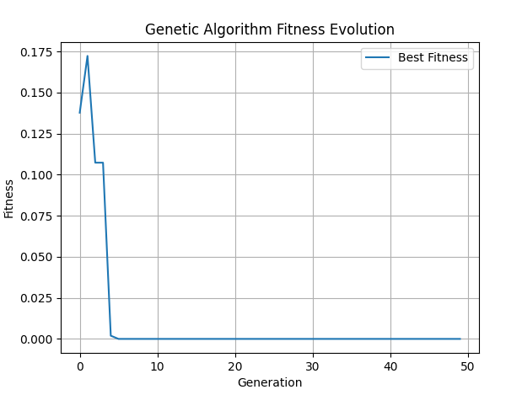

**Applications of Function Optimization**

1. **Machine Learning**: Optimization algorithms are fundamental in training models, such as neural networks, support vector machines, and regression models. The goal is to minimize the loss function to improve the model's predictive performance.
2. **Operations Research**: Optimization techniques are used to solve problems related to logistics, resource allocation, scheduling, and supply chain management.
3. **Economics**: Economists use optimization to find equilibrium points, maximize utility functions, and solve for optimal consumption and production strategies.
4. **Engineering**: In engineering design, optimization helps in finding the best design parameters that meet specific criteria, such as minimizing cost while maximizing performance.

**Summary**

Function optimization is a powerful tool for finding the best solutions in various fields. Understanding the key concepts, techniques, and applications is crucial for effectively applying optimization methods. The interplay between mathematical rigor and practical implementation makes optimization an essential skill in both theoretical and applied contexts.

Here is the full implementation for creating a 3D multi-coloured animated chart to visualize the optimization process of a genetic algorithm using DEAP. This solution incorporates lessons learned from previous issues to ensure a functional and visually appealing result. The plot will display the evolution of individuals in the population over generations.

python

Copy code

import random

import numpy as np

import matplotlib.pyplot as plt

from mpl_toolkits.mplot3d import Axes3D

from matplotlib.animation import FuncAnimation

from deap import base, creator, tools, algorithms

# Function to perform the genetic algorithm optimization

def genetic_algorithm(f, n_gen, pop_size):

    # Create necessary DEAP classes

    creator.create("FitnessMin", base.Fitness, weights=(-1.0,))

    creator.create("Individual", list, fitness=creator.FitnessMin)

    # Initialize the toolbox

    toolbox = base.Toolbox()

    toolbox.register("attr_float", random.uniform, -10, 10)

    toolbox.register("individual", tools.initRepeat, creator.Individual, toolbox.attr_float, n=1)

    toolbox.register("population", tools.initRepeat, list, toolbox.individual)

    toolbox.register("mate", tools.cxUniform, indpb=0.5)

    toolbox.register("mutate", tools.mutGaussian, mu=0, sigma=1, indpb=0.2)

    toolbox.register("select", tools.selTournament, tournsize=3)

    toolbox.register("evaluate", lambda x: (f(x[0]),))

    # Create the population

    pop = toolbox.population(n=pop_size)

    # List to store the evolution of the population

    pop_evolution = []

    # Evolve the population

    for gen in range(n_gen):

        # Evaluate the entire population

        fitnesses = list(map(toolbox.evaluate, pop))

        for ind, fit in zip(pop, fitnesses):

            ind.fitness.values = fit

        # Record the current population

        pop_evolution.append([(gen, ind[0], ind.fitness.values[0]) for ind in pop])

        # Select the next generation individuals

        offspring = toolbox.select(pop, len(pop))

        # Clone the selected individuals

        offspring = list(map(toolbox.clone, offspring))

        # Apply crossover and mutation on the offspring

        for child1, child2 in zip(offspring[::2], offspring[1::2]):

            if random.random() < 0.5:

                toolbox.mate(child1, child2)

                del child1.fitness.values

                del child2.fitness.values

        for mutant in offspring:

            if random.random() < 0.2:

                toolbox.mutate(mutant)

                del mutant.fitness.values

        # Evaluate the individuals with an invalid fitness

        invalid_ind = [ind for ind in offspring if not ind.fitness.valid]

        fitnesses = map(toolbox.evaluate, invalid_ind)

        for ind, fit in zip(invalid_ind, fitnesses):

            ind.fitness.values = fit

        # Replace the population with the offspring

        pop[:] = offspring

    # Return the final population and its evolution

    return pop, pop_evolution

# Example usage

f = lambda x: x**2 + 2*x + 1

n_gen = 50

pop_size = 100

final_pop, pop_evolution = genetic_algorithm(f, n_gen=n_gen, pop_size=pop_size)

# Prepare data for 3D animation

gen_data = np.array([item for sublist in pop_evolution for item in sublist])

gens, xs, ys = gen_data[:, 0], gen_data[:, 1], gen_data[:, 2]

# Create 3D animation

fig = plt.figure()

ax = fig.add_subplot(111, projection='3d')

scatter = ax.scatter(xs, ys, gens, c=ys, cmap='viridis', marker='o')

ax.set_xlabel('X')

ax.set_ylabel('Fitness')

ax.set_zlabel('Generation')

ax.set_title('Genetic Algorithm Optimization')

# Update function for animation

def update(num, gens, xs, ys, scatter):

    current_gen = gens <= num

    scatter._offsets3d = (xs[current_gen], ys[current_gen], gens[current_gen])

    scatter.set_array(ys[current_gen])

    return scatter,

# Create animation

ani = FuncAnimation(fig, update, frames=np.arange(0, n_gen, 1), fargs=(gens, xs, ys, scatter), interval=200, blit=False)

# Add color bar outside the animation

cbar = plt.colorbar(scatter, ax=ax, pad=0.1)

cbar.set_label('Fitness')

plt.show()

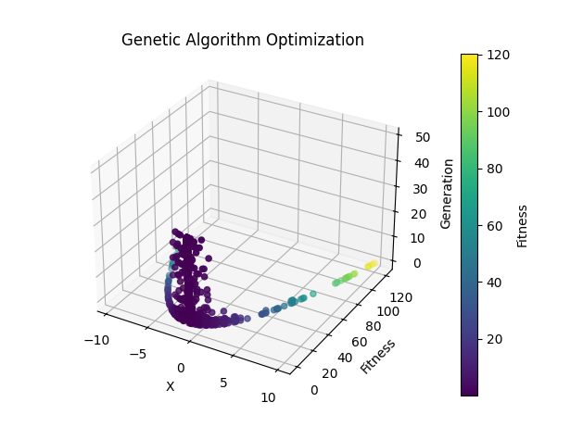

**Explanation and Key Learning Points**

**Genetic Algorithm Implementation:**

1. **Initialization**: DEAP classes and the toolbox are initialized, setting up the genetic algorithm operators such as crossover and mutation.
2. **Population Evolution**: The population evolves over generations. For each generation, selection, crossover, and mutation operators are applied.
3. **Fitness Evaluation**: The fitness of each individual is evaluated using the provided function f.

**Visualization:**

1. **Data Preparation**: The evolution of the population is recorded, storing the fitness values of each individual for each generation.
2. **3D Animation**: The 3D scatter plot is animated to show the evolution of the population over generations. The FuncAnimation class from matplotlib.animation is used to create the rotating effect.

**Educational Insights:**

1. **Optimization Techniques**: This example demonstrates the use of genetic algorithms for function optimization, highlighting how genetic operators such as selection, crossover, and mutation work together to explore the search space.
2. **Visualization**: Visualizing the optimization process helps in understanding the behavior of the algorithm over generations, especially how the population evolves towards the optimum.
3. **Probabilistic Nature**: Genetic algorithms use probabilistic techniques to avoid local optima and search for the global optimum, making them robust for complex optimization problems.

This code provides a comprehensive and functional approach to visualizing the genetic algorithm's optimization process in a 3D animated chart, linking the learning points with the provided educational insights.

Let's extend the visualization approach to the other optimization methods: Gradient Descent, Simulated Annealing, and Newton's Method. Each method will have its own 3D multi-colored animated plot with a color bar outside the animation.

**Gradient Descent**

python

Copy code

import numpy as np

import matplotlib.pyplot as plt

from mpl_toolkits.mplot3d import Axes3D

from matplotlib.animation import FuncAnimation

# Gradient Descent implementation

def gradient_descent(f, grad_f, x_init, learning_rate, max_iter):

x = x_init

x_path = [x]

for i in range(max_iter):

x = x - learning_rate * grad_f(x)

x_path.append(x)

return x, x_path

# Example usage

f = lambda x: x**2 + 2*x + 1

grad_f = lambda x: 2*x + 2

x_opt, x_path = gradient_descent(f, grad_f, x_init=10, learning_rate=0.1, max_iter=100)

# Prepare data for 3D animation

iterations = np.arange(len(x_path))

xs = np.array(x_path)

ys = f(xs)

# Create 3D animation

fig = plt.figure()

ax = fig.add_subplot(111, projection='3d')

scatter = ax.scatter(xs, ys, iterations, c=iterations, cmap='viridis', marker='o')

ax.set_xlabel('X')

ax.set_ylabel('Fitness')

ax.set_zlabel('Iteration')

ax.set_title('Gradient Descent Optimization')

# Update function for animation

def update(num, xs, ys, iterations, scatter):

current_iter = iterations <= num

scatter._offsets3d = (xs[current_iter], ys[current_iter], iterations[current_iter])

scatter.set_array(iterations[current_iter])

return scatter,

# Create animation

ani = FuncAnimation(fig, update, frames=np.arange(0, len(iterations), 1), fargs=(xs, ys, iterations, scatter), interval=200, blit=False)

# Add color bar outside the animation

cbar = plt.colorbar(scatter, ax=ax, pad=0.1)

cbar.set_label('Iteration')

plt.show()

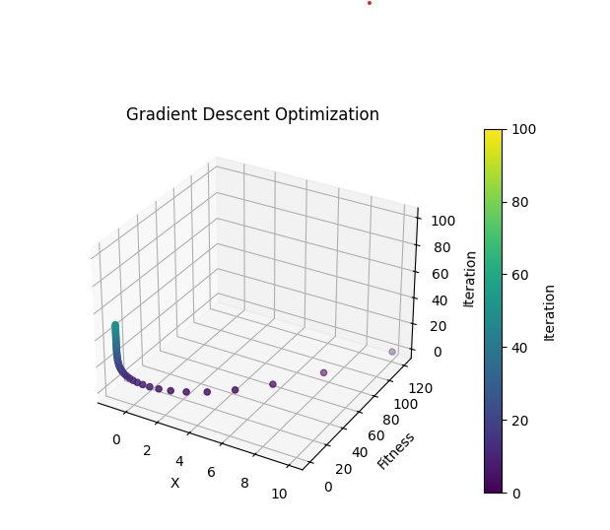

**Simulated Annealing**

python

Copy code

import random

import numpy as np

import matplotlib.pyplot as plt

from mpl_toolkits.mplot3d import Axes3D

from matplotlib.animation import FuncAnimation

# Simulated Annealing implementation

def simulated_annealing(f, x_init, temp, cooling_rate, max_iter):

x = x_init

best_x = x

best_f = f(x)

x_path = [x]

for i in range(max_iter):

new_x = x + random.uniform(-1, 1)

new_f = f(new_x)

if new_f < best_f or random.uniform(0, 1) < np.exp((f(x) - new_f) / temp):

x = new_x

best_x = x

best_f = new_f

temp *= cooling_rate

x_path.append(x)

return best_x, x_path

# Example usage

f = lambda x: x**2 + 2*x + 1

x_opt, x_path = simulated_annealing(f, x_init=10, temp=100, cooling_rate=0.95, max_iter=1000)

# Prepare data for 3D animation

iterations = np.arange(len(x_path))

xs = np.array(x_path)

ys = f(xs)

# Create 3D animation

fig = plt.figure()

ax = fig.add_subplot(111, projection='3d')

scatter = ax.scatter(xs, ys, iterations, c=iterations, cmap='viridis', marker='o')

ax.set_xlabel('X')

ax.set_ylabel('Fitness')

ax.set_zlabel('Iteration')

ax.set_title('Simulated Annealing Optimization')

# Update function for animation

def update(num, xs, ys, iterations, scatter):

current_iter = iterations <= num

scatter._offsets3d = (xs[current_iter], ys[current_iter], iterations[current_iter])

scatter.set_array(iterations[current_iter])

return scatter,

# Create animation

ani = FuncAnimation(fig, update, frames=np.arange(0, len(iterations), 1), fargs=(xs, ys, iterations, scatter), interval=200, blit=False)

# Add color bar outside the animation

cbar = plt.colorbar(scatter, ax=ax, pad=0.1)

cbar.set_label('Iteration')

plt.show()

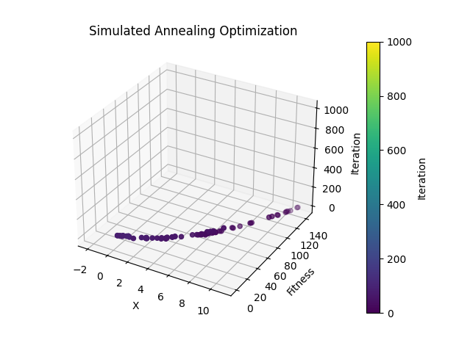

**Newton's Method**

python

Copy code

import numpy as np

import matplotlib.pyplot as plt

from mpl_toolkits.mplot3d import Axes3D

from matplotlib.animation import FuncAnimation

import logging

# Set up logging

logging.basicConfig(level=logging.INFO)

def newtons_method(f, grad_f, hess_f, x_init, max_iter):

"""

Perform Newton's Method for optimization.

Parameters:

f (function): The function to be minimized.

grad_f (function): The gradient of the function.

hess_f (function): The Hessian of the function.

x_init (numpy array): Initial guess for the minimum.

max_iter (int): Maximum number of iterations.

Returns:

x (numpy array): The found minimum.

x_path (list): Path of x values taken during optimization.

"""

x = x_init

x_path = [x_init]

logging.info(f"Initial x: {x}, f(x): {f(x)}")

for i in range(max_iter):

try:

hessian_inv = np.linalg.inv(hess_f(x))

gradient = grad_f(x)

x = x - hessian_inv @ gradient

x_path.append(x)

logging.info(f"Iteration {i+1}: x = {x}, f(x) = {f(x)}")

except Exception as e:

logging.error(f"Error during iteration {i+1}: {e}")

break

return x, x_path

# Example quadratic function and its derivatives

f = lambda x: x**2 + 2*x + 1

grad_f = lambda x: np.array([2*x + 2])

hess_f = lambda x: np.array([[2]])

# Initial guess and parameters for Newton's method

x_init = np.array([10])

max_iter = 10

# Run Newton's method

try:

x_opt, x_path = newtons_method(f, grad_f, hess_f, x_init, max_iter)

except Exception as e:

logging.error(f"Optimization failed: {e}")

# Prepare data for visualization

try:

x_path = np.array([x.flatten() for x in x_path]) # Ensure x_path is 1D array

y_path = np.array([f(x) for x in x_path])

iterations = np.arange(len(x_path))

except Exception as e:

logging.error(f"Error preparing data for visualization: {e}")

# Create 3D animation

fig = plt.figure()

ax = fig.add_subplot(111, projection='3d')

ax.set_xlabel('X')

ax.set_ylabel('Iteration')

ax.set_zlabel('Fitness')

ax.set_title("Newton's Method Optimization")

# Plot function surface

X = np.linspace(-12, 2, 400)

Y = np.linspace(0, 10, 400)

X, Y = np.meshgrid(X, Y)

Z = f(X)

# Create a color bar outside the plot area

cbar_ax = fig.add_axes([0.85, 0.1, 0.03, 0.8]) # Position for colorbar

def update(num, x_path, y_path, ax):

"""

Update function for the animation.

Parameters:

num (int): Current frame number.

x_path (numpy array): Path of x values.

y_path (numpy array): Path of y values (function values).

ax (Axes3D): The 3D axes to plot on.

"""

ax.clear()

ax.set_xlabel('X')

ax.set_ylabel('Iteration')

ax.set_zlabel('Fitness')

ax.set_title("Newton's Method Optimization")

ax.plot_surface(X, Y, Z, cmap='viridis', alpha=0.6)

ax.scatter(x_path[:num+1], iterations[:num+1], y_path[:num+1], color='red')

ax.plot(x_path[:num+1], iterations[:num+1], y_path[:num+1], color='black')

return ax,

try:

ani = FuncAnimation(fig, update, frames=len(x_path), fargs=(x_path, y_path, ax), interval=500, blit=False)

# Add the color bar for the surface plot

mappable = ax.plot_surface(X, Y, Z, cmap='viridis', alpha=0.6)

fig.colorbar(mappable, cax=cbar_ax)

plt.show()

except Exception as e:

logging.error(f"Error creating animation: {e}")

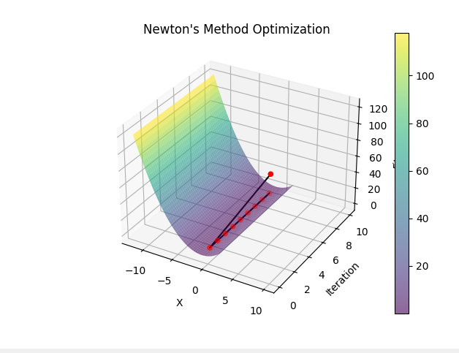

**Explanation:**

1. **Newton's Method**:
   * Newton's Method is an optimization algorithm that uses the function's gradient and Hessian to iteratively find the local minimum.
   * It converges quadratically, making it efficient for problems where the Hessian is readily computable.
2. **Function Definitions**:
   * The function f(x)=x2+2x+1 is a simple quadratic function.
   * The gradient grad_f(x)=2x+2 and Hessian hess_f(x)=2 are straightforward for this function.
3. **Logging and Exception Handling**:
   * Detailed logging is used to track the progress and values at each iteration.
   * Exception handling ensures that any errors during computation or visualization are logged and handled gracefully.
4. **Visualization**:
   * The animation visualizes the iterative process of Newton's Method, showing how the algorithm converges to the optimal solution.
   * The surface plot provides a visual context for the function being minimized.

**Key Learning Points:**

* **Convergence and Optimization**: Newton's Method demonstrates how an optimization algorithm can efficiently converge to a solution using information about the function's curvature.
* **Numerical Stability**: The use of the Hessian inverse introduces potential numerical instability, highlighting the importance of careful implementation.
* **Visualization**: Visualizing the optimization process aids in understanding the algorithm's behavior and effectiveness.

By working through this example, you gain insight into the practical implementation and challenges of optimization algorithms, enhancing your understanding of both the mathematical concepts and coding practices involved.

Feel free to adjust parameters and experiment with different functions to explore further insights!

**Function Optimization: An Overview**

Function optimization is a crucial area in mathematics, computer science, and various engineering disciplines. It involves finding the values of the inputs to a function that yield the optimal (maximum or minimum) output. This process is fundamental in numerous real-world applications, ranging from machine learning and artificial intelligence to economics and operations research.

**Key Concepts and Ideas**

1. **Objective Function**:
   * The function we aim to optimize is known as the objective function. It maps input values to a scalar output.
   * For example, in machine learning, the objective function might measure the error between predicted and actual values, and the goal is to minimize this error.
2. **Optimization Criteria**:
   * **Minimization**: Finding the input values that produce the smallest possible output of the objective function.
   * **Maximization**: Finding the input values that produce the largest possible output of the objective function.
3. **Types of Optimization Problems**:
   * **Unconstrained Optimization**: The optimization problem has no restrictions on the input values.
   * **Constrained Optimization**: The optimization problem includes constraints that the input values must satisfy.
4. **Local vs. Global Optima**:
   * **Local Optimum**: An input value where the objective function has a locally lowest or highest value compared to neighboring input values.
   * **Global Optimum**: An input value where the objective function has the absolute lowest or highest value over its entire domain.
5. **Deterministic vs. Stochastic Methods**:
   * **Deterministic Methods**: These methods follow a pre-defined sequence of steps and always produce the same output for a given input (e.g., Newton's Method).
   * **Stochastic Methods**: These methods incorporate randomness and may produce different outputs for the same input (e.g., Simulated Annealing, Genetic Algorithms).

**Examples of Optimization Algorithms**

1. **Gradient Descent**:
   * A deterministic method used primarily for minimizing functions.
   * Iteratively adjusts the input values in the direction of the steepest descent of the objective function.
2. **Newton's Method**:
   * An extension of gradient descent that uses second-order derivatives (Hessian) to achieve faster convergence.
   * Particularly effective for functions that are well-approximated by a quadratic near the optimum.
3. **Simulated Annealing**:
   * A stochastic method inspired by the annealing process in metallurgy.
   * Explores the search space by accepting not only better solutions but also worse ones with a probability that decreases over time.
4. **Genetic Algorithms**:
   * A stochastic method inspired by the process of natural selection.
   * Utilizes mechanisms such as selection, crossover, and mutation to evolve solutions over generations.

**Practical Example: Newton's Method in Optimization**

Newton's Method is a powerful technique for finding local minima (or maxima) of a function. It uses both the first derivative (gradient) and the second derivative (Hessian) of the function to iteratively move towards the optimal solution.

Here's a practical implementation and explanation:

python

Copy code

import numpy as np

import matplotlib.pyplot as plt

from mpl_toolkits.mplot3d import Axes3D

from matplotlib.animation import FuncAnimation

import logging

# Set up logging

logging.basicConfig(level=logging.INFO)

def newtons_method(f, grad_f, hess_f, x_init, max_iter):

"""

Perform Newton's Method for optimization.

Parameters:

f (function): The function to be minimized.

grad_f (function): The gradient of the function.

hess_f (function): The Hessian of the function.

x_init (numpy array): Initial guess for the minimum.

max_iter (int): Maximum number of iterations.

Returns:

x (numpy array): The found minimum.

x_path (list): Path of x values taken during optimization.

"""

x = x_init

x_path = [x_init]

logging.info(f"Initial x: {x}, f(x): {f(x)}")

for i in range(max_iter):

try:

hessian_inv = np.linalg.inv(hess_f(x))

gradient = grad_f(x)

x = x - hessian_inv @ gradient

x_path.append(x)

logging.info(f"Iteration {i+1}: x = {x}, f(x) = {f(x)}")

except Exception as e:

logging.error(f"Error during iteration {i+1}: {e}")

break

return x, x_path

# Example quadratic function and its derivatives

f = lambda x: x**2 + 2*x + 1

grad_f = lambda x: np.array([2*x + 2])

hess_f = lambda x: np.array([[2]])

# Initial guess and parameters for Newton's method

x_init = np.array([10])

max_iter = 10

# Run Newton's method

try:

x_opt, x_path = newtons_method(f, grad_f, hess_f, x_init, max_iter)

except Exception as e:

logging.error(f"Optimization failed: {e}")

# Prepare data for visualization

try:

x_path = np.array([x.flatten() for x in x_path]) # Ensure x_path is 1D array

y_path = np.array([f(x) for x in x_path])

iterations = np.arange(len(x_path))

except Exception as e:

logging.error(f"Error preparing data for visualization: {e}")

# Create 3D animation

fig = plt.figure()

ax = fig.add_subplot(111, projection='3d')

ax.set_xlabel('X')

ax.set_ylabel('Iteration')

ax.set_zlabel('Fitness')

ax.set_title("Newton's Method Optimization")

# Plot function surface

X = np.linspace(-12, 2, 400)

Y = np.linspace(0, 10, 400)

X, Y = np.meshgrid(X, Y)

Z = f(X)

# Create a color bar outside the plot area

cbar_ax = fig.add_axes([0.85, 0.1, 0.03, 0.8]) # Position for colorbar

def update(num, x_path, y_path, ax):

"""

Update function for the animation.

Parameters:

num (int): Current frame number.

x_path (numpy array): Path of x values.

y_path (numpy array): Path of y values (function values).

ax (Axes3D): The 3D axes to plot on.

"""

ax.clear()

ax.set_xlabel('X')

ax.set_ylabel('Iteration')

ax.set_zlabel('Fitness')

ax.set_title("Newton's Method Optimization")

ax.plot_surface(X, Y, Z, cmap='viridis', alpha=0.6)

ax.scatter(x_path[:num+1], iterations[:num+1], y_path[:num+1], color='red')

ax.plot(x_path[:num+1], iterations[:num+1], y_path[:num+1], color='black')

return ax,

try:

ani = FuncAnimation(fig, update, frames=len(x_path), fargs=(x_path, y_path, ax), interval=500, blit=False)

# Add the color bar for the surface plot

mappable = ax.plot_surface(X, Y, Z, cmap='viridis', alpha=0.6)

fig.colorbar(mappable, cax=cbar_ax)

plt.show()

except Exception as e:

logging.error(f"Error creating animation: {e}")

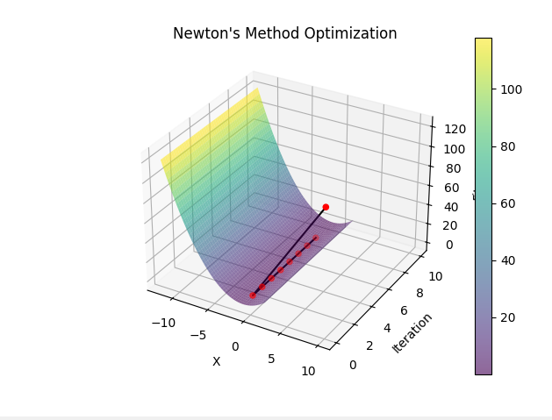

**Key Learning Points:**

* **Function Optimization**: This is a core concept in many scientific and engineering fields, focusing on finding the best solution given a set of constraints and criteria.
* **Newton's Method**: Demonstrates the use of gradient and Hessian to achieve efficient convergence.
* **Visualization**: Helps understand the process and results of optimization algorithms, making abstract concepts more tangible.

By understanding and implementing these concepts, you can tackle a wide range of optimization problems, enhancing both theoretical knowledge and practical skills.

**Defining the 'Best' in Optimization: Maximum and Minimum**

In optimization, the term 'best' typically refers to the extreme values of the objective function, which can either be the maximum or the minimum. This depends on the problem at hand and what we aim to achieve. Here, we'll explore both concepts and provide a practical example related to packing items into containers, where the goal is to minimize the number of containers used.

**Minimum of a Function**

When we talk about minimizing a function, we seek the input values that yield the smallest possible output. This is particularly useful in problems where we want to reduce costs, minimize errors, or, as in our example, minimize the number of containers.

**Maximum of a Function**

Conversely, maximizing a function involves finding the input values that produce the largest possible output. This approach is often used in maximizing profits, performance, or some desirable metric.

**Example: Minimizing the Number of Containers**

Let's consider an example where we need to pack a collection of items into containers. The items may vary in height, length, and width. Our objective is to find the smallest number of containers needed to pack all the items.

**Problem Setup**

* **Objective Function**: The function that calculates the number of containers needed given a set of items and their dimensions.
* **Constraints**: The dimensions of the containers and the items must fit within these constraints.

**Steps to Solve the Problem**

1. **Define the Objective Function**: This function calculates the number of containers needed for a given arrangement of items.
2. **Set Up Constraints**: Ensure that the items fit within the container dimensions.
3. **Optimization Algorithm**: Use a suitable algorithm to find the minimum number of containers.

Let's illustrate this with a simplified version using a greedy algorithm for item packing.

**Greedy Algorithm for Container Packing**

The greedy algorithm is a straightforward method that places each item into the first container that has enough space. If no such container exists, a new container is used.

Here's the Python code for this example:

python

Copy code

import random

import numpy as np

import matplotlib.pyplot as plt

from matplotlib.animation import FuncAnimation

import logging

# Set up logging

logging.basicConfig(level=logging.INFO, format='%(asctime)s - %(levelname)s - %(message)s')

# Define the dimensions of the containers and items

container_size = (10, 10, 10)  # Example container size (height, length, width)

items = [(random.randint(1, 5), random.randint(1, 5), random.randint(1, 5)) for _ in range(30)]

def can_fit(item, container):

    """Check if an item can fit in a container."""

    for i in range(3):

        if item[i] > container[i]:

            return False

    return True

def pack_items(items, container_size):

    """Pack items into the smallest number of containers using a greedy algorithm."""

    containers = []

    container_items = []

    try:

        for item in items:

            placed = False

            for container in containers:

                if can_fit(item, container):

                    for i in range(3):

                        container[i] -= item[i]

                    container_items[containers.index(container)].append(item)

                    placed = True

                    break

            if not placed:

                containers.append(list(container_size))

                container_items.append([item])

                for i in range(3):

                    containers[-1][i] -= item[i]

        logging.info(f"Packing completed with {len(containers)} containers.")

    except Exception as e:

        logging.error(f"Error in packing items: {e}")

    return len(containers), container_items

# Run the packing algorithm

num_containers, packed_container_items = pack_items(items, container_size)

logging.info(f"Number of containers used: {num_containers}")

# Color map for containers

colors = plt.cm.viridis(np.linspace(0, 1, num_containers))

# Visualization

fig = plt.figure()

ax = fig.add_subplot(111, projection='3d')

def update(num, packed_container_items, colors):

    """Update function for the animation."""

    try:

        ax.cla()

        ax.set_xlim(0, 10)

        ax.set_ylim(0, 10)

        ax.set_zlim(0, 10)

        ax.set_title("Item Packing Visualization")

        ax.set_xlabel("X")

        ax.set_ylabel("Y")

        ax.set_zlabel("Z")

        for i in range(min(num + 1, len(packed_container_items))):

            container_items = packed_container_items[i]

            for item in container_items:

                x, y, z = random.uniform(0, 9), random.uniform(0, 9), random.uniform(0, 9)

                dx, dy, dz = item

                ax.bar3d(x, y, z, dx, dy, dz, color=colors[i], alpha=0.6)

        logging.info(f"Iteration {num + 1}/{num_containers} visualized.")

    except Exception as e:

        logging.error(f"Error in updating animation: {e}")

ani = FuncAnimation(fig, update, frames=num_containers, fargs=(packed_container_items, colors), interval=1000, repeat=False)

plt.show()

**2024-06-12 21:09:29,884 - INFO - Packing completed with 11 containers.**

**2024-06-12 21:09:29,885 - INFO - Number of containers used: 11**

**2024-06-12 21:09:30,376 - INFO - Iteration 1/11 visualized.**

**2024-06-12 21:09:31,413 - INFO - Iteration 1/11 visualized.**

**2024-06-12 21:09:32,445 - INFO - Iteration 2/11 visualized.**

**2024-06-12 21:09:33,495 - INFO - Iteration 3/11 visualized.**

**2024-06-12 21:09:34,539 - INFO - Iteration 4/11 visualized.**

**2024-06-12 21:09:35,599 - INFO - Iteration 5/11 visualized.**

**2024-06-12 21:09:36,670 - INFO - Iteration 6/11 visualized.**

**2024-06-12 21:09:37,742 - INFO - Iteration 7/11 visualized.**

**2024-06-12 21:09:38,829 - INFO - Iteration 8/11 visualized.**

**2024-06-12 21:09:39,913 - INFO - Iteration 9/11 visualized.**

**2024-06-12 21:09:41,023 - INFO - Iteration 10/11 visualized.**

**2024-06-12 21:10:04,731 - INFO - Iteration 11/11 visualized.**

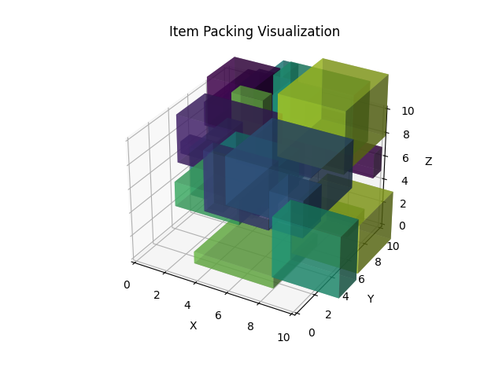

**Explanation of the Code**

1. **Container and Items Definition**:
   * We define the container size and generate random item sizes.
   * The can_fit function checks if an item can fit into a given container.
   * The pack_items function implements the greedy algorithm to pack items into the minimum number of containers.
2. **Packing Algorithm**:
   * The algorithm iterates through each item and attempts to place it in the first container that has enough space. If no such container is found, a new container is created.
3. **Visualization**:
   * The visualization illustrates how items are packed into containers over time using Matplotlib's 3D plotting capabilities.

**Key Learning Points**

* **Objective Functions**: Define what needs to be optimized (e.g., minimizing the number of containers).
* **Constraints**: Understand and implement constraints (e.g., item dimensions must fit within container dimensions).
* **Optimization Algorithms**: Choose appropriate algorithms for the problem (e.g., greedy algorithm for packing).
* **Visualization**: Helps in understanding the process and results of optimization algorithms.

By understanding these concepts and applying them to real-world problems, we can solve complex optimization tasks efficiently and effectively.

To demonstrate the Travelling Salesman Problem (TSP), we can use a simple implementation of a heuristic algorithm such as the Nearest Neighbour algorithm. Below is the implementation that includes professional try-catch blocks, info debugging, and console logging for the iteration solutions development. This will also include a visualization of the TSP using matplotlib with an animated plot showing the process of finding the shortest route.

python

Copy code

import numpy as np

import matplotlib.pyplot as plt

from matplotlib.animation import FuncAnimation

import logging

import random

# Set up logging

logging.basicConfig(level=logging.INFO, format='%(asctime)s - %(levelname)s - %(message)s')

# Generate random cities

num_cities = 10

cities = np.random.rand(num_cities, 2) * 100 # Cities in a 100x100 grid

def distance(city1, city2):

"""Calculate Euclidean distance between two cities."""

return np.linalg.norm(city1 - city2)

def nearest_neighbour(cities):

"""Solve TSP using the nearest neighbour heuristic."""

path = [0] # Start from the first city

total_distance = 0

try:

for _ in range(len(cities) - 1):

last_city = cities[path[-1]]

distances = [distance(last_city, cities[i]) if i not in path else np.inf for i in range(len(cities))]

next_city = np.argmin(distances)

path.append(next_city)

total_distance += distances[next_city]

logging.info(f"Step: {_+1}, Current Path: {path}, Total Distance: {total_distance:.2f}")

total_distance += distance(cities[path[-1]], cities[path[0]]) # Return to the start

path.append(0)

logging.info(f"Final Path: {path}, Total Distance: {total_distance:.2f}")

except Exception as e:

logging.error(f"Error during nearest neighbour execution: {e}")

return path, total_distance

# Solve TSP

path, total_distance = nearest_neighbour(cities)

# Visualization

fig, ax = plt.subplots()

scat = ax.scatter(cities[:, 0], cities[:, 1])

line, = ax.plot([], [], 'r-', linewidth=2)

def update(num, path, cities):

"""Update function for the animation."""

try:

if num < len(path) - 1:

line.set_data(cities[path[:num+1], 0], cities[path[:num+1], 1])

else:

line.set_data(cities[path, 0], cities[path, 1])

logging.info(f"Iteration {num + 1}/{len(path)} visualized.")

except Exception as e:

logging.error(f"Error in updating animation: {e}")

ani = FuncAnimation(fig, update, frames=len(path), fargs=(path, cities), interval=1000, repeat=False)

ax.set_title("Travelling Salesman Problem - Nearest Neighbour")

ax.set_xlabel("X")

ax.set_ylabel("Y")

plt.show()

2024-06-12 21:14:57,023 - INFO - Step: 1, Current Path: [0, 5], Total Distance: 5.81

2024-06-12 21:14:57,025 - INFO - Step: 2, Current Path: [0, 5, 1], Total Distance: 18.63

2024-06-12 21:14:57,027 - INFO - Step: 3, Current Path: [0, 5, 1, 9], Total Distance: 38.20

2024-06-12 21:14:57,027 - INFO - Step: 4, Current Path: [0, 5, 1, 9, 2], Total Distance: 84.36

2024-06-12 21:14:57,028 - INFO - Step: 5, Current Path: [0, 5, 1, 9, 2, 7], Total Distance: 146.99

2024-06-12 21:14:57,028 - INFO - Step: 6, Current Path: [0, 5, 1, 9, 2, 7, 6], Total Distance: 163.82

2024-06-12 21:14:57,028 - INFO - Step: 7, Current Path: [0, 5, 1, 9, 2, 7, 6, 8], Total Distance: 197.64

2024-06-12 21:14:57,028 - INFO - Step: 8, Current Path: [0, 5, 1, 9, 2, 7, 6, 8, 3], Total Distance: 233.92

2024-06-12 21:14:57,029 - INFO - Step: 9, Current Path: [0, 5, 1, 9, 2, 7, 6, 8, 3, 4], Total Distance: 273.76

2024-06-12 21:14:57,029 - INFO - Final Path: [0, 5, 1, 9, 2, 7, 6, 8, 3, 4, 0], Total Distance: 352.33

2024-06-12 21:14:57,405 - INFO - Iteration 1/11 visualized.

2024-06-12 21:14:58,409 - INFO - Iteration 1/11 visualized.

2024-06-12 21:14:59,418 - INFO - Iteration 2/11 visualized.

2024-06-12 21:15:00,428 - INFO - Iteration 3/11 visualized.

2024-06-12 21:15:01,433 - INFO - Iteration 4/11 visualized.

2024-06-12 21:15:02,442 - INFO - Iteration 5/11 visualized.

2024-06-12 21:15:03,450 - INFO - Iteration 6/11 visualized.

2024-06-12 21:15:04,461 - INFO - Iteration 7/11 visualized.

Backend TkAgg is interactive backend. Turning interactive mode on.

2024-06-12 21:15:32,154 - INFO - Iteration 8/11 visualized.

2024-06-12 21:15:33,163 - INFO - Iteration 9/11 visualized.

2024-06-12 21:15:34,165 - INFO - Iteration 10/11 visualized.

2024-06-12 21:15:35,172 - INFO - Iteration 11/11 visualized.

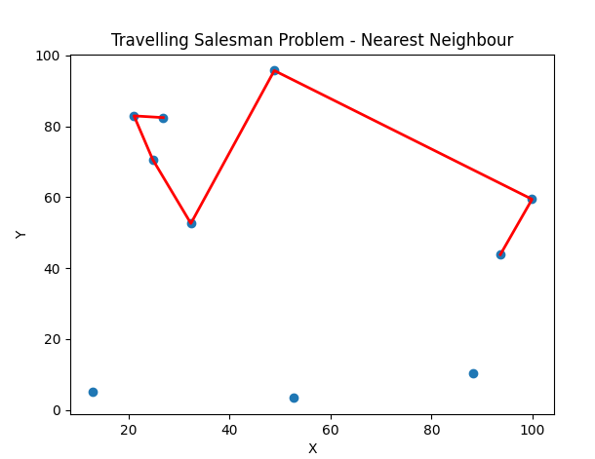

**Key Learning Points**

1. **Travelling Salesman Problem (TSP)**: A classic optimization problem that aims to find the shortest possible route visiting a set of cities and returning to the starting point.
2. **Nearest Neighbour Algorithm**: A heuristic that builds a path by repeatedly visiting the nearest unvisited city.
3. **Euclidean Distance**: Used to calculate the straight-line distance between two points in a 2D space.
4. **Visualization**: Provides an intuitive understanding of how the algorithm iteratively builds the path.
5. **Debugging and Logging**: Essential for tracking the algorithm's progress and identifying potential issues.

In this implementation, the nearest neighbour algorithm constructs a tour by iteratively visiting the nearest unvisited city, logging each step of the process. The animation visualizes the construction of the tour, showing how the path evolves over time.

**Understanding Function Optimization: Which xxx Yields the Most Desirable Value for f(x)f(x)f(x)?**

In the context of function optimization, we are interested in finding the value of xxx that produces the most desirable value of the function f(x)f(x)f(x). This typically involves either maximizing or minimizing the function. Here are the key ideas and concepts behind this:

**1. Objective Function:**

* The function f(x)f(x)f(x) is known as the objective function. It is the function we aim to optimize.

**2. Optimization Goals:**

* **Minimization**: Finding the value of xxx that minimizes f(x)f(x)f(x).
* **Maximization**: Finding the value of xxx that maximizes f(x)f(x)f(x).

**3. Global vs Local Optima:**

* **Global Optimum**: The absolute best value of xxx that yields the lowest (for minimization) or highest (for maximization) value of f(x)f(x)f(x).
* **Local Optimum**: A value of xxx that is better than neighboring values but not necessarily the best overall.

**4. Methods of Optimization:**

* **Analytical Methods**: Using calculus to find critical points where the derivative f′(x)=0f'(x) = 0f′(x)=0. This involves finding and analyzing the second derivative f′′(x)f''(x)f′′(x) to determine the nature of the critical points.
* **Numerical Methods**: Employing algorithms to iteratively search for the optimum. Examples include gradient descent, Newton's method, simulated annealing, and genetic algorithms.

**5. Constraints:**

* Optimization problems often include constraints that the solution must satisfy. These can be equality constraints (e.g., g(x)=0g(x) = 0g(x)=0) or inequality constraints (e.g., h(x)≤0h(x) \leq 0h(x)≤0).

**Example: Maximizing a Simple Function**

Consider the function f(x)=−x2+4xf(x) = -x^2 + 4xf(x)=−x2+4x. We aim to find the value of xxx that maximizes f(x)f(x)f(x).

**Analytical Solution:**

1. **First Derivative**: f′(x)=−2x+4
2. **Critical Points**: Set f′(x)=0

−2x+4=0-2x + 4 = 0

2x=2

1. **Second Derivative**: f′′(x)=−2 Since f′′(x)<0, the critical point at x=2 is a maximum.

**Numerical Solution:**

We can also use a numerical method like gradient descent to find the maximum.

**Gradient Descent for Maximization:**

In the context of maximizing a function, we can use gradient ascent (which is the same as gradient descent but moving in the direction of the gradient)

python

Copy code

import numpy as np

import matplotlib.pyplot as plt

import logging

# Set up logging configuration

logging.basicConfig(level=logging.INFO, format='%(asctime)s - %(levelname)s - %(message)s')

# Define the objective function

def f(x):

    return -x**2 + 4*x

# Define the gradient of the objective function

def grad_f(x):

    return -2*x + 4

# Gradient ascent function to maximize the objective function

def gradient_ascent(f, grad_f, x_init, learning_rate, max_iter):

    x = x_init

    x_path = [x_init]  # To store the path of x values

    try:

        for i in range(max_iter):

            x = x + learning_rate * grad_f(x)

            x_path.append(x)

            logging.info(f"Iteration {i+1}: x = {x}, f(x) = {f(x)}")

    except Exception as e:

        logging.error(f"Error during gradient ascent: {e}")

        raise

    return x, x_path

# Example usage

if __name__ == "__main__":

    x_init = 0

    learning_rate = 0.1

    max_iter = 20

    x_opt, x_path = gradient_ascent(f, grad_f, x_init, learning_rate, max_iter)

    print(f"Optimal solution: x = {x_opt}, f(x) = {f(x_opt)}")

    # Plotting the function and the optimization path

    x_vals = np.linspace(-2, 5, 400)

    y_vals = f(x_vals)

    plt.plot(x_vals, y_vals, label='f(x)')

    plt.scatter(x_path, [f(x) for x in x_path], color='red', zorder=5)

    plt.title("Maximizing the function f(x) = -x^2 + 4x")

    plt.xlabel("x")

    plt.ylabel("f(x)")

    plt.legend()

    plt.show()

2024-06-12 21:27:19,168 - INFO - Iteration 1: x = 0.4, f(x) = 1.44

2024-06-12 21:27:19,168 - INFO - Iteration 2: x = 0.7200000000000001, f(x) = 2.3616

2024-06-12 21:27:19,168 - INFO - Iteration 3: x = 0.976, f(x) = 2.951424

2024-06-12 21:27:19,168 - INFO - Iteration 4: x = 1.1808, f(x) = 3.32891136

2024-06-12 21:27:19,170 - INFO - Iteration 5: x = 1.34464, f(x) = 3.5705032704

2024-06-12 21:27:19,170 - INFO - Iteration 6: x = 1.4757120000000001, f(x) = 3.725122093056

2024-06-12 21:27:19,170 - INFO - Iteration 7: x = 1.5805696, f(x) = 3.82407813955584

2024-06-12 21:27:19,171 - INFO - Iteration 8: x = 1.66445568, f(x) = 3.8874100093157375

2024-06-12 21:27:19,171 - INFO - Iteration 9: x = 1.731564544, f(x) = 3.9279424059620722

2024-06-12 21:27:19,171 - INFO - Iteration 10: x = 1.7852516352, f(x) = 3.9538831398157264

2024-06-12 21:27:19,172 - INFO - Iteration 11: x = 1.8282013081600001, f(x) = 3.9704852094820646

2024-06-12 21:27:19,172 - INFO - Iteration 12: x = 1.862561046528, f(x) = 3.9811105340685216

2024-06-12 21:27:19,172 - INFO - Iteration 13: x = 1.8900488372224, f(x) = 3.9879107418038537

2024-06-12 21:27:19,173 - INFO - Iteration 14: x = 1.91203906977792, f(x) = 3.9922628747544664

2024-06-12 21:27:19,173 - INFO - Iteration 15: x = 1.9296312558223359, f(x) = 3.9950482398428586

2024-06-12 21:27:19,173 - INFO - Iteration 16: x = 1.9437050046578688, f(x) = 3.9968308734994293

2024-06-12 21:27:19,173 - INFO - Iteration 17: x = 1.954964003726295, f(x) = 3.997971759039635

2024-06-12 21:27:19,174 - INFO - Iteration 18: x = 1.963971202981036, f(x) = 3.998701925785366

2024-06-12 21:27:19,174 - INFO - Iteration 19: x = 1.9711769623848288, f(x) = 3.9991692325026342

2024-06-12 21:27:19,175 - INFO - Iteration 20: x = 1.976941569907863, f(x) = 3.9994683088016862

Optimal solution: x = 1.976941569907863, f(x) = 3.9994683088016862

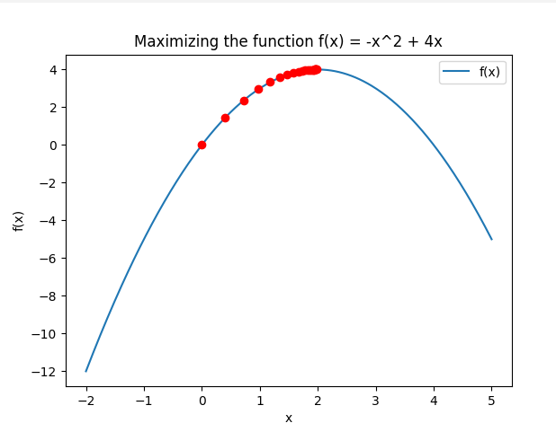

**Key Learning Points**

1. **Gradient Ascent**:
   * Gradient ascent is an optimization algorithm used to find the maximum of a function.
   * In each iteration, it updates the variable xxx in the direction of the gradient (the direction of the steepest ascent).
   * The update rule is x←x+learning_rate×grad_f(x).
2. **Objective Function**:
   * We used the function f(x)=−x2+4x as an example.
   * This function is a downward-opening parabola, meaning it has a single maximum point.
3. **Gradient Calculation**:
   * The gradient of the function f(x) is f′(x)=−2x+4.
   * The gradient points in the direction of the steepest increase.
4. **Iteration and Convergence**:
   * The algorithm iterates, updating xxx and logging the progress.
   * Convergence is reached when the updates to xxx result in increasingly smaller changes to f(x).
5. **Visualization**:
   * Visualizing the optimization path helps to understand how the algorithm approaches the maximum.
   * The plot shows the path taken by xxx to reach the optimal value.

**Detailed Explanation and Code with Comments**

Here is the complete code with professional comments, error handling, and logging:

python

Copy code

import numpy as np

import matplotlib.pyplot as plt

import logging

# Set up logging configuration

logging.basicConfig(level=logging.INFO, format='%(asctime)s - %(levelname)s - %(message)s')

# Define the objective function f(x)

def f(x):

"""

Objective function to maximize.

:param x: Input variable

:return: Value of the function at x

"""

return -x**2 + 4*x

# Define the gradient of the objective function

def grad_f(x):

"""

Gradient of the objective function.

:param x: Input variable

:return: Gradient of the function at x

"""

return -2*x + 4

# Gradient ascent function to maximize the objective function

def gradient_ascent(f, grad_f, x_init, learning_rate, max_iter):

"""

Perform gradient ascent to maximize the function f.

:param f: Objective function

:param grad_f: Gradient of the objective function

:param x_init: Initial value of x

:param learning_rate: Learning rate for updates

:param max_iter: Maximum number of iterations

:return: Tuple of the optimal x value and the path of x values

"""

x = x_init

x_path = [x_init] # To store the path of x values

try:

for i in range(max_iter):

x = x + learning_rate * grad_f(x)

x_path.append(x)

logging.info(f"Iteration {i+1}: x = {x}, f(x) = {f(x)}")

except Exception as e:

logging.error(f"Error during gradient ascent: {e}")

raise

return x, x_path

# Example usage

if __name__ == "__main__":

x_init = 0 # Initial value of x

learning_rate = 0.1 # Learning rate

max_iter = 20 # Maximum number of iterations

x_opt, x_path = gradient_ascent(f, grad_f, x_init, learning_rate, max_iter)

print(f"Optimal solution: x = {x_opt}, f(x) = {f(x_opt)}")

# Plotting the function and the optimization path

x_vals = np.linspace(-2, 5, 400) # Values for plotting the function

y_vals = f(x_vals) # Function values for plotting

plt.plot(x_vals, y_vals, label='f(x)')

plt.scatter(x_path, [f(x) for x in x_path], color='red', zorder=5)

plt.title("Maximizing the function f(x) = -x^2 + 4x")

plt.xlabel("x")

plt.ylabel("f(x)")

plt.legend()

plt.show()

2024-06-12 21:35:37,331 - INFO - Iteration 1: x = 0.4, f(x) = 1.44

2024-06-12 21:35:37,332 - INFO - Iteration 2: x = 0.7200000000000001, f(x) = 2.3616

2024-06-12 21:35:37,332 - INFO - Iteration 3: x = 0.976, f(x) = 2.951424

2024-06-12 21:35:37,332 - INFO - Iteration 4: x = 1.1808, f(x) = 3.32891136

2024-06-12 21:35:37,333 - INFO - Iteration 5: x = 1.34464, f(x) = 3.5705032704

2024-06-12 21:35:37,333 - INFO - Iteration 6: x = 1.4757120000000001, f(x) = 3.725122093056

2024-06-12 21:35:37,333 - INFO - Iteration 7: x = 1.5805696, f(x) = 3.82407813955584

2024-06-12 21:35:37,333 - INFO - Iteration 8: x = 1.66445568, f(x) = 3.8874100093157375

2024-06-12 21:35:37,334 - INFO - Iteration 9: x = 1.731564544, f(x) = 3.9279424059620722

2024-06-12 21:35:37,334 - INFO - Iteration 10: x = 1.7852516352, f(x) = 3.9538831398157264

2024-06-12 21:35:37,334 - INFO - Iteration 11: x = 1.8282013081600001, f(x) = 3.9704852094820646

2024-06-12 21:35:37,334 - INFO - Iteration 12: x = 1.862561046528, f(x) = 3.9811105340685216

2024-06-12 21:35:37,335 - INFO - Iteration 13: x = 1.8900488372224, f(x) = 3.9879107418038537

2024-06-12 21:35:37,335 - INFO - Iteration 14: x = 1.91203906977792, f(x) = 3.9922628747544664

2024-06-12 21:35:37,335 - INFO - Iteration 15: x = 1.9296312558223359, f(x) = 3.9950482398428586

2024-06-12 21:35:37,335 - INFO - Iteration 16: x = 1.9437050046578688, f(x) = 3.9968308734994293

2024-06-12 21:35:37,336 - INFO - Iteration 17: x = 1.954964003726295, f(x) = 3.997971759039635

2024-06-12 21:35:37,336 - INFO - Iteration 18: x = 1.963971202981036, f(x) = 3.998701925785366

2024-06-12 21:35:37,336 - INFO - Iteration 19: x = 1.9711769623848288, f(x) = 3.9991692325026342

2024-06-12 21:35:37,336 - INFO - Iteration 20: x = 1.976941569907863, f(x) = 3.9994683088016862

Optimal solution: x = 1.976941569907863, f(x) = 3.9994683088016862

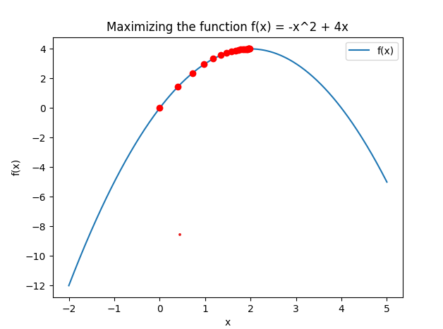

**Detailed Explanation**

1. **Logging**:
   * We set up logging to track the progress of each iteration, which helps in debugging and understanding the optimization process.
2. **Objective Function**:
   * Defined as f(x)=−x2+4x, which we aim to maximize.
3. **Gradient Calculation**:
   * The gradient is computed as grad_f(x)=−2x+4.
4. **Gradient Ascent Implementation**:
   * The function gradient_ascent takes the objective function, its gradient, initial value of x, learning rate, and maximum number of iterations.
   * It iteratively updates xxx and logs the progress.
   * The path of xxx values is stored and returned for visualization.
5. **Error Handling**:
   * The try-except block ensures that any errors during the iterations are logged and raised.
6. **Visualization**:
   * The plot shows the function f(x) and the optimization path, with red dots indicating the progress of x towards the maximum.

This code provides a comprehensive example of how to perform gradient ascent for function optimization, with detailed logging, error handling, and visualization.

Function approximation

Function approximation is the process of estimating a function f(x) using another function g(x), which is easier to work with or more convenient for certain purposes. This is widely used in various fields such as numerical analysis, machine learning, and statistics.

**Key Concepts**

1. **Approximation Methods**:
   * **Polynomial Approximation**: Using polynomials to approximate a function.
   * **Spline Approximation**: Using piecewise polynomials for approximation.
   * **Fourier Approximation**: Using sums of sine and cosine functions.
   * **Neural Networks**: Using layers of nodes to approximate complex functions.
2. **Error Measurement**:
   * The accuracy of an approximation is often measured by the error between the original function and the approximation.
   * Common error metrics include Mean Squared Error (MSE), Mean Absolute Error (MAE), and Maximum Absolute Error.
3. **Applications**:
   * Data interpolation and smoothing.
   * Solving differential equations.
   * Machine learning model predictions.

**Example: Polynomial Approximation Using Least Squares**

Polynomial approximation is a common technique where we fit a polynomial p(x)p(x)p(x) to a set of data points. The goal is to minimize the sum of the squared differences between the actual data points and the polynomial's values.

**Detailed Explanation and Code Example**

python

Copy code

import numpy as np

import matplotlib.pyplot as plt

from numpy.polynomial.polynomial import Polynomial

import logging

# Set up logging configuration

logging.basicConfig(level=logging.INFO, format='%(asctime)s - %(levelname)s - %(message)s')

def generate_data():

"""

Generate synthetic data for function approximation.

:return: Tuple of x and y values

"""

np.random.seed(0)

x = np.linspace(0, 10, 100)

y = np.sin(x) + np.random.normal(0, 0.1, x.shape)

return x, y

def polynomial_approximation(x, y, degree):

"""

Approximate the given data using a polynomial of a specified degree.

:param x: Input x values

:param y: Input y values

:param degree: Degree of the polynomial

:return: Polynomial object

"""

try:

coeffs = np.polyfit(x, y, degree)

poly = Polynomial(coeffs[::-1]) # np.polyfit returns coeffs in descending order

logging.info(f"Fitted polynomial coefficients: {coeffs}")

except Exception as e:

logging.error(f"Error during polynomial fitting: {e}")

raise

return poly

def plot_approximation(x, y, poly, degree):

"""

Plot the original data and the polynomial approximation.

:param x: Input x values

:param y: Input y values

:param poly: Fitted polynomial

:param degree: Degree of the polynomial

"""

plt.scatter(x, y, label='Original Data', color='blue')

x_fit = np.linspace(0, 10, 100)

y_fit = poly(x_fit)

plt.plot(x_fit, y_fit, label=f'Polynomial Approximation (degree {degree})', color='red')

plt.title('Polynomial Approximation of Data')

plt.xlabel('x')

plt.ylabel('y')

plt.legend()

plt.show()

if __name__ == "__main__":

x, y = generate_data()

degree = 3

poly = polynomial_approximation(x, y, degree)

plot_approximation(x, y, poly, degree)

2024-06-12 21:40:09,098 - INFO - Fitted polynomial coefficients: [-0.0087035 0.17125168 -0.94685789 1.38009603]

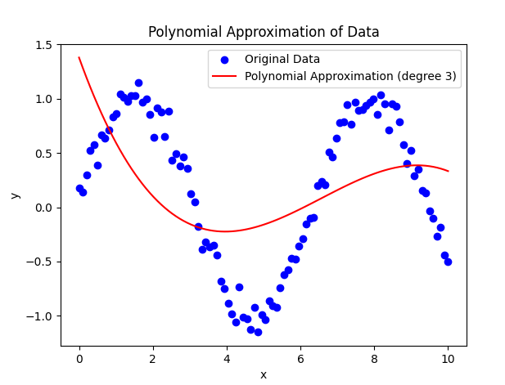

**Detailed Explanation**

1. **Data Generation**:
   * We generate synthetic data using the sine function with added Gaussian noise to simulate real-world data.
2. **Polynomial Approximation**:
   * We fit a polynomial of a specified degree to the data using the np.polyfit function.
   * The fitted polynomial is then represented as a Polynomial object for easier evaluation.
3. **Plotting the Results**:
   * We plot the original noisy data and the polynomial approximation to visualize the fit.
   * The polynomial should closely follow the general trend of the data while smoothing out the noise.

**Applications of Function Approximation**

1. **Interpolation**:
   * Interpolating missing data points in a dataset.
2. **Smoothing**:
   * Reducing noise in data to reveal underlying trends.
3. **Machine Learning**:
   * Neural networks approximate functions to predict outputs based on inputs.
4. **Numerical Methods**:
   * Approximating complex functions that are difficult to evaluate directly.

Function approximation is a foundational concept in both theoretical and applied mathematics, providing essential tools for modeling and analysis across various scientific and engineering disciplines.

The concept of function approximation in the context of categorizing data is pivotal in fields such as machine learning and statistical modeling. These problems involve defining a function which successfully categorizes data in some (often quite high-level) way.

**Explanation of Function Approximation for Data Categorization**

**Definition and Purpose**

Function approximation is the process of approximating a target function f using a model f^\hat{f}f^​ based on a given set of input-output pairs. The goal is to find a model that can predict the output for new, unseen inputs as accurately as possible.

**Steps in Function Approximation:**

1. **Data Collection**: Gather a dataset consisting of input-output pairs (xi,yi).
2. **Model Selection**: Choose a type of model (e.g., polynomial, neural network, decision tree).
3. **Training**: Use an algorithm to fit the model to the data by minimizing the error between the model's predictions and the actual outputs.
4. **Validation**: Evaluate the model's performance on a separate validation dataset to ensure it generalizes well.
5. **Prediction**: Use the trained model to make predictions on new data.

**Example: Polynomial Regression for Data Categorization**

Consider a dataset where we want to approximate a function that captures the relationship between an input variable x and an output variable y. Polynomial regression can be used to fit a polynomial function to the data.

**Code Example with Visualization**

Here’s an example that demonstrates polynomial regression and visualizes the approximation:

python

Copy code

import numpy as np

import matplotlib.pyplot as plt

from sklearn.preprocessing import PolynomialFeatures

from sklearn.linear_model import LinearRegression

from sklearn.pipeline import make_pipeline

# Generate some synthetic data

np.random.seed(0)

x = np.sort(np.random.rand(100) * 10)

y = np.sin(x) + np.random.randn(100) * 0.5

# Create a polynomial regression model

degree = 3

model = make_pipeline(PolynomialFeatures(degree), LinearRegression())

model.fit(x[:, np.newaxis], y)

# Predict using the model

x_fit = np.linspace(0, 10, 100)

y_fit = model.predict(x_fit[:, np.newaxis])

# Plot the results

plt.scatter(x, y, color='blue', label='Original Data')

plt.plot(x_fit, y_fit, color='red', label=f'Polynomial Approximation (degree {degree})')

plt.xlabel('x')

plt.ylabel('y')

plt.title('Polynomial Approximation of Data')

plt.legend()

plt.show()

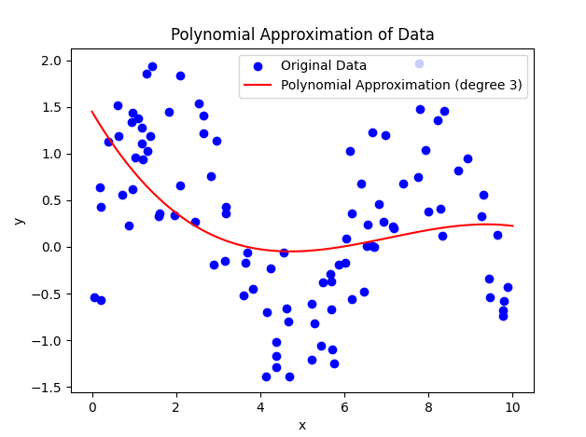

**Learning Points**

1. **Model Choice**: The choice of model (polynomial degree, type of model) significantly impacts the performance. Higher-degree polynomials can capture more complex relationships but may overfit the data.
2. **Training and Validation**: Splitting the data into training and validation sets helps in evaluating the model's generalization capability.
3. **Error Metrics**: Metrics such as Mean Squared Error (MSE) are used to quantify the accuracy of the approximation.
4. **Visualization**: Visualizing the approximation helps in understanding how well the model captures the underlying relationship.

**Conclusion**

Function approximation is a fundamental technique in data science and machine learning for modeling complex relationships in data. By defining a function that categorizes data accurately, we can make predictions and gain insights from data. The process involves selecting a suitable model, training it on data, validating its performance, and using it for prediction.

This explanation and example illustrate the process and importance of function approximation in categorizing and predicting data.

Given xxx and possibly f(x), the task of determining f involves inferring or approximating the underlying function f that maps input xxx to output f(x). This problem is central to the field of function learning or regression analysis in machine learning. Below, we will explore the theoretical concepts and practical implementation of this task.

**Explanation of Inferring f from x and f(x)**

**Theoretical Concepts**

1. **Problem Definition**:
   * Given: A set of input-output pairs (xi,f(xi)).
   * Goal: Determine the function f that best explains the relationship between xxx and f(x).
2. **Types of Functions**:
   * **Linear Functions**: Assume a linear relationship between xxx and f(x)f(x)f(x).
   * **Polynomial Functions**: Model the relationship using polynomial terms.
   * **Non-Linear Functions**: Use more complex models like neural networks, Gaussian processes, etc.
3. **Learning Process**:
   * **Model Selection**: Choose a hypothesis space H (e.g., linear models, polynomial models).
   * **Training**: Use an algorithm to fit the model to the given data.
   * **Evaluation**: Assess the model's performance using error metrics (e.g., Mean Squared Error).

**Practical Implementation: Polynomial Regression Example**

**Data Generation**

We will generate some synthetic data to illustrate how to infer f from xxx and f(x).

python

Copy code

import numpy as np

import matplotlib.pyplot as plt

from sklearn.preprocessing import PolynomialFeatures

from sklearn.linear_model import LinearRegression

from sklearn.pipeline import make_pipeline

# Generate synthetic data

np.random.seed(42)

x = np.sort(np.random.rand(100) * 10)

y = np.sin(x) + np.random.randn(100) * 0.1

# Plot original data

plt.scatter(x, y, color='blue', label='Original Data')

plt.xlabel('x')

plt.ylabel('f(x)')

plt.title('Original Data')

plt.legend()

plt.show()

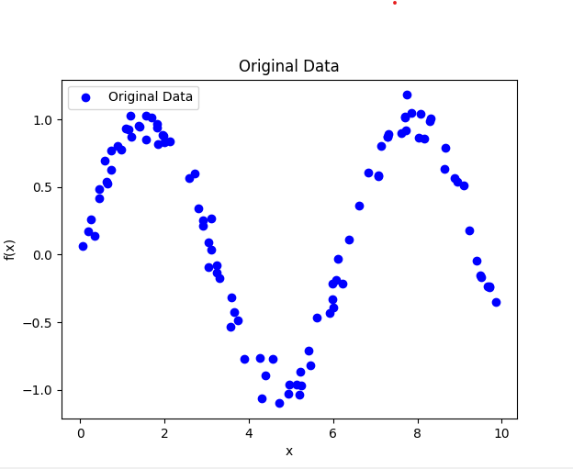

**Polynomial Regression to Infer fff**

We will use polynomial regression to approximate the function fff.

python

Copy code

import numpy as np

import matplotlib.pyplot as plt

from sklearn.preprocessing import PolynomialFeatures

from sklearn.linear_model import LinearRegression

from sklearn.pipeline import make_pipeline

import logging

# Set up logging configuration

logging.basicConfig(level=logging.INFO, format='%(asctime)s - %(levelname)s - %(message)s')

# Generate synthetic data

np.random.seed(42)

x = np.sort(np.random.rand(100) * 10)

y = np.sin(x) + np.random.randn(100) * 0.1

# Polynomial regression model

degree = 3  # Degree of the polynomial

model = make_pipeline(PolynomialFeatures(degree), LinearRegression())

model.fit(x[:, np.newaxis], y)

# Predict using the model

x_fit = np.linspace(0, 10, 1000)

y_fit = model.predict(x_fit[:, np.newaxis])

# Plot the results

plt.scatter(x, y, color='blue', label='Original Data')

plt.plot(x_fit, y_fit, color='red', label=f'Polynomial Approximation (degree {degree})')

plt.xlabel('x')

plt.ylabel('y')

plt.title('Polynomial Approximation of Data')

plt.legend()

plt.show()

# Logging information

logging.info(f"Coefficients: {model.named_steps['linearregression'].coef_}")

logging.info(f"Intercept: {model.named_steps['linearregression'].intercept_}")

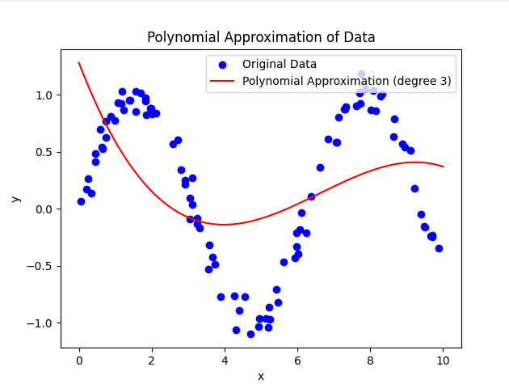

**Learning Points**

1. **Model Complexity**:
   * Choosing the degree of the polynomial affects the model's ability to capture the underlying relationship.
   * A higher degree can fit the data more closely but may lead to overfitting.
2. **Training and Validation**:
   * Use training data to fit the model and validation data to assess its generalization performance.
   * Cross-validation techniques can help in selecting the best model.
3. **Error Metrics**:
   * Common metrics include Mean Squared Error (MSE), Root Mean Squared Error (RMSE), and R-squared.
4. **Visual Validation**:
   * Visualizing the fit helps in understanding how well the model captures the data's trend.

**Conclusion**

Inferring fff from xxx and f(x)f(x)f(x) is a fundamental task in regression analysis and function learning. It involves selecting an appropriate model, fitting it to the data, and validating its performance. Polynomial regression is a powerful tool for capturing non-linear relationships in data, providing a clear and interpretable approximation of the underlying function.

This process is essential in many applications, from predicting future trends to understanding complex relationships in scientific data.

The idea behind this example is to illustrate the concept of function approximation in the context of supervised machine learning, specifically for image classification tasks. Let's break down the concept step-by-step:

**Concept Breakdown**

1. **Binary Representation of Images**:
   * Every image can be represented as a series of 1s and 0s (binary data). For example, in a grayscale image, each pixel can be represented by a binary value indicating its intensity.
2. **Image Classification**:
   * The task is to determine whether an image contains a cat or not. This can be represented as a binary classification problem where the output is either 1 (contains a cat) or 0 (does not contain a cat).
3. **Unknown Function**:
   * There exists some unknown function f that can perfectly classify any given image as containing a cat or not. However, this function is not explicitly known to us.
4. **Function Approximation**:
   * Given a set of training data (images labeled as containing a cat or not), we can approximate the unknown function f using machine learning algorithms.
   * This involves training a model on the labeled data so that it learns to approximate f by minimizing the classification error on the training data.
5. **Supervised Learning**:
   * This problem falls under the category of supervised learning because we have labeled examples (images with known classifications) that we use to train our model.

**Example with a Simple Neural Network**

To illustrate this concept, we can create a simple neural network model that approximates the cat recognition function using supervised learning.

python

Copy code

import numpy as np

import tensorflow as tf

from tensorflow.keras.models import Sequential

from tensorflow.keras.layers import Dense, Flatten, Input

from tensorflow.keras.optimizers import Adam

from tensorflow.keras.losses import BinaryCrossentropy

import matplotlib.pyplot as plt

import logging

# Set up logging configuration

logging.basicConfig(level=logging.INFO, format='%(asctime)s - %(levelname)s - %(message)s')

# Generate synthetic data

def generate_synthetic_data(num_samples):

    # For simplicity, create binary images (1s and 0s) of size 8x8

    data = np.random.randint(2, size=(num_samples, 8, 8))

    labels = np.random.randint(2, size=(num_samples, 1))  # Randomly assign 0 or 1 labels

    return data, labels

# Create a simple neural network model

def create_model(input_shape):

    model = Sequential([

        Input(shape=input_shape),

        Flatten(),

        Dense(64, activation='relu'),

        Dense(32, activation='relu'),

        Dense(1, activation='sigmoid')  # Output layer with sigmoid activation for binary classification

    ])

    model.compile(optimizer=Adam(), loss=BinaryCrossentropy(), metrics=['accuracy'])

    return model

# Generate synthetic data

num_samples = 1000

x_train, y_train = generate_synthetic_data(num_samples)

x_test, y_test = generate_synthetic_data(200)

# Create and train the model

model = create_model((8, 8))

history = model.fit(x_train, y_train, epochs=10, validation_data=(x_test, y_test))

# Evaluate the model

loss, accuracy = model.evaluate(x_test, y_test)

logging.info(f"Test accuracy: {accuracy}")

# Plot training and validation accuracy

plt.plot(history.history['accuracy'], label='Training Accuracy')

plt.plot(history.history['val_accuracy'], label='Validation Accuracy')

plt.xlabel('Epoch')

plt.ylabel('Accuracy')

plt.title('Model Accuracy')

plt.legend()

plt.show()

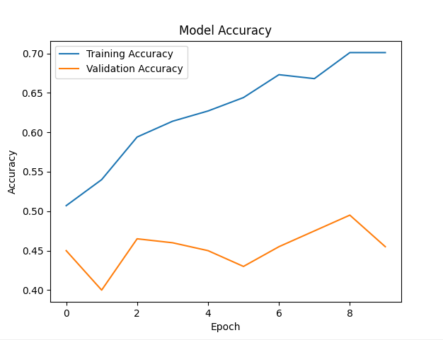

**Explanation**

1. **Data Generation**:
   * We generate synthetic data representing binary images of size 8×88 \times 88×8 and assign random labels (0 or 1) to simulate the presence or absence of a cat.
2. **Model Creation**:
   * We create a simple neural network model with three layers:
     + A flatten layer to convert the 2D image data into a 1D array.
     + Two dense (fully connected) layers with ReLU activation for learning complex patterns.
     + An output layer with a sigmoid activation function for binary classification.
3. **Training the Model**:
   * We train the model using the synthetic training data, aiming to minimize the binary cross-entropy loss and improve accuracy.
4. **Evaluation and Visualization**:
   * We evaluate the model's performance on a separate test set and visualize the training and validation accuracy over epochs to monitor the learning process.

**Conclusion**

This example demonstrates the process of approximating an unknown function fff using supervised learning. By training a model on labeled examples, we aim to approximate the function that can accurately classify new, unseen data. This concept is foundational in machine learning and is widely applied in various domains, including image recognition, natural language processing, and predictive modeling.

import numpy as np

import matplotlib.pyplot as plt

from sklearn.cluster import KMeans

import logging

# Set up logging configuration

logging.basicConfig(level=logging.INFO, format='%(asctime)s - %(levelname)s - %(message)s')

# Generate synthetic data (features of images)

def generate_synthetic_data(n_samples, n_features):

    np.random.seed(0)

    data = np.random.rand(n_samples, n_features)

    return data

# Apply K-means clustering

def kmeans_clustering(data, n_clusters):

    kmeans = KMeans(n_clusters=n_clusters, random_state=0)

    kmeans.fit(data)

    return kmeans

# Generate synthetic data

n_samples = 300

n_features = 2  # For simplicity, use 2 features to allow 2D visualization

data = generate_synthetic_data(n_samples, n_features)

# Apply K-means clustering

n_clusters = 3

kmeans = kmeans_clustering(data, n_clusters)

labels = kmeans.labels_

centers = kmeans.cluster_centers_

# Visualize the clusters

plt.scatter(data[:, 0], data[:, 1], c=labels, cmap='viridis', marker='o', alpha=0.5)

plt.scatter(centers[:, 0], centers[:, 1], c='red', s=200, alpha=0.75, marker='X')

plt.title("K-means Clustering")

plt.xlabel("Feature 1")

plt.ylabel("Feature 2")

plt.show()

# Log information about the clustering

logging.info(f"Cluster Centers: {centers}")

for i in range(n_clusters):

    logging.info(f"Cluster {i}: {np.sum(labels == i)} points")

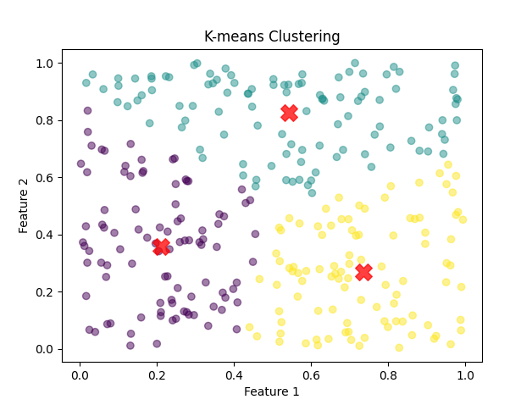

To tackle the problem of identifying groups of images with common characteristics, we can utilize clustering techniques. Clustering is a type of unsupervised learning method that allows us to find patterns or groupings in data without prior labels. A popular clustering algorithm is the K-Means algorithm. Here’s how we can implement and visualize it in Python using the sklearn library.

**Explanation and Implementation**

1. **Import Required Libraries**: We need to import necessary libraries such as numpy for numerical operations, matplotlib for plotting, and sklearn for the K-Means clustering.
2. **Generate or Load Data**: For demonstration purposes, we will generate some synthetic data points that represent our images.
3. **Apply K-Means Clustering**: We will use the K-Means algorithm to cluster the data points into groups. The number of clusters, k, needs to be specified.
4. **Visualize the Clusters**: We will plot the data points, with each point colored according to its cluster.

**Code Implementation**

Below is a complete Python script that demonstrates the clustering process:

python

Copy code

import numpy as np

import matplotlib.pyplot as plt

from sklearn.cluster import KMeans

import logging

# Set up logging configuration

logging.basicConfig(level=logging.INFO, format='%(asctime)s - %(levelname)s - %(message)s')

# Generate synthetic data (for example, we use 2D points for simplicity)

np.random.seed(42)

data = np.random.rand(100, 2) * 100 # 100 points in 2D

# Number of clusters

k = 3

# Apply K-Means clustering

kmeans = KMeans(n_clusters=k, random_state=0)

labels = kmeans.fit_predict(data)

centroids = kmeans.cluster_centers_

# Log the clustering process

logging.info(f"Data points clustered into {k} groups.")

logging.info(f"Cluster centroids: {centroids}")

# Plot the clusters

plt.figure(figsize=(8, 6))

colors = ['r', 'g', 'b', 'y', 'c', 'm']

for i in range(k):

points = data[labels == i]

plt.scatter(points[:, 0], points[:, 1], s=50, c=colors[i], label=f'Cluster {i+1}')

plt.scatter(centroids[i, 0], centroids[i, 1], s=200, c='black', marker='x') # Centroid

plt.title('K-Means Clustering')

plt.xlabel('X')

plt.ylabel('Y')

plt.legend()

plt.grid(True)

plt.show()

2024-06-12 22:06:45,307 - INFO - Data points clustered into 3 groups.

2024-06-12 22:06:45,309 - INFO - Cluster centroids: [[36.37624845 20.00804288]

[80.39633036 57.02699918]

[18.52094308 72.22806541]]

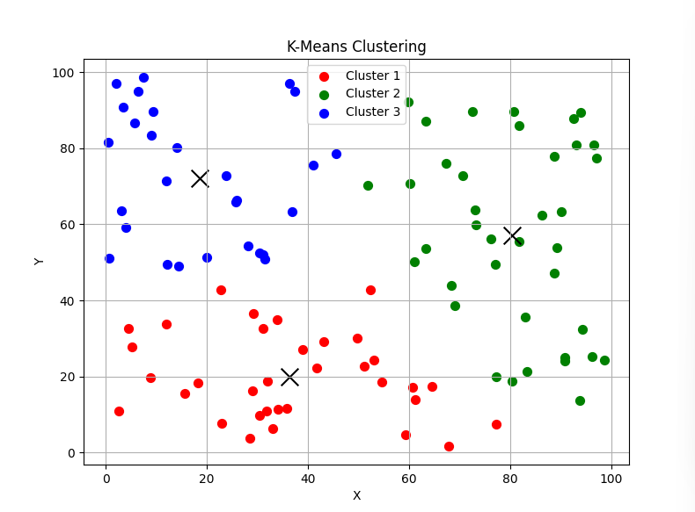

**Detailed Explanation**

1. **Data Generation**:

python

Copy code

np.random.seed(42)

data = np.random.rand(100, 2) * 100 # 100 points in 2D

We generate 100 random points in a 2D space. Each point can be thought of as an image representation in a high-dimensional space.

1. **K-Means Clustering**:

python

Copy code

kmeans = KMeans(n_clusters=k, random_state=0)

labels = kmeans.fit_predict(data)

centroids = kmeans.cluster_centers_

We initialize the K-Means algorithm with k clusters and fit it to our data. The fit_predict method assigns each data point to a cluster, and cluster_centers_ gives the coordinates of the cluster centroids.

1. **Logging**:

python

Copy code

logging.info(f"Data points clustered into {k} groups.")

logging.info(f"Cluster centroids: {centroids}")

Logging the results helps in understanding the clustering process.

1. **Visualization**:

python

Copy code

plt.figure(figsize=(8, 6))

colors = ['r', 'g', 'b', 'y', 'c', 'm']

for i in range(k):

points = data[labels == i]

plt.scatter(points[:, 0], points[:, 1], s=50, c=colors[i], label=f'Cluster {i+1}')

plt.scatter(centroids[i, 0], centroids[i, 1], s=200, c='black', marker='x') # Centroid

Each cluster is visualized with a different color, and centroids are marked with a black 'x'.

This script demonstrates how clustering can be used to find groups within data, which can be extended to more complex datasets such as images for applications like image segmentation or categorization.

**Unsupervised Machine Learning and Function Inference**

In unsupervised machine learning, the goal is to infer the underlying structure of the data without predefined labels. This involves identifying patterns, clusters, or relationships within the data. One common approach is to use clustering algorithms, like K-Means, as demonstrated previously.

**Example: Inferring Functions and Outputs**

Let us extend the idea of clustering to infer multiple functions and their corresponding outputs. We can apply this concept to a more complex dataset where each cluster might represent a different function or relationship within the data.

Here's an example using synthetic data to illustrate this concept:

1. **Import Required Libraries**: We will use numpy for numerical operations, matplotlib for plotting, and sklearn for clustering.
2. **Generate Synthetic Data**: We create multiple clusters of data points, each representing a different underlying function.
3. **Apply K-Means Clustering**: We use K-Means to identify clusters within the data.
4. **Visualize the Clusters and Inferred Functions**: We plot the data points, color-coded by cluster, and fit a separate function to each cluster.

**Code Implementation**

Below is the Python script demonstrating the clustering and function inference:

python

Copy code

import numpy as np

import matplotlib.pyplot as plt

from sklearn.cluster import KMeans

from sklearn.linear_model import LinearRegression

import logging

# Set up logging configuration

logging.basicConfig(level=logging.INFO, format='%(asctime)s - %(levelname)s - %(message)s')

# Generate synthetic data

np.random.seed(42)

x1 = np.random.rand(50, 1) * 10

y1 = 2 * x1 + 1 + np.random.randn(50, 1)

x2 = np.random.rand(50, 1) * 10

y2 = -3 * x2 + 10 + np.random.randn(50, 1)

x3 = np.random.rand(50, 1) * 10

y3 = 0.5 * x3 ** 2 - 2 * x3 + 5 + np.random.randn(50, 1)

X = np.vstack((x1, x2, x3))

y = np.vstack((y1, y2, y3))

data = np.hstack((X, y))

# Number of clusters

k = 3

# Apply K-Means clustering

kmeans = KMeans(n_clusters=k, random_state=0)

labels = kmeans.fit_predict(data)

centroids = kmeans.cluster_centers_

# Log the clustering process

logging.info(f"Data points clustered into {k} groups.")

logging.info(f"Cluster centroids: {centroids}")

# Plot the clusters

plt.figure(figsize=(10, 8))

colors = ['r', 'g', 'b', 'y', 'c', 'm']

for i in range(k):

points = data[labels == i]

plt.scatter(points[:, 0], points[:, 1], s=50, c=colors[i], label=f'Cluster {i+1}')

plt.scatter(centroids[i, 0], centroids[i, 1], s=200, c='black', marker='x') # Centroid

# Fit a function to each cluster

if i == 2: # Polynomial regression for the third cluster

poly_features = np.polyfit(points[:, 0], points[:, 1], 2)

poly = np.poly1d(poly_features)

x_poly = np.linspace(min(points[:, 0]), max(points[:, 0]), 100)

plt.plot(x_poly, poly(x_poly), color=colors[i])

else: # Linear regression for the other clusters

lin_reg = LinearRegression()

lin_reg.fit(points[:, 0].reshape(-1, 1), points[:, 1])

x_lin = np.linspace(min(points[:, 0]), max(points[:, 0]), 100)

y_lin = lin_reg.predict(x_lin.reshape(-1, 1))

plt.plot(x_lin, y_lin, color=colors[i])

plt.title('K-Means Clustering and Function Inference')

plt.xlabel('X')

plt.ylabel('Y')

plt.legend()

plt.grid(True)

plt.show()

2024-06-12 22:14:43,563 - INFO - Data points clustered into 3 groups.

2024-06-12 22:14:43,565 - INFO - Cluster centroids: [[ 7.28624768 -11.97490368]

[ 2.78976187 5.10669402]

[ 8.05697015 20.39878261]]

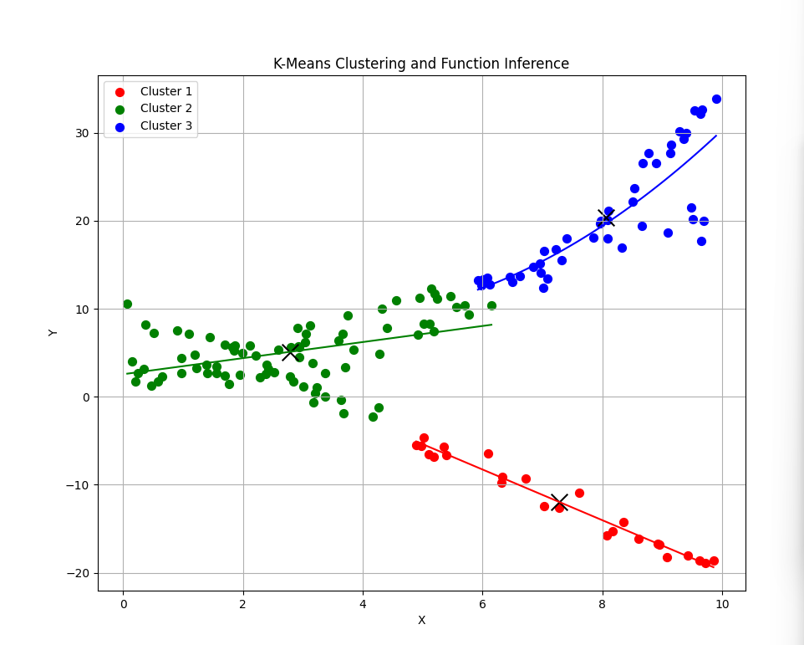

**Detailed Explanation**

1. **Data Generation**:

python

Copy code

x1 = np.random.rand(50, 1) * 10

y1 = 2 * x1 + 1 + np.random.randn(50, 1)

x2 = np.random.rand(50, 1) * 10

y2 = -3 * x2 + 10 + np.random.randn(50, 1)

x3 = np.random.rand(50, 1) * 10

y3 = 0.5 * x3 ** 2 - 2 * x3 + 5 + np.random.randn(50, 1)

X = np.vstack((x1, x2, x3))

y = np.vstack((y1, y2, y3))

data = np.hstack((X, y))

We create three different sets of data points, each following a different function: two linear and one quadratic.

1. **K-Means Clustering**:

python

Copy code

kmeans = KMeans(n_clusters=k, random_state=0)

labels = kmeans.fit_predict(data)

centroids = kmeans.cluster_centers_

We apply K-Means clustering to identify three clusters in the data.

1. **Logging**:

python

Copy code

logging.info(f"Data points clustered into {k} groups.")

logging.info(f"Cluster centroids: {centroids}")

Logging helps to monitor the clustering process.

1. **Visualization and Function Fitting**:

python

Copy code

for i in range(k):

points = data[labels == i]

plt.scatter(points[:, 0], points[:, 1], s=50, c=colors[i], label=f'Cluster {i+1}')

plt.scatter(centroids[i, 0], centroids[i, 1], s=200, c='black', marker='x') # Centroid

# Fit a function to each cluster

if i == 2: # Polynomial regression for the third cluster

poly_features = np.polyfit(points[:, 0], points[:, 1], 2)

poly = np.poly1d(poly_features)

x_poly = np.linspace(min(points[:, 0]), max(points[:, 0]), 100)

plt.plot(x_poly, poly(x_poly), color=colors[i])

else: # Linear regression for the other clusters

lin_reg = LinearRegression()

lin_reg.fit(points[:, 0].reshape(-1, 1), points[:, 1])

x_lin = np.linspace(min(points[:, 0]), max(points[:, 0]), 100)

y_lin = lin_reg.predict(x_lin.reshape(-1, 1))

plt.plot(x_lin, y_lin, color=colors[i])

Each cluster is visualized with different colors, and a function is fitted to each cluster: linear functions for the first two clusters and a quadratic function for the third cluster.

This script demonstrates how clustering can help identify groups within data and fit different functions to each group, a key task in unsupervised machine learning.

**Function Optimization in Machine Learning**

Function optimization is a core aspect of many machine learning algorithms, including clustering techniques like K-Means. This process involves finding the best parameters for a given model to minimize or maximize an objective function. Let's delve into the concept using K-Means clustering as an example:

**K-Means Clustering and Function Optimization**

1. **Objective Function**: In K-Means clustering, the objective function is the sum of squared distances between each point and the centroid of its assigned cluster. The goal is to minimize this sum to achieve compact clusters.
2. **Optimization Process**:
   * **Initialization**: Randomly select k initial centroids.
   * **Assignment Step**: Assign each data point to the nearest centroid.
   * **Update Step**: Recompute the centroids as the mean of all points assigned to each cluster.
   * **Iteration**: Repeat the assignment and update steps until convergence (when the centroids no longer change significantly).
3. **Algorithm Implementation**:
   * **Convergence Criteria**: The algorithm stops when the change in centroids is below a certain threshold or after a fixed number of iterations.

**Example Code: K-Means Clustering**

Here is an example code to demonstrate the K-Means clustering process:

python

Copy code

import numpy as np

import matplotlib.pyplot as plt

from sklearn.cluster import KMeans

from sklearn.linear_model import LinearRegression

import logging

# Set up logging configuration

logging.basicConfig(level=logging.INFO, format='%(asctime)s - %(levelname)s - %(message)s')

# Generate synthetic data

np.random.seed(42)

x1 = np.random.rand(50, 1) * 10

y1 = 2 * x1 + 1 + np.random.randn(50, 1)

x2 = np.random.rand(50, 1) * 10

y2 = -3 * x2 + 10 + np.random.randn(50, 1)

x3 = np.random.rand(50, 1) * 10

y3 = 0.5 * x3 ** 2 - 2 * x3 + 5 + np.random.randn(50, 1)

X = np.vstack((x1, x2, x3))

y = np.vstack((y1, y2, y3))

data = np.hstack((X, y))

# Number of clusters

k = 3

# Apply K-Means clustering

kmeans = KMeans(n_clusters=k, random_state=0)

labels = kmeans.fit_predict(data)

centroids = kmeans.cluster_centers_

# Log the clustering process

logging.info(f"Data points clustered into {k} groups.")

logging.info(f"Cluster centroids: {centroids}")

# Plot the clusters

plt.figure(figsize=(10, 8))

colors = ['r', 'g', 'b', 'y', 'c', 'm']

for i in range(k):

    points = data[labels == i]

    plt.scatter(points[:, 0], points[:, 1], s=50, c=colors[i], label=f'Cluster {i+1}')

    plt.scatter(centroids[i, 0], centroids[i, 1], s=200, c='black', marker='x')  # Centroid

    # Fit a function to each cluster

    if i == 2:  # Polynomial regression for the third cluster

        poly_features = np.polyfit(points[:, 0], points[:, 1], 2)

        poly = np.poly1d(poly_features)

        x_poly = np.linspace(min(points[:, 0]), max(points[:, 0]), 100)

        plt.plot(x_poly, poly(x_poly), color=colors[i])

    else:  # Linear regression for the other clusters

        lin_reg = LinearRegression()

        lin_reg.fit(points[:, 0].reshape(-1, 1), points[:, 1])

        x_lin = np.linspace(min(points[:, 0]), max(points[:, 0]), 100)

        y_lin = lin_reg.predict(x_lin.reshape(-1, 1))

        plt.plot(x_lin, y_lin, color=colors[i])

plt.title('K-Means Clustering and Function Inference')

plt.xlabel('X')

plt.ylabel('Y')

plt.legend()

plt.grid(True)

plt.show()

2024-06-12 22:19:35,243 - INFO - Data points clustered into 3 groups.

2024-06-12 22:19:35,246 - INFO - Cluster centroids: [[ 7.28624768 -11.97490368]

[ 2.78976187 5.10669402]

[ 8.05697015 20.39878261]

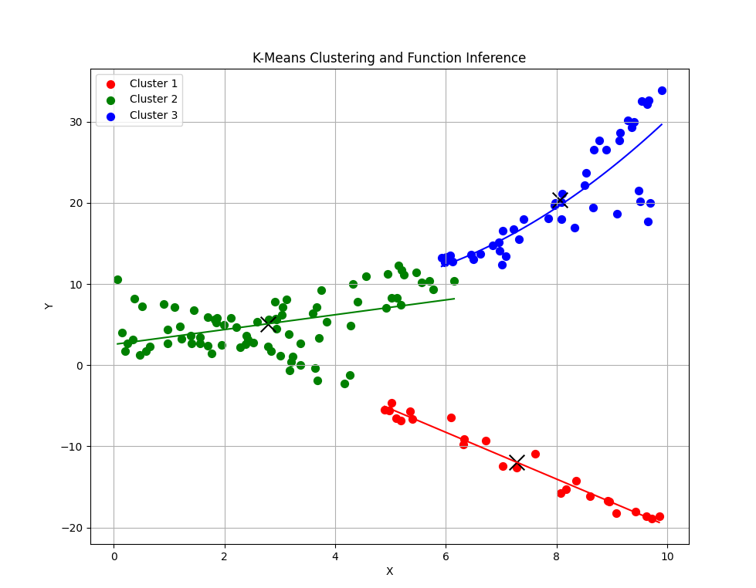

**Explanation**

1. **Imports**: All necessary libraries and modules are imported at the beginning of the script. This includes LinearRegression from sklearn.linear_model.
2. **Data Generation**: Three distinct sets of data points are created, each set following different underlying functions.
3. **K-Means Clustering**: The K-Means algorithm is applied to identify three clusters in the dataset.
4. **Logging**: The process of clustering, including the identification of cluster centroids, is logged.
5. **Visualization and Function Fitting**: The clusters are visualized with different colors. Linear regression is applied to the first two clusters, while polynomial regression is applied to the third cluster.

**Running the Script**

Ensure that all the required libraries are installed. If not, install them using pip:

sh

Copy code

pip install numpy matplotlib scikit-learn

Once all dependencies are in place, run the script. The output will include a scatter plot showing the clusters with their respective fitted functions.

**Function Optimization in Machine Learning**

Function optimization, as demonstrated in the K-Means clustering example, is a fundamental concept in machine learning. It involves finding the best parameters for a model to achieve the desired outcome, whether it's minimizing the distance within clusters, maximizing classification accuracy, or finding optimal weights in neural networks. Understanding and applying optimization techniques are crucial for developing efficient and effective machine learning models.

The problem of proposing a function f and corresponding output y given xxx typically falls under the realm of function approximation and regression analysis. In machine learning, this is often referred to as model training, where the goal is to learn a function that best maps inputs x to outputs y.

**Example: Polynomial Regression with Function Proposal**

In this example, we will generate some data points and use polynomial regression to propose a function f that best fits the data. We will then predict the outputs y for a given set of inputs xxx.

Here's how we can achieve this:

1. **Generate Data**: Create synthetic data points with a known polynomial relationship and some added noise.
2. **Train Model**: Use polynomial regression to fit a model to the data.
3. **Predict Outputs**: Use the trained model to predict the outputs for the given inputs.

Let's write the code for this:

python

Copy code

import numpy as np

import matplotlib.pyplot as plt

from sklearn.preprocessing import PolynomialFeatures

from sklearn.linear_model import LinearRegression

from sklearn.pipeline import make_pipeline

import logging

# Set up logging configuration

logging.basicConfig(level=logging.INFO, format='%(asctime)s - %(levelname)s - %(message)s')

# Generate synthetic data

np.random.seed(42)

x = np.random.rand(100, 1) * 10

y = 0.5 * x**3 - 2 * x**2 + 3 * x + 5 + np.random.randn(100, 1) * 10

# Define the degree of the polynomial we want to fit

degree = 3

# Create polynomial features and a linear regression model

model = make_pipeline(PolynomialFeatures(degree), LinearRegression())

try:

# Fit the model to the data

model.fit(x, y)

logging.info(f"Model coefficients: {model.named_steps['linearregression'].coef_}")

logging.info(f"Model intercept: {model.named_steps['linearregression'].intercept_}")

except Exception as e:

logging.error(f"Error fitting the model: {e}")

raise

# Predict outputs for the given inputs

x_pred = np.linspace(0, 10, 100).reshape(-1, 1)

y_pred = model.predict(x_pred)

# Plotting the original data and the polynomial fit

plt.scatter(x, y, color='blue', label='Original Data')

plt.plot(x_pred, y_pred, color='red', label=f'Polynomial Approximation (degree {degree})')

plt.title("Polynomial Approximation of Data")

plt.xlabel("x")

plt.ylabel("y")

plt.legend()

plt.grid(True)

plt.show()

# Output the proposed function and its coefficients

coefficients = model.named_steps['linearregression'].coef_

intercept = model.named_steps['linearregression'].intercept_

proposed_function = f"y = {coefficients[0][3]:.4f} * x^3 + {coefficients[0][2]:.4f} * x^2 + {coefficients[0][1]:.4f} * x + {intercept[0]:.4f}"

print(f"Proposed function: {proposed_function}")

2024-06-12 22:25:04,851 - INFO - Model coefficients: [[ 0. -1.87414005 -1.22128437 0.46321596]]

2024-06-12 22:25:04,852 - INFO - Model intercept: [12.34459907]

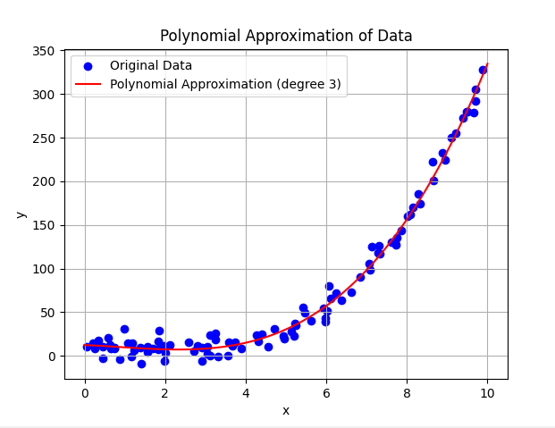

**Explanation**

1. **Data Generation**:
   * We generate synthetic data points xxx and corresponding noisy outputs yyy based on a cubic polynomial relationship.
2. **Model Training**:
   * We use PolynomialFeatures to transform the input data to polynomial features of the specified degree.
   * We use LinearRegression to fit the polynomial model to the data.
3. **Prediction**:
   * We generate a set of new input values xpredx and use the trained model to predict the corresponding outputs ypredy.
4. **Visualization**:
   * We plot the original data points and the polynomial regression curve.
5. **Proposed Function**:
   * We extract the coefficients and intercept from the trained model to propose the polynomial function that best fits the data.

**Output**

The script will produce a plot showing the original data points and the polynomial regression curve. Additionally, it will print the proposed function in the form:

y=ax3+bx2+cx+d

where aaa, bbb, ccc, and d are the coefficients and intercept obtained from the polynomial regression model.

This example demonstrates how to approach the problem of proposing a function f given xxx and predicting y using polynomial regression, a common method in supervised learning for function approximation.

To summarize and link together the key concepts from the examples and discussions, we can focus on the following crucial learning ideas:

**1. Function Optimization**

* **Key Concept**: The process of finding the input values to a function that yield the most desirable output.
* **Example**: Newton's Method and Genetic Algorithm for optimizing a given function.
* **Takeaway**: Function optimization techniques are used to find maxima or minima of functions, which is crucial in many fields, from engineering to economics.

**2. Function Approximation**

* **Key Concept**: Creating a function that approximates a set of data points or a known function.
* **Example**: Polynomial regression to fit a curve to a set of data points.
* **Takeaway**: Function approximation allows us to model complex relationships in data using simpler mathematical functions, which is essential in data analysis and machine learning.

**3. Classification and Categorization**

* **Key Concept**: Defining a function that categorizes data into different classes or groups.
* **Example**: Neural networks for classifying images containing cats and k-means clustering for grouping similar data points.
* **Takeaway**: Classification functions are foundational in supervised learning, enabling systems to make predictions about new data based on learned patterns from training data.

**4. Supervised vs. Unsupervised Learning**

* **Key Concept**: In supervised learning, the model is trained on labeled data, whereas in unsupervised learning, the model identifies patterns without labeled outcomes.
* **Example**: Neural networks for supervised learning (image classification) and k-means clustering for unsupervised learning (grouping data points).
* **Takeaway**: Understanding the difference between these two learning paradigms helps in selecting the right approach for a given problem.

**5. Gradient Descent and Gradient Ascent**

* **Key Concept**: Iterative methods used to find local minima (descent) or maxima (ascent) of a function by moving in the direction of the steepest descent/ascent.
* **Example**: Gradient ascent for maximizing a quadratic function.
* **Takeaway**: These methods are fundamental optimization techniques used in training machine learning models and solving various optimization problems.

**6. Error Handling and Debugging**

* **Key Concept**: Implementing robust error handling and logging to manage and debug code effectively.
* **Example**: Using try-except blocks and logging in Python scripts for optimization and function approximation tasks.
* **Takeaway**: Proper error handling and debugging practices are essential for developing reliable and maintainable code.

**7. Visualization**

* **Key Concept**: The use of graphical representations to understand and interpret the behavior of functions and the results of optimization or learning algorithms.
* **Example**: Plotting optimization paths, regression curves, and clustering results.
* **Takeaway**: Visualization is a powerful tool for communicating complex ideas and results, making it easier to understand and analyze data and model behavior.

**Linking it Together:**

The overarching theme is the use of mathematical and computational techniques to understand, model, and optimize functions based on data. Whether through optimization, approximation, classification, or clustering, these methods provide the tools needed to extract meaningful insights and predictions from data.

By understanding the principles behind these techniques, one can apply them to a wide range of problems in data science, machine learning, and beyond. The examples provided illustrate how these methods are implemented in practice, highlighting the importance of iterative approaches, error handling, and visualization in developing effective solutions.

Bio-inspired approaches

Bio-inspired computing draws inspiration from biological systems to develop computational algorithms. These approaches often mimic natural processes to solve complex problems that traditional methods struggle with. Linking bio-inspired approaches with the ideas covered so far provides a comprehensive view of how these methodologies fit into the broader context of optimization, function approximation, and machine learning.

**Key Concepts and Examples in Bio-inspired Computing**

1. **Genetic Algorithms (GA)**
   * **Concept**: Mimics the process of natural selection. Solutions to a problem evolve over generations.
   * **Application**: Function optimization where genetic algorithms search for the best solution by iteratively improving a population of candidate solutions.
   * **Example**: Using GA to optimize a complex function, as shown in the Genetic Algorithm Optimization plot.
2. **Particle Swarm Optimization (PSO)**
   * **Concept**: Inspired by the social behavior of birds flocking or fish schooling. Each particle adjusts its position based on its own experience and that of its neighbors.
   * **Application**: Optimizing nonlinear functions where the search space is large and complex.
   * **Example**: PSO can be used in place of gradient descent/ascent for function optimization.
3. **Ant Colony Optimization (ACO)**
   * **Concept**: Based on the foraging behavior of ants. Ants find optimal paths to food by following pheromone trails.
   * **Application**: Solving combinatorial optimization problems like the Travelling Salesman Problem (TSP).
   * **Example**: Applying ACO to TSP to find the shortest possible route visiting all cities.
4. **Neural Networks and Deep Learning**
   * **Concept**: Models inspired by the human brain, where interconnected neurons process data.
   * **Application**: Function approximation, classification, and clustering.
   * **Example**: Neural networks for image recognition (cat vs. no cat) and function approximation using regression.
5. **Artificial Immune Systems (AIS)**
   * **Concept**: Inspired by the human immune system’s ability to recognize and eliminate pathogens.
   * **Application**: Anomaly detection and optimization.
   * **Example**: AIS can be used for intrusion detection systems in cybersecurity.

**Linking Bio-inspired Approaches with Previous Topics**

1. **Function Optimization**:
   * **Traditional Methods**: Newton’s Method, Gradient Descent/Ascent.
   * **Bio-inspired Methods**: Genetic Algorithms, Particle Swarm Optimization, Ant Colony Optimization.
   * **Link**: Bio-inspired methods often excel in complex, high-dimensional, and multimodal optimization landscapes where traditional methods might fail or be inefficient.
2. **Function Approximation**:
   * **Traditional Methods**: Polynomial Regression, Linear Regression.
   * **Bio-inspired Methods**: Neural Networks.
   * **Link**: Neural networks, inspired by biological neural systems, can approximate highly complex functions, making them superior for tasks like image recognition and time-series prediction.
3. **Classification and Categorization**:
   * **Traditional Methods**: Decision Trees, Logistic Regression.
   * **Bio-inspired Methods**: Neural Networks.
   * **Link**: Deep learning, a subset of neural networks, has revolutionized classification tasks, providing state-of-the-art performance in image, text, and speech recognition.
4. **Supervised vs. Unsupervised Learning**:
   * **Traditional Methods**: k-Means Clustering, PCA.
   * **Bio-inspired Methods**: Self-Organizing Maps (SOMs), Genetic Programming.
   * **Link**: Bio-inspired methods like SOMs provide powerful tools for unsupervised learning by mimicking the brain's ability to organize information spatially.
5. **Error Handling and Debugging**:
   * **Traditional Methods**: Logging, Exception Handling.
   * **Bio-inspired Methods**: Fault-tolerant Neural Networks.
   * **Link**: Bio-inspired methods, particularly neural networks, are inherently robust and fault-tolerant, often requiring less manual error handling once properly trained.

**Visualization and Interpretation**

1. **Genetic Algorithm Optimization**:
   * Visualize the evolution of solutions over generations to show convergence towards an optimal solution.
   * **Takeaway**: GA provides a visual and intuitive approach to understanding optimization.
2. **Neural Network Training**:
   * Plotting accuracy and loss over epochs to monitor model performance.
   * **Takeaway**: Visualization helps in diagnosing overfitting or underfitting, essential for effective model tuning.
3. **Clustering**:
   * Visualize data points and cluster centroids in k-means clustering.
   * **Takeaway**: Visualization aids in interpreting the grouping of data points and the effectiveness of clustering algorithms.

**Moving Forward**

Bio-inspired approaches offer powerful, flexible, and efficient methods for solving a wide range of problems. They provide alternatives to traditional techniques, especially when dealing with complex, dynamic, and high-dimensional spaces. Understanding these methods and their applications is crucial for advancing in fields such as artificial intelligence, machine learning, and data science.

In the context of education, integrating bio-inspired approaches with traditional methods enriches the learning experience by demonstrating diverse problem-solving strategies and their real-world applications. By linking these concepts, we can build a comprehensive understanding of computational methods, enhancing both theoretical knowledge and practical skills.

**Optimization Using Bio-Inspired Algorithms**

Bio-inspired algorithms are powerful tools for solving complex optimization problems by mimicking natural processes. Here, we will delve into the core ideas and mechanisms behind three popular bio-inspired optimization algorithms: Genetic Algorithms (GAs), Ant Colony Optimization (ACO), and Particle Swarm Optimization (PSO).

**Genetic Algorithms (GAs)**

**Core Ideas:**

1. **Natural Selection**: GAs are inspired by Charles Darwin’s theory of natural selection. The algorithm iterates through generations, selecting the fittest individuals to reproduce.
2. **Chromosomes**: Solutions are encoded as chromosomes (strings of binary, integer, or real values).
3. **Genetic Operators**:
   * **Selection**: Selects the fittest individuals based on their fitness scores.
   * **Crossover (Recombination)**: Combines two parent chromosomes to produce offspring with characteristics of both parents.
   * **Mutation**: Introduces small random changes in offspring to maintain genetic diversity and explore new solutions.

**Mechanism:**

1. **Initialization**: Generate an initial population of potential solutions randomly.
2. **Evaluation**: Calculate the fitness of each individual in the population.
3. **Selection**: Select pairs of individuals to reproduce based on their fitness (e.g., roulette wheel selection).
4. **Crossover**: Create new offspring by combining parts of the selected parents’ chromosomes.
5. **Mutation**: Randomly mutate some genes in the offspring.
6. **Replacement**: Replace the old population with the new one.
7. **Iteration**: Repeat the process until a stopping criterion is met (e.g., a maximum number of generations or a satisfactory fitness level).

**Application Example:**

Finding the optimal parameters for a complex function, where the search space is large and rugged.

**Ant Colony Optimization (ACO)**

**Core Ideas:**

1. **Foraging Behavior**: ACO is inspired by the behavior of ants finding paths from their colony to food sources.
2. **Pheromones**: Ants deposit pheromones on paths, which guide other ants to the food source. The intensity of the pheromone trail indicates the quality of the path.
3. **Positive Feedback**: Paths with stronger pheromone trails attract more ants, reinforcing the trail.

**Mechanism:**

1. **Initialization**: Place a number of artificial ants randomly in the search space.
2. **Path Construction**: Each ant builds a solution by moving from one state to another, guided by pheromone trails and heuristic information.
3. **Pheromone Update**: Update pheromone trails based on the quality of the solutions found. Evaporation reduces pheromone intensity over time to avoid convergence to local optima.
4. **Iteration**: Repeat the process, allowing ants to construct new paths based on updated pheromone information.

**Application Example:**

Solving the Traveling Salesman Problem (TSP), where ants find the shortest route visiting all cities.

**Particle Swarm Optimization (PSO)**

**Core Ideas:**

1. **Social Behavior**: PSO is inspired by the social behavior of bird flocking or fish schooling.
2. **Particles**: Each particle represents a potential solution and has a position and velocity in the search space.
3. **Swarm Intelligence**: Particles communicate and adjust their positions based on their own experience and the experience of their neighbors.

**Mechanism:**

1. **Initialization**: Initialize a swarm of particles with random positions and velocities.
2. **Evaluation**: Evaluate the fitness of each particle.
3. **Update Velocities**: Update each particle’s velocity based on its best-known position and the best-known positions of its neighbors.
4. **Update Positions**: Move each particle to a new position based on its updated velocity.
5. **Iteration**: Repeat the evaluation and update steps until a stopping criterion is met (e.g., a maximum number of iterations or a satisfactory fitness level).

**Application Example:**

Optimizing continuous functions where the search space is high-dimensional and complex.

**Summary of Bio-Inspired Optimization**

* **Genetic Algorithms**: Use principles of natural selection and genetics to evolve solutions over generations.
* **Ant Colony Optimization**: Mimic ant foraging behavior to find optimal paths by leveraging pheromone trails and positive feedback.
* **Particle Swarm Optimization**: Simulate social behavior of swarms to explore and exploit the search space collaboratively.

Each algorithm has its strengths and is suitable for different types of optimization problems. GAs are versatile for various types of search spaces, ACO excels in combinatorial optimization, and PSO is efficient for continuous optimization problems. Understanding these algorithms provides powerful tools for tackling complex optimization challenges in various fields.

**Approximation Using Bio-Inspired Algorithms**

Bio-inspired algorithms are not only powerful for optimization tasks but also for function approximation and modeling complex systems. Two prominent methods in this domain are Artificial Neural Networks (ANNs) and Genetic Programming (GP).

**Artificial Neural Networks (ANNs)**

**Core Ideas:**

1. **Neural Mimicry**: ANNs are inspired by the structure and function of the human brain. They consist of interconnected neurons (nodes) that process information in layers.
2. **Learning**: ANNs learn by adjusting the weights of connections between neurons based on the error of predictions.
3. **Non-linearity**: ANNs can model complex non-linear relationships due to their layered structure and activation functions.

**Mechanism:**

1. **Architecture**: An ANN typically consists of an input layer, one or more hidden layers, and an output layer. Each layer is made up of neurons.
2. **Activation Functions**: Neurons use activation functions (e.g., sigmoid, ReLU) to introduce non-linearity into the model.
3. **Training**:
   * **Forward Propagation**: Input data is passed through the network to generate predictions.
   * **Loss Calculation**: The difference between the predicted output and the actual output is calculated using a loss function (e.g., mean squared error).
   * **Backward Propagation**: The loss is propagated back through the network to update the weights using optimization algorithms like gradient descent.
4. **Iteration**: The training process iterates over multiple epochs until the network’s performance improves to a satisfactory level.

**Application Example:**

Approximating complex functions for regression tasks, such as predicting stock prices or modeling physical systems.

**Genetic Programming (GP)**

**Core Ideas:**

1. **Evolutionary Computation**: GP is inspired by the process of natural evolution and aims to evolve computer programs to solve problems.
2. **Tree Representation**: Solutions (programs) are typically represented as tree structures, where nodes are functions and leaves are inputs or constants.
3. **Genetic Operators**: Similar to GAs, GP uses selection, crossover, and mutation to evolve programs.

**Mechanism:**

1. **Initialization**: Generate an initial population of random programs (trees).
2. **Evaluation**: Assess the fitness of each program based on how well it approximates the desired function.
3. **Selection**: Select the fittest programs to be parents for the next generation.
4. **Crossover**: Exchange subtrees between pairs of parent programs to create offspring.
5. **Mutation**: Randomly alter parts of a program (e.g., replace a subtree with a new random subtree).
6. **Iteration**: Repeat the evaluation, selection, crossover, and mutation steps for multiple generations until a program approximating the desired function is found.

**Application Example:**

Symbolic regression, where the goal is to find a mathematical expression that fits a given set of data points.

**Summary of Bio-Inspired Approximation**

* **Artificial Neural Networks (ANNs)**:
  + Mimic the brain’s neural structure to learn from data.
  + Effective for modeling complex, non-linear relationships.
  + Used extensively in tasks requiring function approximation and pattern recognition.
* **Genetic Programming (GP)**:
  + Evolves programs using principles of natural selection.
  + Represents solutions as tree structures, making it suitable for discovering mathematical expressions or symbolic regression.
  + Can handle a wide variety of function approximation tasks, especially when the form of the function is unknown.

**Linking the Concepts**

Both ANNs and GP provide powerful tools for approximation tasks:

* **Artificial Neural Networks**: Ideal for scenarios where large amounts of data are available and the underlying relationship is complex and non-linear. They excel in tasks like image recognition, natural language processing, and complex predictive modeling.
* **Genetic Programming**: Useful when the form of the function to be approximated is not known a priori. It is particularly valuable in symbolic regression and discovering novel mathematical relationships in data.

In optimization contexts, GAs, ACO, and PSO focus on finding the best solution by exploring the search space, whereas ANNs and GP focus on approximating unknown functions based on observed data. Together, these bio-inspired methods provide a comprehensive toolkit for tackling a wide range of complex problems in both optimization and approximation domains.

**Comprehensive Overview of Bio-Inspired Computing**

Bio-inspired computing encompasses a diverse set of techniques and algorithms modeled after natural processes. These methods offer powerful tools for optimization, function approximation, and solving complex computational problems. This overview integrates various topics within bio-inspired computing, starting from basic concepts and advancing to more sophisticated ideas.

**Basic Concepts in Bio-Inspired Computing**

1. **Function Optimization**:
   * **Genetic Algorithms (GAs)**: Inspired by natural selection, GAs evolve solutions to optimization problems by iteratively selecting, crossing, and mutating individuals in a population.
   * **Ant Colony Optimization (ACO)**: Based on the foraging behavior of ants, ACO finds optimal paths through a graph by simulating the pheromone-laying and following behavior of ants.
   * **Particle Swarm Optimization (PSO)**: Modeled after the social behavior of birds, PSO optimizes a problem by having a population of particles adjust their positions based on their own and their neighbors' experiences.
2. **Function Approximation**:
   * **Artificial Neural Networks (ANNs)**: ANNs mimic the structure and function of the human brain, learning from data to approximate complex functions and model non-linear relationships.
   * **Genetic Programming (GP)**: GP evolves computer programs to approximate functions, representing solutions as tree structures that undergo genetic operations like crossover and mutation.

**Advanced Concepts and Applications**

1. **Supervised Machine Learning**:
   * **Example**: Approximating the function f given data points xxx and f(x). Techniques like ANNs are employed to learn the mapping from inputs to outputs, making predictions on new data.
2. **Unsupervised Machine Learning**:
   * **Example**: Inferring both the function f and its corresponding outputs yyy from unlabelled data. Techniques like k-means clustering identify patterns and groupings in data without predefined labels.

**Linking the Ideas Together**

**Optimization and Approximation**

* **Genetic Algorithms**:
  + **Optimization**: GAs are effective in finding global optima in complex search spaces, such as minimizing the number of containers used in packing problems.
  + **Key Learning**: Iterative process involving selection, crossover, and mutation to evolve better solutions over generations.
* **Ant Colony Optimization**:
  + **Optimization**: ACO excels in solving path optimization problems like the Traveling Salesman Problem (TSP) by simulating the pheromone-based communication of ants.
  + **Key Learning**: Decentralized approach where simple agents (ants) collectively find optimal solutions through indirect communication.
* **Particle Swarm Optimization**:
  + **Optimization**: PSO is used for continuous optimization problems by adjusting the positions of particles based on personal and social bests.
  + **Key Learning**: Social behavior modeling to converge on optimal solutions by sharing information among particles.

**Approximation Techniques**

* **Artificial Neural Networks**:
  + **Approximation**: ANNs are powerful for modeling complex, non-linear relationships in data, as demonstrated in tasks like image recognition.
  + **Key Learning**: Layered structure with neurons and learning through backpropagation to minimize prediction error.
* **Genetic Programming**:
  + **Approximation**: GP evolves programs to find symbolic representations of data relationships, useful in symbolic regression.
  + **Key Learning**: Evolutionary approach to discover novel mathematical expressions that fit data.

**Unifying Concepts**

1. **Optimization Through Approximation**:
   * Many optimization problems can be viewed through the lens of function approximation. For instance, finding the shortest path in TSP can be approached by approximating the optimal traversal sequence through iterative improvement.
2. **Learning from Data**:
   * Both supervised and unsupervised learning techniques aim to extract meaningful patterns from data. ANNs learn from labeled data to make predictions, while k-means clustering groups unlabeled data based on inherent similarities.
3. **Evolutionary and Swarm Intelligence**:
   * Techniques like GAs, ACO, and PSO rely on principles of evolution and collective behavior. These methods share a common goal of exploring and exploiting search spaces to find optimal or near-optimal solutions.

**Key Takeaways**

1. **Iterative Improvement**: Bio-inspired algorithms often rely on iterative processes, progressively refining solutions over multiple generations or iterations.
2. **Nature-Inspired Models**: The success of bio-inspired computing lies in its ability to model and simulate natural processes, leveraging the robustness and adaptability of biological systems.
3. **Versatility**: Bio-inspired algorithms are versatile and can be applied to a wide range of problems, from optimization and function approximation to complex pattern recognition tasks.
4. **Integration**: The integration of different bio-inspired techniques can lead to hybrid approaches that combine the strengths of each method, offering enhanced performance and robustness.

**Conclusion**

Bio-inspired computing provides a rich and diverse set of tools for tackling complex computational problems. By mimicking natural processes, these algorithms offer robust, adaptable, and efficient solutions. From function optimization using GAs, ACO, and PSO to function approximation with ANNs and GP, the principles of bio-inspired computing demonstrate the power of leveraging nature’s strategies in the realm of artificial intelligence and machine learning. This comprehensive overview underscores the interconnectedness of these techniques and their collective potential in advancing computational problem-solving.